Open Invoice Report (OIR)

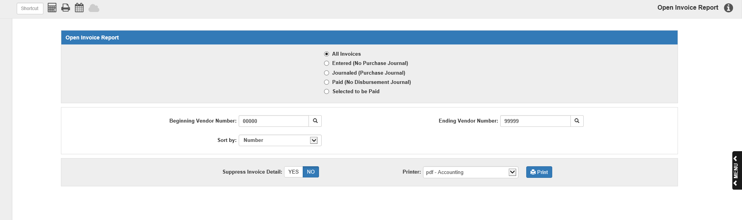

The Open Invoice Report (OIR) provides information about the invoices stored in A/P. You can choose to print or display invoice information for:

- All vendor accounts
- A range of vendors
- A single vendor

To access this function, you can either:

- Select “Accounts Payable” from the menu and choose the “Memo Reports” submenu. Click on “Open Invoice.”
- Type “OIR” in the Shortcuts Bar.

You can also open the program with the Selected to be Paid reporting option automatically selected by doing the following:

- Select “Accounts Payable” from the menu and choose the “Memo Reports” submenu. Click on “Invoices Selected For Payment.”
- Type “APSI” in the Shortcuts Bar.

Field Descriptions:

Select Invoice Status: Select the type of invoices you want to review by choosing a status code:

- All Invoices-Review all active invoices of all or specific vendors, regardless of the Status Code.
- Entered–Review invoices that have been entered but not journaled in the A/P Purchase Journal (APPJ) yet.
- Journaled–Review invoices that have been posted to the Purchase Journal, but not currently selected for payment.
- Paid–Review invoices that have been paid but not journaled in the A/P Disbursement Journal (DJ) yet.
- Selected to be paid–Review invoices that have been selected for payment, but not yet paid. You can open the report with this option automatically selected using the APSI shortcut.

Beginning Vendor Number: This field and the Ending Vendor Number field let you select which vendors will be included on your report. To begin a range search, type the first (lowest number) vendor number in this field. You can search for the vendor by entering all or part of the vendor’s name in this field. Locate the desired vendor and click it to fill the field.

Leave 00000 as the first vendor account to select all vendors for the report.

If running the report for a specific vendor, enter that vendor number in both this field and the Ending Vendor Number field.

Ending Vendor Number: Type the last (highest) vendor number of your range in this field. You can search for the vendor by entering all or part of the vendor’s name in this field. Locate the desired vendor and click it to fill the field.

Leave 99999 as the last vendor account to select all vendors for the report.

If running the report for a specific vendor, enter that vendor number in both this field and the Beginning Vendor Number field.

Sort by:

- Choose Number to sort the printout by Vendor Number.
- Choose Alphabetic to sort the printout by Vendor Name.

Suppress Invoice Detail: The report comes in two versions: a Detailed printout and a Summary printout. To receive the Detailed printout, which shows all the invoices on the report, choose No. To receive the Summary printout, which only gives vendor totals, choose Yes.

Printer: A default printer is pre-filled but you may change it as necessary. Use the pdf-Display printer to display the report on your screen. The report can also be directed to a spreadsheet (a sample is shown after the printed copy)

Press “Print” to generate the report.

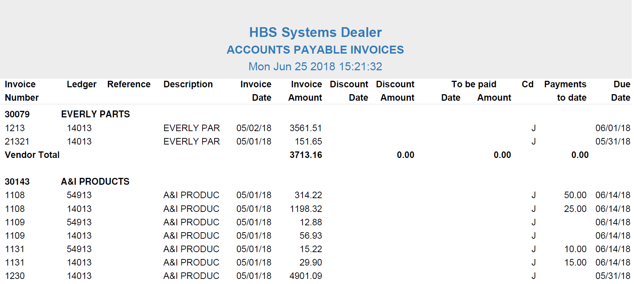

Open Invoice—Detail Report: The report is sorted into sections by vendor. The vendor number and name are printed on the first line of the section, followed by the invoices. The report lists the following information per each invoice line:

Invoice Number: The invoice number is shown here.

Ledger: This is the G/L account number used as the offset account for the invoice line (such as Parts Freight or Parts Inventory).

Reference: This is an optional field and is not required, unless the account number for this line has a subledger or is related to a specific unit.

For a subledgered account, you will see the control number.

For a Unit account, you will see the stock number.

Description: This column prints the description entered on the particular invoice line in Enter A/P Invoices (EAPI).

Invoice Date: This column shows the date that the invoice was written.

Invoice Amount: This is the original amount of the invoice line item before any payments. It also includes discounts not yet taken.

Discount Date: This prints the date by which the invoice must be paid in order to receive a discount, if applicable.

Discount Amount: This is the dollar amount of the discount if paid by the discount date, if applicable.

To Be Paid Date: If the check paying off the invoice line has already been printed, but not yet posted to the General Ledger, the check’s paid date prints here (Status Code=P).

To Be Paid Amount: This column shows the amount of the invoice line selected for payment, but not yet posted to the General Ledger (Status Code=S or P).

CD (Code): The column displays the status of the invoice:

- E=Entered
- J=Journaled
- S=Selected
- P=Paid

Payments to Date: If partial payments have been made toward this invoice line, or if the invoice’s Status Code is P, the amount of payments made to date on the line appears here.

Due Date: The date when the payment is due prints here.

Vendor Totals: This line calculates the invoice totals for this vendor account by adding up the values on all the lines of all the vendor’s invoices on the report. It prints vendor totals for the following columns:

Invoice Amount

Discount Amount

To Be Paid Amount

Payments to Date

Grand Totals: This line appears at the end of the report and shows totals for all vendors. It shows the total number of invoices as well as report totals for the following columns:

Invoice Amount

Discount Amount

To Be Paid Amount

Payments to Date

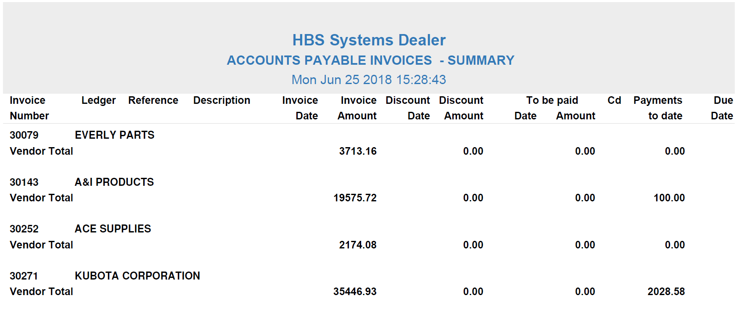

Open Invoice—Summary Report: The Summary version of the report only shows the vendor information and Total lines for each vendor, as well as the Grand Totals line at the end. This report is useful if you only want a general overview of the open invoice totals for each vendor.

Open Invoice Report – Spreadsheet Sample: The report can be directed to a spreadsheet. This format includes BOTH a Summary version and a Detail version with each as different tabs in the spreadsheet.

Open Invoice Report – Spreadsheet Sample – Summary Version:

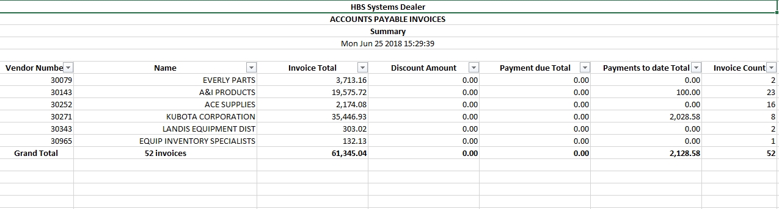

Open Invoice Report – Spreadsheet Sample – Detail Version:

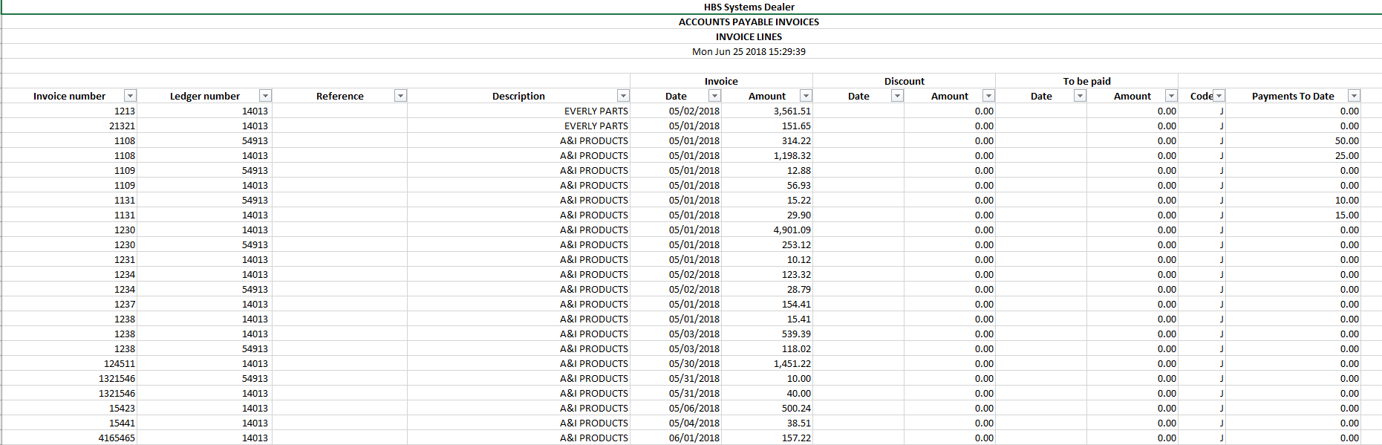

Print AP Accounts: If you have the Multiple A/P Accounts feature turned on in Information Defaults (ID), this report option will appear.

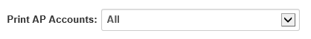

This field determines which invoices will print on the report based on their A/P account number. It defaults to “All,” but if you only want the report to show invoices for a specific account number, select that number from the drop-down menu. The account number will appear on the same line as the vendor name and number:

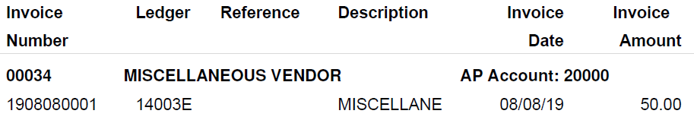

The report will also include a total line for the account, listed at the bottom of the report above the “Grand Totals” line.

If you print all accounts, the report will show a total line for each A/P account included on the report.

