Open Order Inquiry (OOI)

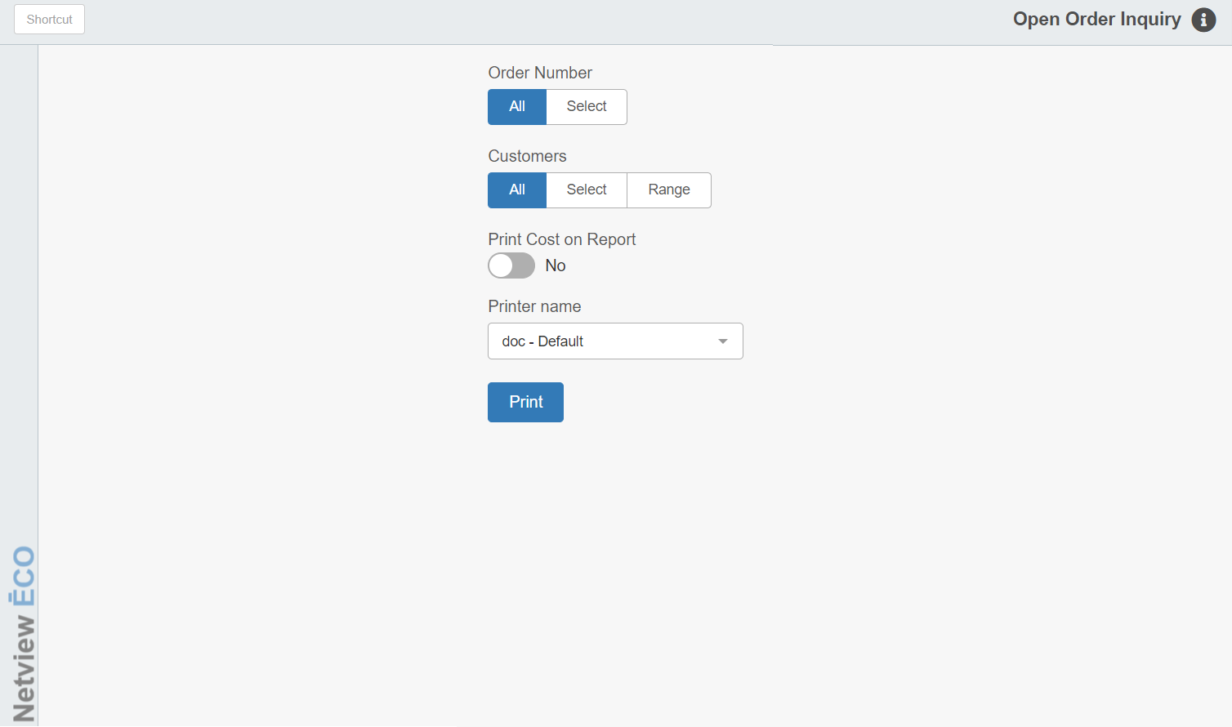

You can use this program to print or view any of your open Parts orders.

To access this function, you can either:

Select “Inventory” from the menu. Choose the “Orders” submenu and click “Open Order Inquiry.”

Type “OOI” in the Shortcuts Bar.

Field Definitions:

Order Number:

- Choose All to view all open orders.
- Choose Select to pick a specific open order to view.

Customers:

- Choose All to look at an order or all orders for all customers.
- Choose Select to pick a specific customer whose open order(s) you want to view.
- Choose Range to pick a set of customers whose open orders you want to view.

Print Cost on Report: Set this option to “Yes” to include part costs on your display/report.

Printer Name: Set the desired printer to receive the inquiry printout. Choose the PDF printer to view the results as a PDF on your screen.

Print: Click this button to generate the inquiry results.

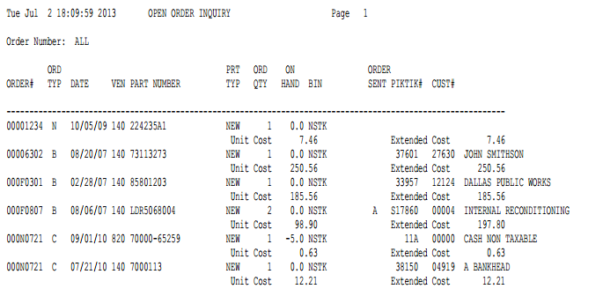

Report Definitions: The printout provides the following information:

Order #: This column shows the order number(s) selected.

Ord Typ: This column shows the order type:

N=New

B=Back-Ordered

C=Customer

E=Emergency

Date: This is the date the order was created.

Ven: The vendor number for the part shows here.

Part Number: This is the part number on order.

Prt Typ: This is the part type from the Part Master. It can be any of the following:

N=New

U=Used

C=Core

R=Reman

M=Memo

Ord Qty: This column shows the quantity on order or back order.

On Hand: This column shows the current On Hand quantity of the part.

Bin: Here you will find the primary bin location for the part.

Order Sent: This column lists whether or not the part has been marked as “Sent” on the order.

Pik Tik #: If this order was created from a POS or Service Back Order, the picking ticket number that the part was ordered on will print here.

Cust #: If this order was created from a POS or Service Back Order, the customer number and name of the customer who ordered the part will print here.

Unit Cost: This field will show the cost for one instance of the part if the option to include the cost was checked on the setup screen.

Extended Cost: This field will show the extended cost for the part on the order if the option to include the cost was checked on the setup screen. It is calculated by multiplying the unit cost time the quantity ordered.

Average Cost: If you have Average Costing enabled, the average cost will display on the line with the other costs.

