Parts Alias Maintenance (PAM)

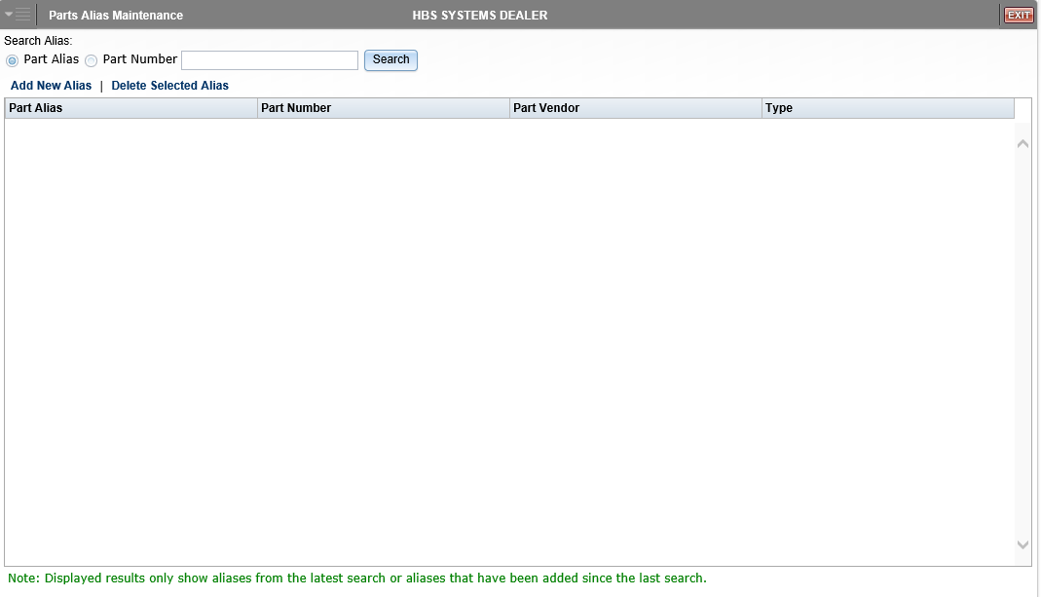

Parts Alias Maintenance (PAM) lets you define aliases or shortcuts for standard part numbers. For example, you could create an alias for a hydraulic hose part number that is difficult to type or remember. The application enables you to:

- Review existing aliases
- Delete an alias
- Add a new alias

To access the maintenance screen, you can either:

- Select “Inventory” from the menu and choose the “Parts/Source Update” submenu. Click on “Parts Alias Maintenance.”
- Type “PAM” in the Shortcuts Bar.

Searching for an Alias: To search for an alias to review, choose to search either by the alias itself or by the part number connected to the alias. Click the Search button to generate a list of results.

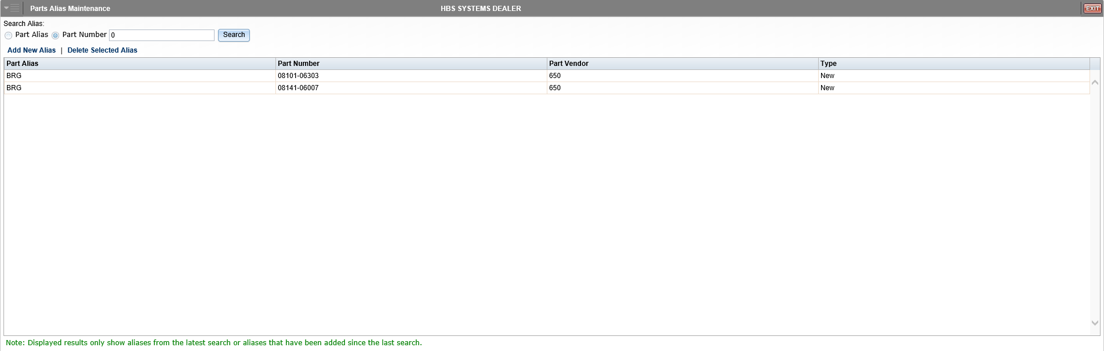

Deleting an Alias: To delete an alias, first pull up the alias record in the Part Alias box. Note that if you have not recently added or searched for the record, you will have to search for it. Once it appears in the box, click the record to select it. Click Delete Selected Alias to delete the alias from the system.

Adding an Alias: To add an alias, click on Add New Alias. The following box appears to help you define the new code:

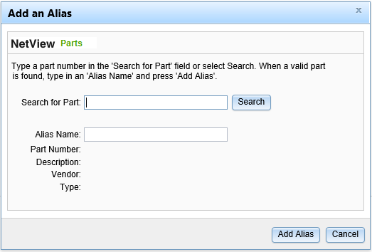

Use the Search button to find the original part number and then click Add Selected to create an alias/shortcut.

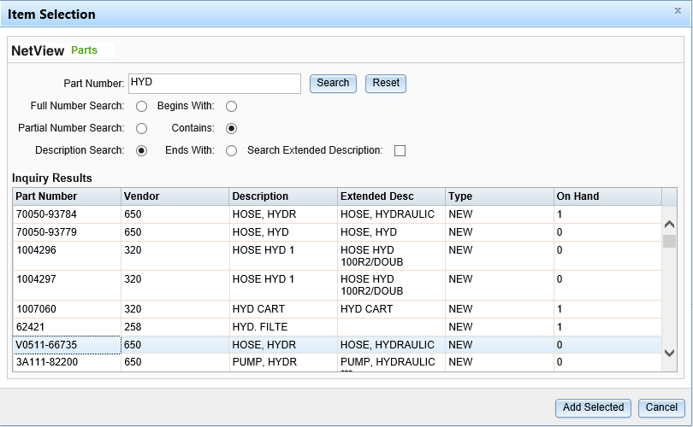

Fill in the part alias you want to use and press Add Alias.

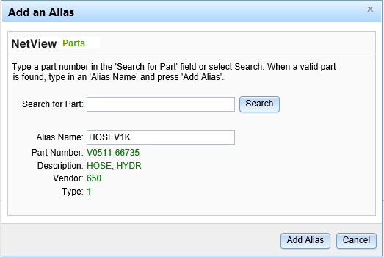

Using a Parts Alias in Parts Inquiry (PI): In Parts Inquiry (PI), select Alias from the Search drop-down menu and type the alias in the Search field. Click the Search button to begin the search.

The system will display the part as a search result. Click on the entry.

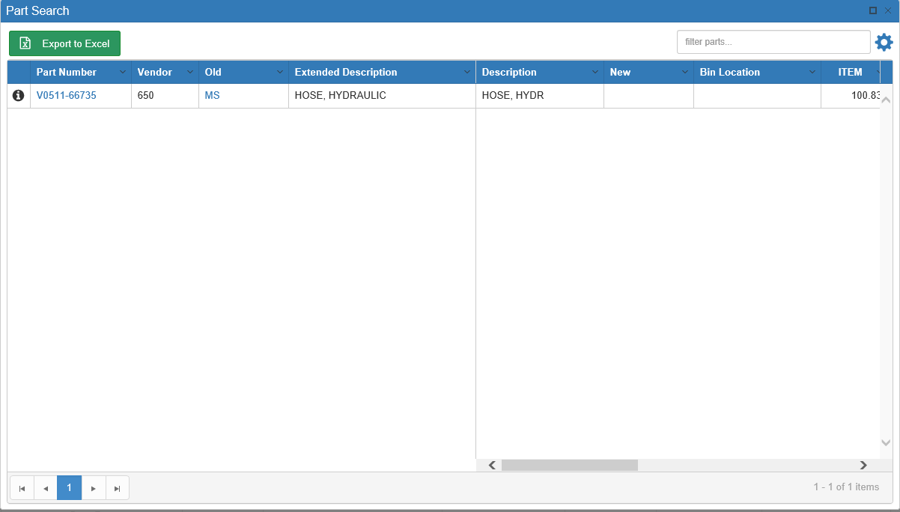

The part’s information will then display in the main PI screen.

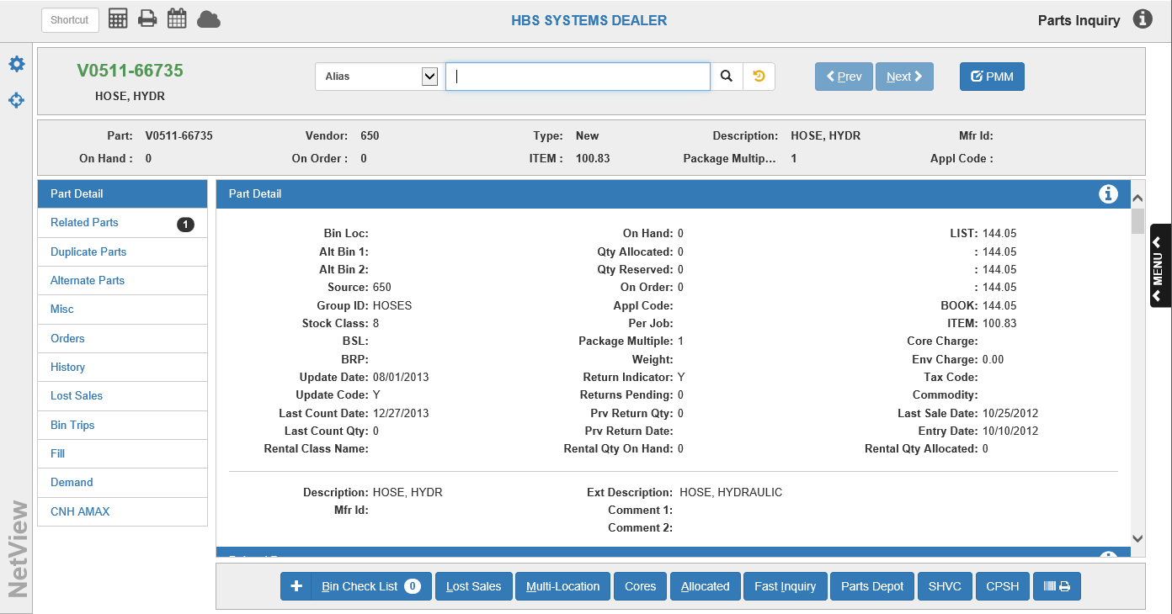

You can also search for a “group” of alias codes, particularly if they share characters, for instance if you defined all the aliases for the hydraulic hoses so the codes all begin with HOSE. In PI, select “Alias” from the Search menu, type the shared portion of the alias code in the Search field, and click the Search button.

The results for this search include all the alias codes that begin with HOSE:

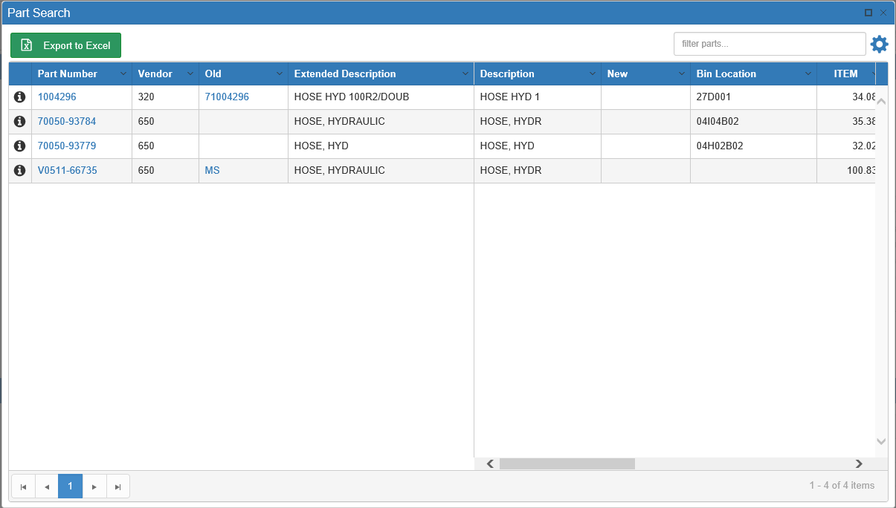

Using a Parts Alias in Point-of-Sale (POS): To use the alias code in Point-of-Sale (POS), type the code in the Part Number field, followed by a space and the letter “A” (for Alias).

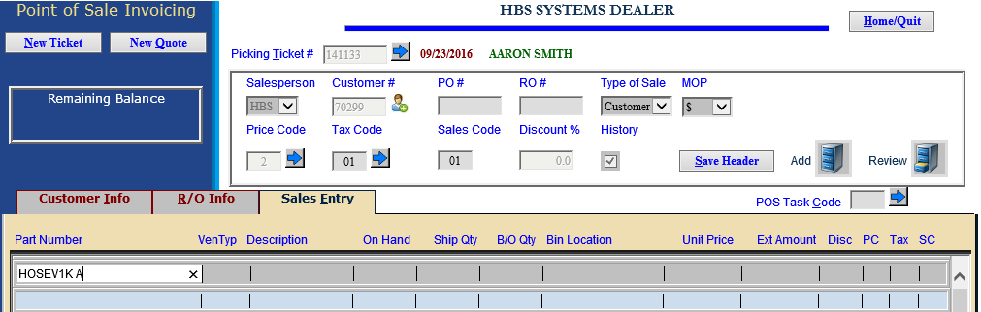

Press “Enter” to have the alias add the actual part number to the ticket.

Likewise, you can search for a group of similar alias codes by entering a portion of the code:

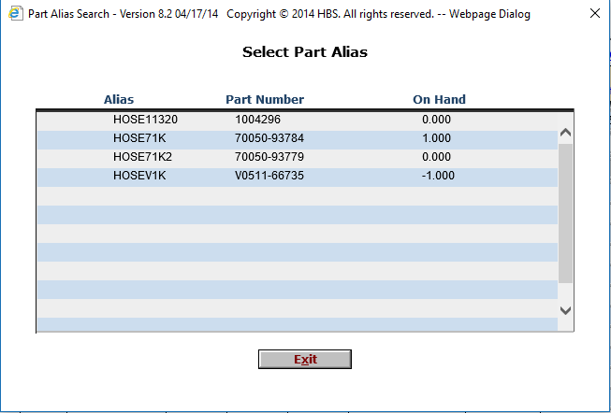

Choose the alias/part number needed from the box, and it will be added to the open ticket.

Using a Parts Alias in Repair Order Maintenance (ROM): To use the alias code in Repair Order Maintenance (ROM), type the code in the Part Number field, followed by a space and the letter “A” (for Alias).

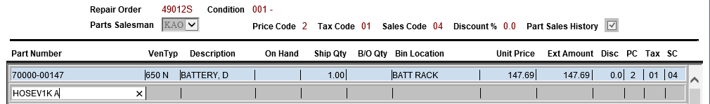

When you press “Enter,” the alias adds the actual part number to the ticket.

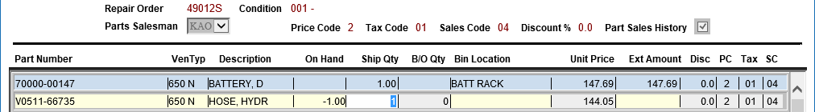

Likewise, you can search for a group of similar alias codes by entering a portion of the code:

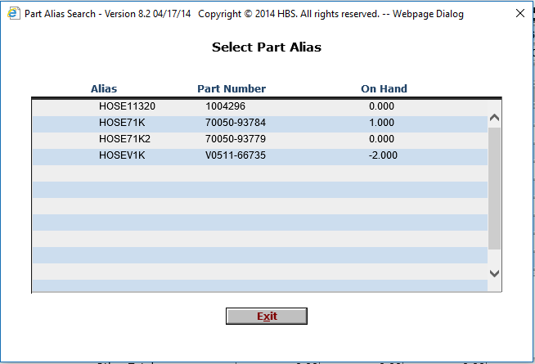

Choose the alias/part number needed from the box, and it will be added to the open repair order.

Using a Parts Alias in Quick Order Adjustments (QOA): You can use an alias in Quick Order Adjustments (QOA) through the Part Search option.

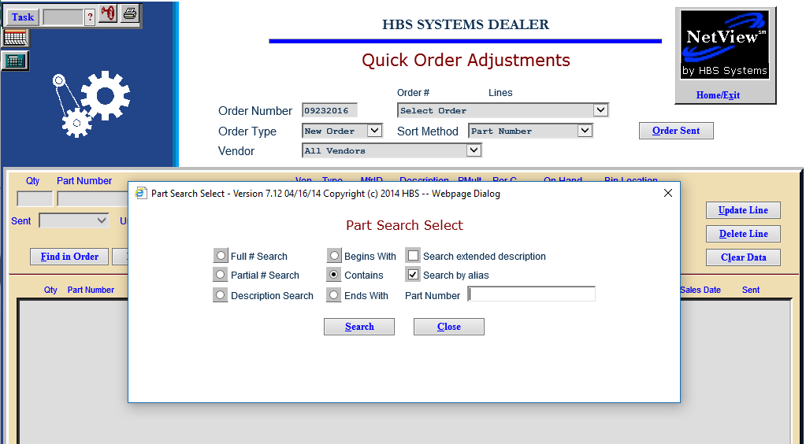

Using a Parts Alias in Post Return Adjustment (PRA): You can use an alias in Post Return Adjustments (PRA) through the Part Search option.

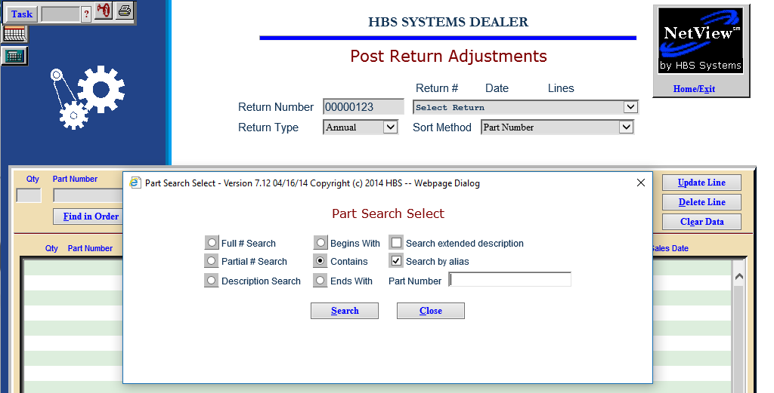

Using a Parts Alias in Report Writer (RW): A new database has been added to Report Writer (RW) so you can create a report of any aliases you add.

