Print Bin Barcode Labels (PBB)

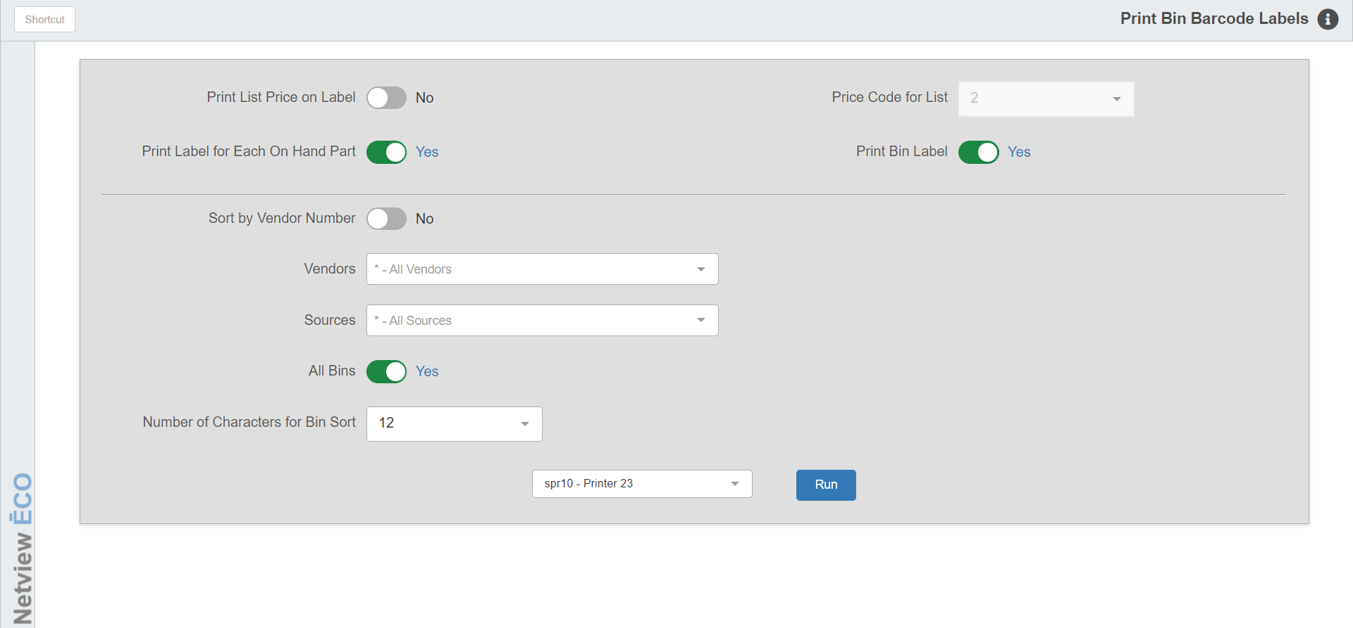

Print Bin Barcode Labels (PBB) lets you print barcode labels for parts and bin labels for selected parts or all parts. The information on a Parts Bin Barcode Label includes the following:

- Part number
- Vendor number
- List price (optional)
- Description
- Bin location

To access this function, you can:

- Select “Inventory” from the menu. Choose the “Bar Code and UPCs” submenu and click “Print Bin Barcode Labels.”
- Type “PBB” in the Shortcuts Bar.

Field Definitions

Print List Price on Label: Choose here to have the List Price (factored selling price) print on the label.

Select Yes to have the List Price print on the label.

Select No to exclude the List Price.

Price Code for List: This field is accessible only when you print the list price. This field will pre-fill with the price code you selected in Print Bar Code Defaults (PBD). If you want to change the Price Code used for this selection of bar code labels, you may change it here. It accepts any of the price codes 1–6.

Print Label for Each On Hand Part: This option lets you print a barcode label for each part you currently have on hand.

If you choose Yes, you will print a label based on the quantity on hand field. For example, if and you have 27 of an item on hand, you’ll get 27 labels for that part number.

If you select No here, you will receive just the bin label for each part number selected.

Print Bin Label:

- Select Yes to have an additional label printed for the bin itself. This label will be over and above any other labels printed for the other choices you make.
- Choose No to bypass printing the barcode label for the bin.

Sort by Vendor Number: Choose the sorting order here.

- Select Yes to sort the labels by vendor number.
- Select No to sort them by bin location and then part number.

Vendors: You may select to print labels for “All Vendors” or specific vendors.

Remember, if you select “All Vendors” that this choice works with ALL the other selections for labels on this screen. For example, you could choose “ALL” here and then limit the label printing to a specific parts source or bin location.

You may choose up to ten individual vendors to be included by typing them into the first field or selecting them from the drop-down menu.

Select Sources: You may select to print labels for “All Sources” or specific sources.

- This choice works with ALL the other selections for labels on this screen.
- You may choose up to ten individual sources to be included by typing them into the first field or selecting them from the drop-down menu.

All Bins: Set this option to “Yes” to print labels for all bins within the vendors and sources selected in the previous fields. This choice works with ALL the other selections for labels on this screen.

From/To Bin: These fields appear if you set “All Bins” to “Yes.” Enter up to four ranges of bin locations in these fields.

Number Of Characters For Bin Sort: You can choose to accept the default of 12 characters or select 1 through 11 from the drop-down menu. This lets you limit the length of the bin locations for the label sort. For instance, if you put a “4” in this field, it would limit the sorting of all bin locations selected to 4 characters or less. We suggest using all 12 positions of the bin location for sorting.

Printer Name: Set the printer to receive the barcode labels. Note that you can only print the labels using a specialty barcode label printer, and that only printers of that kind will be available to select here.

Run: Press “Run” to generate the labels.

