Parts Barcode Defaults Maintenance (PBD)

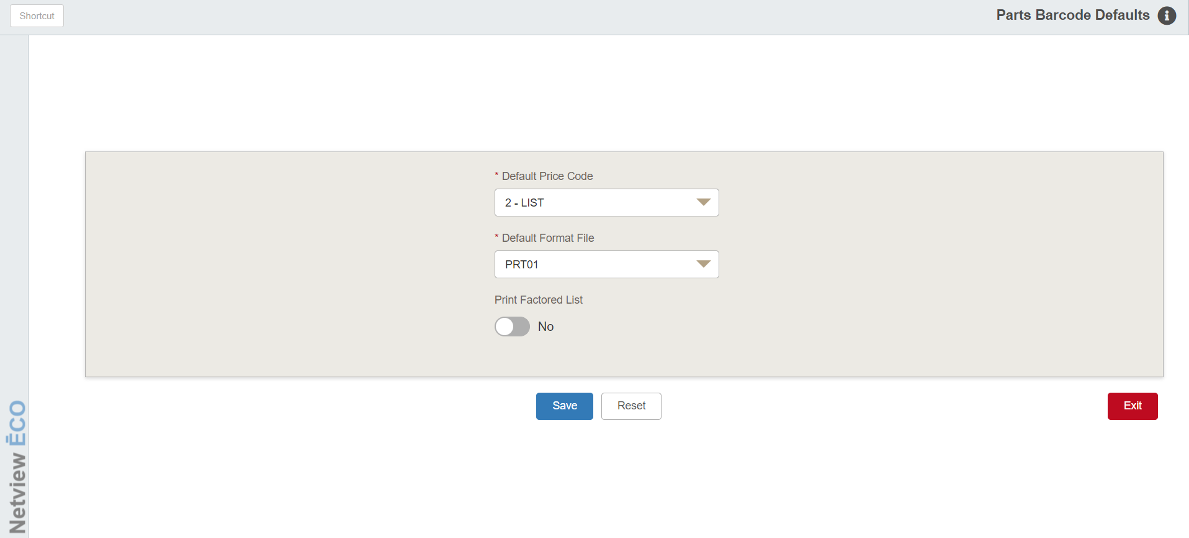

Print Barcode Defaults Maintenance (PBD) lets you manage your barcode label printing defaults.

To access this function, either:

- Select “Inventory” from the menu. Choose the “Bar Code and UPCs” submenu and click “Parts Barcode Defaults.”
- Type “PBD” in the Shortcuts Bar.

Field Descriptions:

Default Price Code: Choose the price code you want to use when printing parts pricing on your bar code labels. You may choose any of the six available price codes. They include:

Price Code |  | Common Definition
1 |  | Cost (Mfr Cost)
2 |  | List (Your Selling Price)
3 |  | DS01 or other dealer defined code
4 |  | Dealer defined code
5 |  | Dealer defined code
6 |  | Book or MSRP (Mfr List)

Default Format File: There are five bar code label formats currently available: PRT01, PRT02, PRT03, PRT04, and PRT05 (the last added to better fit the 3-inch bin drawers). They have differing print sizes and layout. Choose one of these for the style for your parts bar code labels.

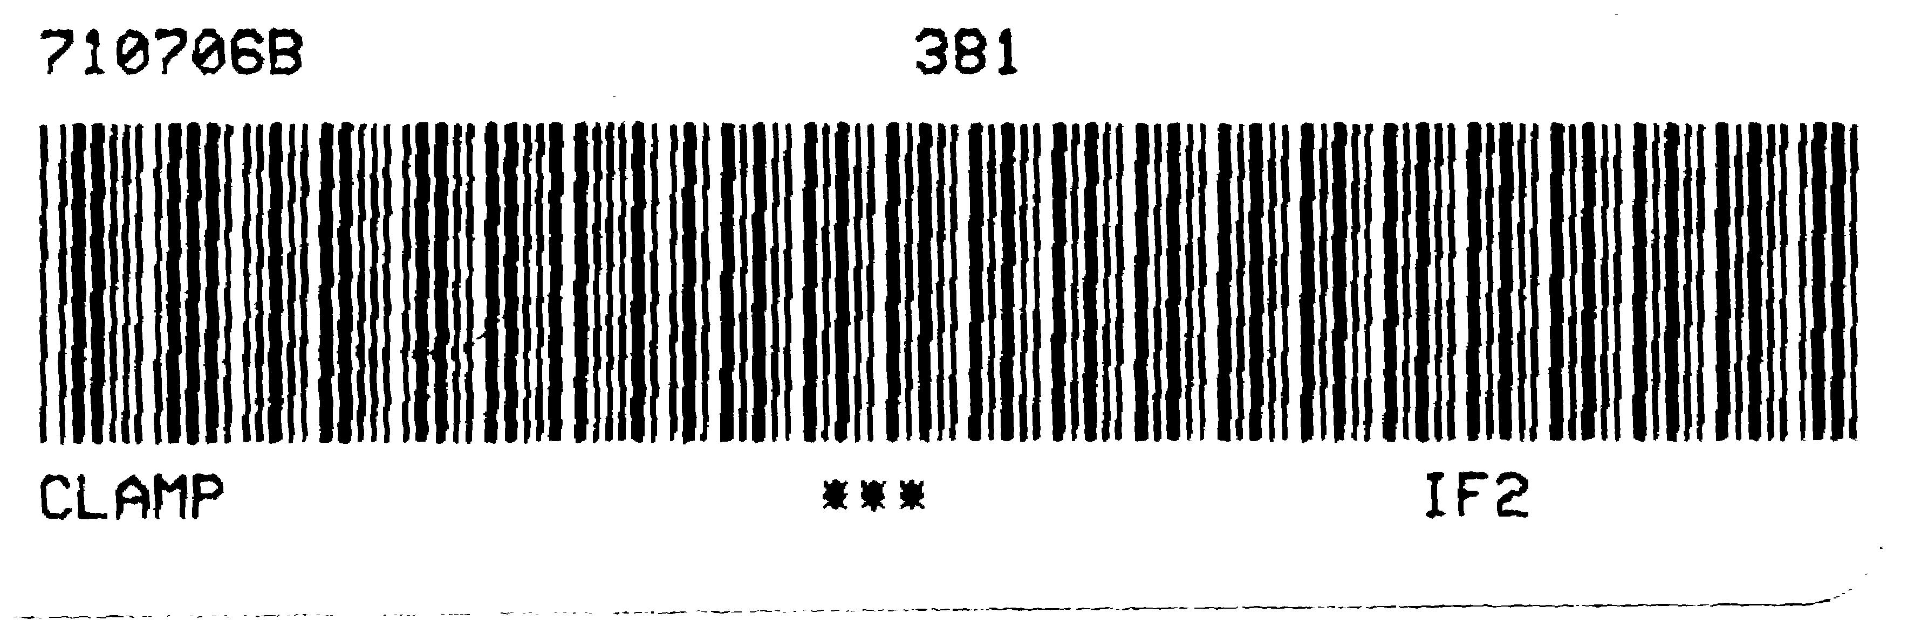
Format PRT01

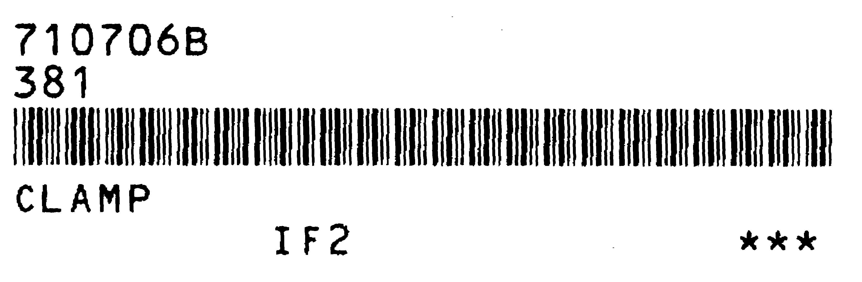
Format PRT02

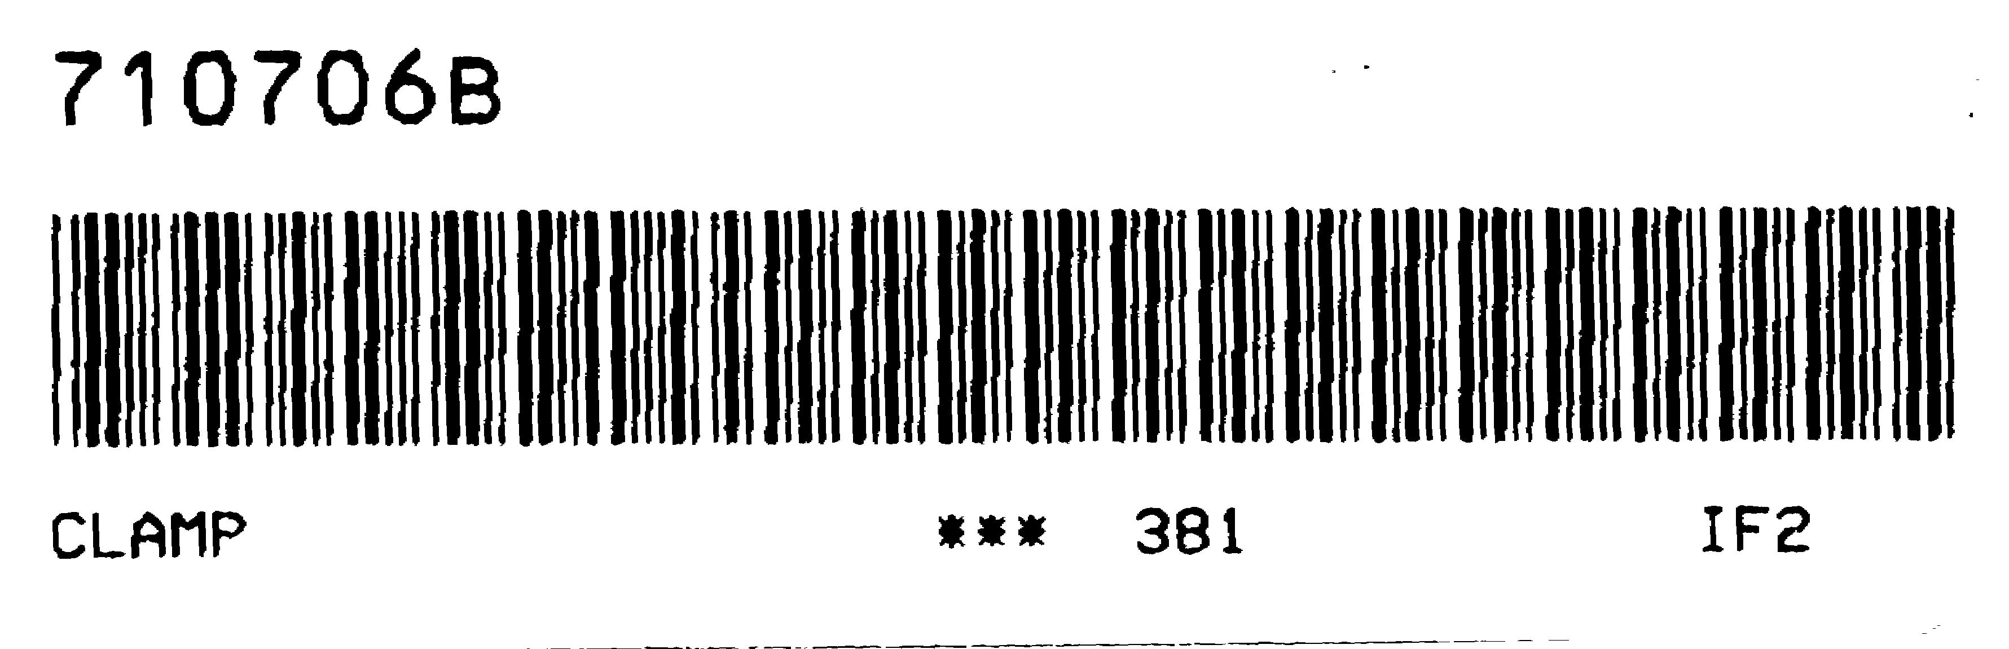
Format PRT03

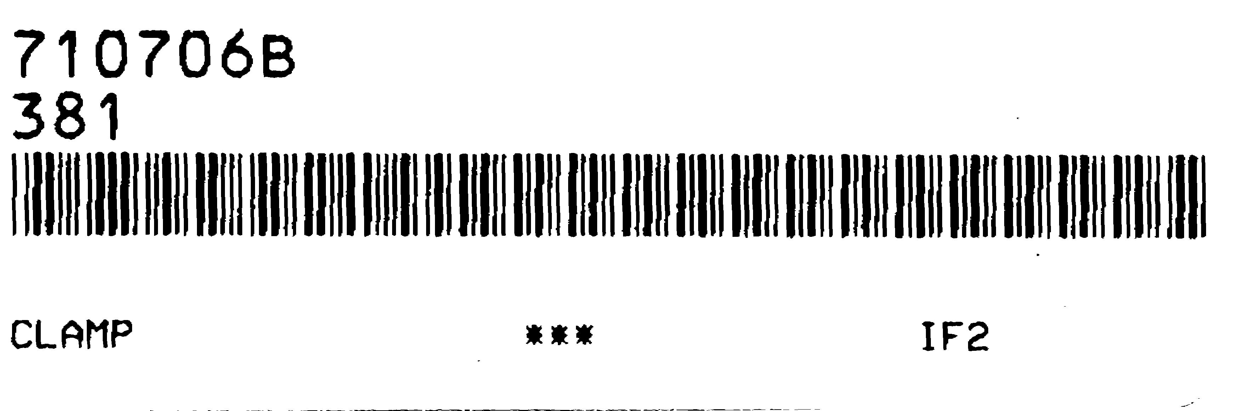
Format PRT04

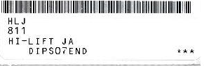
Format PRT05

Print Factored List: Choose if you want to factor the price code.

Selecting Yes means you will factor the price code selected by the factor in the Parts Source for the part being printed.

Choosing No will simply use the raw price code value without factoring by the value in the Parts Source.

Save: Click this button to save your settings.

Reset: Click this button before clicking Save to revert any changes made to your settings.

