Print Barcode Labels (PBL)

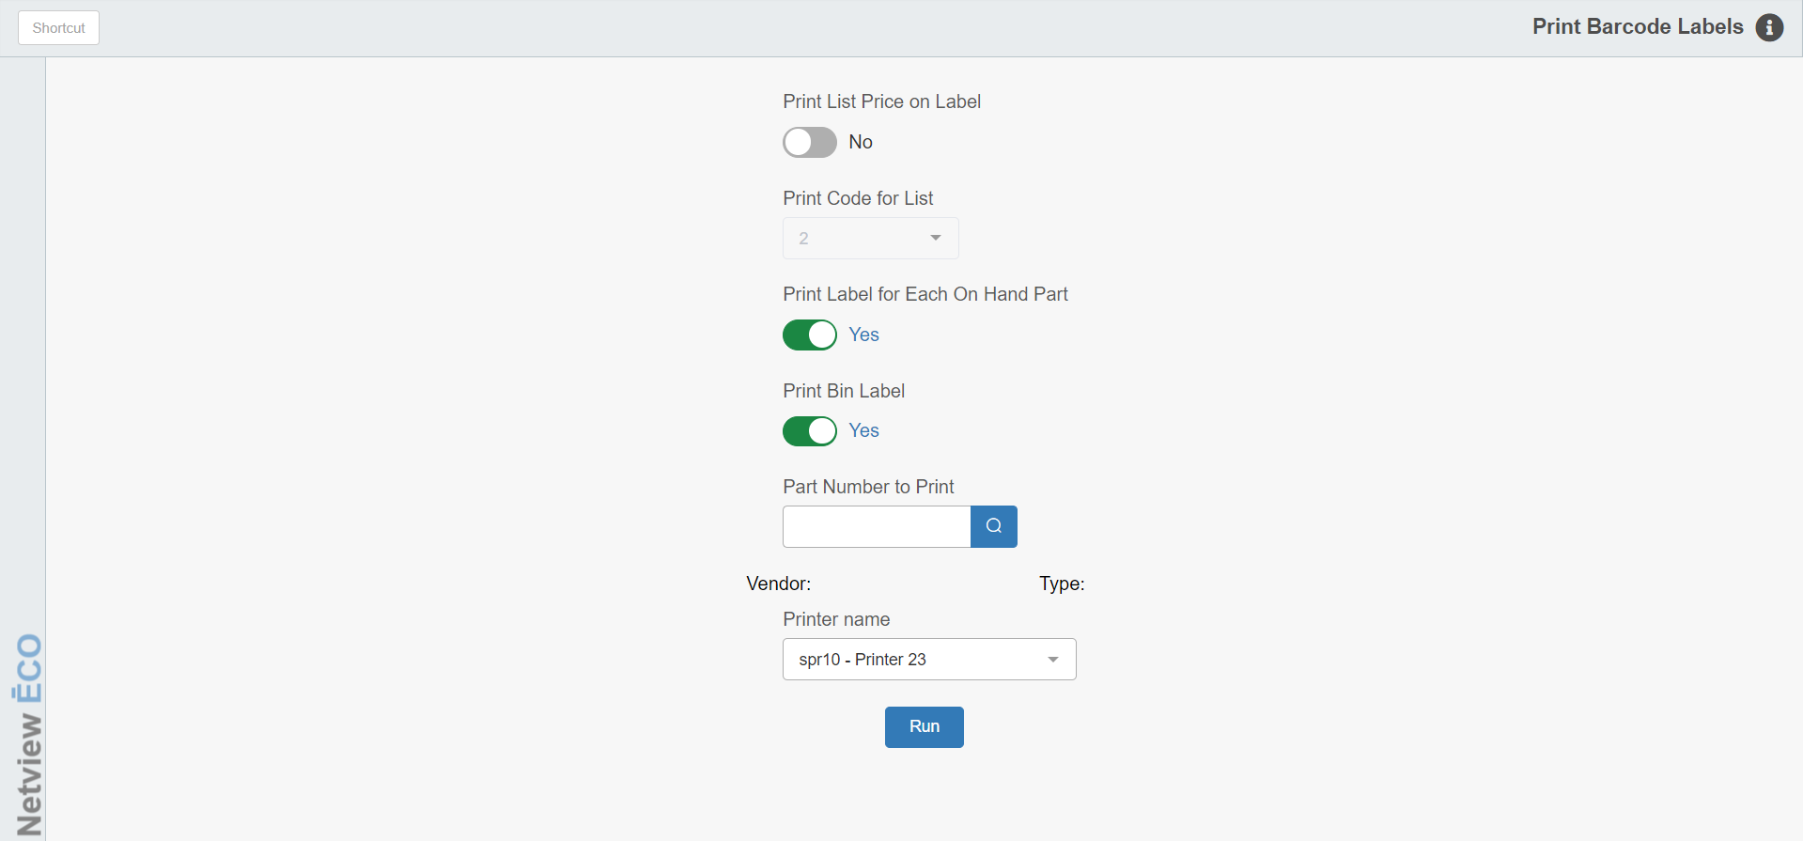

Print Barcode Labels (PBL) lets you print barcode labels for specific part numbers or groups of part numbers. The information on a Parts Barcode Label includes the following:

- Part number
- Vendor number
- List price (optional)
- Description
- Bin location

To access this function, you can:

- Select “Inventory” from the menu. Choose the “Barcodes and UPCs Maintenance” submenu and click “Print Barcode Labels.”
- Type “PBL” in the Shortcuts Bar.

Field Definitions

Print List Price on Label: Choose here to have the List Price (factored selling price) print on the Barcode label.

- Select Yes to have the List Price print on the label.
- Select No to exclude the List Price.

Price Code for List: This field is accessible only when you choose to print the list price. It shows the Price Code to be used for this selection of bar code labels. The system pre-fills this field with the price code selected in Print Bar Code Defaults (PBD). You may change the value at this field to any of the prices codes 1–6.

Print Label for Each On Hand Part: This option lets you print a barcode label for each part you currently have on hand.

- If you select Yes, you will print a label based on the quantity on hand field. For example, if you have 27 of an item on hand, you’ll get 27 labels for that part number.
- If you select No, you will receive one label for the part number selected.

Print Bin Label:

- Select Yes to have an additional label printed for the bin itself. This label will be over and above any other labels printed to satisfy the other choices you make.
- Select No to bypass printing the barcode label for the bin.

Part Number to Print/Vendor/Type: Enter the part number to print. Once you enter a part number, the part’s Vendor Number and Type will appear on the screen.

Printer Name: Set the printer to receive the barcode labels. Note that you can only print the labels using a specialty barcode label printer, and that only printers of that kind will be available to select here.

Run: Click this button to print your label selection.

