Print Checks (PC)

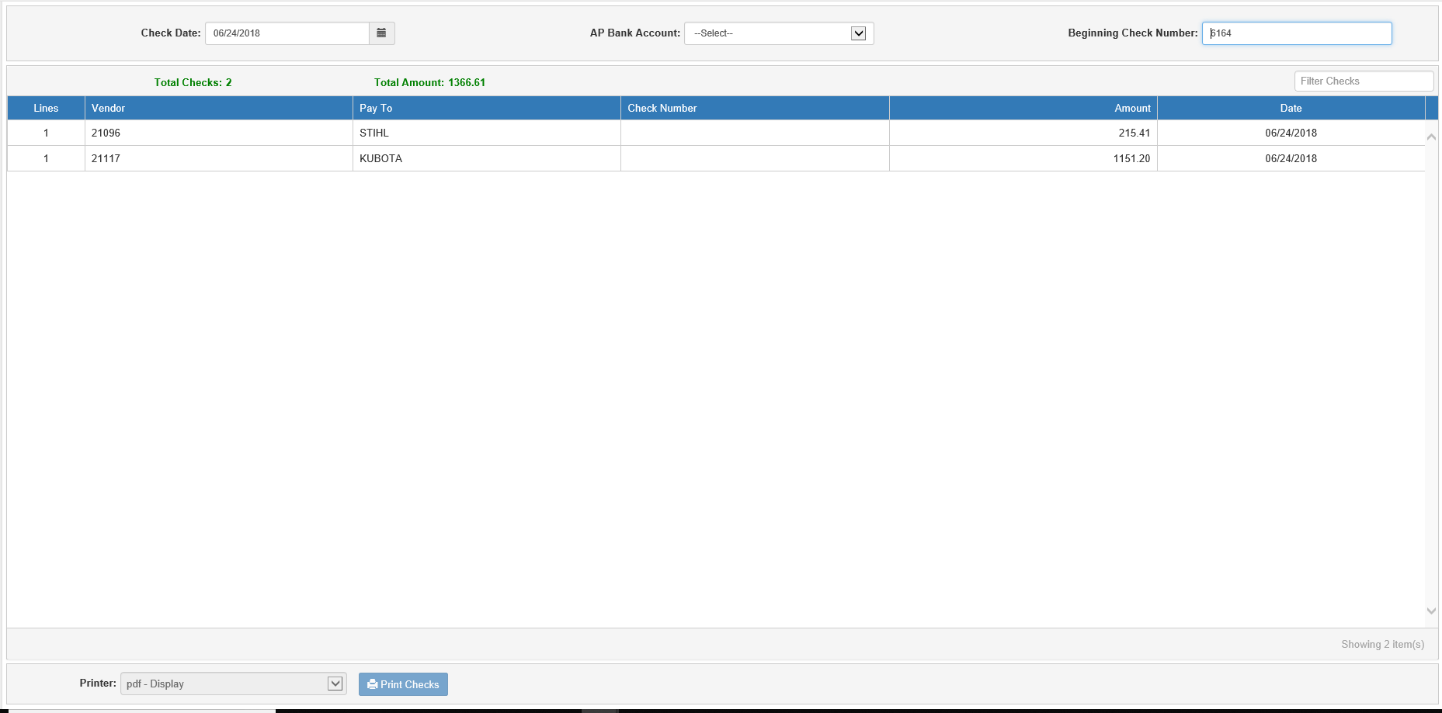

Print Checks (PC) is where you print the actual checks. Using PC, you can also reprint checks if something is wrong.

To access this function, you can either:

- Select “Accounts Payable” from the menu and choose the “Process Checks” submenu. Click on “Print Checks.”
- Type “PC” in the Shortcuts Bar.

If there are checks waiting to print, the screen will open and display the list of checks in the grid. If there are no invoices currently selected to be paid, and so no checks waiting, the screen will be inactive and the following message will appear:

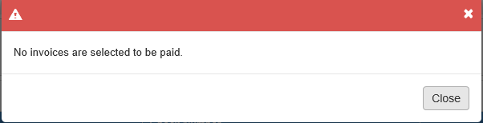

Field Descriptions:

Check Date: Enter the date to print on the checks. This date becomes the document date. The date defaults to the current date, but can be changed to any date in an open accounting month.

AP Bank Account: Use the drop-down menu to select the A/P bank account for the check payments if multiple bank accounts are in use. The default account is selected automatically but can be changed as needed.

Beginning Check Number: This is the first check number for this check run. The system remembers the last number used for this account and displays the next sequential number. Verify the number is correct or change it as necessary.

Total Checks: This field shows the total number of checks that will print for this check run, based on the number of vendors with invoice lines selected for payment.

Total Amount: This field shows the dollar amount of the check run.

Check Run List Grid: This grid shows every check set to be printed in this run.

Filter Checks: If you have a large number of checks and only want to see if a particular check is listed for the run, use this field to filter the check listing by entering specific information about the check you are looking for, such as vendor number, check amount, etc. The grid will change to show only those checks with matching information.

Grid Columns:

Lines: This column shows the number of stub lines that will print on the check.

Vendor: This column shows the vendor number.

Pay To: This column shows who the check will be paid to. This typically shows the vendor name.

Check Number: This column shows the check number. This column will be blank, as the numbers will only be assigned when the run occurs.

Amount: This column shows the check amount.

Date: This column shows the check date.

Print Checks: Press this button when you have verified the printer name and are ready to print.

NOTE: Information will only print on a check stub if the option is turned on in Vendor Information (VIM).

Sample Check with Stub Information

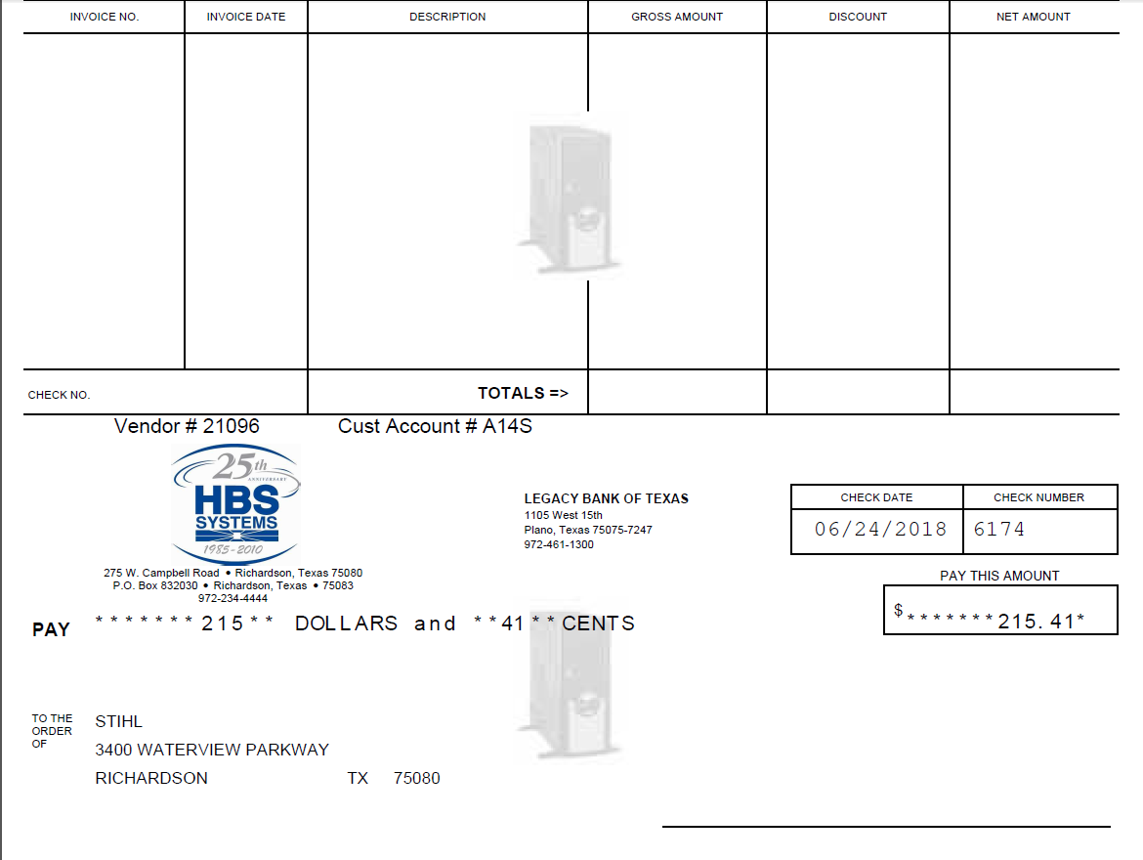

Check Stub Information: The stub information includes the following:

- Invoice Number(s)
- Invoice Date(s) and Description(s)
- Invoice Gross Amount (the original amount before any discount or partial payments are applied)
- Invoice’s Discount Amount
- Invoice Net Amount (the amount after a discount is applied)
- Check Number
- Totals for all invoices listed on the stub, such as:
  - Total Gross Amount
  - Total Discount Amount
  - Total Net Amount
- Vendor Account Number
- Your Customer Account Number with that Vendor

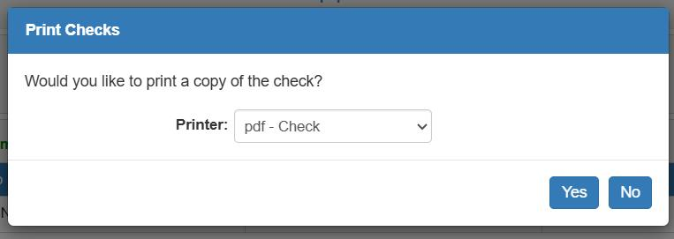

Print Record Copy?: This prompt appears after a check run of e-forms style checks completes.

- Answer Yes if you want a voided copy for your records.
- Answer No to bypass the record copy.

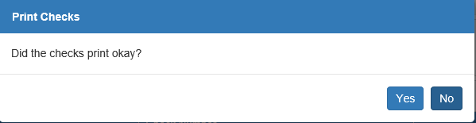

Did the checks print ok?: This prompt appears after a check run completes.

- Answer Yes when you have retrieved the checks and made sure they are correct.
- Answer No to reprint the checks.

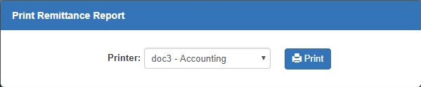

Full Remittance Report: If any vendors in this check run are set to receive a Full Remittance Report, this prompt will appear after you click Yes at the “Did the checks print ok?” prompt. Select a printer and click Print to print the report for the vendor.

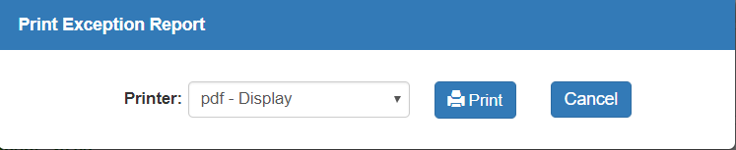

Print Exception Report: If there is an Exception Report for the check run, the option to print the report will appear after you click Yes at the “Did the checks print ok?” prompt.

- Select a printer and click Print to print the report.
- Click Cancel to continue without printing it.

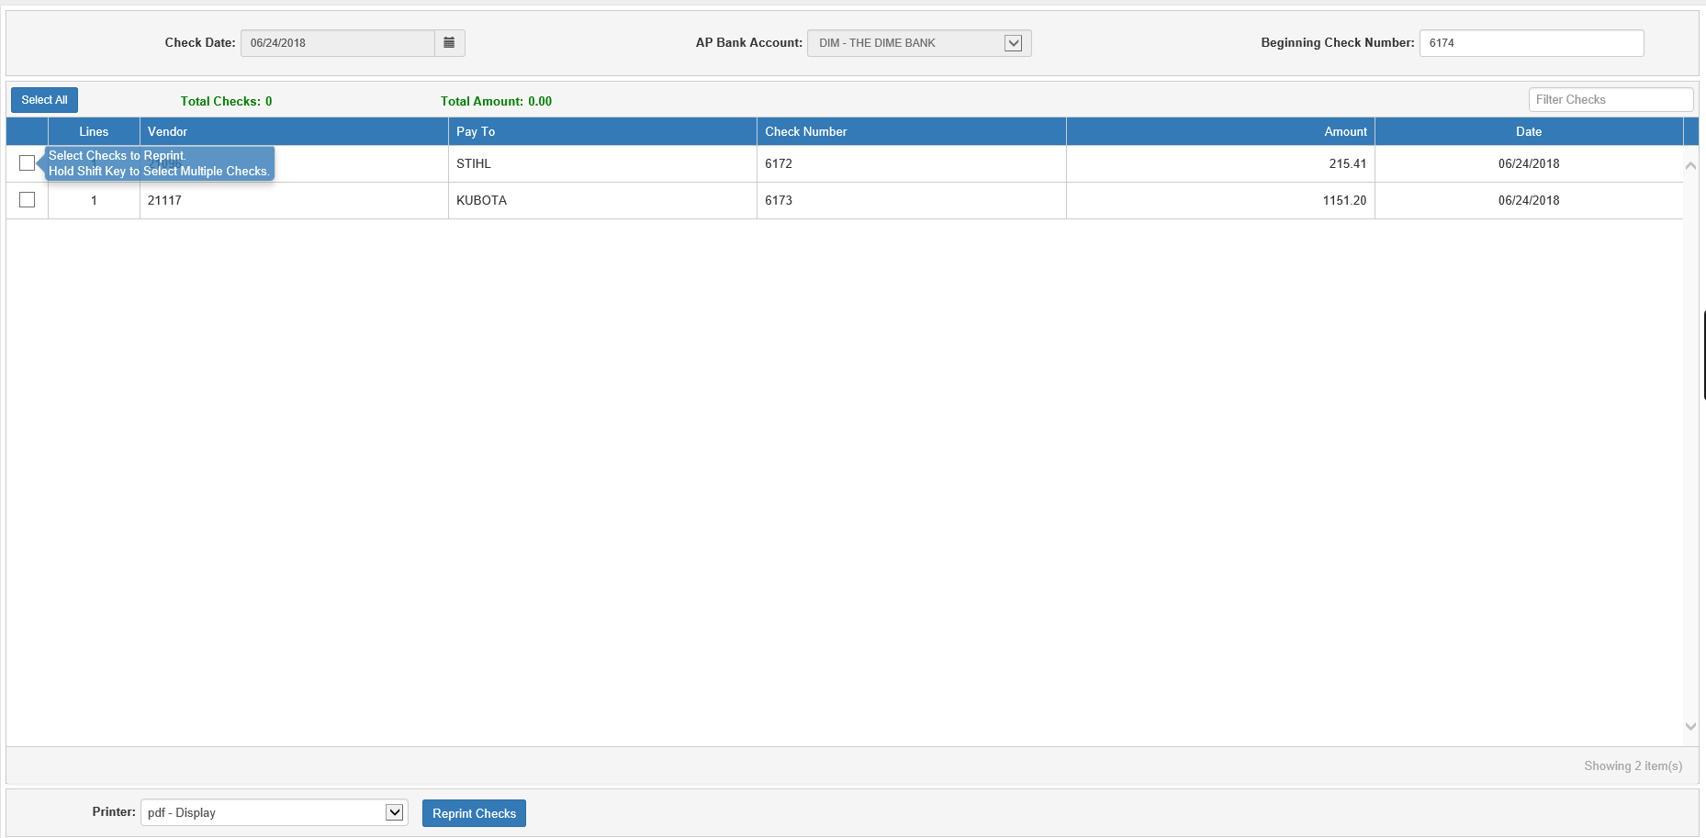

Reprint Checks: If you say No when asked if the checks printed okay, the program will switch to Reprint mode. This screen will allow you to select which checks from the previous run you want to reprint.

Check Date: This field will be inactive; you will not be able to change the originally selected check date.

AP Bank Account: This field will be inactive; you will not be able to change the originally selected bank account.

Beginning Check Number: This is the first check number for the reprint run, which is the next number available after the initial printing run. Verify the number is correct or change it as necessary.

Total Checks: In Reprint mode, this field shows the number of checks currently selected for reprinting.

Total Amount: In Reprint mode, this field shows the total dollar amount of checks currently selected for reprinting.

Check Run List Grid: This grid now functions to let you select the checks you want to reprint.

Filter Checks: If you have a large number of checks and only want to find a particular check to reprint, use this field to filter the check listing by entering specific information about the check you are looking for, such as the vendor number, check amount, etc. The grid will change to show only those checks with matching information.

Select/Clear All: This button only appears in Reprint mode. Click it to select or clear all checks for reprinting.

Grid Columns:

- Select/Clear: Check the box next to the check(s) to reprint. Leave the box blank if the check already printed okay.
- Lines: This column shows the number of stub lines that will print on the check.
- Vendor: This column shows the vendor number for the check.
- Pay To: This column shows who will receive the check. This typically shows the vendor name.
- Check Number: In Reprint mode, this column will hold the check numbers assigned during the original print run. When you reprint a check, it will be assigned a new check number, while the original number will be recorded in the General Ledger with a value of “0.00.”
- Amount: This column shows the check amount.
- Date: This column shows the check date.

Reprint Checks: Press this button when you have selected which checks will reprint, verified the printer name, and are ready to receive the new checks.

You will see the “Did the checks print okay?” message again after you reprint the checks.

- If they all reprinted correctly, click Yes to end your session.
- If any did not, click No to return to the Reprint screen and repeat the process until all the checks do print correctly. NOTE: There is no limit on how many times you can reprint the checks.

Reprinting Checks – Proof Sheet & Disbursement Journal: After you reprint the checks, the Proof Sheet (PP) and the Disbursement Journal (DJ) contain both the original check document and the reprinted check document. The original check number is recorded in both so that you can track this information when reconciling your bank account. The original check number has lines showing the actual void (which will have the description “Voided Check”) as well as lines showing the check amount being credited back to the dealer. The reprinted check document contains the new check number and the actual accounting information.

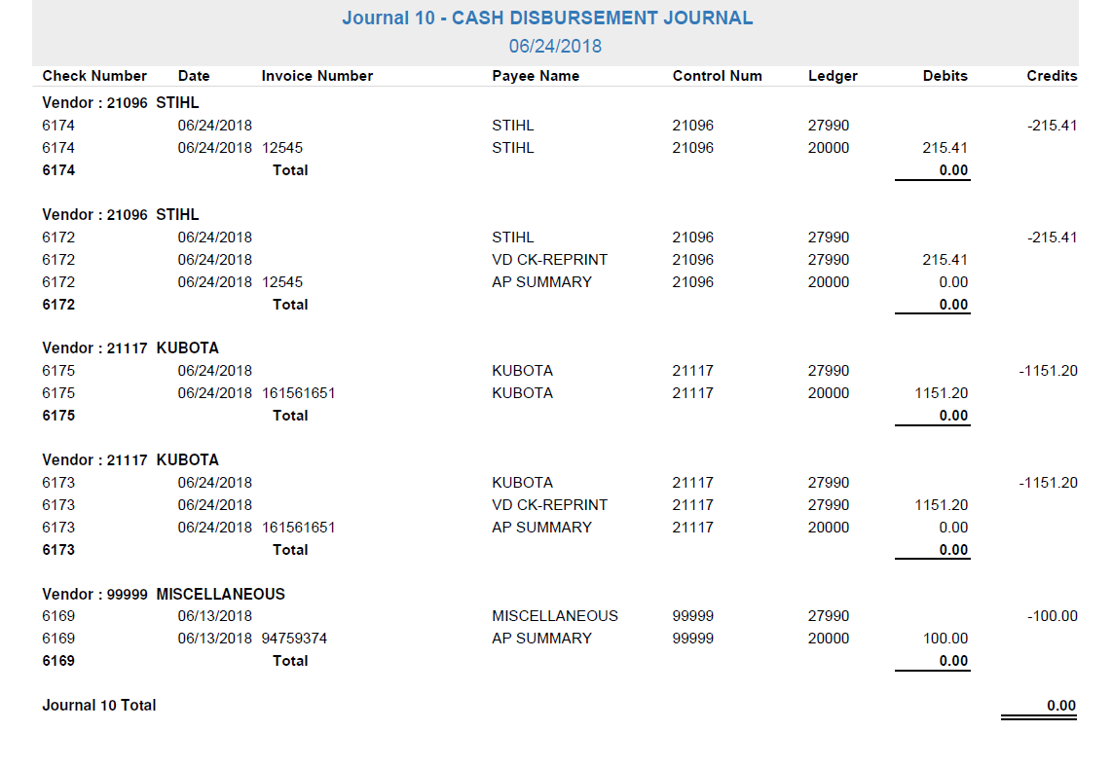

Handling Incomplete Check Runs: If you start a check run and then close the program without completing your session, the following message will appear the next time the program is opened:

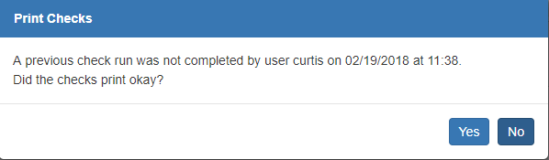

- If the check run is successfully completed and ready for journaling, click Yes.
- If a reprint is required to complete the run, click No.

NOTE: You will not be able to perform any other actions in PC until the incomplete check run is finished.

