Print Custom G/L Statements (PCGL)

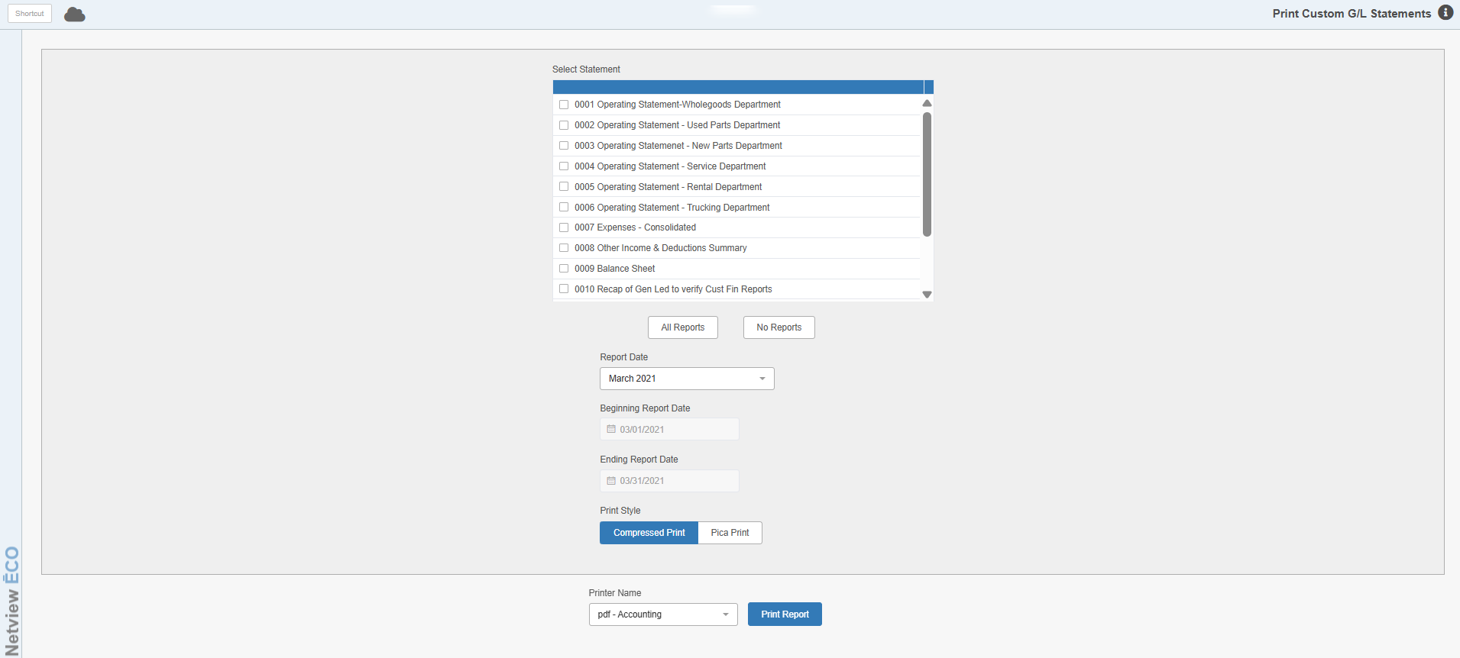

Print Custom G/L Statements (PCGL) allows you to create a customized General Ledger report containing up to 11 different reports in one, all concerning the dates you have specified. This program is only avaiable if you have the Custom Financials package.

Field Definitions:

Select Statement: Check the boxes next to the individual reports you want to include on the statement. The options will be different depending on the dealership.

All Reports: Click this button to automatically select all the reports.

No Reports: Click this button to deselect all the reports.

Report Date: Select the month you wish the statement to cover from the drop-down menu. If you want to select specific beginning and ending dates that may not be the first and last day of a month, choose the Custom Dates option.

Beginning/Ending Report Date: If you select the Custom Dates option in the Report Date field, either type in the beginning and ending dates in these fields or select the dates from the attached calendars.

Print Style: Choose one of the following options from the drop-down menu:

- Compressed Print
- Pica Print

Printer Name: Select the printer you want to send the statement to from the drop-down menu.

Print Report: Click this button to print the report. The report’s appearance and content will depend entirely on your selections.

