PER: Customer List—Numeric

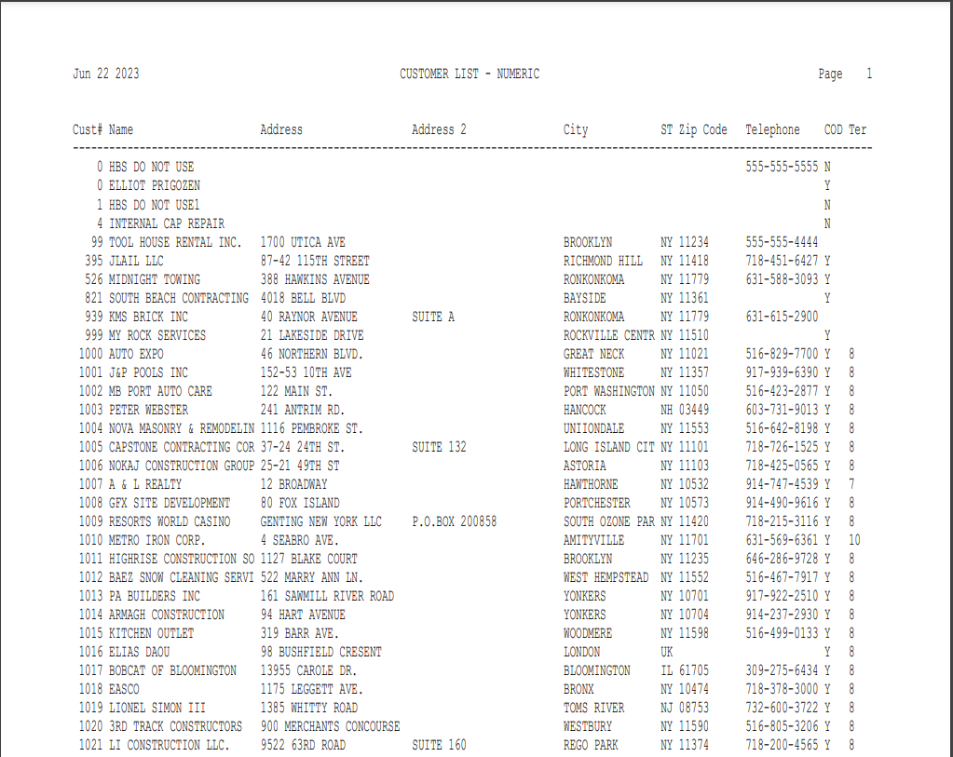

This Report Writer report offers basic information about the entire customer base. It can be run from Print Established Report (PER). The information is sorted in numerical order based on the customer number field in the Customer Master. When you run this report, it prompts for the Customer Number so you can select all or part of customer base for the report. NOTE: One of the fields this report provides is the Territory Code. This report is an easy way to find out which codes are in use on your system.

To access this report:

- Select “Report Writer” from the menu and click on “Print an Established Report.” Choose the report you want from the application.
- Type “PER” in the Shortcuts Bar and select the report

Columns Include:

Cust#: This column shows the Customer Number assigned to this customer.

Name: This column shows the Customer Name as entered in the Customer Master.

Address: This column shows the street address information about the customer from the 1st line of address information in the Customer Master.

Address 2: This column shows any secondary information about the customer from the 2nd line of address information in the Customer Master.

City: This column lists the Customer’s City.

St: This column lists the Customer’s State or Province.

Zip Code: This column lists the Customer’s Zip or Postal Code.

Telephone: This column lists the Customer’s telephone number.

COD: This column tells you if the customer is on COD.

Ter: If the Territory Code has been filled in, the value in that field is shown here.

