PER: Parts-12 Mo Sales (By Dollars)

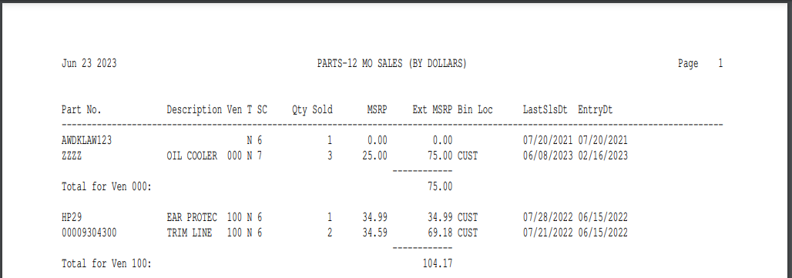

This report writer report shows dollar sales in ascending order for parts of the selected Vendor(s) for the last 12 months. This report is sorted is based upon the Extended List Price. When you run this report, it prompts for Vendor. You may run it for:

- A single vendor
- Range of vendors
- All vendors

To access Report Writer, you can either:

- Select “Report Writer” from the menu, click “Print an Established Report,” and choose the report number.
- Type “PER” into the Shortcuts Bar and select the report number.

Report Detail: This report contains the following information:

Part No.: This is the part number with sales in the last 12 months.

Description: This field is the part number description from the Part Master.

Ven: This is the vendor number assigned to this part.

T: This is the part’s type, which could be:

New

Used

Reman

Core

Memo

SC: SC is the Stock Class for this part from the Part Master.

Qty Sold: This is the quantity that you have sold of this part number in the last 12 months.

MSRP: This is the manufacturers suggest selling price for this part number.

Ext MSRP: The ext list is the MSRP multiplied by the quantity sold.

Bin Loc: This is the part’s bin location.

LastSlsDt: This is the date of the last time this part was sold.

EntryDt: This is the date of when the part number was first entered in the system.

Report Totals: This report provides:

A total of the extended MSRP by vendor

A total for all vendors on the report

