PER: Current COD Customers

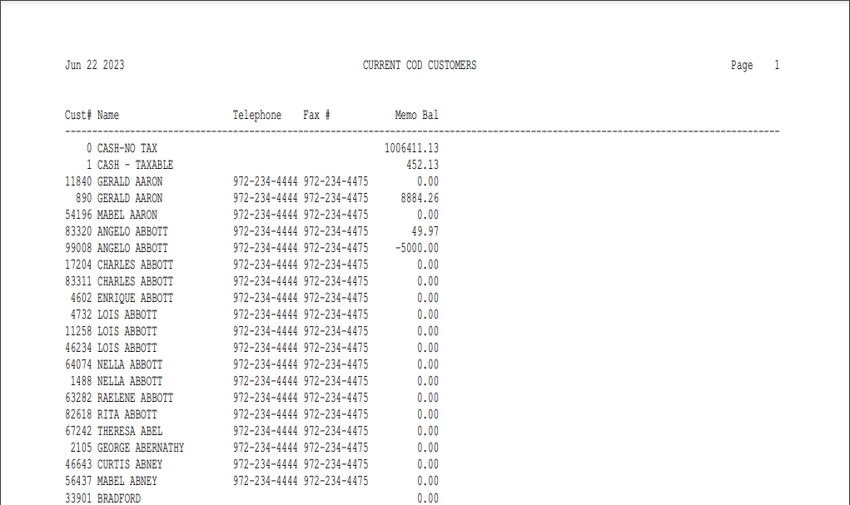

This Report Writer report provides information about the customers flagged as COD only. To appear on this report, the customers must have “Y” in the COD status. The information is sorted in alphabetical order based on the Alpha Sort field in the Customer Master.

- To access this report:
  - Select “Report Writer” from the menu and click “Print an Established Report.” Choose the report from the selection in the application.
  - Type “PER” in the Shortcuts Bar and select the report

Columns Include:

Cust #: This column shows the customer number.

Name: This column shows the customer name.

Telephone: This column shows the customer’s telephone number.

Fax #: This column shows the customer’s fax number.

Memo Bal: This column shows the Memo Balance of the customer. This balance consists of the posted balance from Current Balance plus the un-posted entries made through POS invoicing, Service Invoicing, or Cash Applications (CA).

