PER: Verify Customer Information—Alpha

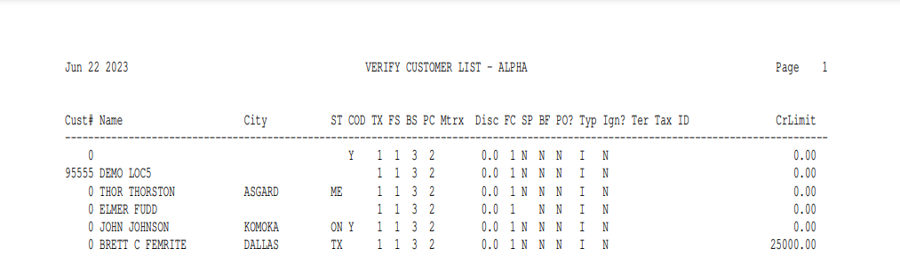

This Report Writer report provides detailed information about the customer base. It prints a variety of information about the customer’s:

- COD status
- Sales codes
- Discounts
- Credit limit
- Any price matrix available to him/her

The information is sorted in alphabetical order based on the Alpha Sort field in the Customer Master. The report prompts for the Alpha Sort field so you can use it to examine just a portion of your customer information if needed.

To access this report:

- Select “Report Writer” from the menu and click “Print an Established Report.” Choose the report from the selection in the application.
- Type “PER” in the Shortcuts Bar and select the report

Columns Include:

Cust #: This column shows the Customer Number assigned to this customer.

Name: This column shows the Customer’s Name.

City: This column lists the Customer’s City.

St: This column lists the Customer’s State or Province.

COD: This column shows the COD Status from the Customer Master:

Y for Yes (CASH ONLY)

N for No (Not on COD status)

TX: This column defines the customer’s taxable status. Here you will find the tax code that follows their usual taxable nature. Typical settings are:

“00” for Non-Taxable

“01” for Taxable

FS: This column shows the front sales code that best fits the customer’s buying habits at the Front Counter (Parts Counter). The most common codes for this field are:

01=Parts Counter Sales

02=Parts Counter Sales

05=Parts Counter Sales

07=Parts Counter Sales

09=Shop Internal Taxable

10=Shop Internal Nontaxable

11=Shop Warranty

12-20=Dealer Defined Sales Codes

BS: This column shows the back sales code that best fits the customer’s buying habits at the Back Counter (Shop). The most common codes are:

03=Shop Sales

04=Shop Sales

06=Shop Sales

08=Shop Sales

09=Shop Internal Taxable

10=Shop Internal Nontaxable

11=Shop Sales Warranty

12-20=Dealer Defined Sales Codes

PC: This column holds the customer’s basis for pricing (price code). Valid choices are:

1=Cost

2=List

3=Dealer Defined Price Level

4=Dealer Defined Price Level

5=Dealer Defined Price Level

6=MSRP (Manufacturer’s Suggested).

Mtrx: This column is used to point to a defined price matrix number for this customer. An entry here indicates this customer has a special pricing structure in place that applies to one or more parts sources.

Disc: This column shows any pre-defined discount rate in place for this customer. A percentage entered here will apply to all purchases of pre-priced items made in POS or SMS.

FC: This column shows the Finance Charge code for this customer.

Typically, 00 means that no finance charges will be assessed.

Code 01 is usually the one that defines the standard finance charge rate at the dealership.

Other codes of 02-09 can also be defined.

SP: This column indicates if the A/R statement for this customer is suppressed.

Y means no statement will be printed.

N means the statement will be printed (default).

BF: This column shows the style of detail to be kept for the customer’s A/R account.

Y means Balance Forward detail.

N means Open Item detail.

PO?: This column indicates if a PO number is required for the customer.

Y means the customer requires a PO number.

N means no PO number is required.

Typ: For Case dealers, this column defines the customer type of this customer record. This information is used for the Case Salesmaker Customer Extract program. Standard definitions are:

S=Sole Proprietor

I=Individual

C=Corporation

G=Government

P=Partnership

R=Rental Yard

Ign?:

Y in this column means the customer’s tax code and sales codes override individual ones (Ignore Part Tax Override).

N or blank means the tax override on individual parts applies to the customer.

Ter: If the Territory Code has been filled in, the value in that field is shown here.

Tax ID: This column contains the customer’s tax identification number.

CrLimit: This column shows the credit limit for this customer.

