**Overdue Equipment Report:** The Overdue Equipment Report in Rental Reports (RR) creates a report of Rental Units that are currently overdue.

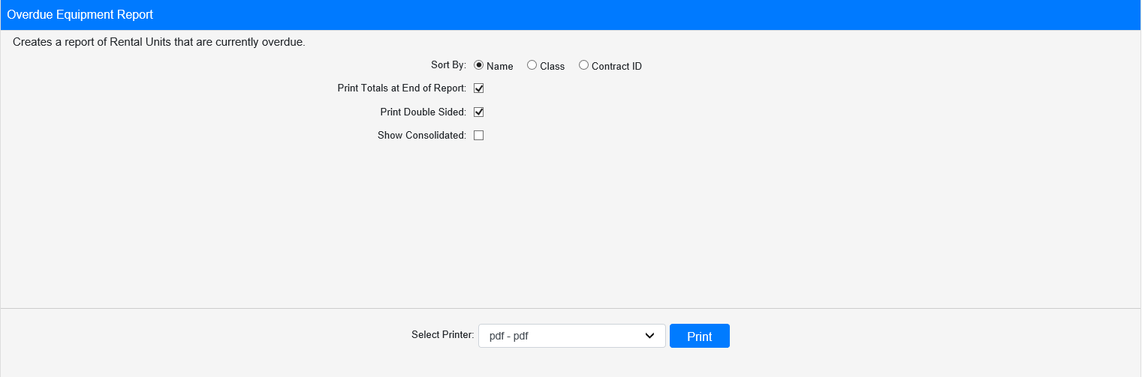

**Field Definitions:**

Sort By: Choose what to sort the report by:

* Name
* Class
* Contract ID

Print Totals at End of Report:

* **Check** this box to include total counts at the end of the report.
* Leave it **unchecked** to omit the totals.

Print Double Sided:

* **Check** this box to print the report pages double-sided.
* Leave it **unchecked** to print the report pages single-sided.

Show Consolidated: If you are a multi-location dealership with a **Consolidated** location, check this box to include the Consolidated location’s information on your report. Uncheck it to only print a report for your individual location. **NOTE:** If running the report in the Consolidated location, you **must** check this box to receive a report.

Select Printer: Select the printer to receive the report. Use the **pdf** printer to preview the report.

**Click “Print” to print the report.**

**Sample Report:**

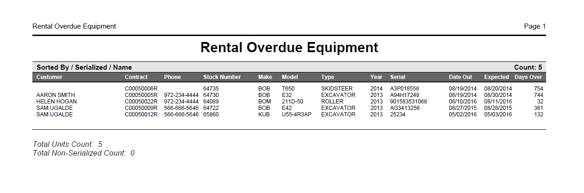

This example of the report is sorted by **Name** and includes totals at the bottom. Regardless, the report will always list the total count of overdue units at the top, then list the individual units. Each unit’s information will include the following:

* Tenting customer (if applicable)
* Contract number
* Contact phone number (if applicable)
* Stock number
* Make
* Model
* Type
* Year
* Serial number
* Date rented out
* Date expected due
* Number of days overdue