**Rental Conflict Report:** The Rental Conflict Report in Rental Reports (RR) creates a list of Rental units being rented out that have conflicts within the time period covered by the report.

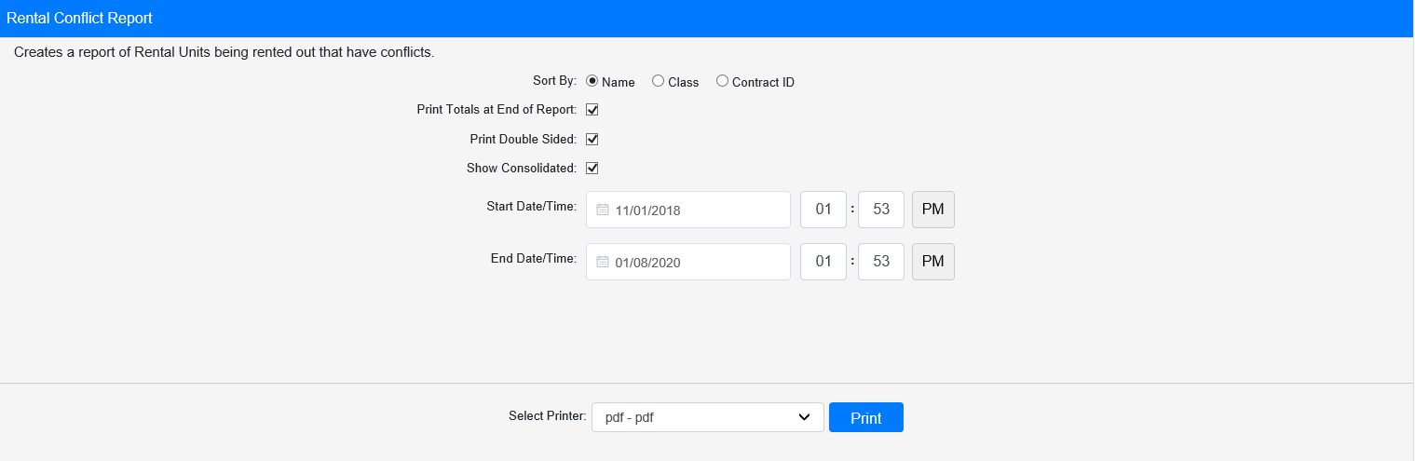

**Field Definitions:**

Sort By: Choose what to sort the report by:

* Name
* Class
* Contract ID

Print Totals at End of Report:

* **Check** this box to include a total count at the end of the report.
* Leave it **unchecked** to omit the totals.

Print Double Sided:

* **Check** this box to print the report pages double-sided.
* Leave it **unchecked** to print the report pages single-sided.

Show Consolidated: If you are a multi-location dealership with a **Consolidated** location, check this box to include the Consolidated location’s information on your report. Uncheck it to only print a report for your individual location. **NOTE:** If running the report in the Consolidated location, you **must** check this box to receive a report.

Start Date/Time: Select the start date/time for the report. All conflicts listed on the report occur at or after this point in time.

End Date/Time: Select the end date/time for the report. All conflicts listed on the report occur before or at this point in time.

Select Printer: Select the printer to receive the report. Use the **pdf** printer to preview the report.

**Click “Print” to print the report.**

**Sample Report:**

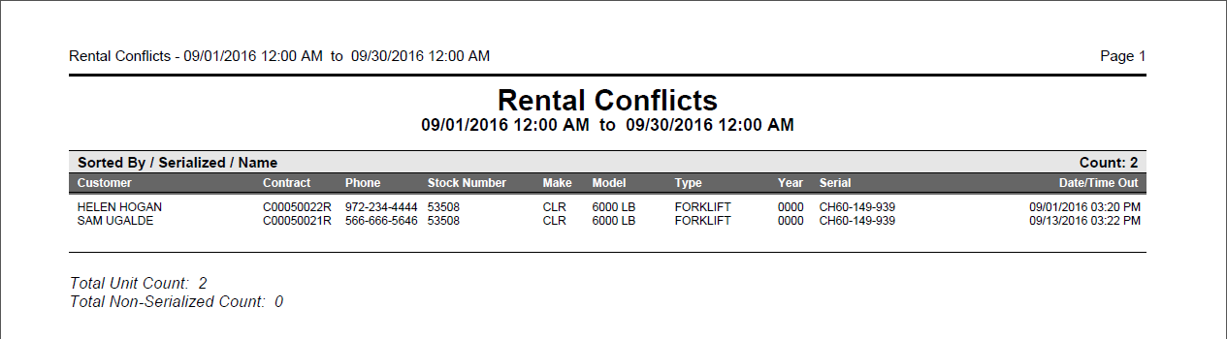

This example is sorted by **Name**. It lists the unit in conflict once for each customer who has it recorded on a contract, along with the relevant details concerning the rental.

If you chose to print **Totals** at the end of the report, you will see a total count for both the serialized and non-serialized units included on the report.