**Rental Equipment List:** This report creates a list of the Rental units recorded in your system according to your specifications.

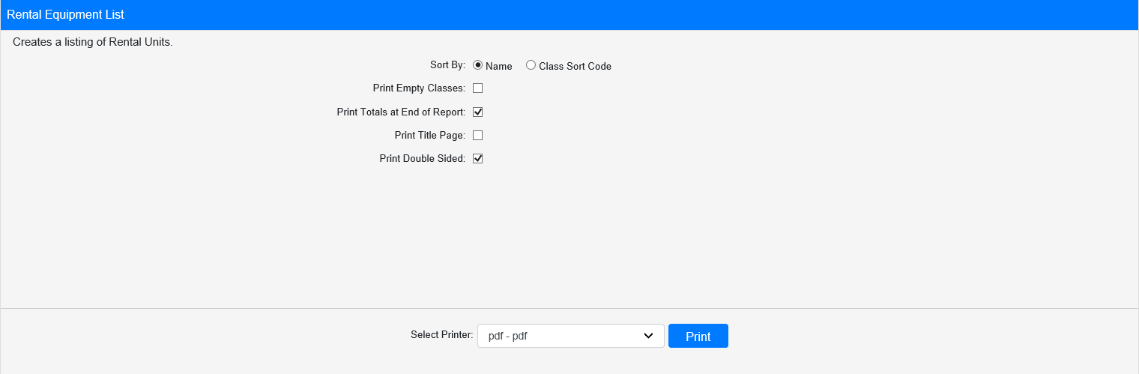

**Field Definitions:**

Sort By: Choose whether to sort the report by **Name** or **Class Sort Code**.

Print Empty Classes:

* **Check** this box to include Rental classes that currently have no units in stock on the report.
* Leave it **unchecked** to exclude those classes.

Print Totals at End of Report:

* **Check** this box to included total counts at the end of the report.
* Leave it **unchecked** to omit the totals.

Print Title Page:

* **Check** this box to include a title page in the report.
* Leave it **unchecked** to print the report without a title page.

Print Double Sided:

* **Check** this box to have the report print double-sided pages.
* Leave it **unchecked** to print the report single-sided.

Select Printer: Select the printer you want to receive the report from here. Use the **pdf** printer to preview the report.

**Click “Print” to print the report.**

**Sample Report:**

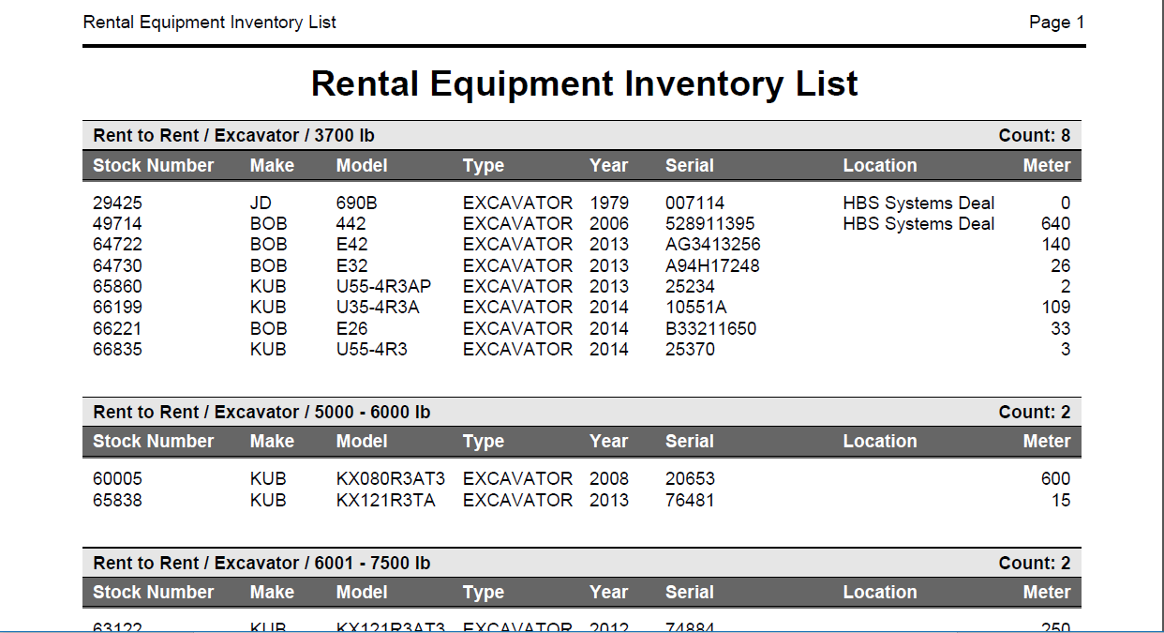

This example of the report is organzied by **Name**. Regardless of how they are sorted for printing, the units are grouped on the report by class, with the total count for each class display in the upper right-hand corner of the class section. The units are listed by stock number, along with the following:

* Make
* Model
* Type
* Year
* Serial number
* Location (if applicable)
* Meter

If you chose to print **Totals** at the end of the report, you will see a total count for each of the following on the report:

* Number of Family/Group/Class(es)
* Number of serialized units
* Number of non-serialized units