**Rental Outbound Report:** The Rental Outbound Report creates a report of Rental units being rented out.

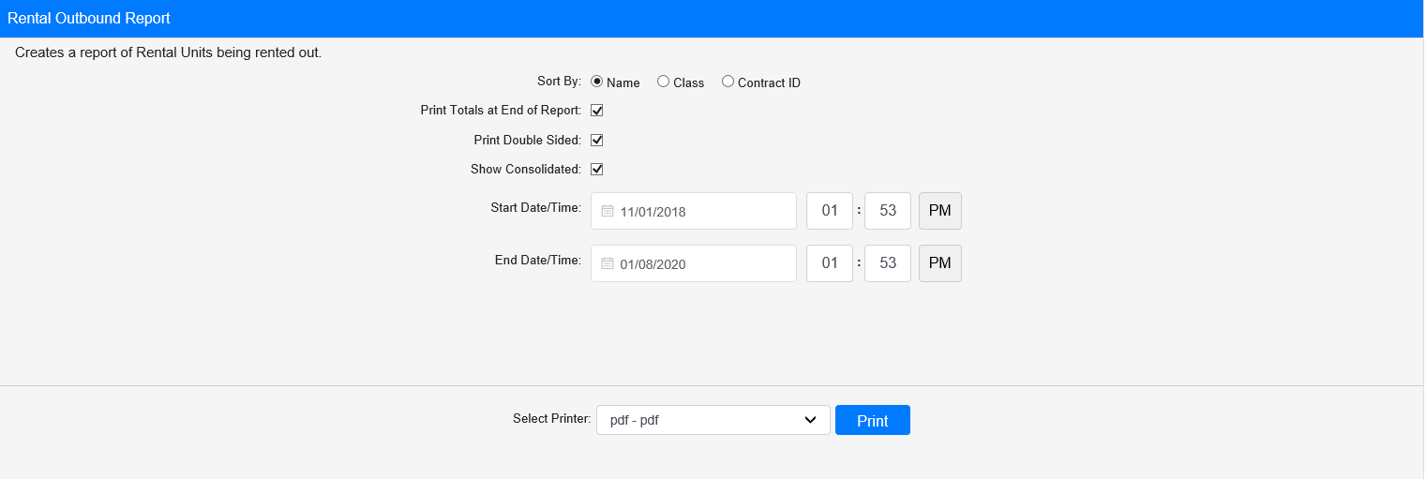

**Field Definitions:**

Sort By: Choose how to sort the report from the drop-down menu:

* Name
* Class
* Contract ID

Print Totals at End of Report:

* **Check** this box to include total counts at the end of the report.
* Leave it **unchecked** to omit the totals.

Print Double Sided:

* **Check** this box to print the report pages double-sided.
* Leave it **unchecked** to print the report pages single-sided.

Show Consolidated: If you are a multi-location dealership with a **Consolidated** location, check this box to include the Consolidated location’s information on your report. Uncheck it to only print a report for your individual location. **NOTE:** If running the report in the Consolidated location, you **must** check this box to receive a report.

Start Date/Time: Select the start date/time for the report. All units listed on the report will have been rented out at or after that point in time.

End Date/Time: Select the end date/time for the report. All units listed on the report will have been rented out before or at that point in time.

Select Printer: Select the printer to receive the report. Use the **pdf** printer to preview the report.

**Click “Print” to print the report.**

**Sample Report:**

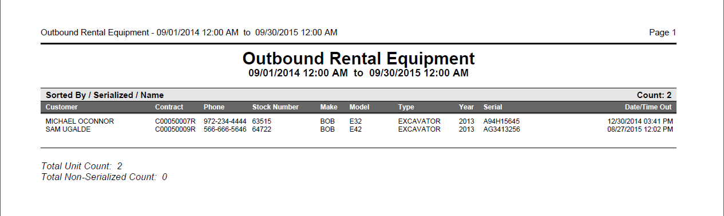

This example is sorted by **Name** with totals included at the end. Each entry shows the following:

* Rental customer
* Contract number
* Contact phone number
* Stock number
* Make
* Model
* Type
* Year
* Serial number
* Date and time rented out