Polaris Connect (POL): Polaris Connect (POL) is an HBS Systems NetView Connect program designed specifically for Polaris dealers. The program allows you to look up information about Polaris parts and service plans, as well as information about Polaris vehicles your dealership has serviced.

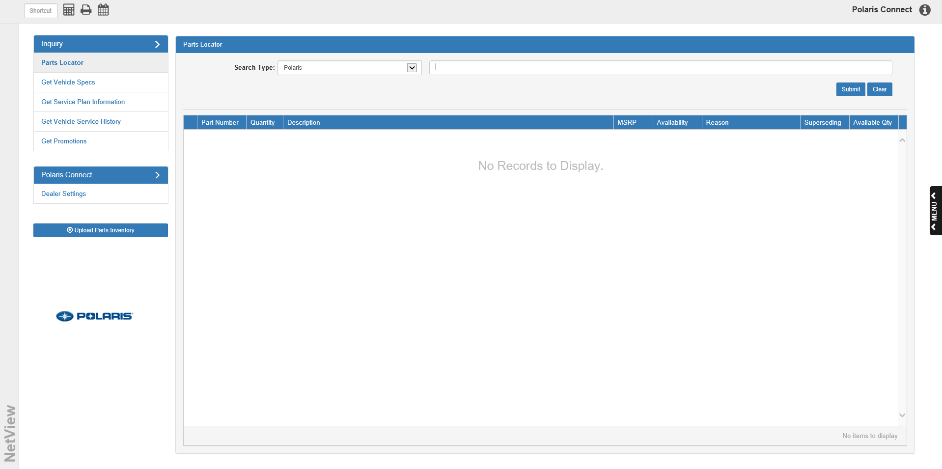

To access this program, you can either:

- Select “Communications” from the menu and choose the “Netview Connect” submenu. Click on “Polaris Connect.”
- Type “POL” in the Shortcuts Bar.

Dealer Settings Tab—Activating Polaris Connect: The first time you open Polaris Connect for your dealership, you will need to activate your credentials in order to use the program. To do so, you will need to open the Dealer Settings tab (see below) and enter your Polaris Connect dealer credentials in the fields provided.

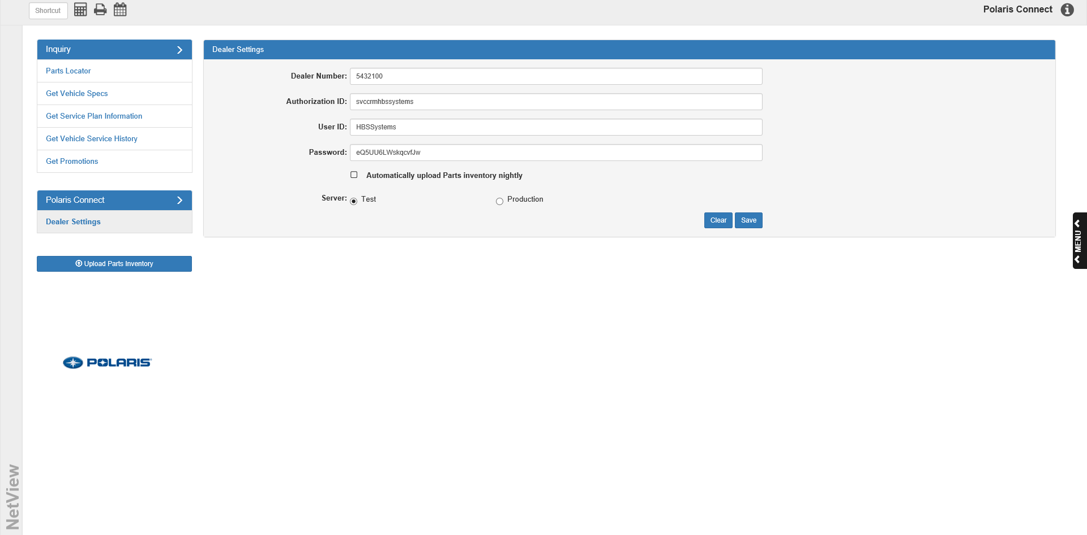

Dealer Number: Enter your Polaris dealer number here.

Authorization ID: Enter your authorization ID for Polaris Connect here.

User ID: Enter your Polaris user ID here.

Password: Enter your password for Polaris here.

Automatically upload Parts inventory nightly: If you want the program to automatically update the Polaris parts inventory every night, make sure this box is checked.

Server: Make sure the server is set to Production instead of Test; otherwise, you will be blocked from using the program features.

Save: When you are ready, click the Save button to save your dealer information. The following window will then appear:

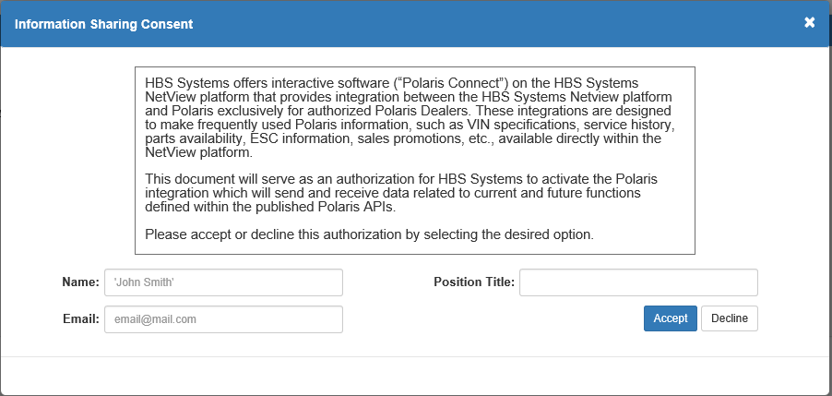

To use Polaris Connect, you must authorize HBS Systems to activate the program and consent to letting the program share information between your system and Polaris. Enter your name, your contact email address, and your position title at your dealership in the fields provided.

Click Accept to authorize the program. A copy of the authorization will then be sent to both your email and HBS Systems’ Support department. You will now be able to utilize Polaris Connect with your NetView system. Additionally, if you did not previously check “Automatically upload Parts inventory nightly,” accepting the contract will automatically check the box.

Note that this window will always appear when you click Save in the Dealer Settings tab, so you will be required to re-accept the contract every time you change your dealer information. Each time, the program will send a copy of the authorization to both your email and the HBS Support department, so both parties will always have an up-to-date version of the contract on file.



Parts Locator Inquiry Tab: The Inquiry tabs hold the program’s main search functions. The Parts Locator inquiry tab allows you to look up information about Polaris parts.

Search Type/Part Number: Use this drop-down menu to set the type of parts search you want to make, then enter the part number(s) you want to locate in the field to the right. There are three search types, each of which will provide a different set of information:

Polaris Search: To simply look up Polaris parts, use the Polaris search type. With this type, you will be able to enter up to 200 part numbers in the Part Number search field (see below image).

After you enter a part number, click either the “Enter” key or the Submit button to search for it. The results grid below will add an entry for each part number as you submit it. You can also then remove individual parts from the search results by clicking on the little “x” next to the number (see below image), or you can clear them all using the Clear button.

NOTE: Polaris Search is the only search type that shows a Part Number column in the Search Results Grid. For the other two search types, a Dealer Name column replaces it.
Dealer Search: To look up which Polaris dealers carry a specific part, use the Dealer search type. You will only be able to search for a single part number using this type (see below image).

After you enter a part number, click either the “Enter” key or the Submit button to search for it. The results grid below will add an entry for each part number as you submit it. You can clear the Part Number field for a new search by either clicking on the little “x” next to the number or using the Clear button.

Dealer Radius/Distance: To see if there is a Polaris dealer within a certain distance from your dealership that carries a specific part, use the Dealer Radius search type. You will only be able to search for a single part number using this type, but you will also have to enter the distance from your dealership (in miles or kilometers) you want the search to cover (see below image). You can search for up to 100 miles or 160 kilometers.

Search Results Grid-Definitions:

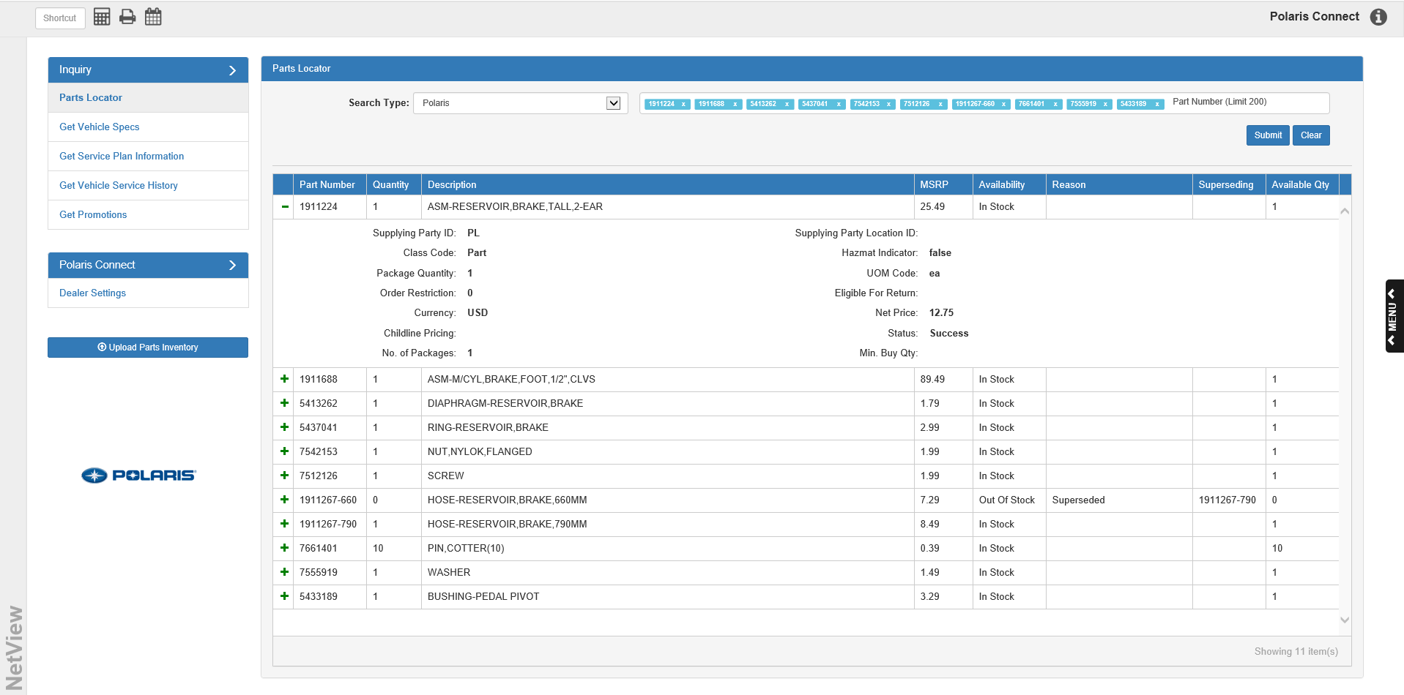

Columns:

- Part Number: This column shows the part number for the entry, and only appears when you use the Polaris search type (as that is the only search that allows for more than one part number to appear in the grid).
- Dealer Name: This column (see below image) shows the dealer name for the entry, and only appears when you use the Dealer and Dealer Radius search types (as both types only allow for a single part search, but can show multiple dealers).

- Quantity: This column shows the part’s package quantity.
- Description: This column shows the part’s description.
- MSRP: This column shows the part’s MSRP (in the manufacturer’s chosen currency type—see “Further Detail Fields” for more information).
- Availability: This column shows the part’s stock status (in stock, out of stock, etc.).
- Reason: If the part is out of stock, this column may show a reason why that is.
- Superseding: If the part number has been superseded, this column shows the superseding part number. Additionally, if you search for a superseded part number, the search will automatically add the superseding part number to the results grid below the superseded number, so you do not have to search for it separately.
- Available Qty: This column shows the part’s available quantity, in general or at the specific dealership (depending on the search type used).

Further Detail Fields: You can view more details about an individual part in the grid by clicking the green “+” sign on the far left of the grid entry. This will change the “+” sign to a “-“ sign; click the “-“ sign to hide the details again.

- Supplying Party ID: This shows the part’s manufacturer ID, which will generally be “PL” for Polaris.
- Supplying Party Location ID: This shows the part’s location ID, or where the manufacturer is currently keeping the part.
- Class Code: This shows the part’s class code.
- Hazmat Indicator: This shows if this is a hazardous part or not (by displaying “true” or “false”).
- Package Quantity: This shows the part’s package quantity, which will be the same as the value for the part in the Quantity column.
- UOM Code: This shows the part’s UOM code.
- Order Restriction: This shows if there are any restrictions on the quantity of the part number that you can order.
- Eligible For Return: This shows if the part is eligible for return or not.
- Currency: This shows what currency the part’s pricing shows in (such as USD).
- Net Price: This shows the part’s net price (in the selected currency).
- Childline Pricing: This column shows the part’s childline pricing (in the selected currency).
- Status: This shows whether or not the part number was successfully returned by the search.
  - If the search successfully located the part number, it will read “Success.”
  - If the part number was not found, it may say something else; for example, if the number entered is not a valid part number, this field will say, “Invalid Part.”
- No. of Packages: This shows the number of packages available for the part number.
  - If the available quantity is identical to the package quantity, then this field will show “1,” as there is only one package available.
  - However, if the available quantity is greater than the package quantity, this number may be higher.
- Min. Buy Qty.: This shows if there is a required minimum purchase quantity of the part.

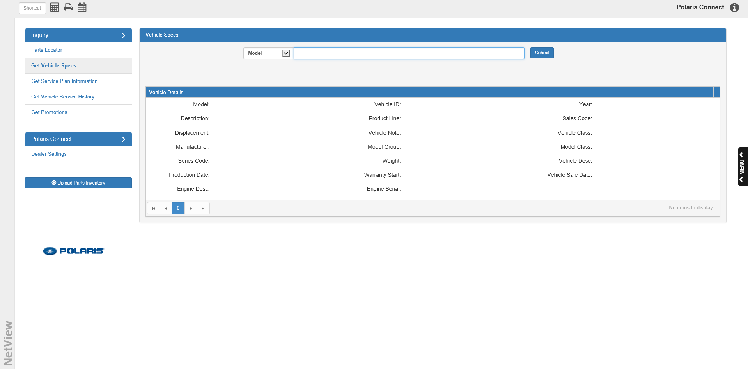

Get Vehicle Specs Inquiry Tab: The Get Vehicle Specs inquiry tab allows you to look up the specifications for either a specific vehicle model or an individual vehicle.

Making a Vehicle Spec Search: Use the drop-down menu at the top of the screen to select whether to search by model number (Model) or vehicle ID (Vehicle ID). Enter the desired number in the search field to the right, then click the Submit button or hit the “Enter” key. The Vehicle Details fields below will populate with the model or vehicle’s details.

NOTE: Certain fields will only fill if you use the Vehicle ID search, as they show data related to an individual vehicle and so would not apply to a model number. The field descriptions below will note which fields only appear for the Vehicle ID search.

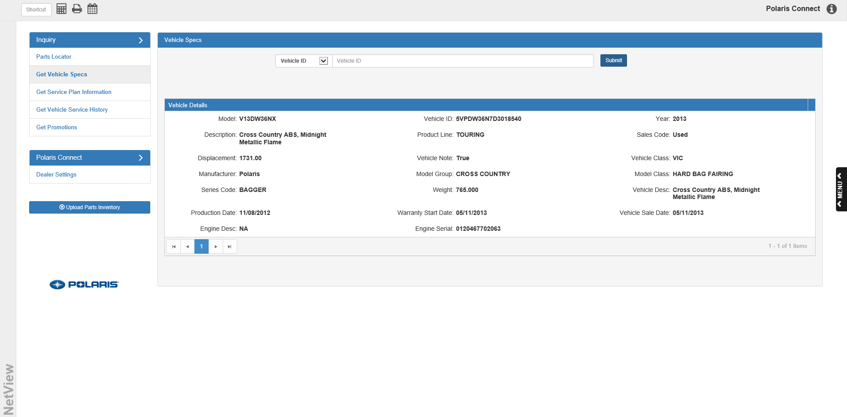

Field Descriptions:

Model: This field shows the model number.

Vehicle ID: This field shows the vehicle ID. NOTE: Only appears for a Vehicle ID search.

Year: This field shows the model year.

Description: This field shows the model description.

Product Line: This field shows the model’s product line.

Sales Code: This field shows the sales code for the model/vehicle (the exact code will vary depending on if you did a Model or Vehicle ID search).

Displacement: This field shows the model’s displacement value.

Vehicle Note: This field shows if there is a note on the vehicle. NOTE: Only appears for a Vehicle ID search.

Vehicle Class: This field shows the model’s vehicle class.

Manufacturer: This field shows the manufacturer name, which will almost always be Polaris.

Model Group: This field shows the model group.

Model Class: This field shows the model class.

Series Code: This field shows the model’s series code.

Weight: This field shows the weight of the model/vehicle (vehicles of a specific model will share that model’s weight value).

Vehicle Desc: This field shows the vehicle description, which will generally be the same as the model description.

Production Date: This field shows the vehicle’s production date. NOTE: Only appears for a Vehicle ID search.

Warranty Start: This field shows the warranty start date for the vehicle. NOTE: Only appears for a Vehicle ID search.

Vehicle Sale Date: This field shows the sale date for the vehicle, if applicable. NOTE: Only appears for a Vehicle ID search.

Engine Desc: This field shows a description for the model/vehicle’s engine, if available.

Engine Serial: This field shows the engine’s serial number. NOTE: Only appears for a Vehicle ID search.

Options: This button is reserved for future use.

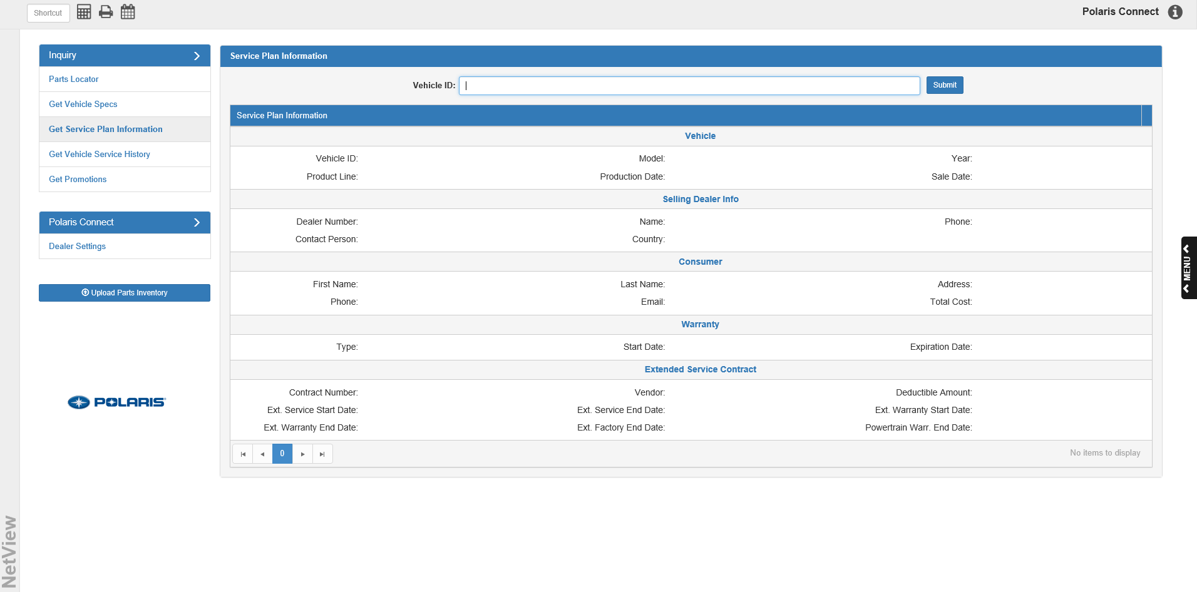

Get Service Plan Information Inquiry Tab: The Get Service Plan Information inquiry tab allows you to look up service plan information for a specific vehicle.

Vehicle ID: Enter the vehicle ID in this field.

Submit: Click this button to begin your inquiry. The service plan information for the vehicle will populate the sections below.

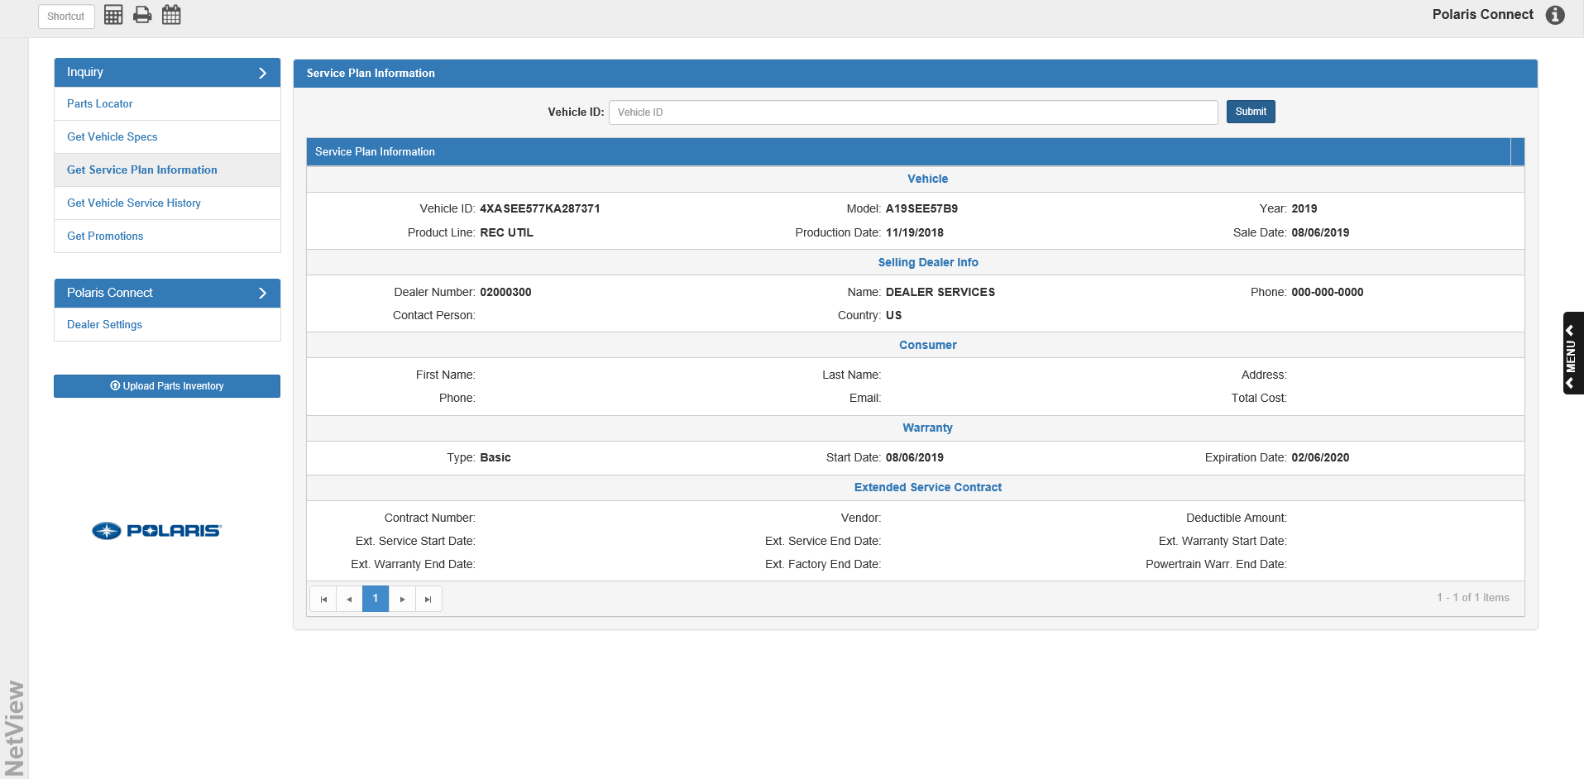

Vehicle Section:

Vehicle ID: This field shows the vehicle’s ID number, which will be the same as the number you entered to look up the service plan information.

Model: This field shows the vehicle’s model number.

Year: This field shows the vehicle’s model year.

Product Line: This field shows the model’s product line.

Production Date: This column shows the vehicle’s production date.

Sale Date: This field shows the sale date for the vehicle, if applicable. NOTE: Only appears for a Vehicle ID search.

Selling Dealer Info Section:

Dealer Number: This field shows the selling dealer number for the vehicle.

Name: This field shows the selling dealer name for the vehicle.

Phone: This field shows the selling dealer’s primary phone number.

Contact Person: This field shows the contact person for the selling dealer.

Country: This field shows the selling dealer’s country.

Consumer Section:

First Name: This field shows the first name of the consumer that purchased the vehicle.

Last Name: This field shows the consumer’s last name.

Address: This field shows the consumer’s address.

Phone: This field shows the consumer’s phone number.

Email: This field shows the consumer’s email address.

Total Cost: This field shows the vehicle’s total cost to the consumer.

Warranty Section:

Type: This field shows what type of warranty the vehicle has.

Start Date: This field shows the vehicle’s warranty start date.

Expiration Date: This field shows the vehicle’s warranty expiration date.

Extended Service Contract Section:

Contract Number: This field shows the contract number.

Vendor: This field shows the vendor.

Deductible Amount: This field shows the contract’s deductible amount.

Ext. Service Start Date: This field shows the extended service start date.

Ext. Service End Date: This field shows the extended service end date.

Ext. Warranty Start Date: This field shows the extended warranty start date.

Ext. Warranty End Date: This field shows the extended warranty end date.

Ext. Factory End Date: This field shows the extended factory warranty end date.

Powertrain Warr. End Date: This field shows the Powertrain warranty end date.

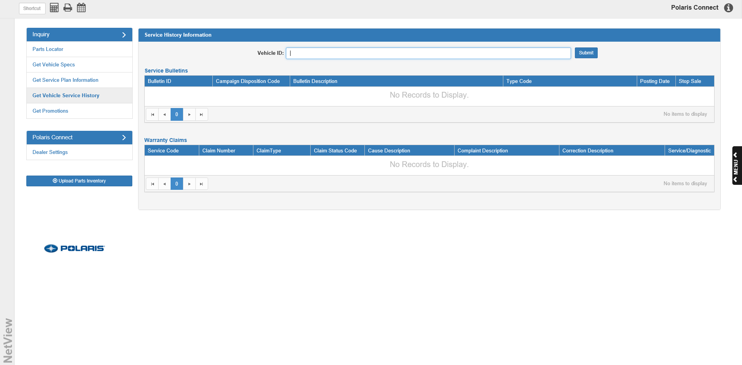

Get Vehicle Service History Inquiry Tab: The Get Vehicle Service History inquiry tab allows you to look up information about service campaigns and warranty claims that figured in a specific vehicle’s service history.

Vehicle ID: Enter the vehicle’s ID number here.

Submit: Click this button to begin the search. The results will populate the grids below:

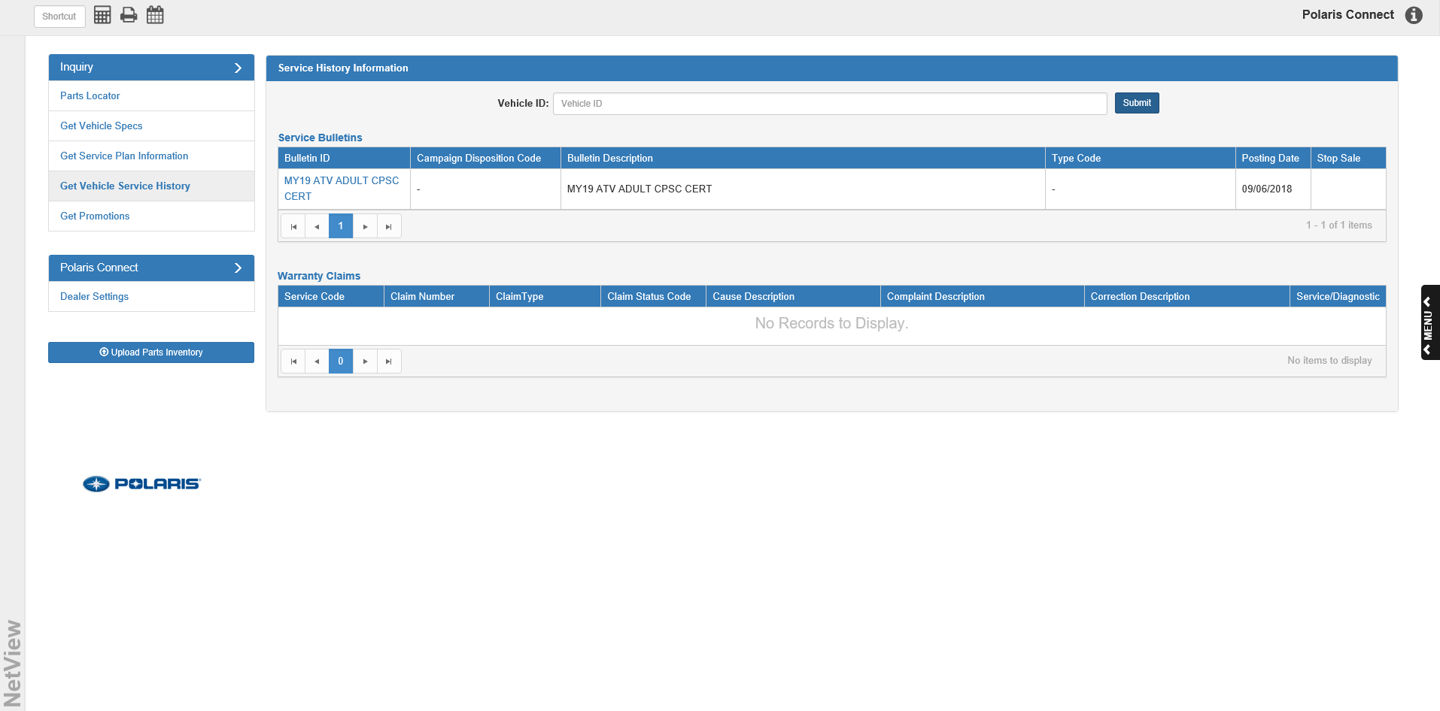

Service Bulletins Grid: This grid lists all service campaigns that have ever been issued for the vehicle’s model.

Bulletin ID: This column shows the campaign bulletin’s ID. Clicking on it will open a copy of the original bulletin in a new window.

Campaign Disposition Code: This column indicates the campaign disposition code.

Bulletin Description: This column shows the bulletin’s description

Type Code: This column shows the campaign’s type code.

Posting Date: This column shows the campaign’s posting date.

Stop Sale: This column indicates whether or not the bulletin required dealerships to stop selling the vehicle’s model until any issues with the models were fixed (Y/N).

Warranty Claims Grid: This grid lists all warranty claims made on the vehicle during its service history.

Service Code: This column shows the service type code, which will generally be “Warranty.”

Claim Number: This column lists the claim number.

Claim Type: This column lists the claim type.

Claim Status Code: This column lists the claim status code.

Cause Description: This column lists the reason for the claim.

Complaint Description: This column lists a description of the complaint.

Correction Description: This column indicates how the issue will get corrected.

Service/Diagnostic: Click the button in this column to view the service details for the claim, including the diagnostic codes and any service parts used.

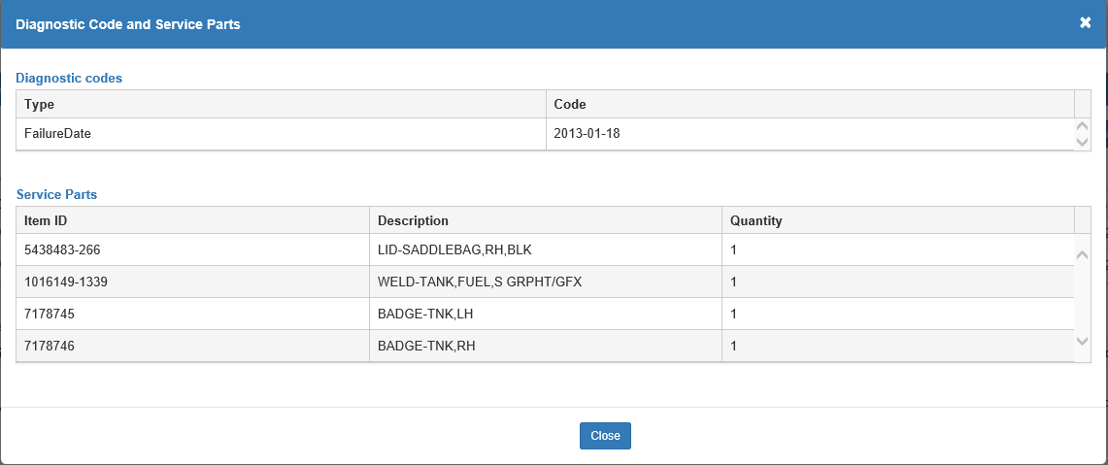

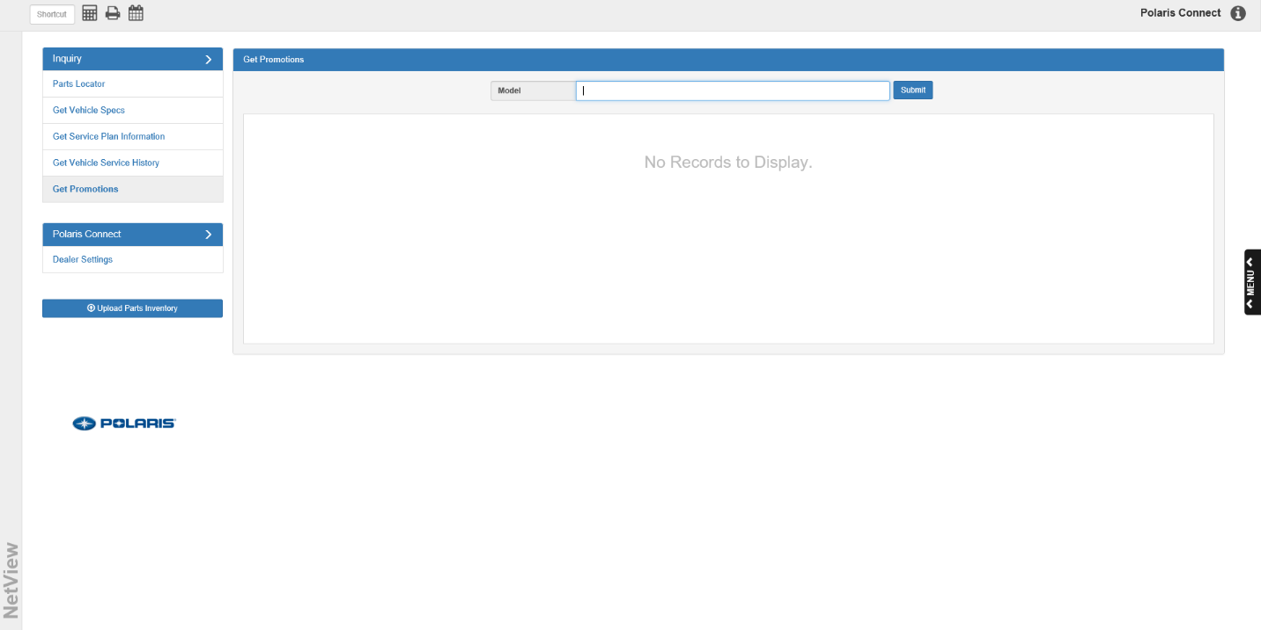

Get Promotions Inquiry Tab: The Get Promotions inquiry tab allows you to look up information about available promotional offers concerning specific Polaris models.

Model: To see if a particular model has any available promotions, enter the model number here.

Submit: Click this button to begin the search. If one or more promotions are available, the promotion information will populate the screen:

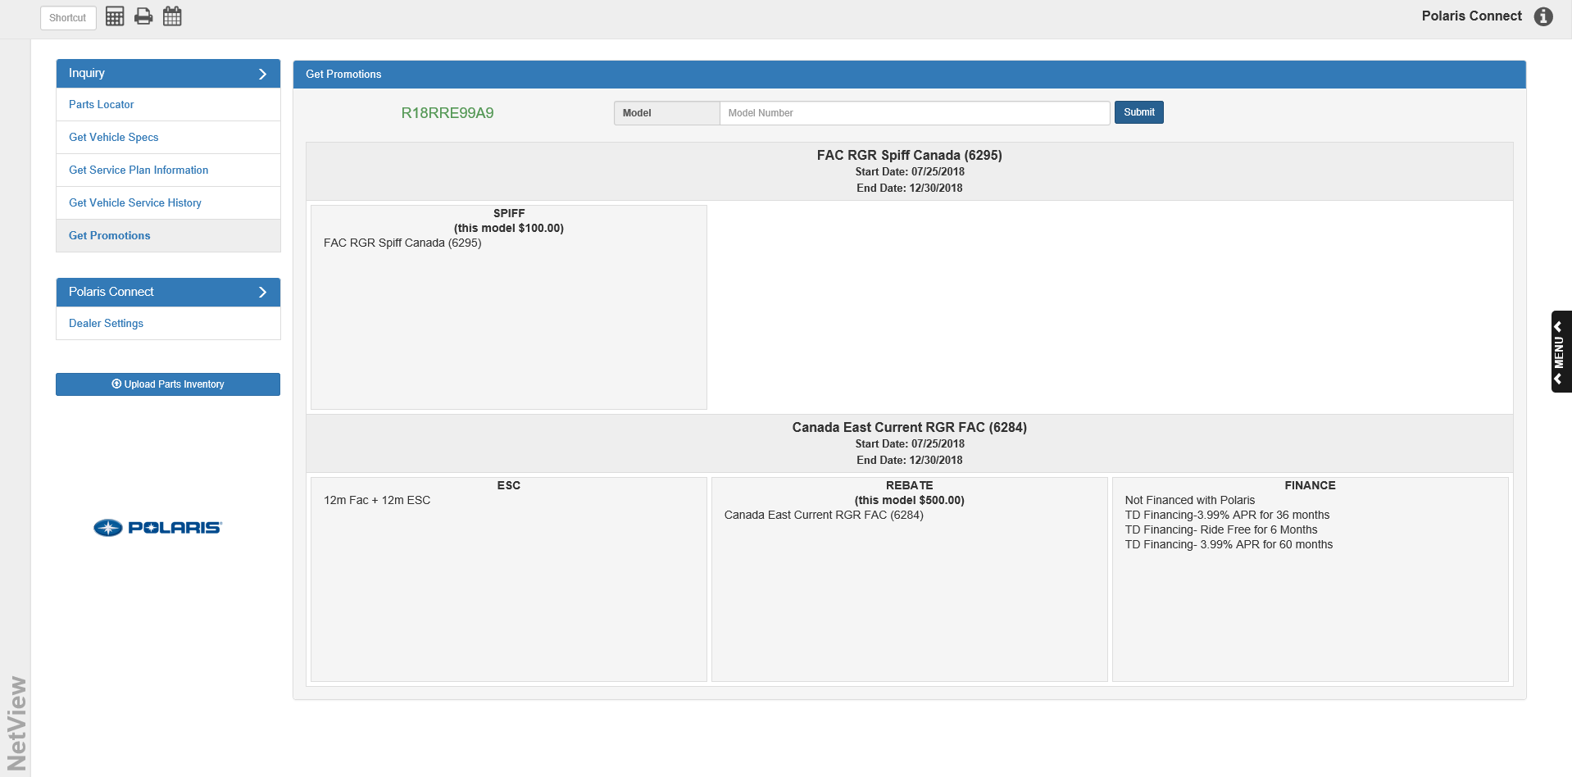

Promotion Results Display: The model’s available promotions will show in blocks: a header to indicate the promotion name, and sections below it displaying the details of the different promotion types available. Polaris makes up to 5 promotion types available for their models:

- Spiff
- ESC
- Rebate
- Finance
- Extended Warranty



Upload Parts Inventory: This feature appears on the left side of the Polaris Connect screen, below the tab listings. Click on it to manually update the parts inventory from Polaris at any time. NOTE: If you have the “Automatically upload Parts inventory nightly” option selected in the Dealer Settings tab, the program will automatically update the parts inventory every night.

