Charging a Card with Smart Iron

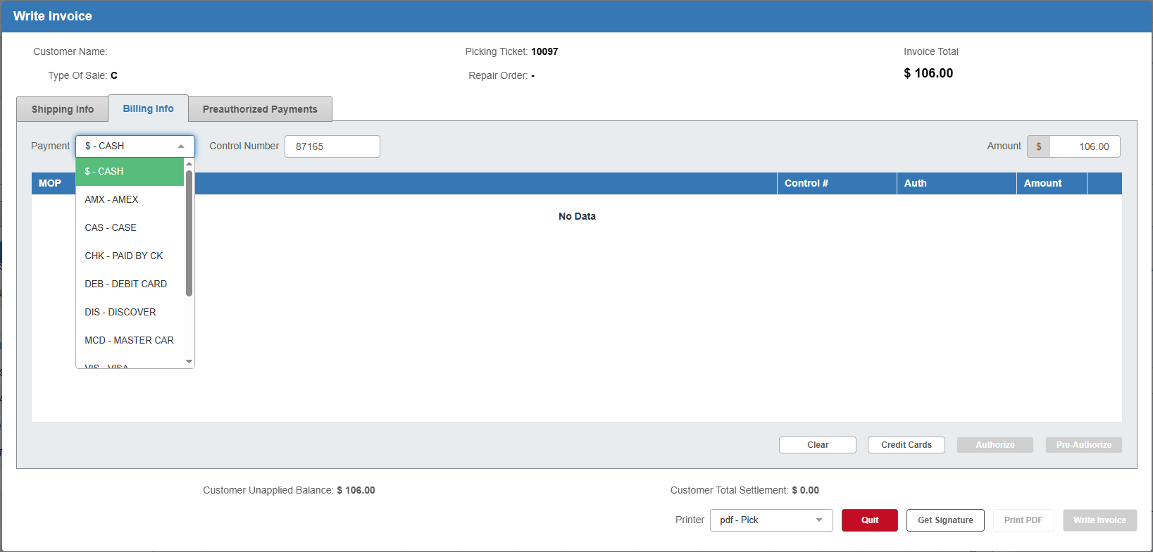

This topic covers how to charge a customer's credit cards using a Smart Iron credit card processor. Smart Iron can be used in Point-of-Sale (POS), Repair Order Maintenance (ROM), Rental Reservations & Contracts (RENT), and Unit Sale (US) as part of the invoicing routine.

Setup: Before using the processor type, you must make sure you have your terminals set up both with Smart Iron itself and within NetView in Credit Card Dealer Information (CCDI) so that they will work correctly. If you are part of a multi-location dealership, you must set up the terminals for each location, and if you have a Consolidated location, you must not use that location for the setup. Each specific store location needs its specific terminals set up within that location.

Accessing Smart Iron: After you have accessed the Invoice Settlement screen in each program, you can select a credit card as the customer's method of payment. NOTE: The sample Settlement screen used here is from Point of Sale (POS), but the process works the same for all programs.

- Choose the type of card the customer wants to use from the drop-down menu.
- Hit “Tab” or "Enter" on the keyboard until you pass through the dollar amount. The Smart Iron processing screen will open in a new window. NOTE: If the program fails to connect to the device within 15 seconds, the connection will time out and you will need to try connecting again.

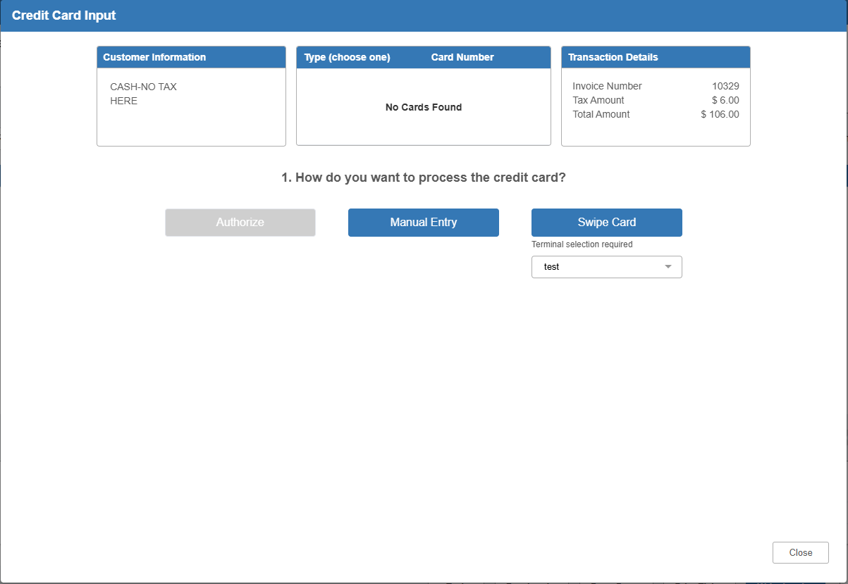

Smart Iron—Layout:

Customer Information: The Customer Information box displays the customer’s name and address.

Type/Card Number: This box displays the full list of credit cards already available for this customer in the system.

Transaction Details: The Transaction Details box displays the details of the transaction being paid for, which include:

- Invoice number
- Tax amount
- Total amount

Charging a Card in Smart Iron: Charge the card using the blue buttons underneath the “How do you want to process the credit card?” heading. There are three different methods of charging a card.

Authorize: Use this method if the customer wants to pay with a token. Select the card you want from the list in the middle box. The chosen card will highlight in blue and the Authorize button will activate. Click the button to run the card automatically without requiring any manual action.

NOTE ON SIGNATURES: When a signature is required, the terminal will prompt you to ask the customer for their signature. The customer must sign their name on the terminal to complete the transaction. The signature will not show up on the invoice.

Failed Transaction: If the transaction is not successful, an error message will display. For example, if the card is declined, you might see this:

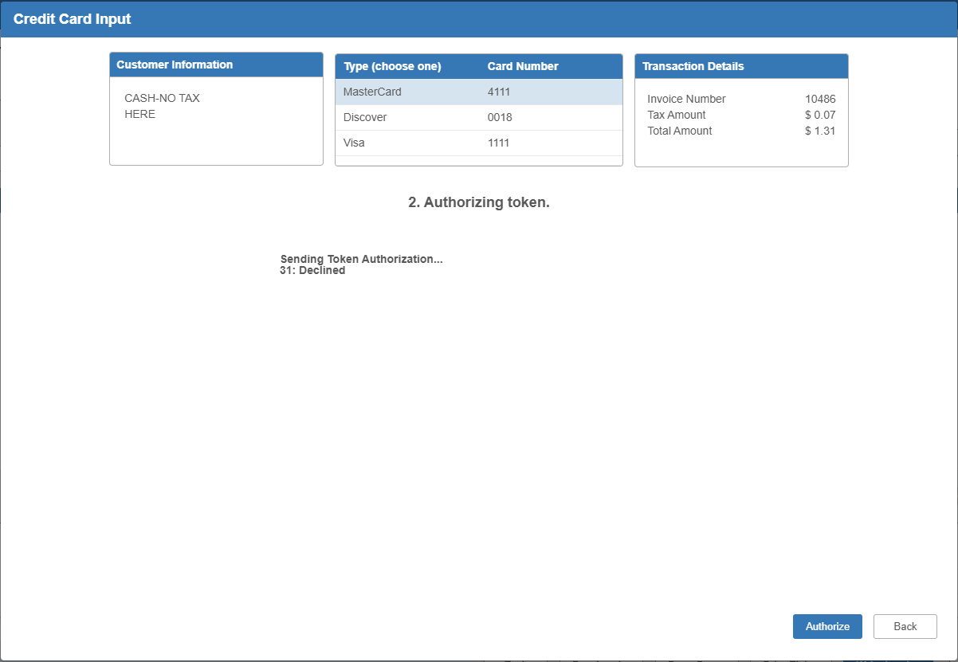

Successful Transaction: If the transaction is successful, the window will automatically close and return you to the invoicing screen to show the payment has been accepted:

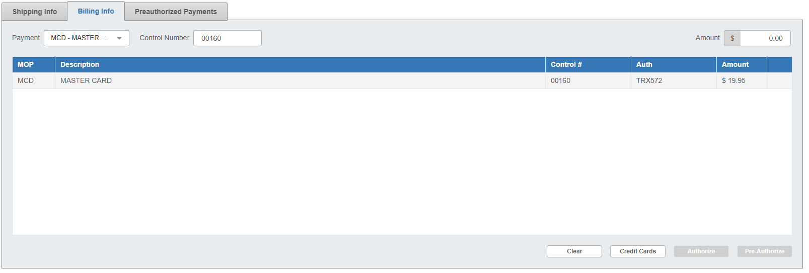

Manual Entry: Use this method to charge the card by manually entering its information. Start by clicking Manual Entry. The following will appear:

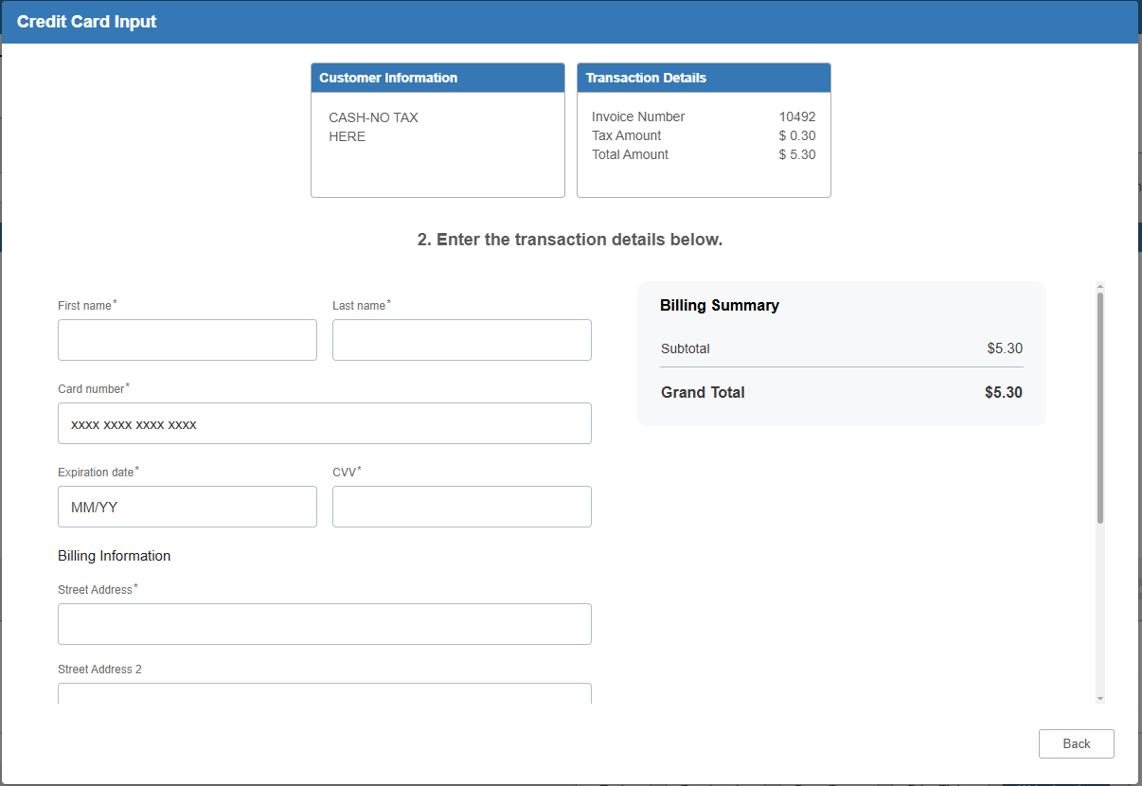

- Enter the card’s information and billing address. The fields that must be filled in to complete the transaction are indicated by a “*” next to the field name.

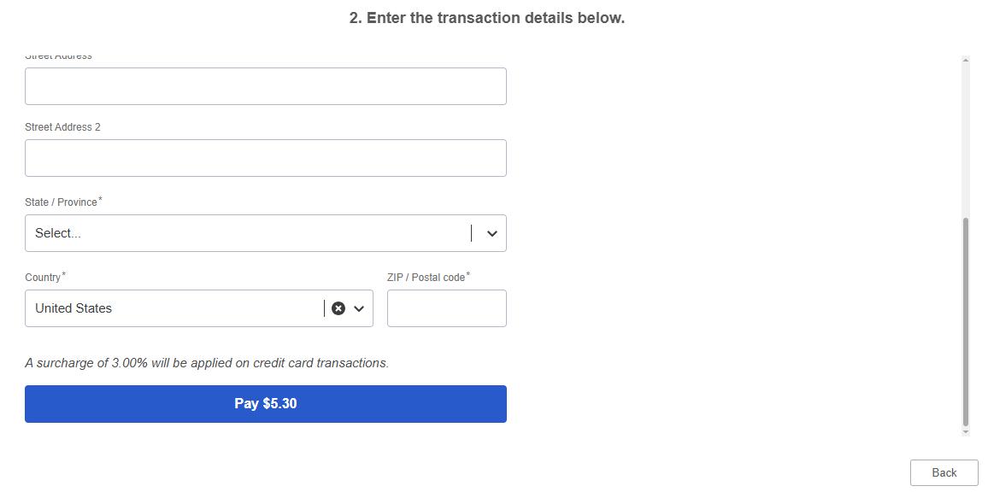

- Click Pay [x amount] (where “x amount” is the dollar amount of the transaction. The program will process the transaction and indicate that it was successful before returning to the Invoice screen.
- If the transaction does not go through, the screen will show an error message.



Swipe Card: Use this method to charge the card using a credit card terminal. NOTE: This is the method to use when running a chip transaction.

Choose the terminal you’re using from the drop-down menu. The terminal will default to the default terminal assigned to the current user in their user settings, but must be changed if they are using a different terminal.

Click Swipe Card to process the card through the terminal. You will see a processing note on this screen while the transaction is being carried out via the terminal.

NOTE ON SIGNATURES: When a signature is required, the terminal will prompt you to ask the customer for their signature. The customer must sign their name on the terminal to complete the transaction. The signature will not show up on the invoice.

Terminal Connection Failure: If for whatever reason the program is not properly connected to your terminal, an error message will appear after you click Swipe Card. Make sure the terminal is properly set up and connected before trying to process the card again.

Finishing the Transaction: Once the transaction is completed, the program will either show a message indicating that the transaction was unsuccessful or, if the transaction is successful, return to the Invoice screen and show the payment has been accepted.

Close/Back:

- If you want to stop processing the card and return to the main screen, use the Close button.
- Back will appear if you are in the middle of a process and will allow you to return to the default Smart Iron processing screen.

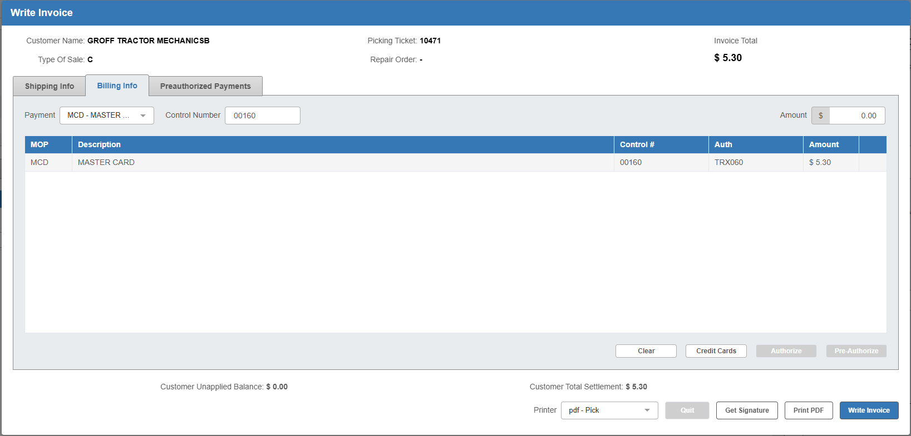

Completing the Ticket: Once you have charged the card and been returned to the Invoice screen, click the Write Invoice button at the bottom of the screen to add the transaction to the ticket.

Surcharges: Smart Iron will allow surcharges to be applied on credit card payments. The option must first be configured through the outside Smart Iron portal and requires entering a General Ledger account number during the processor setup in CCDI to capture the dollar amounts for the surcharges. If a surcharge amount is charged during a transaction, it will show up on invoices printed anywhere in the system. Here are some examples of what that will look like:

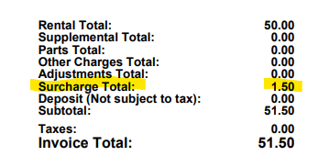

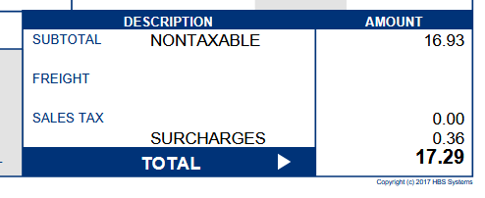

Returns/Refunds in Smart Iron: Smart Iron has specific procedures for processing returns/refunds. Begin by creating a ticket with the part the user wants to return/be refunded for, with the same quantity, but make the quantity negative to signify it’s a return. Then begin the invoicing process.

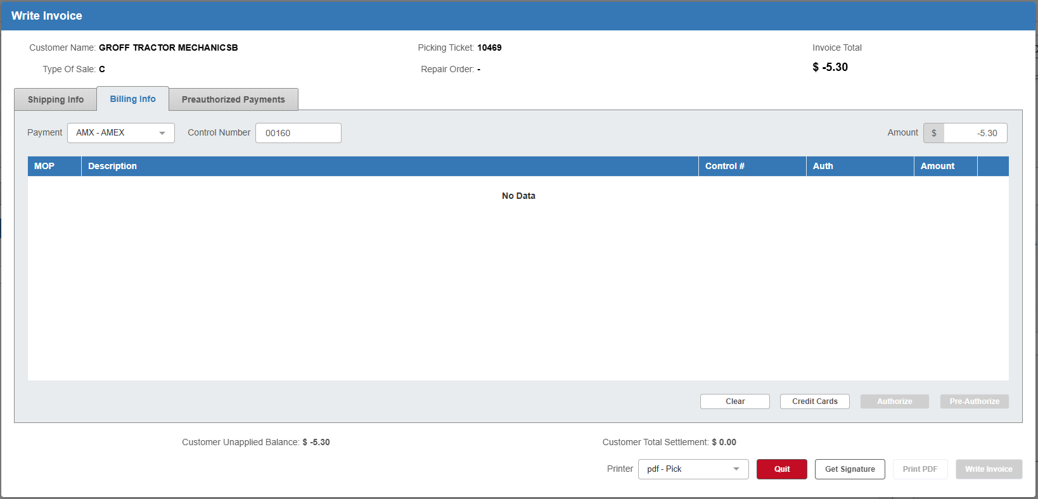

When you trigger the credit card screen, it will look like this:

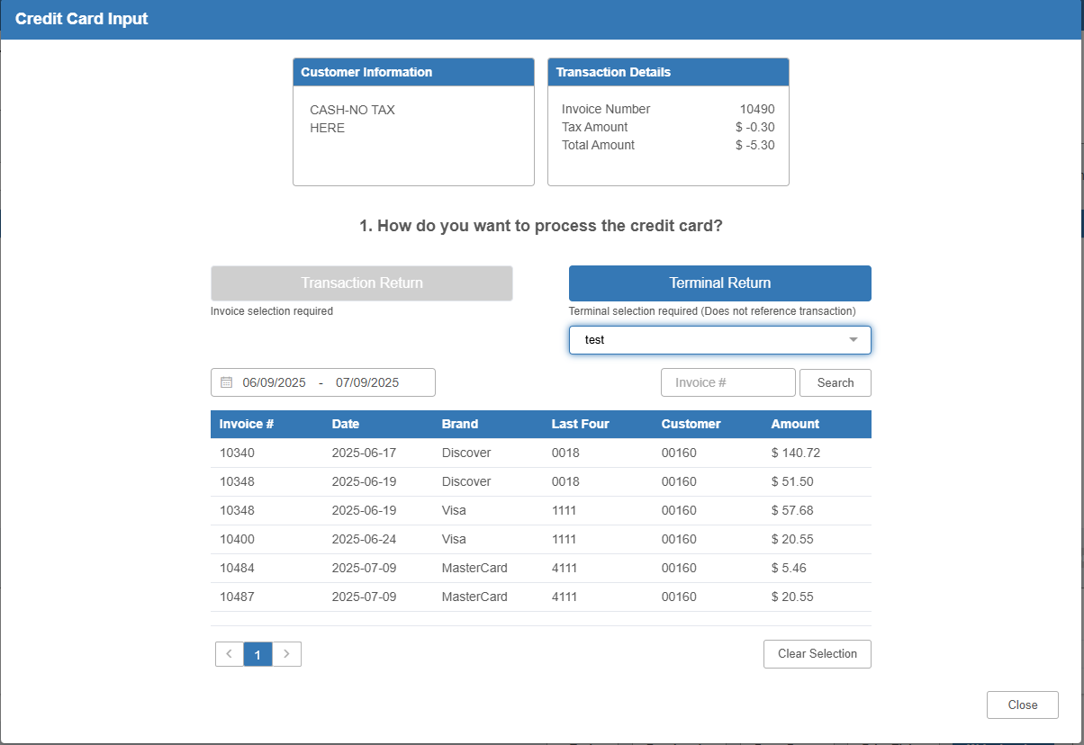

The screen presents two options for refunding the purchase: Transaction Return and Terminal Return.

Transaction Return: This is the recommended process for refunding a credit card purchase. By selecting the invoice itself to use as the basis for the refund, Smart Iron will be able to refund not only the purchase, but also any surcharges that may have accompanied it, as they would be recorded on the invoice.

Begin by using the Invoice Search features to locate the purchase’s specific invoice. Put in the date range of the transaction to see all the customer’s invoices charged with cards during that period. You can also type in the specific invoice number to look it up.

Once you find the invoice, click on it to select it. This will activate the Transaction Return button.

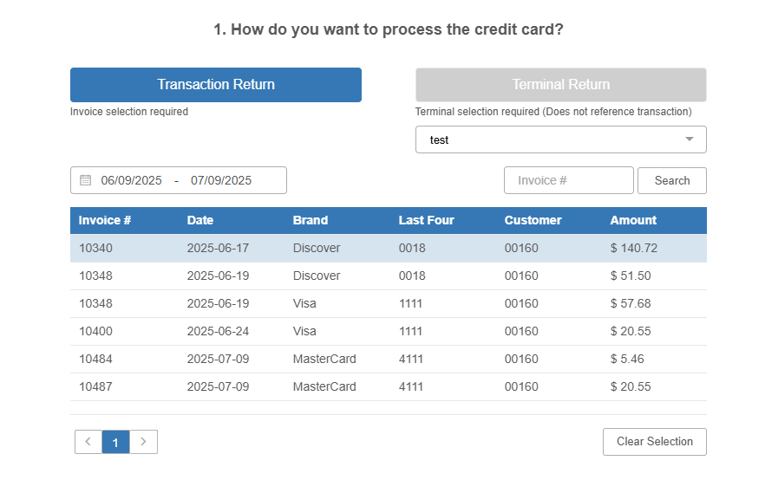

Click the button to process the refund. If it is successful, you will be returned to the Invoicing screen to finish creating the return invoice. NOTE: You will not be able to refund the customer any more than the exact dollar amount of the invoice using this method, but using this method will ensure they are properly refunded any surcharges listed on the invoice.



Terminal Return: If the card used for the transaction being refunded is present at the time of the refund, you can use the card with the payment terminal to process the refund. Select the terminal you want to use to process the refund, then click Terminal Return to process the refund via the selected terminal. You will see a processing screen while the transaction is being carried out. Once the return successfully completes, the program will return to the Invoicing screen with the returned quantity accepted for invoicing.

Terminal Connection Failure: If for whatever reason the program is not properly connected to your terminal, an error message will appear after you click Terminal Return. Make sure the terminal is properly set up and connected before trying to process the card again.

NOTE: The Terminal Return procedure is intended for transactions made outside of the Smart Iron system, and it does not refund any surcharges.

