Technician Time Entry (TTE)

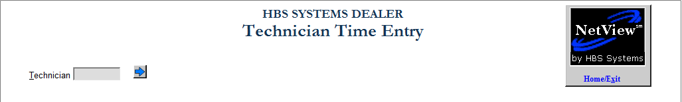

Technician Time Entry (TTE) allows Service technicians to clock in and out of a repair order, thereby keeping track of which technicians have worked on which RO and for what length of time.

- To open the program, you can either:
  - Select “Service” from the menu. Choose the “Time Slip Management” submenu and click “Technician Time Entry.”
  - Type “TTE” in the Shortcuts Bar.

Clocking in on a Repair Order

Technician: Enter your Technician Number.

- You can also use the Arrow to look it up. Click on your name to select it.

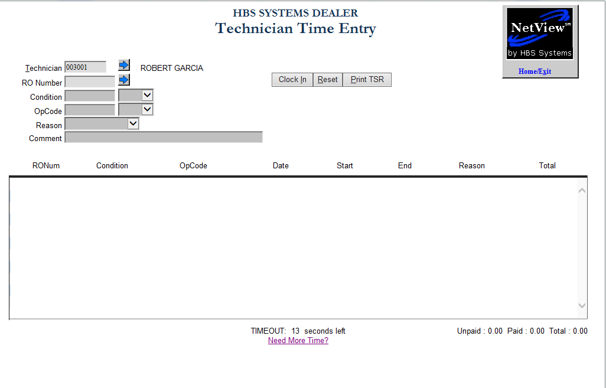

RO Number: Enter the Repair Order Number.

- You can also use the Arrow to look it up. Click on the number to select it.

Condition:

- The condition will default if there is only one condition on the RO.
- Enter the Condition or use the drop-down menu to select it .

Op Code: Enter the Op Code or select it from the drop-down menu .

Press the Clock In button or the “Enter” key to begin work on the RO. A confirmation message will show on the screen telling you which RO, condition, and op code you have just logged into.

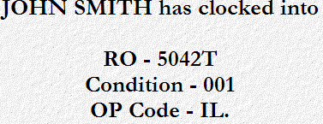

Clocking out of a Repair Order

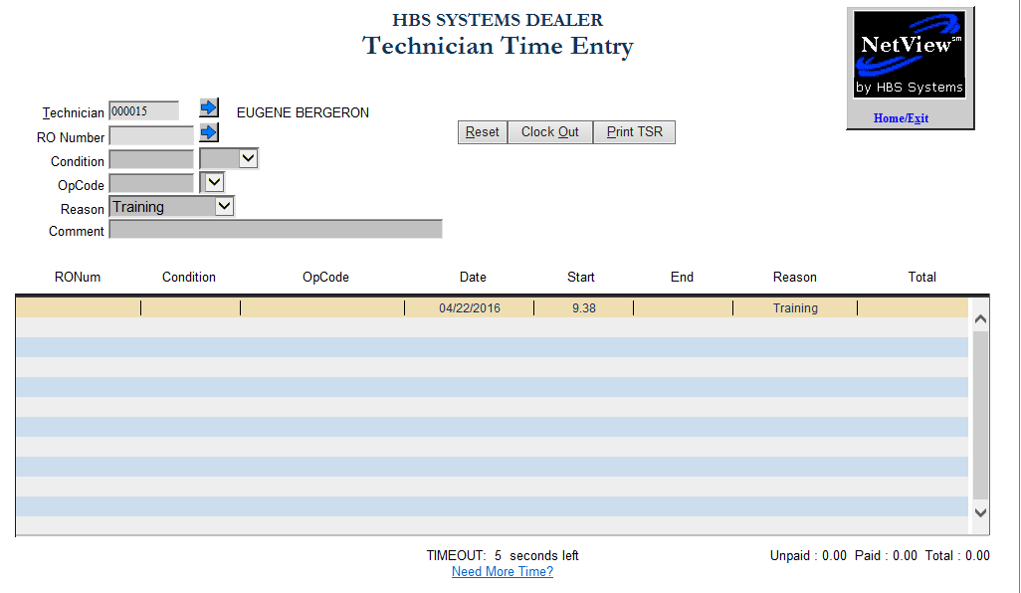

Technician: Enter your Technician number.

- You can also use the Arrow to look it up. Click on your name to select it.

The RO you have been working on will be displayed in the center of the screen. Press the Clock Out button to clock out of the RO.

Printing a Time Slip Report (TSR) in TTE

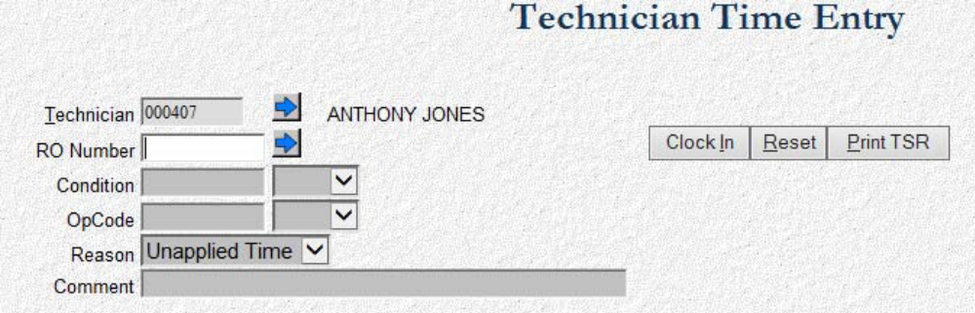

Click on the Print TSR button to begin generating the report. The following window will display:

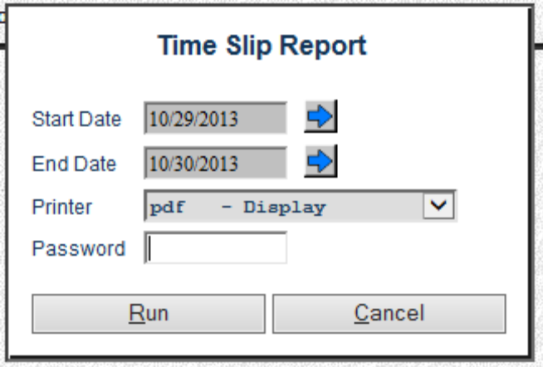

- Start Date/End Date: Choose a date range for the report. Yesterday’s date through today pre-fills in the fields.
- Printer: Choose a printer name or keep the default of PDF to display the report.
- Password: The password for this function is the password of the login mapped to the tech number entered on the screen.

Click Run to generate the report.

