Vermeer Connect (VMDI): Vermeer Connect (VMDI) is an HBS Systems NetView Connect program designed specifically for Vermeer dealers. The program allows you to upload your parts inventory to Vermeer.

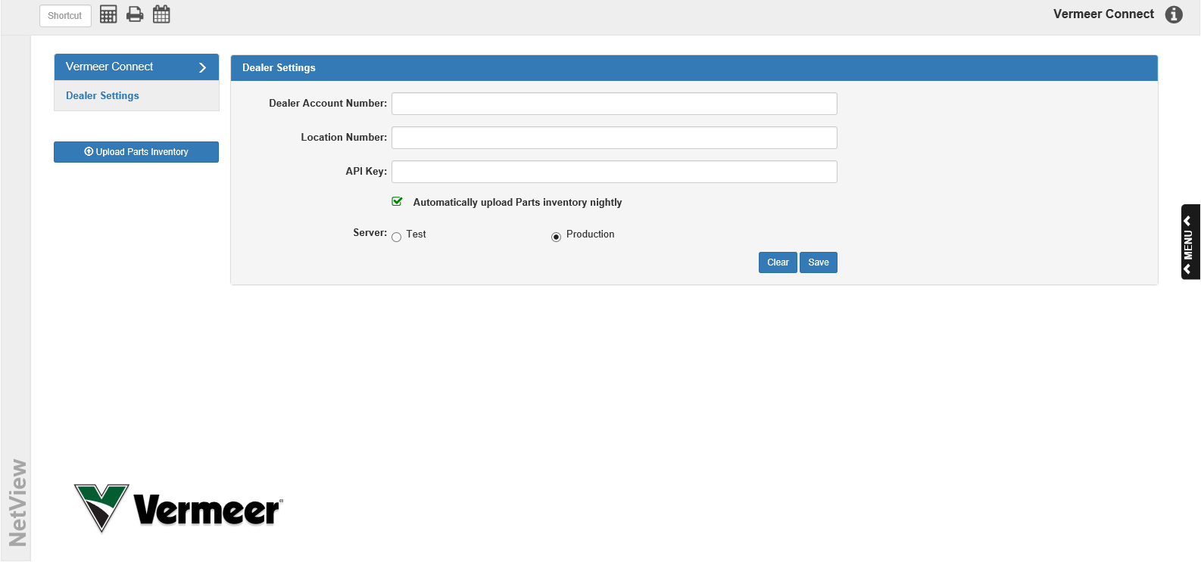

To access this program, type “VMDI” in the Shortcuts Bar.

Dealer Settings: You will need to enter your Vermeer dealership credentials in order to set up your inventory upload.

Dealer Account Number: Enter your Vermeer dealer account number here.

Location Number: Enter your Vermeer location number here.

API Key: Enter your unique Vermeer API key in this field. This is a security key provided by Vermeer.

Automatically upload Parts inventory nightly: If you want the program to automatically upload your parts inventory to Vermeer every night, make sure this box is checked. Otherwise, you will have to manually upload your inventory.

Server: Make sure the server is set to Production instead of Test; otherwise, your inventory uploads will not work.

Save: Click the Save button to save your dealer information.

Upload Parts Inventory: Click this button to manually upload your parts inventory to Vermeer at any time. NOTE: If you have the “Automatically upload Parts inventory nightly” option selected, the program will automatically update the parts inventory every night.

