Help: The Help category is located below the Desktop category on the main menu panel, and is represented by an icon of a question mark. Clicking on the icon will allow you to access the Help sub-menu about NetView Desktop and its operations.

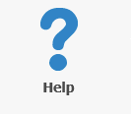

NetView Guide: The NetView Guide panel lets you access the Help function that you are reading right now. Also see the "Help" tab in “Menu” under “NetView Desktop Main Page.” Features included in the Help are:

- NetView Desktop User Guide
- Table of Contents linked to the different pages within the guide
- Instructional videos included in certain topics
- Search function
- Index
- Glossary of terms

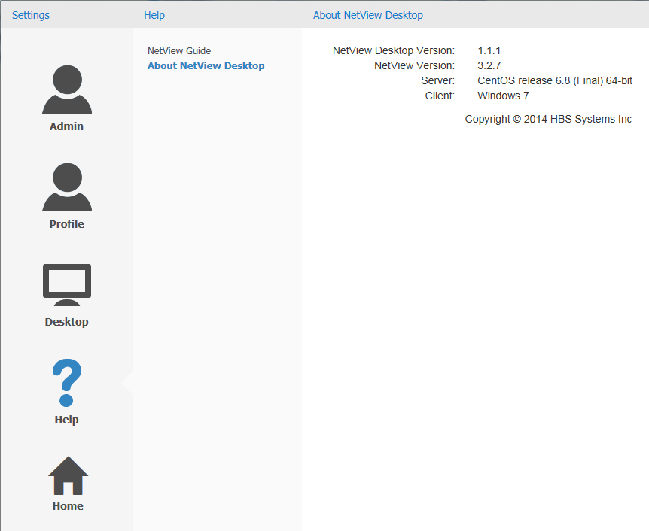

About NetView Desktop: The About NetView Desktop panel displays basic information about the program, such as its version, associated server, compatible web browser(s), and its copyright information.

