Integrated Purchase Orders (IPO)

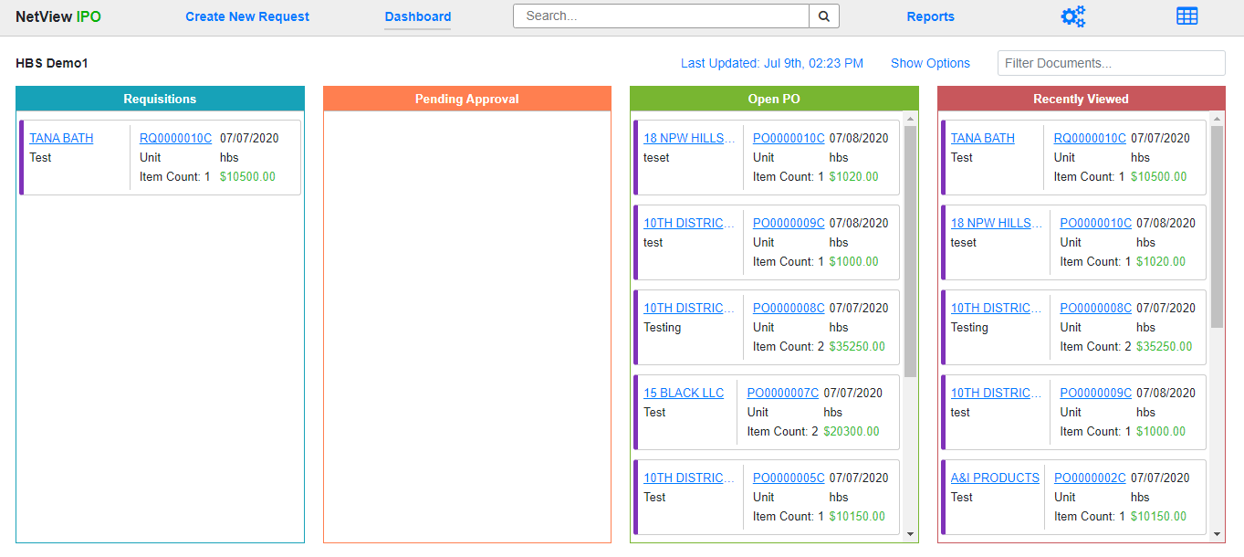

Integrated Purchase Orders (IPO) serves as the central purchase ordering program for NetView. The program allows you to manage multiple types of purchase orders from creation to completion while sharing the purchase information with other relevant programs. To access this program, type “IPO” in the Shortcuts Bar.

The following topics will cover all aspects of IPO, from setup to basic program information to the life cycles of each type of purchase order the program handles.

