Krone Connect (KRONE): Krone Connect (KRONE) is an HBS Systems NetView Connect program designed specifically for Krone dealers. The program allows you to upload your parts inventory to Krone.

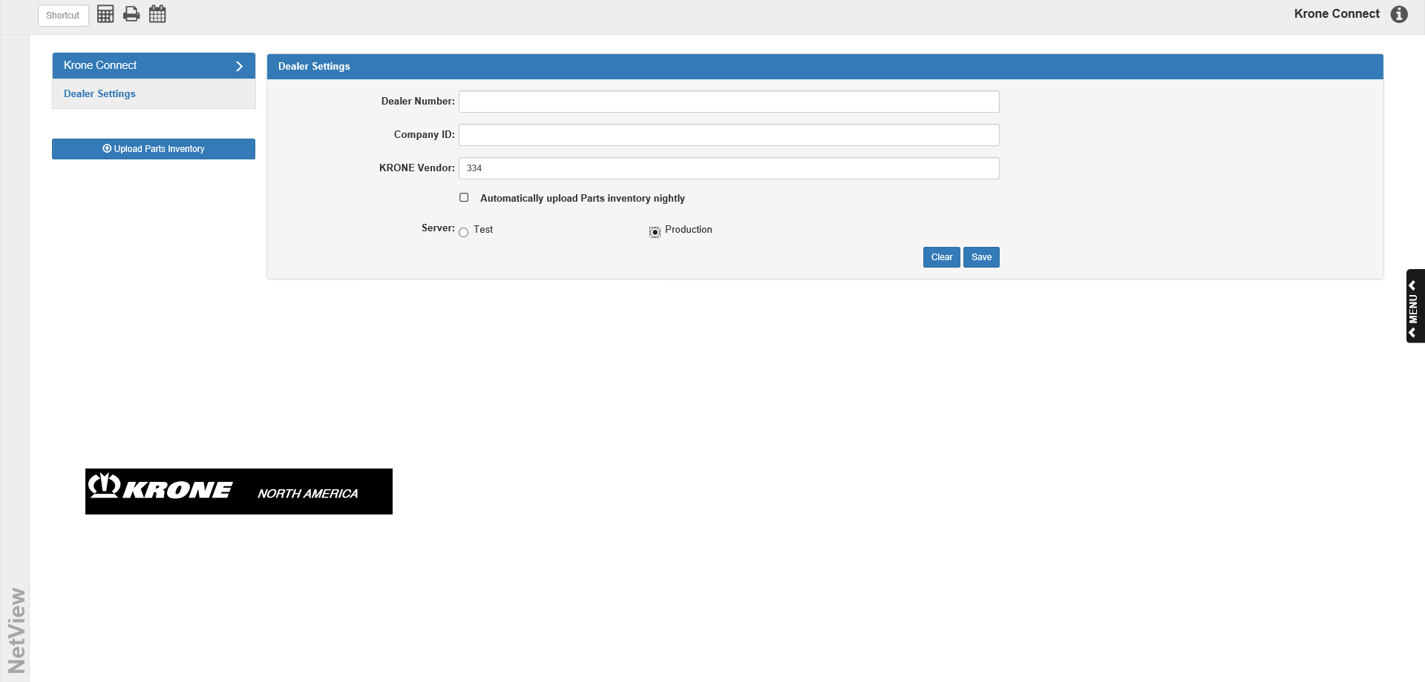

To access this program, type “KRONE” in the Shortcuts Bar.

Dealer Settings: You will need to enter your Krone dealership credentials in order to set up your inventory upload.

Dealer Account Number: Enter your Krone customer number here.

Company ID: Enter your Krone contract number here.

KRONE Vendor: Enter your system’s Krone vendor number here, which will currently be 334.

Automatically upload Parts inventory nightly: If you want the program to automatically upload your parts inventory to Krone every night, make sure this box is checked. Otherwise, you will have to manually upload your inventory.

Server: Make sure the server is set to Production instead of Test; otherwise, your inventory uploads will not work.

Save: Click the Save button to save your dealer information.

Upload Parts Inventory: Click this button to manually upload your parts inventory to Krone at any time. NOTE: If you have the “Automatically upload Parts inventory nightly” option selected, the program will automatically update the parts inventory every night.

