KubotaConnect (KUB)

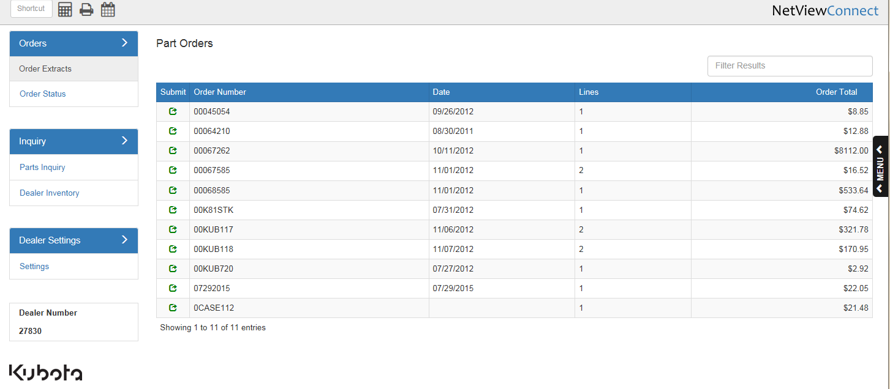

NOTE: Only available to Kubota dealers.

KubotaConnect is a NetView Connect application intended to help Kubota dealers communicate with the manufacturer and better access information about Kubota products.

The application can be accessed by typing the shortcut “KUB” into the Shortcuts Bar. The screen initially shows all open Kubota parts orders. Here you have access to the Order Submission feature and the Order Inquiry feature.

Order Extracts: To review an order shown and prep it for submission to Kubota, click
on the green symbol in the Submit column.

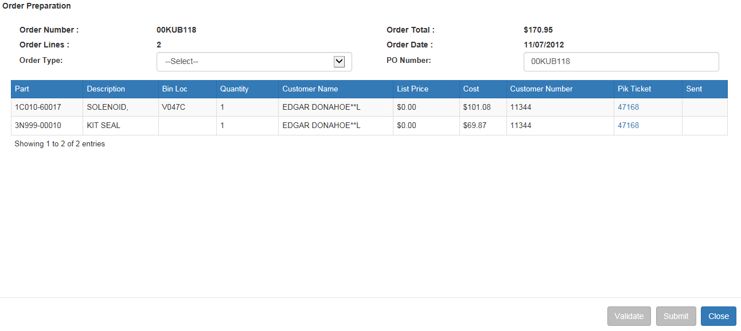

From the Order Preparation screen, you can change the PO number as needed and choose the order type.

- Valid order types are:
  - EM=Emergency
  - PR=Promotional
  - RG=Regular
  - ST=Stock
  - ZDST=Daily Stock
- When you choose Regular or Emergency order types, there is an optional checkbox for entering a special shipping address.
  - When checked, the screen opens to offer the ability to enter the shipping address for the order. You may:
    - Enter a shipping address in the fields provided and validate it against the customer file
    - Look up a customer address from the system (click on “Lookup Address” and search for the customer).

Validate: When you have the order type selected and optionally entered the shipping address, you may validate the information before the order is submitted by clicking on the “Validate” button.
- The validation step provides the following:
  - A validation message showing either (see below images):
    - Success

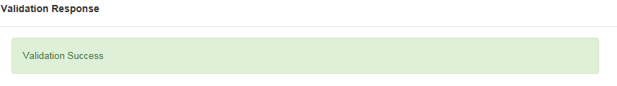

    - A reason why the order is not valid
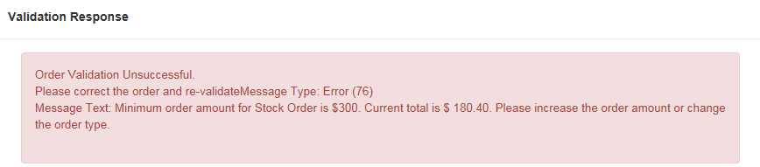

  - Dealership name
  - Dealer number
  - Total cost of order date
  - Billing info
  - Ship-to address info.

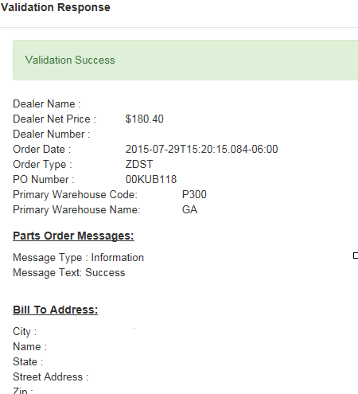

Each order line item is also reported with details like those shown below.

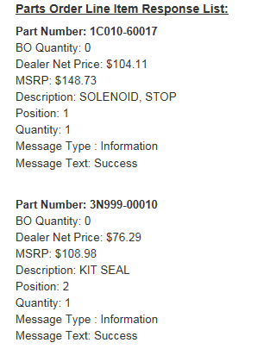

Finishing the Order: When ready, click “Submit” to send the order to Kubota.

Order Status: The Order Status screen initially opens with order search options for:

- Part Number
- Order Date
- Dealer PO
- Invoice ID
- Order ID

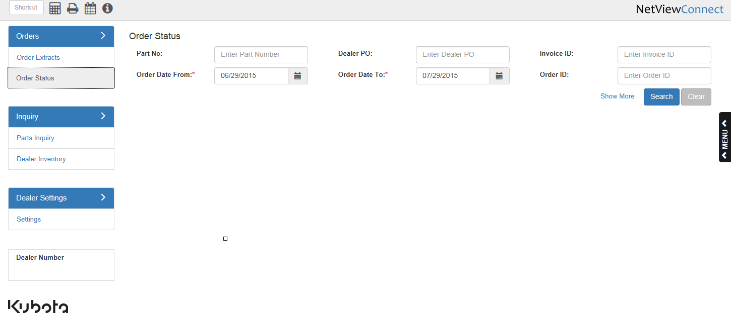

Show More: Click on “Show More” to enhance the search options to include:

- Order Type
- Ship Date
- Warehouse
- Status
- Ship Via
- Tracking Number

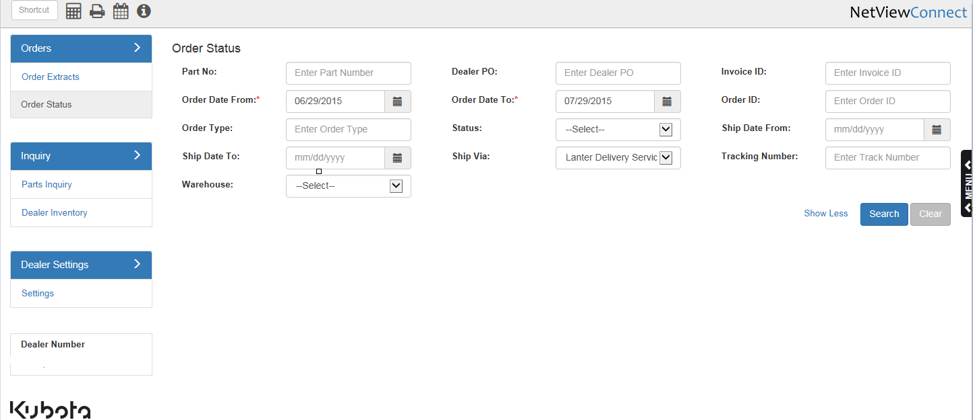

Order Inquiry: The Order Inquiry returns info based on the details sent.

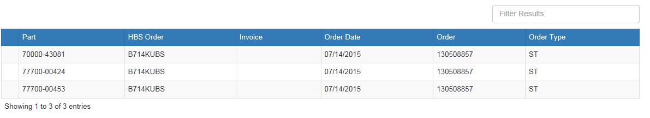

In addition, you can click on any given line and get detailed info for that particular part number.

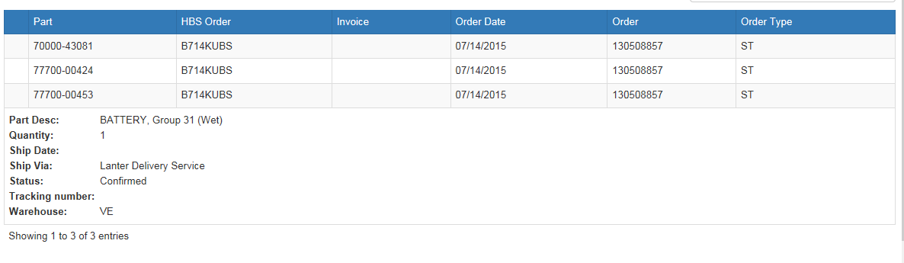

Dealer Inventory Inquiry: From the Inquiry screen you can also do a Dealer Inventory search.

- Enter a Kubota part number.
- The search will show:
  - The dealers who have that part number
  - The quantity they have on hand
  - Their contact info

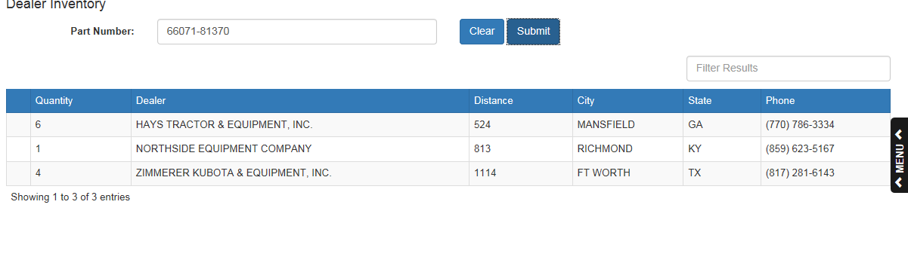

Fast Inquiry: The Fast Inquiry function (Shift F12) allows you to do an immediate parts inquiry to Kubota. This feature is available inside the following programs:

Parts Inquiry

- Shortcut: PI
- Hotkey: I

Quick Order Adjustments

- Shortcut: QOA

Price File Inquiry

- Shortcut: PFI
- Hotkey: F

Accessing Fast Inquiry: To access the feature:

- In Parts Inquiry (PI/I):

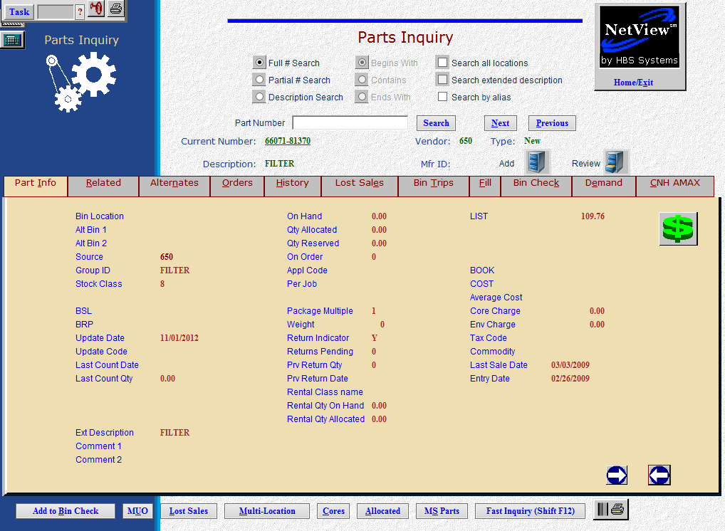

  - Fill in a Kubota part number
  - Click on the “Fast Inquiry” button or hit “Shift F12” on the keyboard.
- In Price File Inquiry (PFI/F)

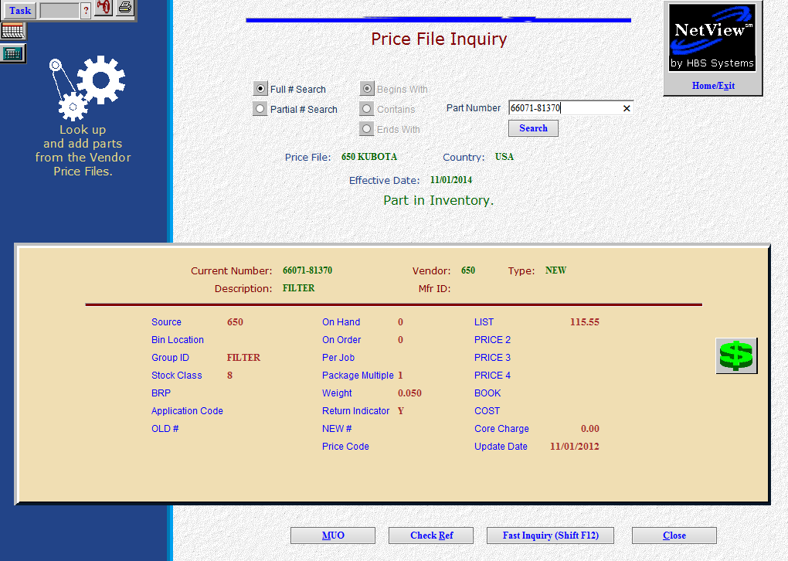

  - Enter a Kubota part number.
  - Click the Fast Inquiry button at the bottom of the screen or hit “Shift F12” on the keyboard.
- In Quick Order Adjustments (QOA)

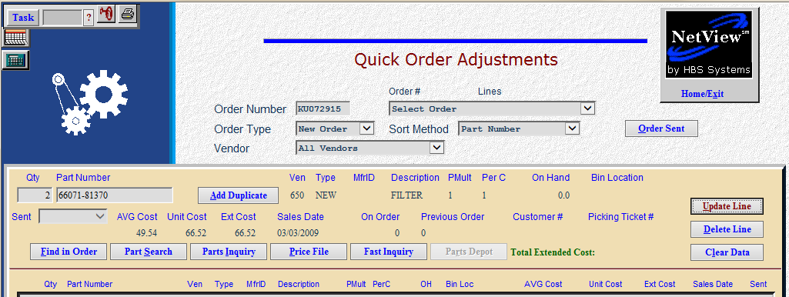

  - Enter a Kubota part number.
  - Click the Fast Inquiry button on the order line or hit “Shift F12” on the keyboard.

Using Fast Inquiry: The resulting screen shows as below:

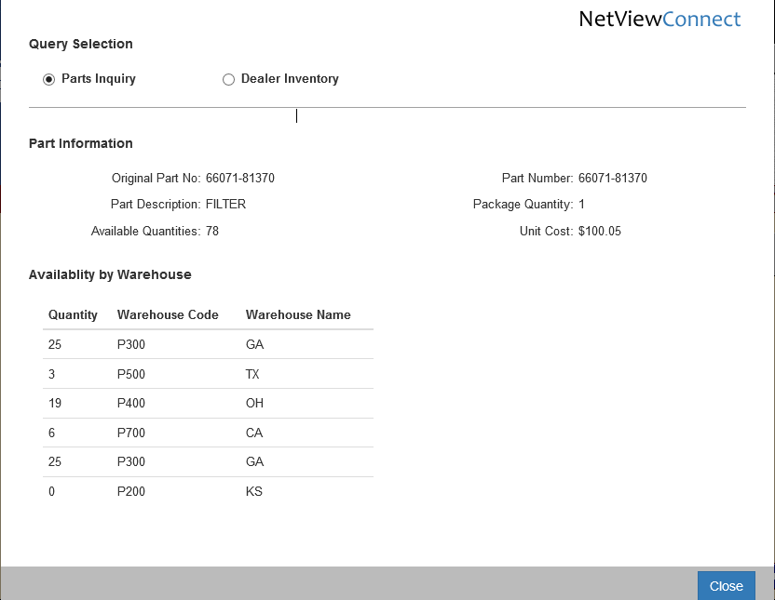
- Parts Inquiry: The inquiry initially returns the Parts Inquiry info. This includes:
  - Original part number
  - Description
  - Package quantity
  - Available quantities at Kubota, shown by:
    - Warehouse Code
    - Name
  - Unit Cost
- Dealer Inventory: Click on “Dealer Inventory” to find the part number in a dealer’s inventory

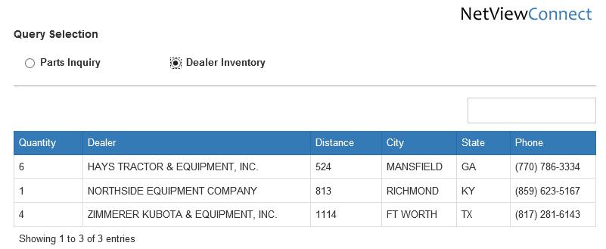

  - The Dealer Inventory info includes:
    - The quantity they have
    - The dealer’s name
    - The dealer’s distance from your dealership
    - The city
    - The state
    - The dealer’s phone number.

