Repair Order Maintenance (ROM)

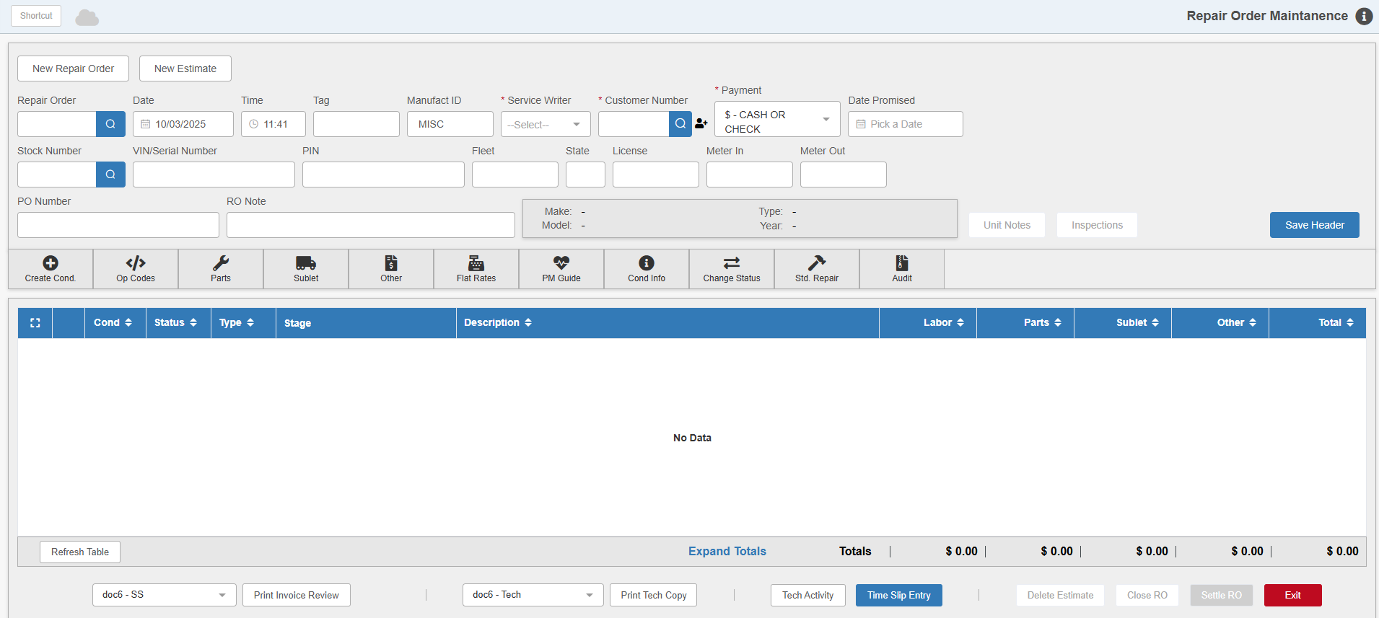

Repair Order Maintenance (ROM) allows you to create, maintain, and close Service repair orders. The following topics will cover the many functions possible in this program.

To access ROM, you can either:
- Select "Service" from the menu and click on "Repair Order Maintenance."
- Type "ROM" in the Shortcuts Bar.

NOTE: You cannot open ROM in a Consolidated location.

