Reversing a Unit Sale

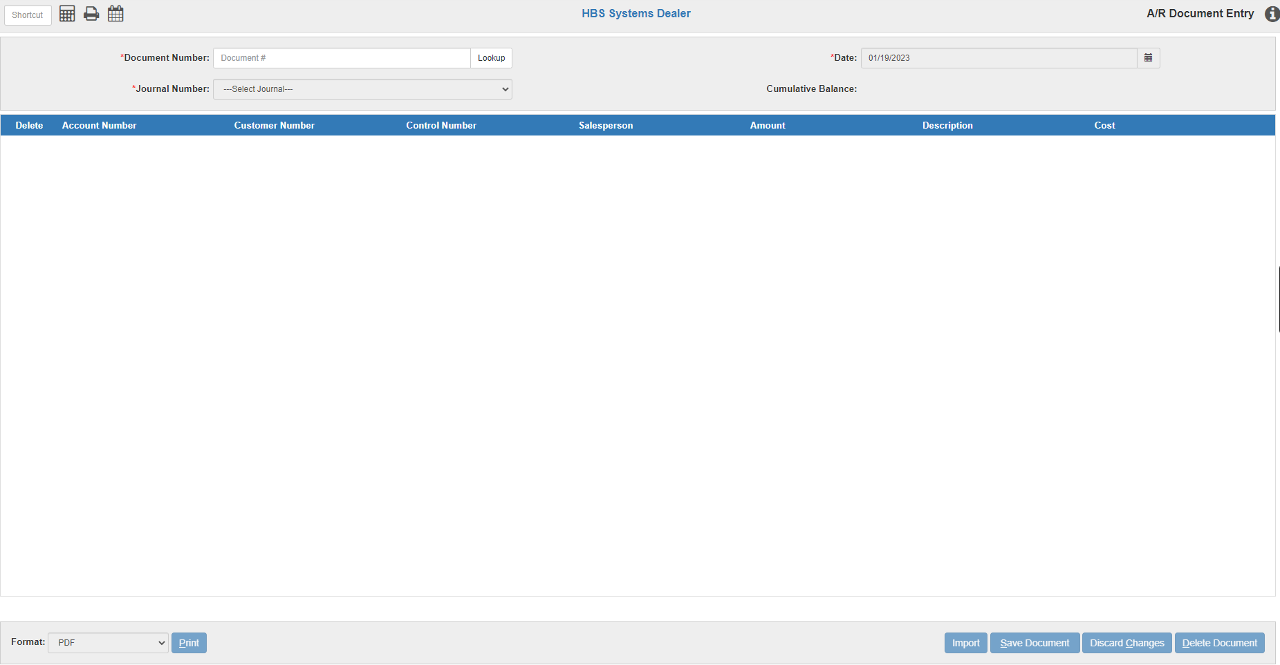

From time to time you may need to reverse a unit sale you have entered. This process will walk you through the necessary steps to reversing a unit sale. When finished, the unit sold will be returned to inventory as it was before it was sold.

We recommend that you process the reversal when the Journal entry for the sale has been journaled or posted. You will need a printout of the Journal entry or a printout of the sales entry from the G/L Detail Inquiry (GLDI) function.

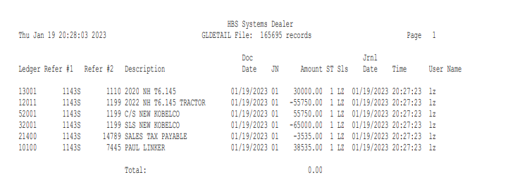

Balance Forward Maintenance (BFM): We must start with the Unit side of the correction. Access the unit sold in Balance Forward Maintenance (BFM). **Balance Forward should NOT be used for any regular or day-to-day activity in Units.**

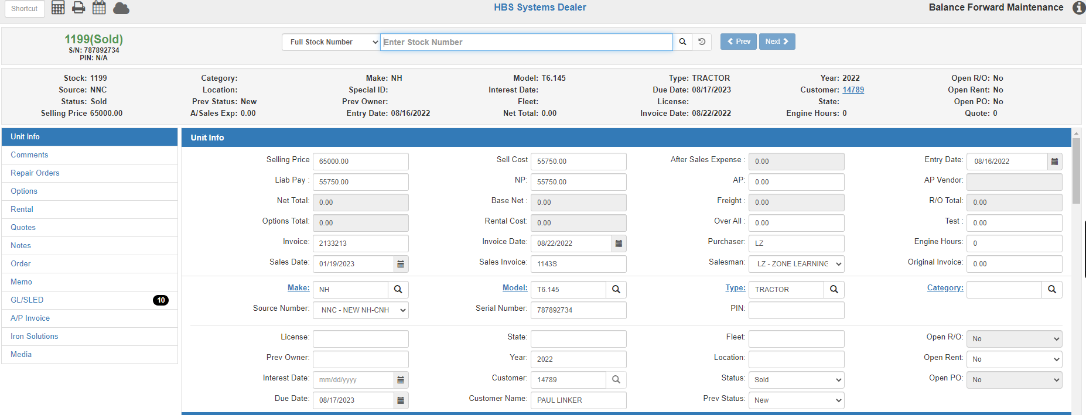

The object of this part of the process is to make the unit sold appear as if it had not been sold. The example above shows the record as it was after the sale. Make corrections ONLY to the following fields:

N/U/S – Status: Change the status from Sold to New or Used to show its original status.

Sell Price: The value shown here is the selling price of the unit. You may leave it in this field if you believe it was the value in the List Price before the unit was sold. If in doubt, zero the value shown.

Sell Cost: The value shown here is the cost at the time the unit was sold. Put a zero in this field to eliminate the number.

Base Net: This field should remain at zero as it shows on the screen.

Customer Number: This field shows the number of the customer who purchased the unit. Clear the customer number and it should clear the name from the field below.

Sales Invoice: This field holds the sales invoice number from the transaction. Clear this field.

Sales Date: This field shows the sales date of the unit. Clear the date from the field.

Salesman: Clear the salesman’s initials from this field. Clear the initials if you do not have a pull-down box in the field or choose “Select” from the pull-down box if present.

Press the Save button to save your changes.

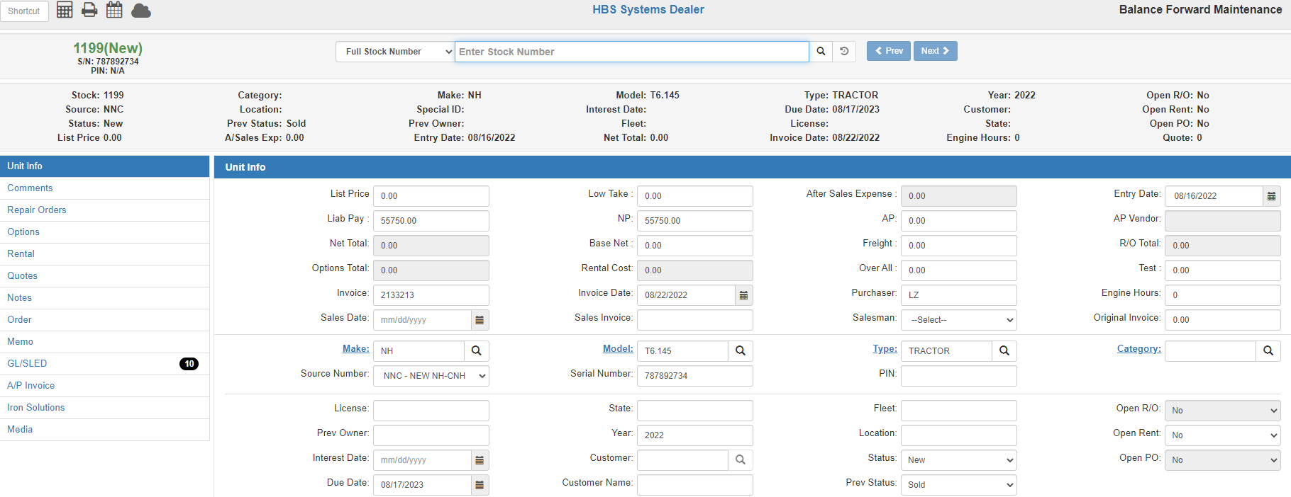

This screen shows the same unit record after it has been restored to its original settings. If there was more than one unit sold on the invoice to be reversed, repeat the process for each additional unit sold.

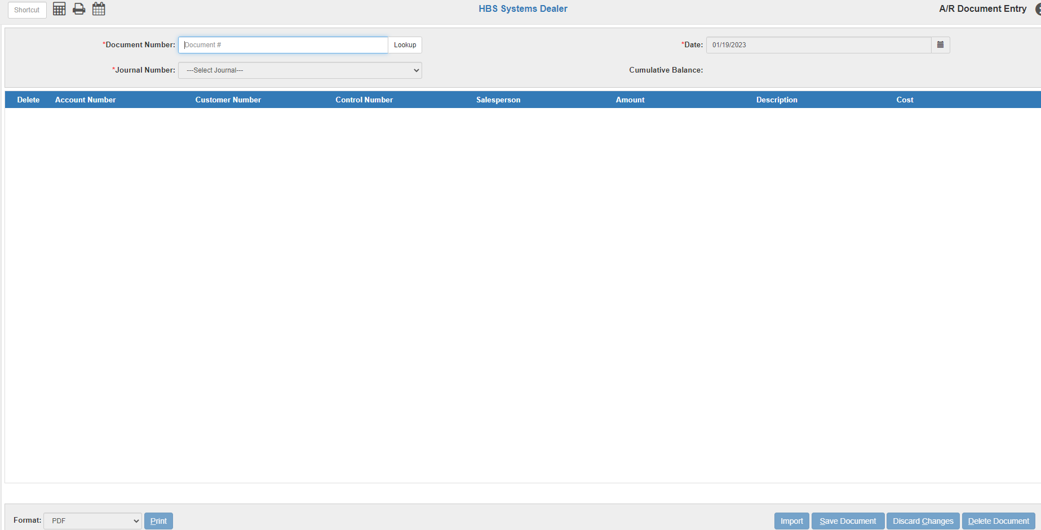

G/L Document Entry (GLED): We will process the accounting portion of the reversal now by creating a document in G/L Document Entry (GLED).

Create a journal entry to reverse the original sale. We suggest using the ORIGINAL invoice number and Journal 15 to make the entry. Simply duplicate the Journal entry with the original amounts reversed. For example, all the debits “+” become credits “-“ and all the credits “-“ become debits “+”. When you reach any Unit inventory accounts, choose “Base Net” to apply the full cost to that field in the Unit record.

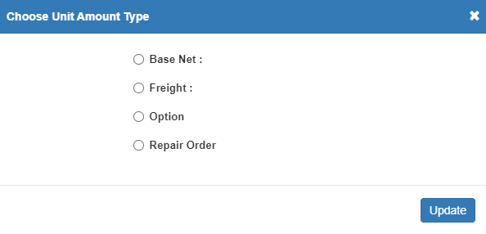

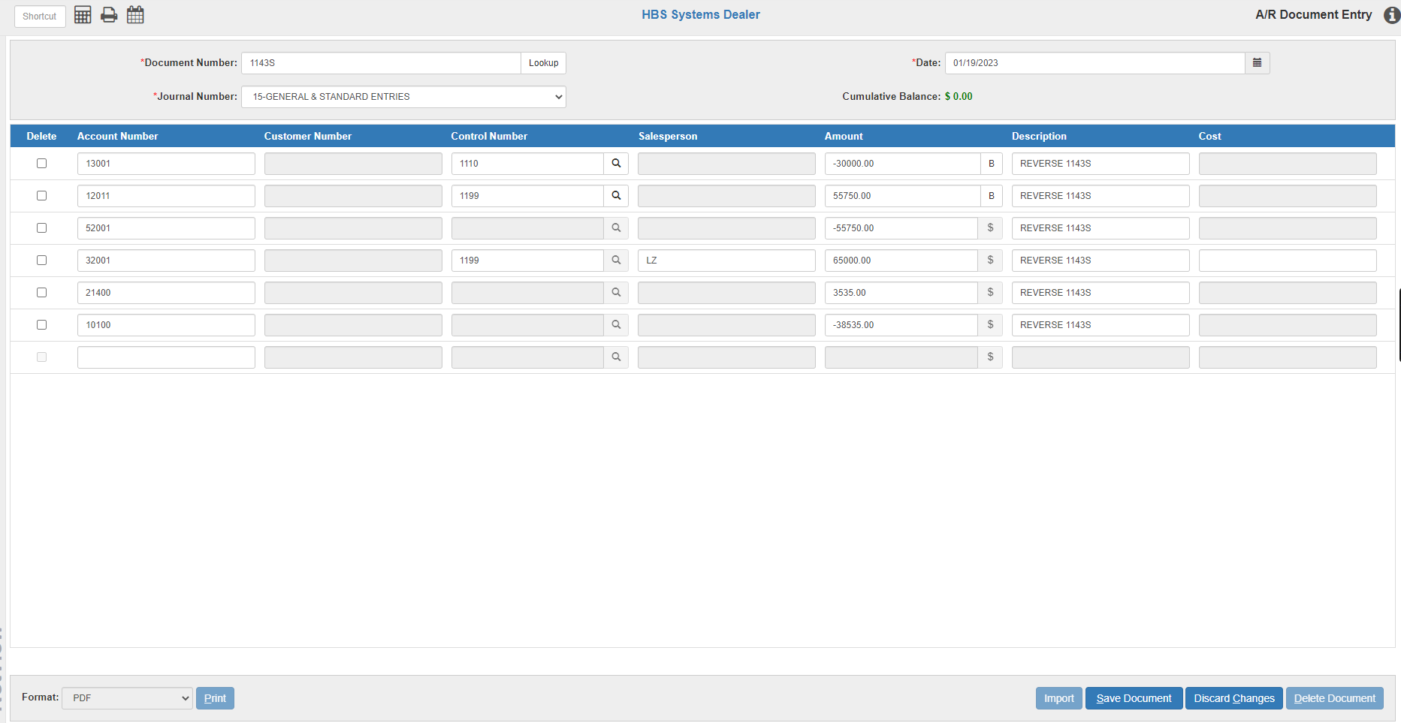

Journal or post the entry when it is completed using G/L Post Journals (GLPJ).

Handling Trade-Ins: Next, we will work on the trade-in(s) if there were any on the sale being reversed. How the trade-ins were handled will determine which of the following methods you need to use:

- Trade-In of a Historical Status or Previously Sold Unit
- Trade-In unit that had never been added or processed in HBS prior to this.

Trade-In of a Historical Status or Previously Sold Unit: For a trade-in that was previously sold by your dealership or it was a unit entered as a historical unit for the customer, access the trade-in unit in BFM. **Balance Forward should NOT be used for any regular or day-to-day activity in Units.**

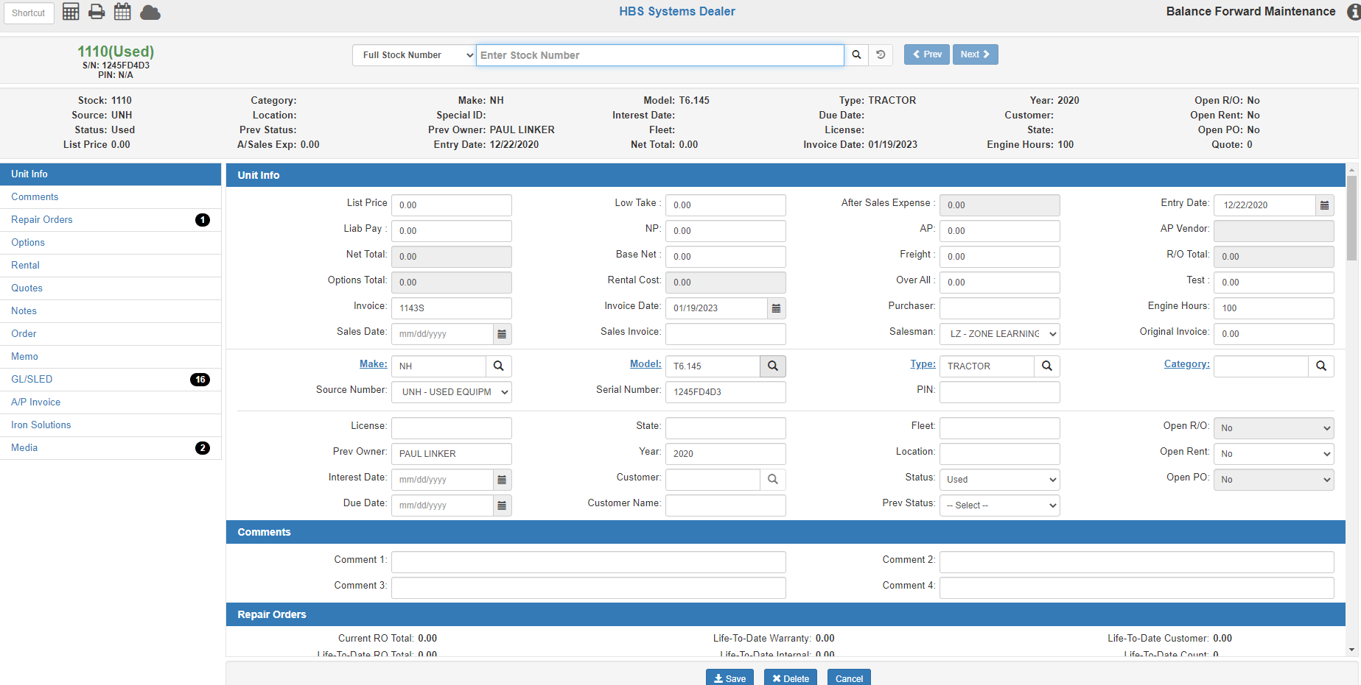

N/U/S – Status: Change the status from Used to Sold or Historical to show its original status.

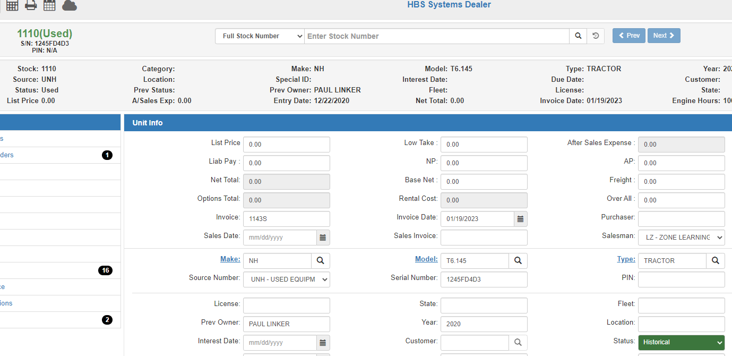

Press Save to record your changes.

Trade-In unit that had never been added or processed in HBS prior to this: For a trade-in that had not been in HBS prior to this sale, access the trade-in unit in BFM. **Balance Forward should NOT be used for any regular or day-to-day activity in Units.**



If the trade-in was ADDED during the sales transaction, technically you could delete it using the Delete button at the bottom of the screen. However, we recommend just changing the status to historical, so the information is there if you need to bring the unit in as a trade-in later!

N/U/S – Status: Change the status from Used to Historical.



Press Save to record your changes.

Sales Tax History Maintenance (STXHM): If you get your sales tax information from the Sales Tax Report (STXR), you must make an entry in STXHM to show the reversal on the report. Type “STXHM” in the Shortcuts Bar to reach the Sales Tax History Maintenance screen.

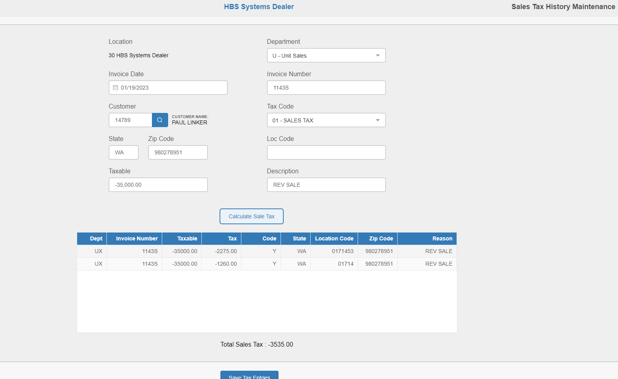

Department: Choose Units.

Invoice Date: Enter the date of the transaction to be reversed.

Invoice #: Enter the invoice number of the transaction.

Customer #: Enter the customer number or look it up.

Tax Code: Choose the tax code that applies to the transaction.

State: Enter the state where the sale occurred (our example above uses the dealership state).

Zip Code: Enter the zip code where the transaction occurred.

If the transaction is to be taxed at the dealership tax rate, the dealership’s zip code should be entered (our example above was taxed at the dealership rate so we put their zip code)

If it is to be taxed at the rate based on the customer’s address, enter that zip code.

Taxable: Enter the amount of the transaction to be reversed as a credit “-". It will be flagged as taxable if the tax code chosen is taxable and non-taxable if the tax code chosen is non-taxable.

Description: Enter a short description of the transaction.

Calculate Sale Tax: Press this button to calculate the tax for the transaction.

For SST states (like in our example), it will use either the customer’s zip code or the dealership’s zip code to perform that calculation (our example used the dealership zip code to determine the tax rate from the table).

For non-SST states, it will use the tax code to determine the tax.

Press the Save Tax Entries button to save the transaction to the sales tax transaction file.

Below is an example of the STXR report for our sales transaction before the adjustment was made. The tax in this example is from an SST state so it used the table to determine the sales tax based on the dealership’s zip code – 1260.00 local tax and 2275.00 state tax for a total of 3535.00.

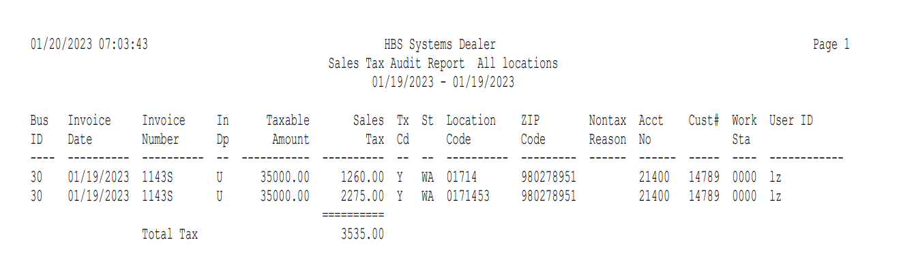

The next example shows the updated version of the same STXR report. Notice that the Dept shows “UX” to indicate we made a manual entry. This adjustment zeroes out the original entry.

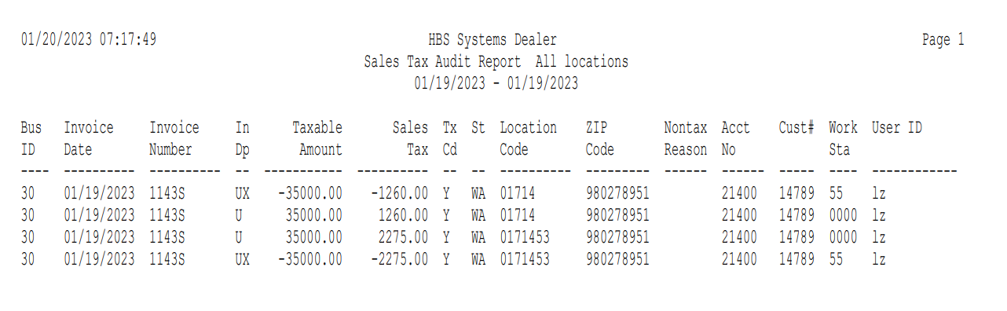

Recap: The sold unit has been returned to inventory, the accounting entries have been made, the trade-in information has been reset/updated, and the Sales Tax report has been updated. Now you may re-process the sale as needed.

