Parts Trend Report (TR)

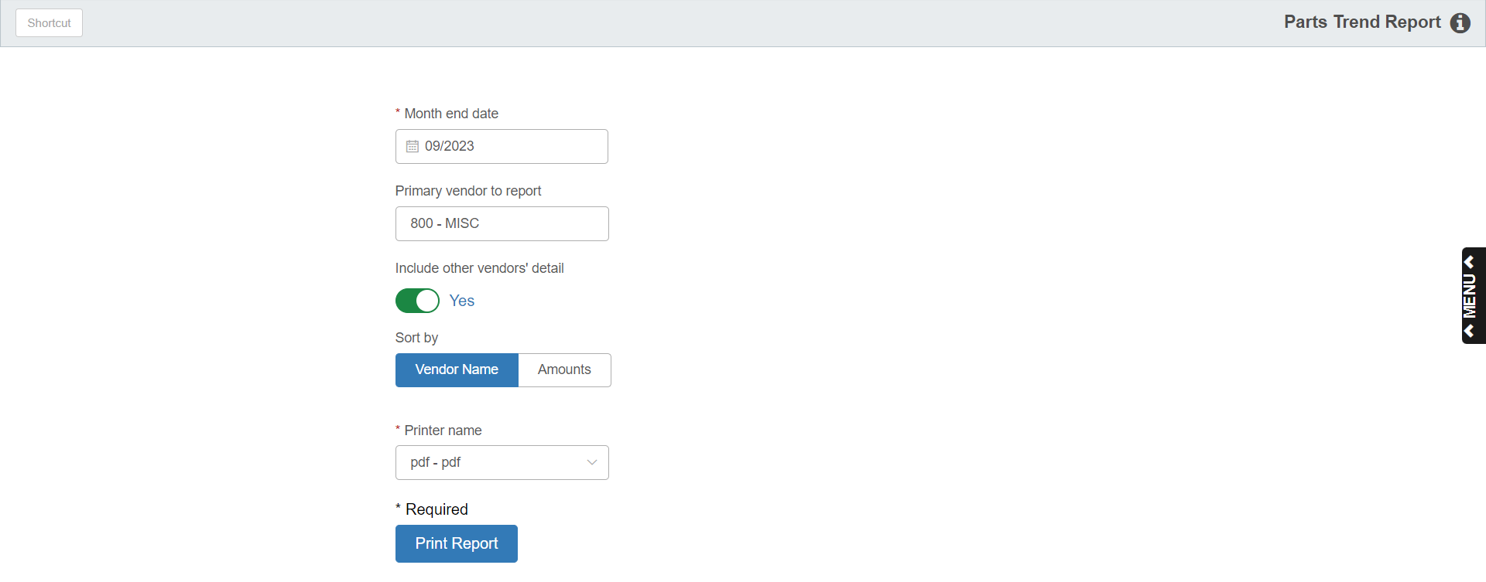

This report is a management tool to help you monitor sales, inventory, and performance levels of your parts inventory. You can examine a full 12 months of detail by individual vendor or look at statistics for all vendors. The report consists of three sections:

- Parts Inventory Values
- Parts Sales Dollars
- Parts Turnover Ratios

Each section focuses on a vendor of your choice and compares it to all of your other vendors.

To access the Parts Trend Report, you can either:

- Select “Inventory” from the menu. Choose the “Reports” submenu and click “Parts Trend Report.”
- Type “TR” in the Shortcuts Bar.

Field Definitions

Month End Date: This field pre-fills with the month and year of the last month end run. You may use the provided date or set a month of your choice. The report will use the date you enter to prepare a report that covers that month and the previous 11 months.

Primary Vendor for Report: Choose the primary vendor to feature on the report. Your default vendor will pre-fill in the field.

Include Other Vendors’ Detail:

- Choose Yes to show the details for all other vendors besides the primary one selected in the previous field.
- If you only want to highlight the primary vendor selected, choose No, and the report will summarize all other vendor activity into a single line of the report.

Sort by: This field will only activate if you set “Include Other Vendors’ Detail” to “Yes.”

- Choose Vendor Name to sort the report by Vendor Name.
- Choose Amounts to have it sort the various reports ranked by the amounts of the report.

Printer Name: Select the printer to receive the printout. A default printer name is pre-filled but can be changed as necessary. Use the pdf printer to view the report on the screen without printing a copy of it.

Print Report: Press this button to print your report.

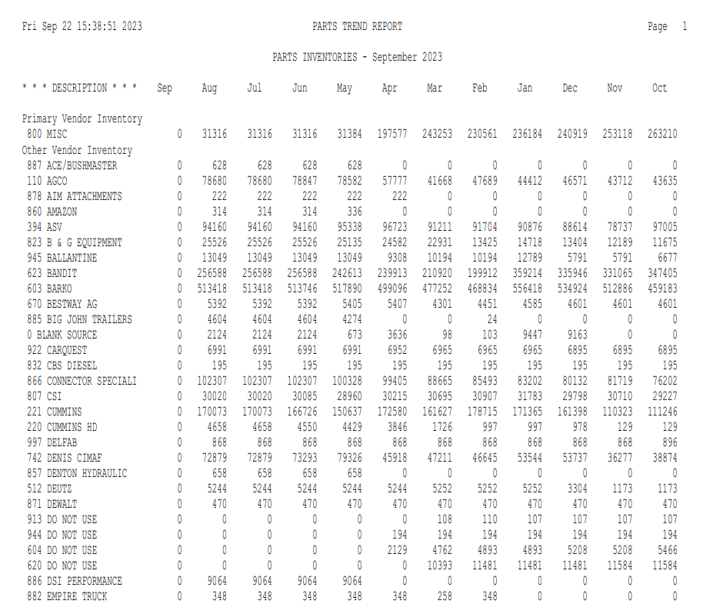

Detail Version—Parts Inventory Values: The first section of the Parts Trend report deals with Parts Inventories. This section shows the dollar value (in cost) of the inventories for each of the months listed.

If you chose to show the detail for the other vendors on the report, you’ll receive a report formatted similar to the one shown here.

Totals are provided for the following:

Primary Vendor

All Other Vendors Combined

Total Inventory

A short section at the bottom of the page provides information about Non-Stock Inventory values.

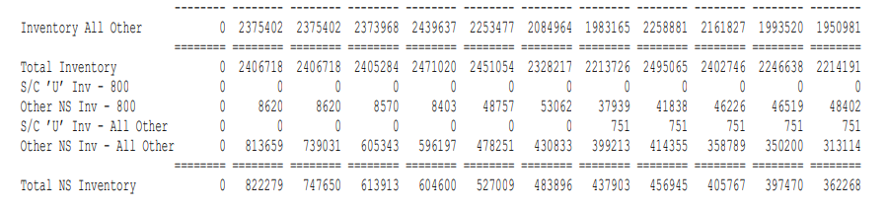

S/C U Inv: There are two lines in this section that detail the dollar value (in cost) of the Stock Class U parts for:

The Primary Vendor

All Other Vendors Combined

Other NS Inv: There are two lines in this section that detail the dollar value (in cost) of the other Non-Stock inventory (Stock Class 8 & 9 parts) for:

The Primary Vendor

All Other Vendors Combined

Total NS Inventory: This line totals the dollar value (in cost) of the all Non-Stock inventory (Stock Class U, 8, & 9 parts) for all vendors combined.

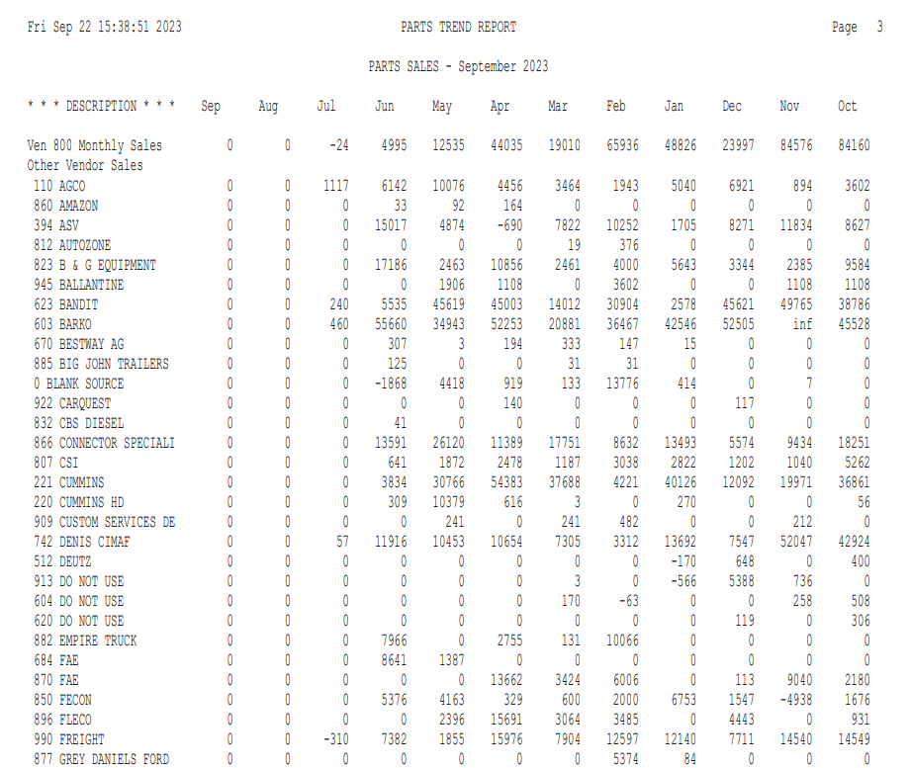

Detail Version—Parts Sales Dollars: The second section of the Parts Trend report deals with Parts Sales. This section shows the Sales Volume (in Actual Sales Dollars) for each of the months listed.

If you chose to show the detail for the other vendors on the report, you’ll receive a report formatted similar to the one shown here.

Totals are provided for the following:

Primary Vendor

All Other Vendors Combined

Total Sales

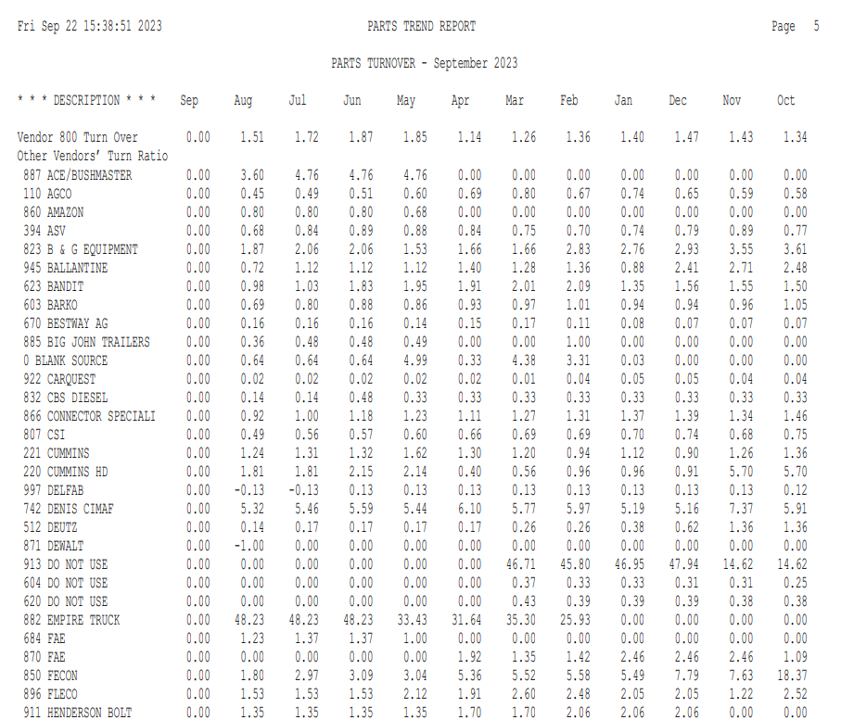

Detail Version—Parts Turnover Ratios: The third section of the Parts Trend report compares Parts Turn Ratios and other parts movement statistics.

All Vendors’ Turn Ratio: This section shows the 12-month Rolling Turn Ratios as of the end of each month shown on the report.

If you chose to show the detail for the other vendors on the report, you’ll receive a report formatted similar to the one shown here.

Totals are provided for the following:

Primary Vendor

All Other Vendors Combined

Total Sales

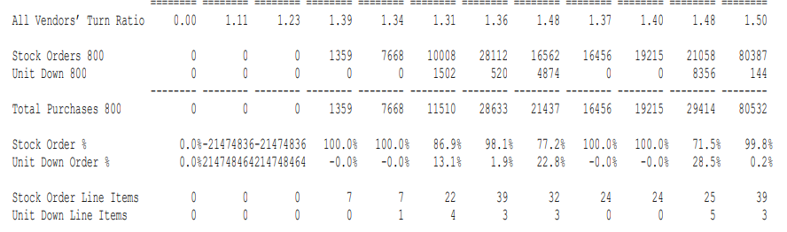

Vendor XXX Price Change: This line shows the change in value of the inventory due to the loading of a price file and application of the prices with Price Update and Variance.

Stock Orders XXX: This line shows the value of stock orders received for the vendor selected.

Unit Down XXX: This line shows the value of unit down orders received for the vendor selected.

Total Purchases XXX: This total is the sum of the value of the stock orders and unit down orders received for this vendor.

Stock Order %: This percentage is the dollar value of the stock orders receipted compared to the total purchases for the vendor.

Unit Down Order %: This percentage is the dollar value of the unit down orders receipted compared to the total purchases for the vendor.

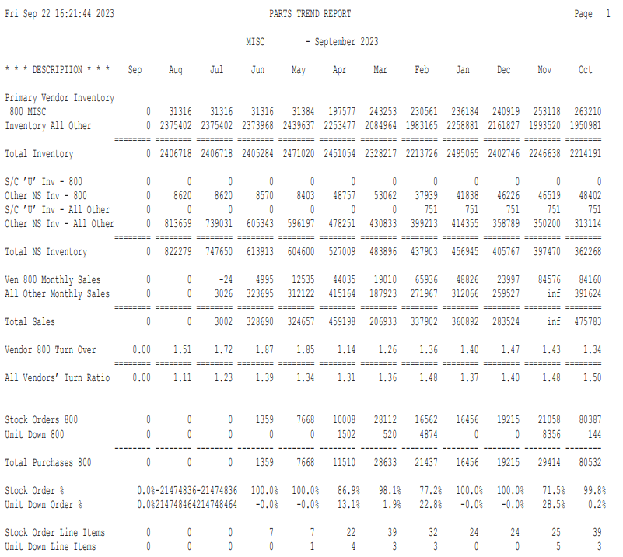

No Detail Version: This report summarizes the information and compares the primary vendor inventory to all other vendors combined.

Inventory: Totals are provided by month for:

The primary vendor

All other vendors combined

Total inventory

NS Inventory: There’s also a section of information about Non-Stock Inventory values.

There are two lines in this section that detail the dollar value by month (in cost) of the Stock Class U parts for the Primary vendor and All Other vendors combined (S/C U).

The other two lines in this section detail the dollar value by month (in cost) of the other NonStock inventory (Stock Class 8 & 9 parts) for the Primary vendor and All Other vendors combined (Other NS).

Totals are provided by month for the dollar value (in cost) of all NonStock inventory (Stock Class U, 8, & 9 parts) for all vendors combined.

Sales: For Sales, totals are given by month for:

The primary vendor

All other vendors combined

Total sales

Turn Ratios: For Turn Ratios, figures are shown by month for:

The primary vendor

All other vendors combined

Vendor XXX Price Change: This line shows the change in value of the inventory due to the loading of a price file and application of the prices with Price Update and Variance.

Stock Order XXX: This line shows the value of stock orders received for the vendor selected.

Unit Down XXX: This line shows the value of unit down orders received for the vendor selected.

Total Purchases XXX: This total is the sum of the value of the stock orders and unit down orders received for this vendor.

Stock Order %: This percentage is the dollar value of the stock orders receipted compared to the total purchases for the vendor.

Unit Down Order %: This percentage is the dollar value of the unit down orders receipted compared to the total purchases for the vendor.

