Units A/P Report (UAPR)

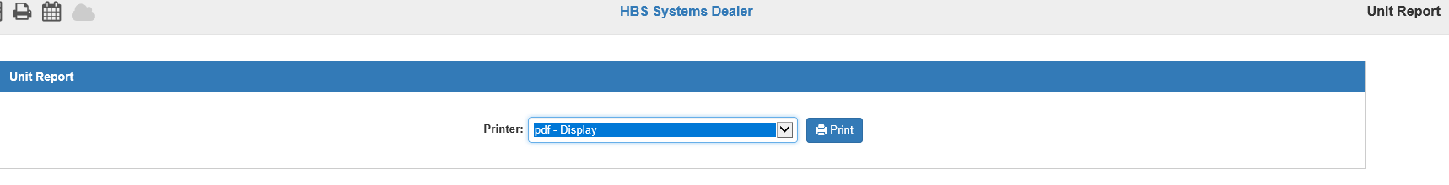

The Units A/P Report (UAPR) shows you all of the invoices tied to a given stock number within Units. The information on this report should match the data that prints for A/P on the Unit Accounting Reports (UAR).

The link between stock numbers and A/P is accomplished in a number of programs. The list below shows where the link can be established or used.

- Enter A/P Invoices (EAPI)
- Unit Purchase (UP)
- Bulk Items Purchase (BIP)
- Enter Transfers and Adjustments (ETA)

To access this report, you can either:

- Select “Accounts Payable” and choose the “Memo Reports” submenu. Click on “Units A/P Report.”
- Type “UAPR” in the Shortcuts Bar.

Printer: Identify the printer to receive your printout. A default printer is pre-filled but may be changed as necessary. Use the pdf-Display printer to display the report.

Click “Print” to print the report.

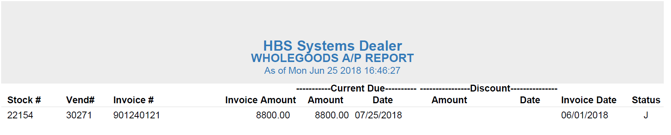

Report Printout:

Stock #: This is the stock number for this piece of equipment.

Vend#: The vendor’s number is printed here.

Invoice #: This column holds the invoice number connected to the stock number.

Invoice Amount: This is the original amount of the invoice.

Current Due Amount: This is the amount currently due for the invoice (original amount less any payments).

Current Due Date: This is the due date for the remaining invoice amount.

Discount Amount: This is discount amount for this invoice, if any.

Discount Date: This is the discount date for the invoice, if any.

Invoice Date: This is the invoice date for this invoice.

Status: The column displays the status of the invoice:

- J=Journaled
- S=Selected
- E=Entered
- P=Paid

