DealerNow Settings (DN)

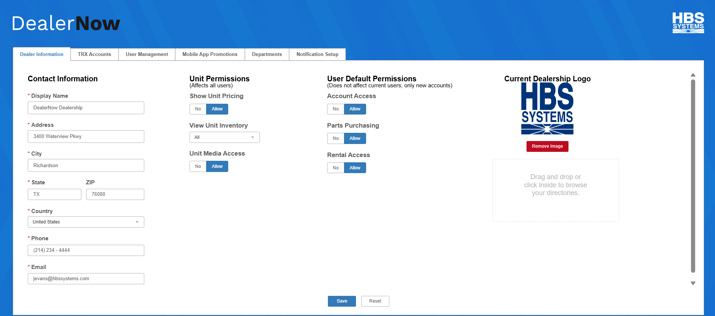

DealerNow Settings (DN) is the the primary settings program for the dealership’s use of the DealerNow app. Here, the dealership controls app settings for their customers, including user permissions and dealership contact information. If you are a multi-location dealership, you must maintain settings for each individual location, as DealerNow connects users to their dealerships via the specific location that they use.

To access this program, type DN in the Shortcuts Bar.

Dealer Information Tab: The first tab that appears when you open the program holds the dealer location’s basic data and general permissions for the app.

Contact Information: These fields hold the main information about the dealer location that will be presented to users in the app. NOTE: This information is intended to be the main contact inforamtion for the location. You will be able to enter contact information for specific departments in your dealer location in the Departments tab (see that section for more details).

Display Name: Set the name by which you want your dealer location displayed in the app for customers to find. If you are part of a multi-location dealership, we recommend choosing a name that will most easily identify your specific location to your customers.

Address/City/State/Zip/Country: Enter the physical address for your dealer location that you want displayed in the app.

Phone: Enter the main contact phone number you want your customers to see in the app.

Email: Enter the main contact email address you want your customers to see in the app.

Unit Permissions: These fields control global permissions for your app that impact every user that has access to your dealership.

Show Unit Pricing:

- If you want your customers to be able to view unit pricing in the DealerNow app, set this option to Allow.
- If you do not want your customers to view unit pricing in the app, set this option to No. This will cause the app to prompt your customers to directly contact you to learn pricing information.

View Unit Inventory: This setting controls how much of your unit inventory your customers can view on the app. Choose from the following options:

- All: Customers can view all units in your inventory on the app.
- New Only: Customers can only view units on the app that are marked as New in your system.
- Pre-Owned Only: Customers can only view units on the app that are marked as pre-owned or Used in your system.
- None: Customers cannot view any units in your app, and thus are blocked from accessing any of the related functions on the app.

Unit Media Access:

- If you want your customers to be able to view any media files included with a unit on the app, set this option to Allow.
- If you do not want your customers to view unit media in the app, set this option to No.

User Default Permissions: As stated on the program screen, these settings do not impact current users, but control the default permission settings assigned to new accounts when they are created/added to your dealer location.

Account Access: This controls the default setting for the “Account Access” permission setting, which controls whether or not a user can access their account balance and make payments on their balance through the app.

- Setting this option as Allow will cause the permission setting to be automatically checked for each new user added.
- Setting this option as No will cause the permission setting to be automatically unchecked for each new user added.

Parts Purchasing: This controls the default setting for the “Parts Purchase” permission setting, which controls whether or not a user can buy parts through the app.

- Setting this option as Allow will cause the permission setting to be automatically checked for each new user added.
- Setting this option as No will cause the permission setting to be automatically unchecked for each new user added.

Rental Access: This controls the default setting for the “Rental Access” permission setting, which controls whether or not a user can use the app’s Rental feature. NOTE: The dealership will only have Rental features available on their version of the app in the first place if they have the NetView Rental software package.

- Setting this option as Allow will cause the permission setting to be automatically checked for each new user added.
- Setting this option as No will cause the permission setting to be automatically unchecked for each new user added.

Current Dealership Logo: Use this feature to add an image file of your dealership’s logo to the program. The program will then upload it to your location’s platform on the app for branding. You can remove the image used at any time using the Remove Image button and replace it with something else.

Save: Click this button to save your settings in this tab.

Reset: Click this button to reset any unsaved changes made in the tab to the previously-saved options.

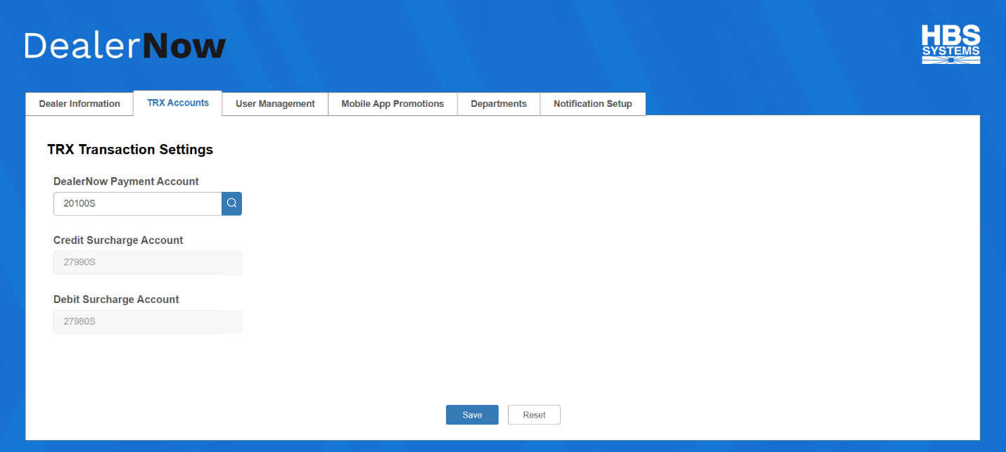

TRX Transaction Settings: This tab holds the General Ledger accounts that NetView will use to handle payment and surcharge amounts that come into the accounting system from credit card transactions on the DealerNow app.

DealerNow Payment Account: This is the primary account number where any payments made on the app will go. Enter the account number in the field or use the Search feature to look one up.

Credit Surcharge Account: This account number will handle any credit surcharges that come from credit card transactions in the app. The number will auto-fill with the corresponding account chosen to handle credit surcharges for the dealer location’s Smart Iron processor in Credit Card Dealer Information (CCDI).

Debit Surcharge Account: This account number will handle any debit surcharges that come from credit card transactions in the app. The number will auto-fill with the corresponding account chosen to handle debit surcharges for the dealer location’s Smart Iron processor in Credit Card Dealer Information (CCDI).

Save: Click this button to save your settings in this tab.

Reset: Click this button to reset any unsaved changes made in the tab to the previously-saved options.

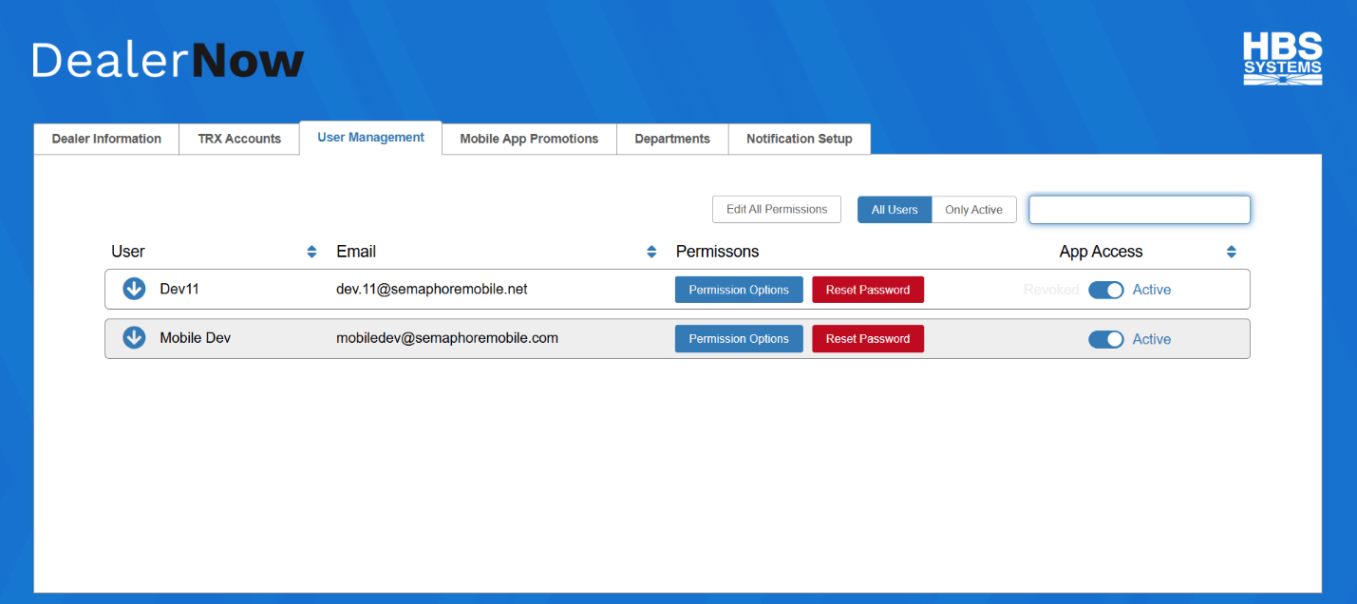

User Management Tab: This tab is where you determine how much access your customers have to your dealer location through the DealerNow app. NOTE: In order for one of your customers to be listed on this screen, they must have both a DealerNow account and a Customer Master record in your system, and you must have run DealerNow Customer Extract (DNCE) in this location to link their account to this program. The customer can create their DealerNow account with the unique email that you identified them with after you’ve already extracted them, but both actions must be done before they will appear in this screen.

Edit All Permissions: Click this button opens a screen which allows you to automatically set global permissions for all users at once. NOTE: You can still go into individual users’ permissions and modify them as well, but any modifications done in this screen will automatically impact every user.

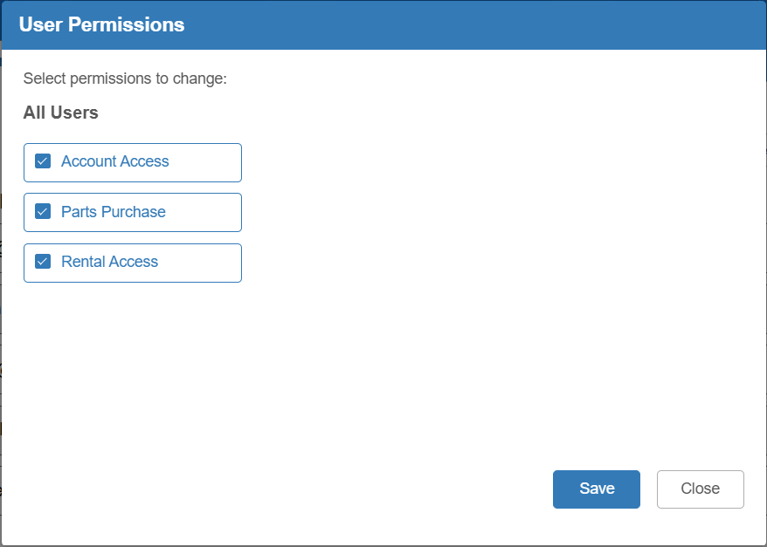

Account Access: Check this box to allow all users to view their account balances and make payments on their accounts via the app. Uncheck it to prevent any users from accessing their accounts on the app.

Parts Purchase: Check this box to allow all users to make parts purchases from your dealer location through the app. Uncheck it to prevent any users from accessing your dealer location’s Parts features on the app.

Rental Access: If you have the NetView Rental software package, check this box to allow all users to access your location’s Rental features on the app. Uncheck it to prevent any users from accessing the Rental features. NOTE: If you do not have the Rental package, your users will not have access to any Rental features for your location on the app to begin with.

Save: Click this button to save the global permission changes.

Close: Click this button to close the window without saving any changes.

All Users/Only Active: Use this option to control which users are displayed in the grid below.

- All Users: Shows all potential app users regardless of their current access to the app.
- Only Active: Shows only the app users who you have currently granted access to the app.

Filter: Use this field to find a particular user on your list by entering the user’s name or email address and hitting the “Enter” key. Note that the filter will only be able to find a user’s entry if that user is present in the selected view, i.e. if the view is set to “Only Active” and the user is not currently active, the filter will not find them. It also will not find subusers, only the main user entry.

User Management Grid: This grid lists the location’s app users and lets the dealer manage their account’s level of access to both their specific store location AND DealerNow in general. The grid can be reordered by using the arrows next to the User, Email, and App Access column headings.

User: This column shows the user’s name. If they have any subuser accounts registered to their main user account, you can click the arrow icon next to their name to view and modify the subusers’ information and permission:

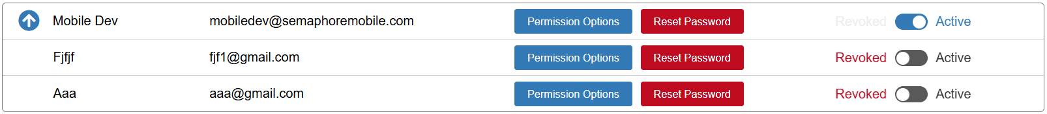

Email: Shows the user or subuser’s unique email address that they use for the DealerNow app.

Permission Options: Click this button to view and manage the permissions for that specific user or subuser. The following screen will appear:

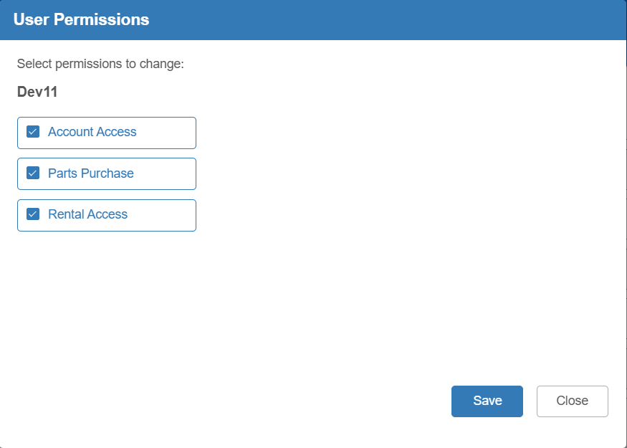

- Account Access: Check this box to allow the user to view their account balances and make payments on their account via the app. Uncheck it to prevent the user from accessing their account on the app.
- Parts Purchase: Check this box to allow the user to make parts purchases from your dealer location through the app. Uncheck it to prevent the user from accessing your dealer location’s Parts features on the app.
- Rental Access: If you have the NetView Rental software package, check this box to allow the user to access your location’s Rental features on the app. Uncheck it to prevent the user from accessing the Rental features. NOTE: If you do not have the Rental package, your users will not have access to any Rental features for your location on the app to begin with.
- Save: Click this button to save the user’s permissions
- Close: Click this button to close the window without saving any changes.

Reset Password: Click this button to reset the user or subuser’s DealerNow password. Note that this applies to their password for the entire app, not just for your specific store. The following window will appear:

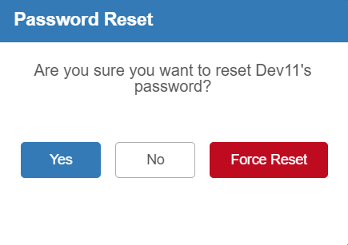

- Click Yes to have the system email the customer a link to reset their password to a new password of their choosing.
- Click No to close the window without resetting the password.
- Click Force Reset to forcibly reset the user’s password and have the system email them a randomly auto-generated password.

App Access: This setting controls whether the user or subuser can access your store on the app at all. Set them to Active in order to grant them access, or to Revoked to block them from accessing your store.

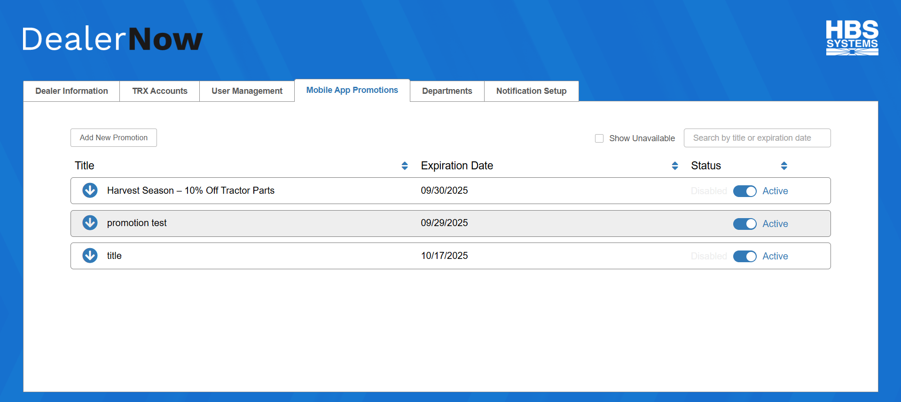

Mobile App Promotions Tab: This tab allows you to create and manage promotions for your store location on the DealerNow app.

Add New Promotion: Click this button to create a new promotion for your store in the app. The following screen will appear:

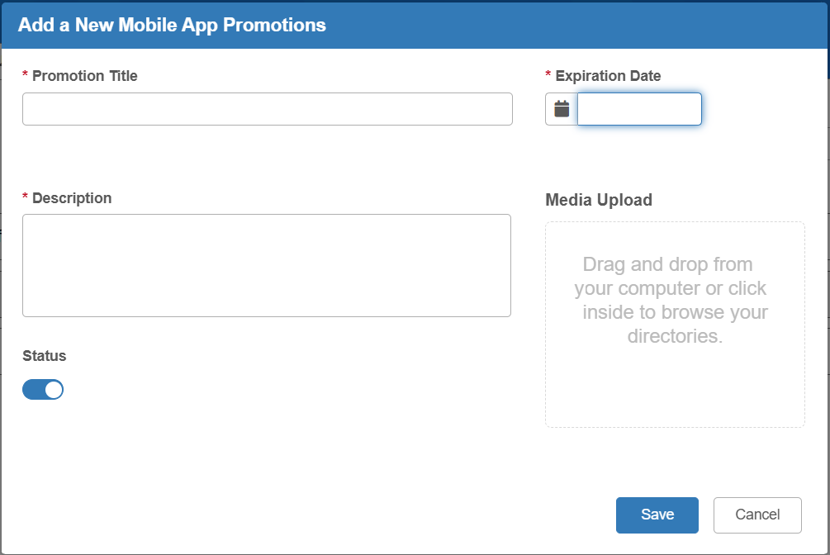

Promotion Title: Enter the title of the promotion here.

Expiration Date: Enter the promotion’s expiration date or select it from the calendar.

Description: Enter a description for the promotion.

Media Upload: Use this feature to add any media files you would like to display with the promotion in the app.

Status: Use this option to set whether the promotion is active or inactive. If the option is blue, then the promotion will be marked Active once created.

Save: Click this button to save the promotion. It will then appear in the list of promotions on the main screen if it has been marked Active.

Cancel: Click this button to close the screen without creating the promotion.

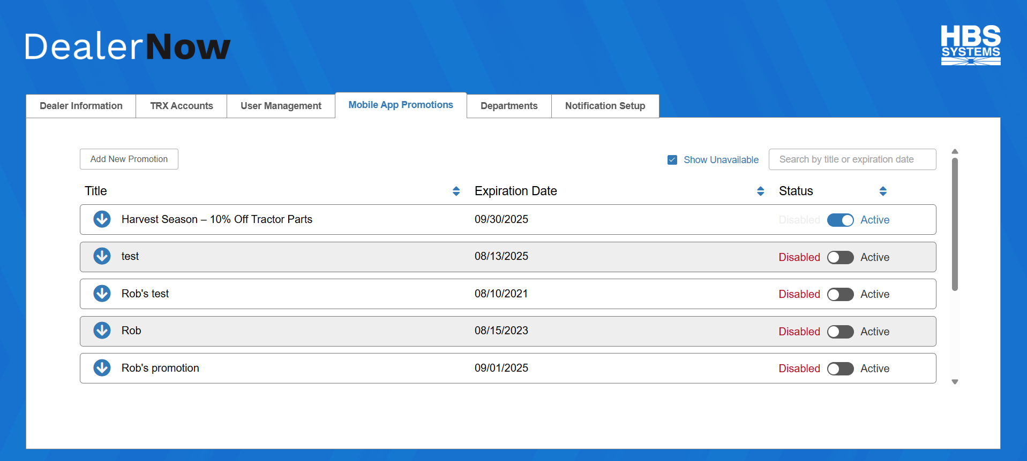

Show Unavailable: Check this box to show all unavailable promotions in the list, which will cause all Disabled promotions to appear alongside the Active promotions.

Filter: Use this field to find a particular promotion on your list by entering the promotion’s title or expiration date and hitting the “Enter” key. Note that the filter will only be able to find a promotion if it is currently visible, i.e. shown in the grid. For example, if the Show Unavailable box is unchecked, then the filter will only look at the Active promotions displayed and will not show any Disabled promotions.

Promotion Management Grid: This grid lists the promotions and lets the dealer modify them as desired. The grid can be reordered by using the arrows next to the column headings.

Grid Columns: The grid contains the following columns:

- Title: shows the promotion title and contains the Promotion Details arrow icon (see below for more information).
- Expiration Date: shows the promotion’s expiration date.
- Status: shows if the promotion is Active or Disabled. This option can be changed on the program’s main grid entry at any time.
- Media Indicator: If a promotion has media files attached, the promotion’s grid entry will indicate this by showing an icon of a paperclip. You can then expand the entry’s promotion details to actually look at what you have attached.

View/Edit Promotion Details: Click the Promotion Details arrow icon to view and modify the details for a promotion:

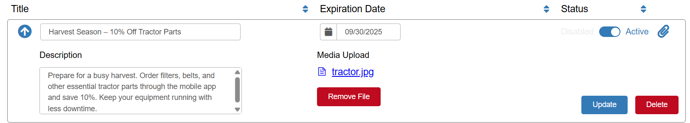

You can now view and change all aspects of the promotion, including the attached media files. Be sure to click the Update button to save any changes you make.

You can also, if desired, delete the promotion by clicking on the Delete button. The following window will appear:

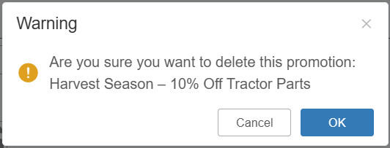

Click OK to delete the promotion. Its entry will be removed from the grid and it will no longer be available in the app if it was previously visible.

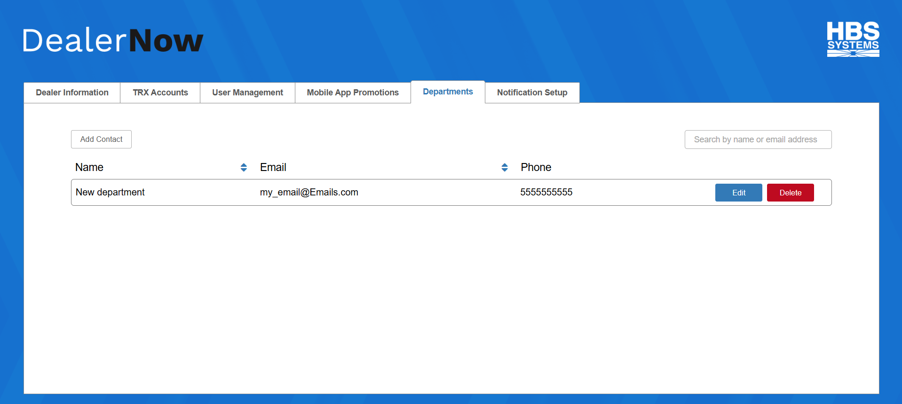

Departments Tab: This tab lets you create contacts for specific departments at your dealer location that you can make available to your customers in the app, alongside your main location contact details.

Add Contact: Click this button to create a new department contact. The following window will open:

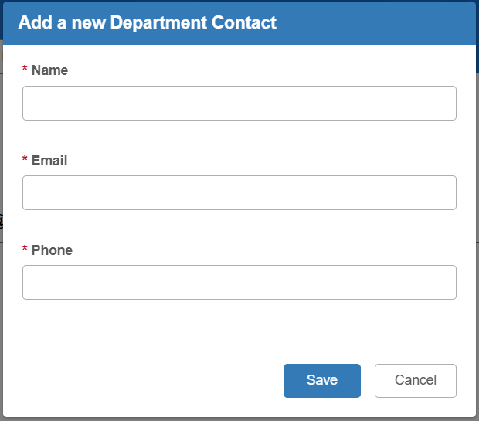

Enter the department name, the department’s contact email address, and the department’s contact phone number. Click Save to add the department to the app. It will show up in the list of available contacts in the main tab.

Filter: Use this field to find a particular department contact on your list by entering the department’s name, contact email address, or contact phone number, then hitting the “Enter” key.

Department Management Grid: This grid lists all current department contacts for your dealer location on the app and allows you to modify them as needed. You can reorder the list using the arrows next to the column headers.

Name: Shows the department name.

Email: Shows the department’s contact email address.

Phone: Shows the department’s contact phone number.

Edit: When clicked, opens the department’s contact details in a new window where you can modify them as desired.

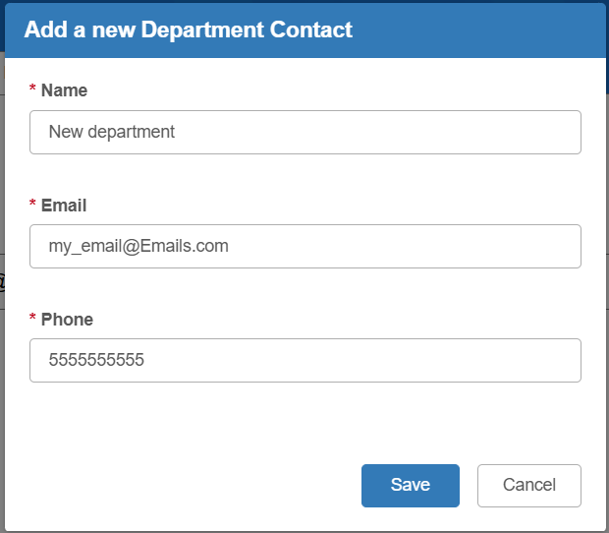

Delete: Click this button if you want to delete the department contact and remove it from the app.

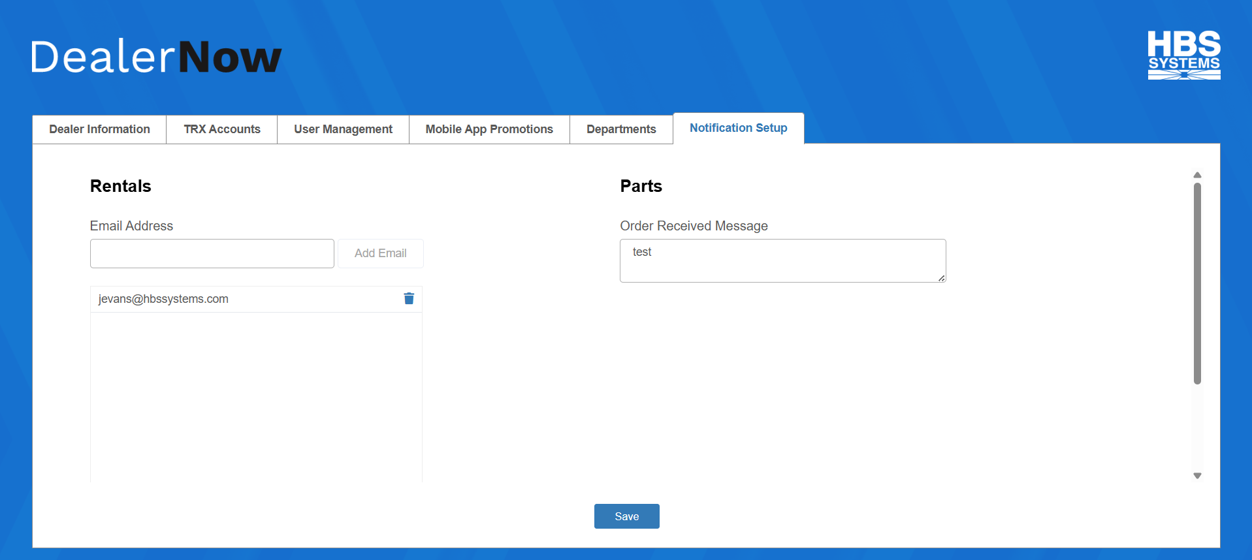

Notification Setup Tab: This tab allows you to set up notifications related to activity in the app, either to be sent to the customer or to one of your employees.

Rentals: This section creates a list of employee email addresses that you want to receive Rental request notification emails triggered from the app.

- To add an address to the list, enter it in the Email Address field and click Add Email.
- To remove an address from the list, click the trash can icon next to it.

Parts: This section contains the message that will be sent to app users when the dealer location successfully receives a Parts order they made on the app. Enter your desired message in the field here.

Save: Click this button to save your notification settings.

