DealerNow Customer Extraction (DNCE)

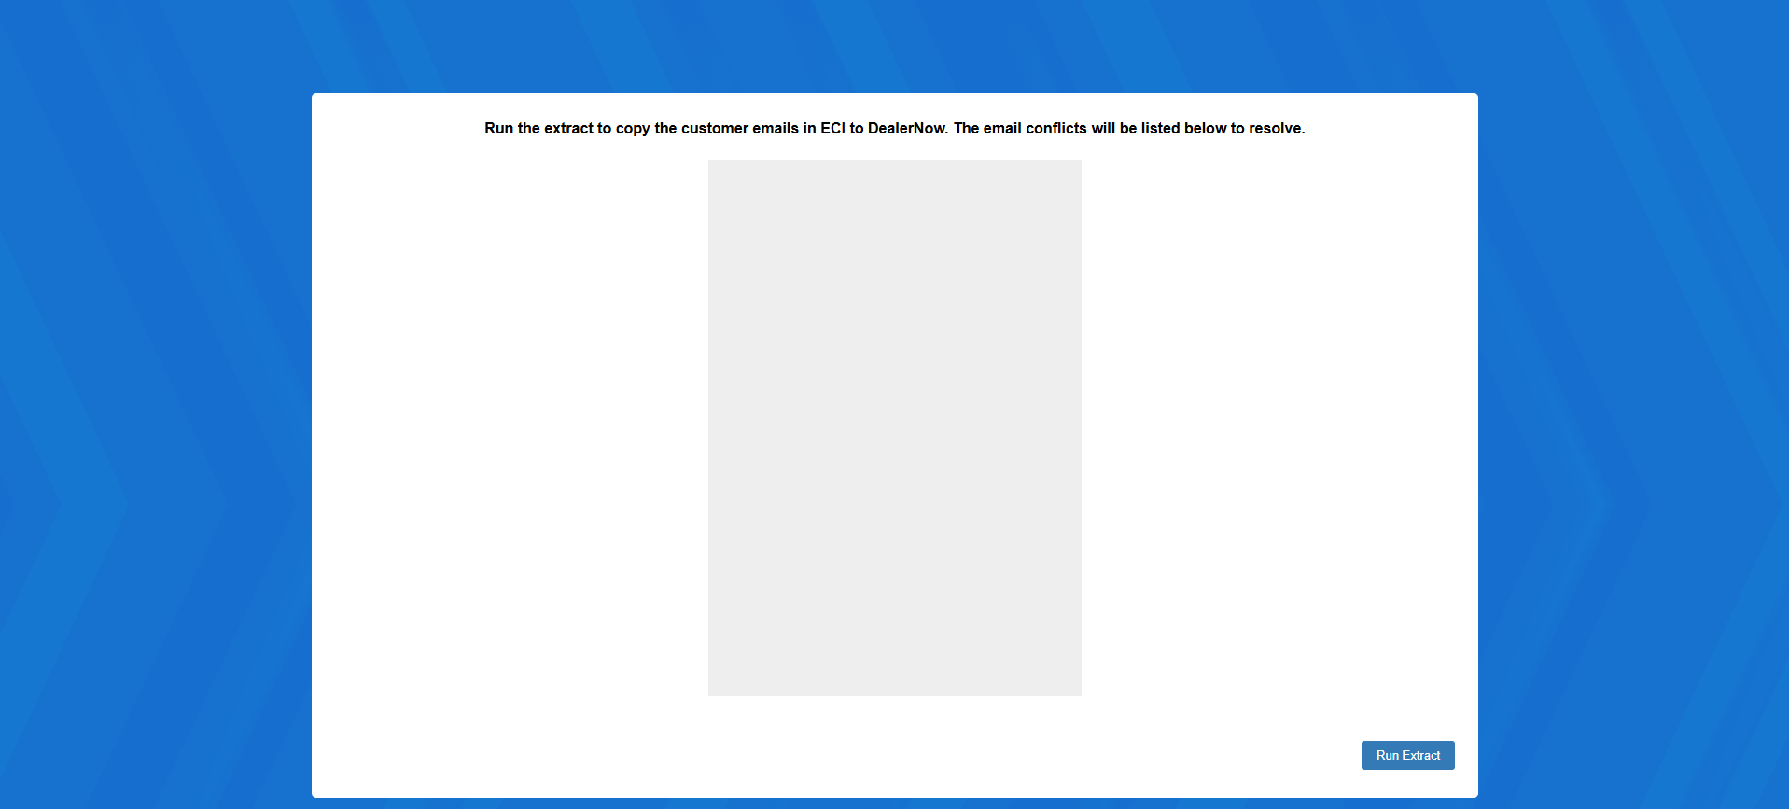

DealerNow Customer Extraction (DNCE) is the first step dealerships need to take in order to grant their customers access to their data on the DealerNow app. The program extracts all customer emails from Enter Customer Information (ECI) so they can be used to link the customer’s account on the app itself to the dealership. NOTE: This program needs to be run both when you first set up your dealership to work with the app and every time a new customer is added to your dealership’s system (if you want the new customer(s) to also have access to the app).

To access this function, type “DNCE” in the Shortcuts Bar.

Run Extract: Click this button to extract the customer emails. For most customers, this will be the only action you need to take in order to have the customer’s account appear in DealerNow Settings (DN) so you can properly set up their access to your dealership on the app. However, if the extraction process finds that any of your customers have identical email addresses, they will show up on the screen after you run the extract:

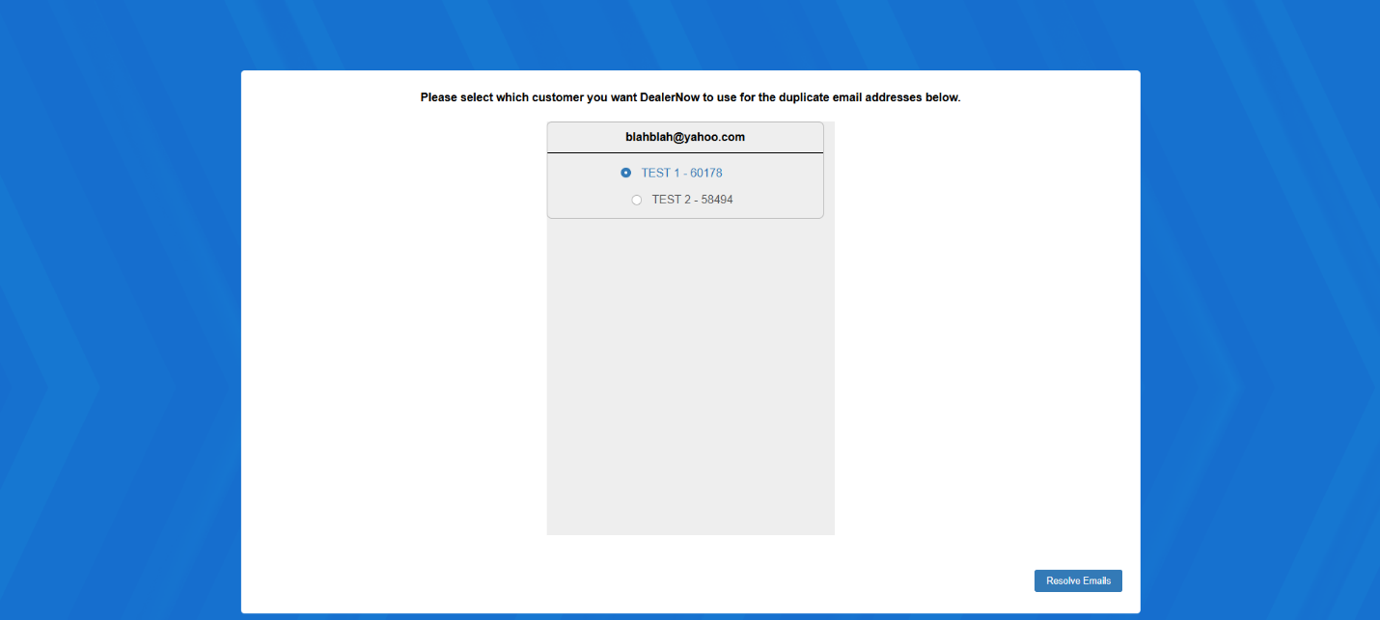

Resolve Emails: Select which customer you want each duplicated email address to be associated with for DealerNow purposes, then click “Resolve Emails.” This will automatically assign the email to that particular customer as their DealerNow email, while excluding the other customer. The other customer will then need to provide you with a unique additional email address that they intend to use as their DealerNow login for your specific dealership. You can then add the address to their record in ECI and run DNCE again to get them set up.

