E-Commerce Portal (ECOM)

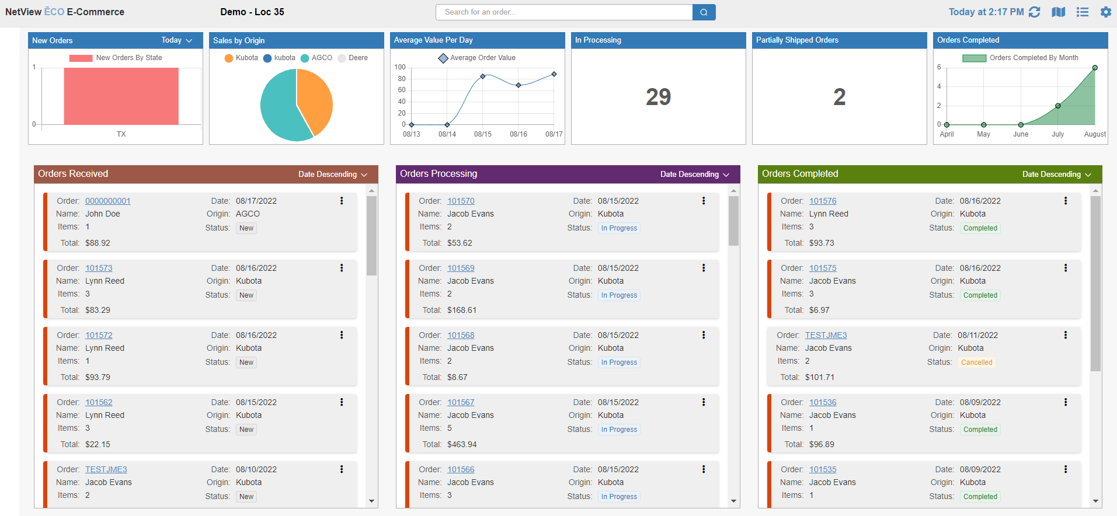

The NetView ECO E-Commerce Fulfillment Portal (ECOM) allows you to receive orders made by your clients through an OEM’s online purchasing system and manage them inside NetView, including converting them directly into Parts Point-of-Sale tickets.

To access this program, type “ECOM” in the Shortcuts Bar.

Main ECOM Management Screen: The program’s main management screen provides a central desktop-style view to help you manage your orders and see related statistics, as well as being able to manage your settings. You have two primary view options for the screen: Column View, as shown above, or Table View, as shown below.

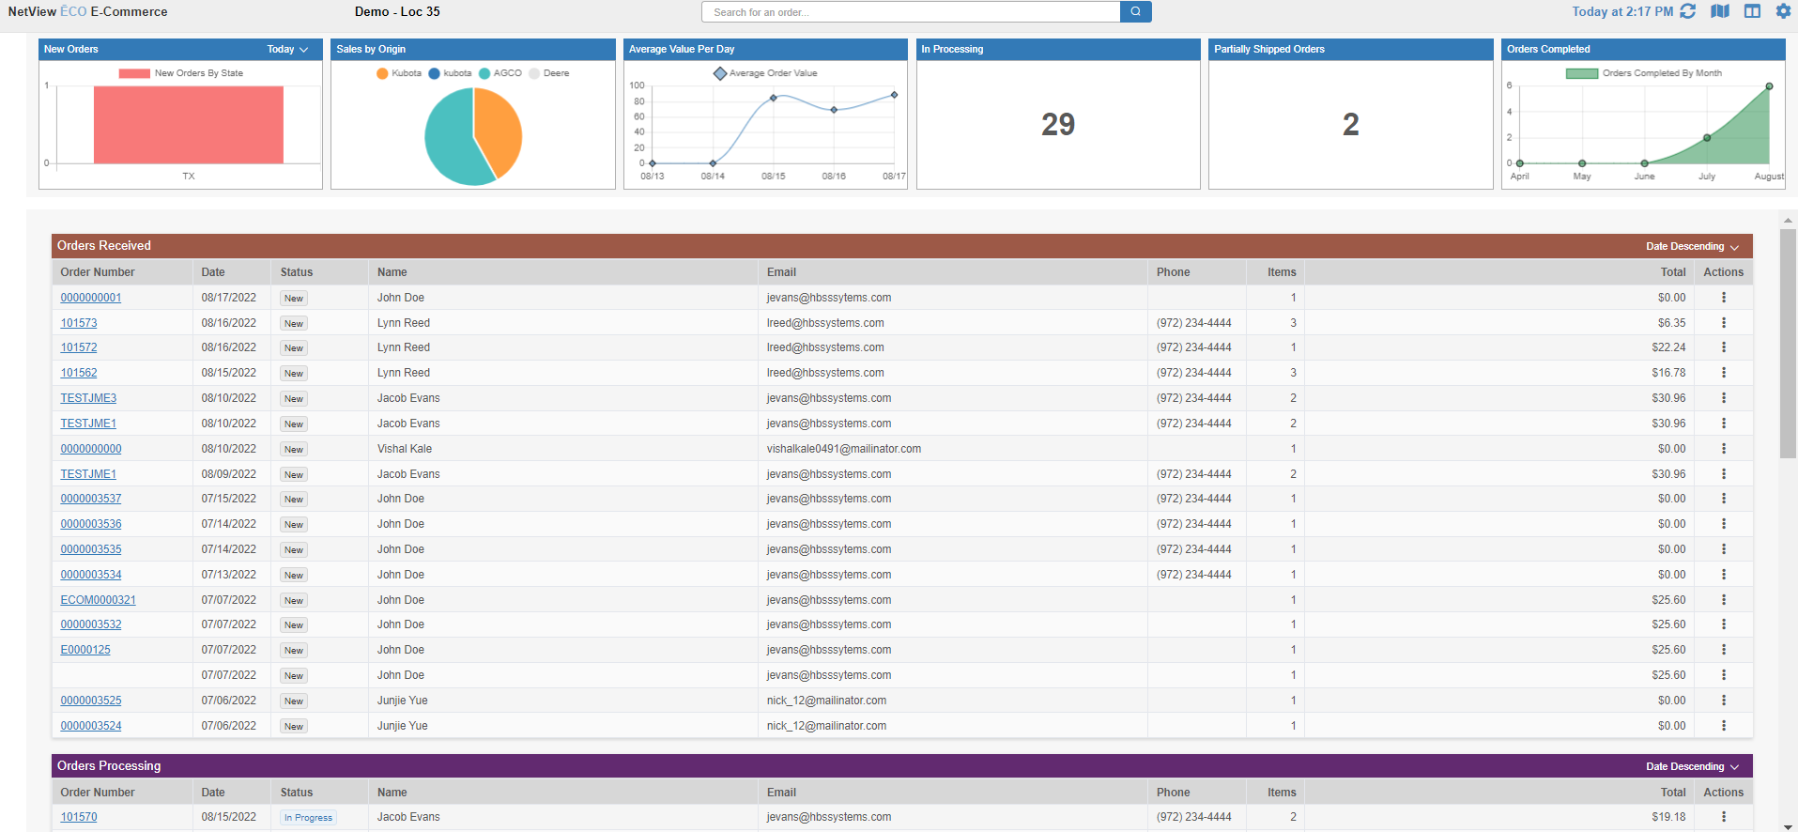

Switching Views: You can switch between the two views using the icons in the upper right-hand corner of the screen. The Table View icon is  and will appear when you are in Column View. It will switch to the Column View icon, 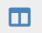, which when clicked will return you to the Column View.

Refresh Screen: The upper right-hand corner of the screen also shows the “Refresh Screen” icon and display:



The displayed time stamp shows you when the screen was last updated. Clicking on the icon will refresh the screen and update the time stamp.

NetView Vision: This icon  is reserved for future use and will not do anything if clicked.

ECOM Program Settings: This final icon , when clicked, opens the ECOM Settings screen:

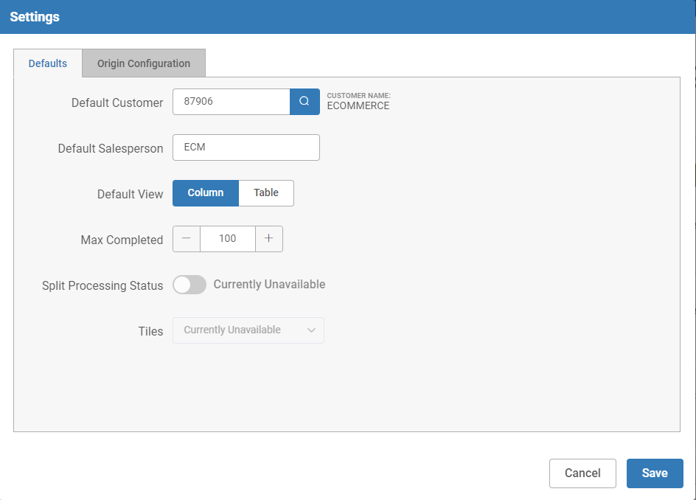

Here, you manage the defaults that control both aspects of the main screen display and how orders from the OEM websites get imported into Parts Point-of-Sale (POS) as picking tickets. These settings will be specific to the location and must be set at each location your dealership operates. You must enter your settings in this screen in order for ECOM to properly work with both the OEM websites and the rest of NetView on this dealer location.

Defaults Tab: This tab controls general ECOM settings that are not specific to any one OEM connection.

- Default Customer: This field sets the default customer that will always be listed on any POS tickets created by accepting a part order purchased via an OEM website. We recommend you create a specific ECOM customer to make keeping track of the tickets and their associated accounting easier.
- Default Salesperson: This field sets the default salesperson that will always be listed on any POS tickets created by accepting a part order purchased via an OEM website. We recommend you create a specific ECOM salesperson to make keeping track of tickets easier.
- Default View: Choose which view you want the main ECOM management screen to open in by default: Column or Table.
- Max Completed: Set the maximum number of recently completed (or cancelled) orders you want visible in the “Completed” column on the main management screen.
- Split Processing Status: This option is currently unavailable.
- Tiles: This option is currently unavailable.

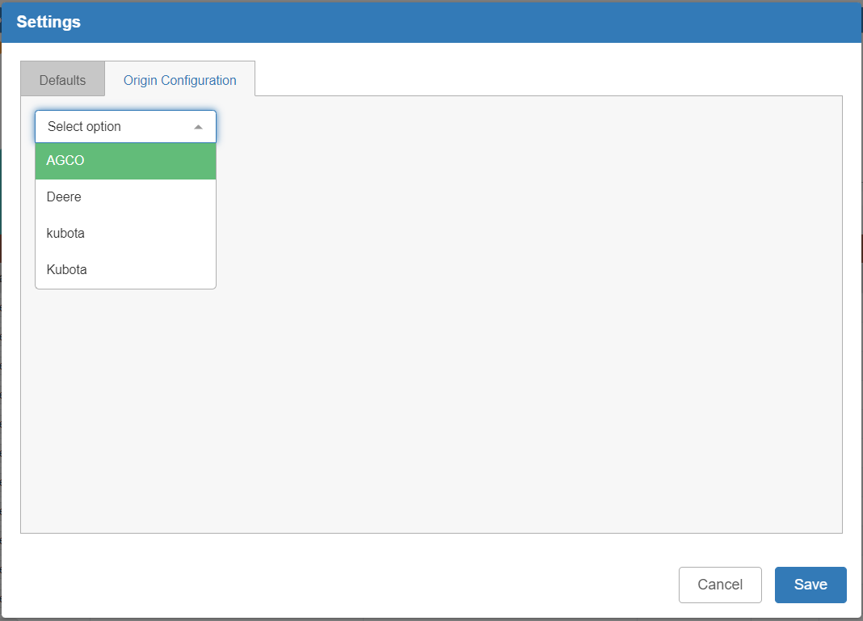

Origin Configuration Tab: This tab manages the required configuration settings to have ECOM work with OEM websites and properly import the orders into POS. Begin by selecting which OEM you wish to work with in order to access the input fields. NOTE: Currently ECOM only supports AGCO and Kubota.

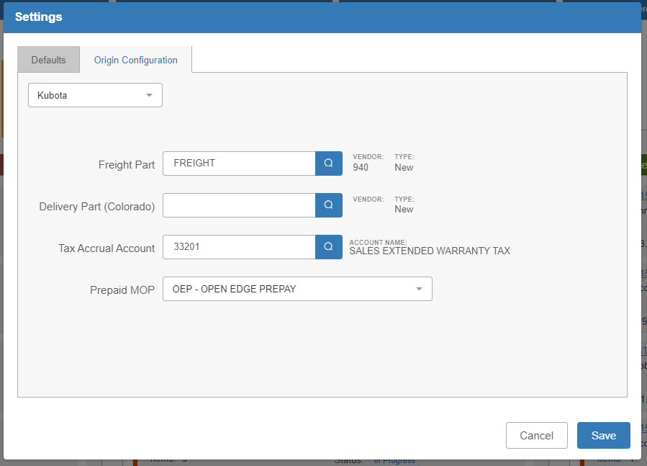

- Freight Part: Enter the specific Freight part number in your system that will be added to POS tickets any time you accept an order with a freight value on it as a way to add the freight charge to the ticket. We recommend creating a specific part record for each OEM you work with, especially if you intend to charge different freight values.
- Delivery Part (Colorado): This field is not in use yet.
- Tax Accrual Account: Enter the tax accrual account you wish POS to send the tax amounts from this specific OEM’s orders to when you invoice the orders’ picking tickets.
- Prepaid MOP: Choose the method of payment that POS will automatically select when you accept a prepaid order through ECOM for this specific OEM. We recommend you create a specific MOP to handle prepaid ECOM purchases (or more than one if you wish to use separate MOPs for different OEMs).

Click Save to save your settings in both tabs and return to the main screen.



ECOM Tiles: The main ECOM management screen includes 5 tiles that show statistics related to your ECOM orders.

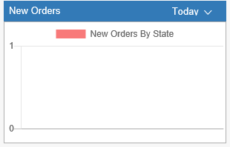

New Orders: This tile shows you new orders made, displayed by the state where they came from. You can view 3 different time periods in the tile: Today (default), Yesterday, and Month-to-Date (MTD).

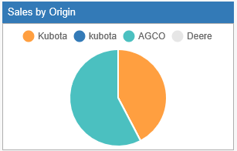

Sales by Origin: This tile shows the division of ECOM-related sales by OEM of origin.

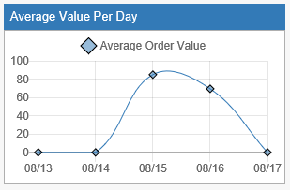

Average Value Per Day: This tile shows the average order value per day for the last 5 days, including the current date.

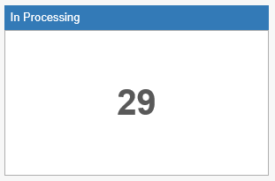

In Processing: This tile shows the total number of orders in ECOM that you have marked as in process.

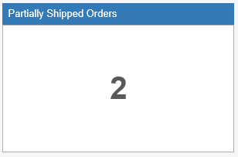

Partially Shipped Orders: This tile shows the total number of ECOM orders you have partially shipped to the customer.

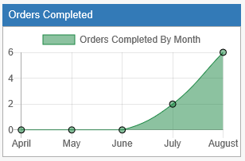

Orders Completed: This tile shows the number of orders completed per month for the last 5 months, including the current month.



Order Columns & Tables: Below the tiles are the Orders columns/tables, which change form depending on whether you are in Column View or Table View.

Orders Received: The Orders Received section holds all orders received from OEM sites, but not yet accepted or rejected by the dealership. In Column View, it looks like this:

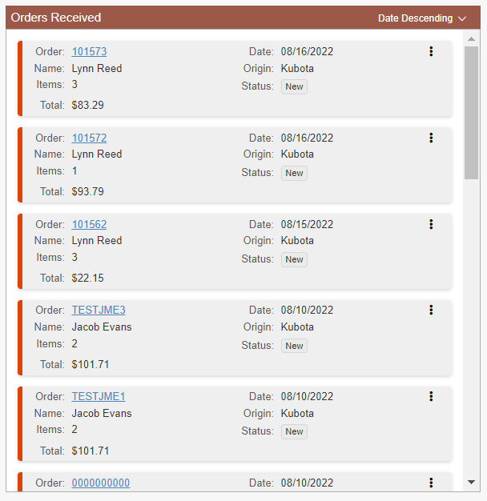

- Order: Shows the order number, which if clicked will open the Order Details (see the “Order Details” section for more information).
- Date: Shows the order date.
- Name: Shows the name of the ordering customer.
- Origin: Shows the OEM that the order came from. Currently, ECOM only supports AGCO and Kubota.
- Items: Shows the number of items on the order.
- Status: Shows the order’s status, which in this section will generally be “New.”
- Total: Shows the total dollar amount of the order.
- Actions: The icon of 3 vertical dots in the upper-right corner of the order display can be clicked on to show a menu of quick action items:
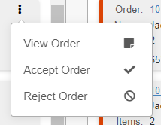

- View Order: Will open the Order Details to view, same as clicking on the order number.
- Accept Order: Will start the order acceptance process (see the “Accepting an Order” section for more information).
- Reject Order: Will start the order rejection process (see the “Rejecting an Order” section for more information).

In Table View, the Orders Received table looks like this:

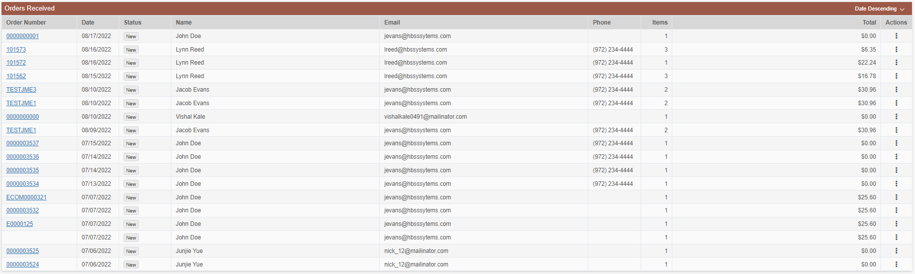

- Order Number: Shows the order number, which if clicked will open the Order Details (see the “Order Details” section for more information).
- Date: Shows the order date.
- Status: Shows the order’s status, which in this section will generally be “New.”
- Name: Shows the name of the ordering customer.
- Email: Shows the customer’s contact email.
- Phone: Shows the customer’s contact phone number, if provided.
- Items: Shows the number of items on the order.
- Total: Shows the total dollar amount of the order.
- Actions: Clicking the icon in this column shows a menu of quick action items:

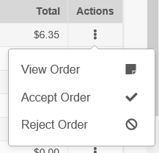

- View Order: Will open the Order Details to view, same as clicking on the order number.
- Accept Order: Will start the order acceptance process (see the “Accepting an Order” section for more information).
- Reject Order: Will start the order rejection

Orders Processing: The Orders Processing section holds all orders from OEM sites that have been accepted by the dealership, but not yet completed. In Column View, it looks like this:

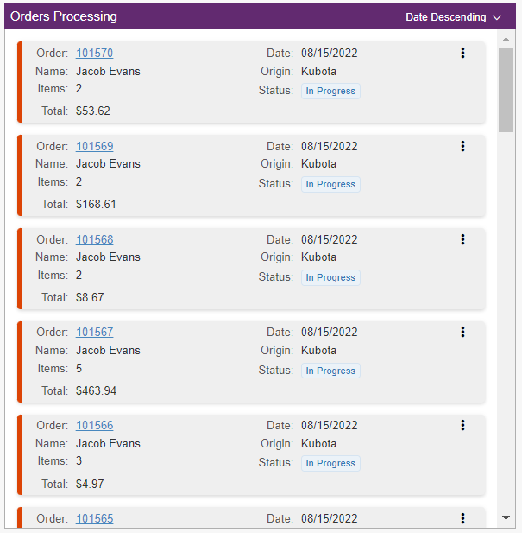

- Order: Shows the order number, which if clicked will open the Order Details (see the “Order Details” section for more information).
- Date: Shows the order date.
- Name: Shows the name of the ordering customer.
- Origin: Shows the OEM that the order came from. Currently, ECOM only supports AGCO and Kubota.
- Items: Shows the number of items on the order.
- Status: Shows the order’s status, which in this section will generally be “In Progress” or “Partially Shipped.”
- Total: Shows the total dollar amount of the order.
- Actions: The icon of 3 vertical dots in the upper-right corner of the order display can be clicked on to show a menu of quick action items:
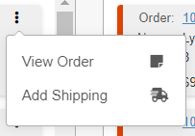

- View Order: Will open the Order Details to view, same as clicking on the order number.
- Add Shipping: Wil open the Create Shipment screen to add shipping details to the order (see the “Add Shipping” section for more information).

In Table View, the Orders Processing table looks like this:

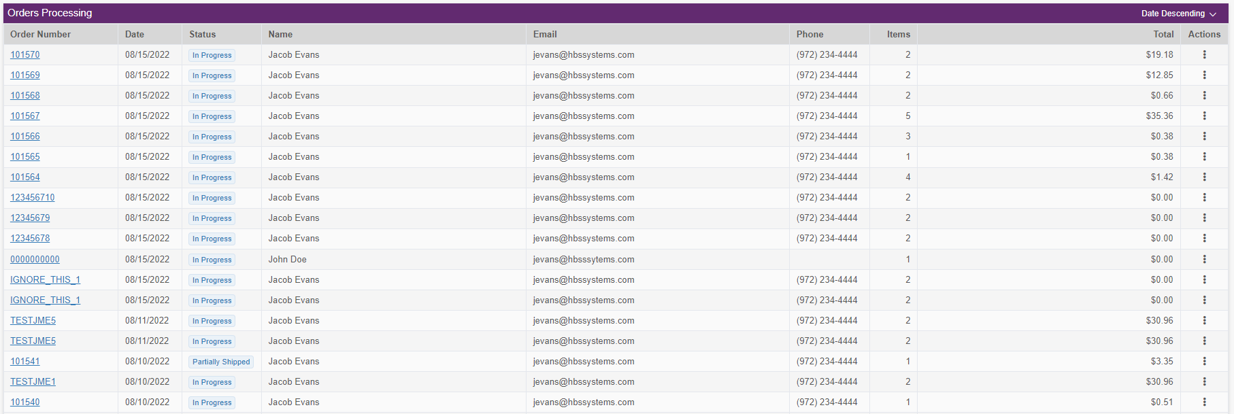

- Order Number: Shows the order number, which if clicked will open the Order Details (see the “Order Details” section for more information).
- Date: Shows the order date.
- Status: Shows the order’s status, which in this section will generally be “In Progress” or “Partially Shipped.”
- Name: Shows the name of the ordering customer.
- Email: Shows the customer’s contact email.
- Phone: Shows the customer’s contact phone number, if provided.
- Items: Shows the number of items on the order.
- Total: Shows the total dollar amount of the order.
- Actions: Clicking the icon in this column shows a menu of quick action items:

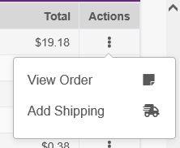

- View Order: Will open the Order Details to view, same as clicking on the order number.
- Add Shipping: Wil open the Create Shipment screen to add shipping details to the order (see the “Add Shipping” section for more information).

Orders Completed: The Orders Completed section holds the most recently completed or cancelled orders, with the number of orders visible determined by the “Max Completed” option in the Settings screen. In Column View, it looks like this:

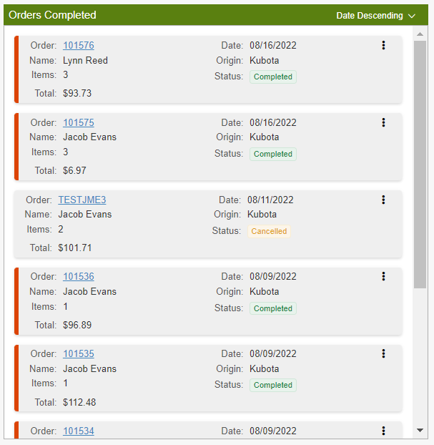

- Order: Shows the order number, which if clicked will open the Order Details (see the “Order Details” section for more information).
- Date: Shows the order date.
- Name: Shows the name of the ordering customer.
- Origin: Shows the OEM that the order came from. Currently, ECOM only supports AGCO and Kubota.
- Items: Shows the number of items on the order.
- Status: Shows the order’s status, which in this section will be “Completed” or “Cancelled.”
- Total: Shows the total dollar amount of the order.
- Actions: The icon of 3 vertical dots in the upper-right corner of the order display can be clicked on to show a menu of quick action items:

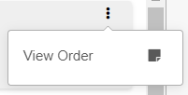

- View Order: Will open the Order Details to view, same as clicking on the order number. This is the only action available for completed or cancelled orders.

In Table View, the Orders Completed table looks like this:

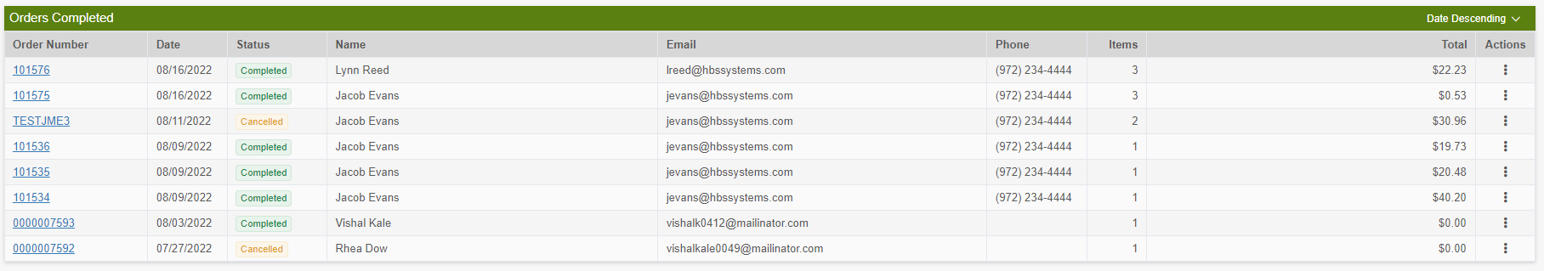

- Order Number: Shows the order number, which if clicked will open the Order Details (see the “Order Details” section for more information).
- Date: Shows the order date.
- Status: Shows the order’s status, which in this section will be “Completed” or “Cancelled.”
- Name: Shows the name of the ordering customer.
- Email: Shows the customer’s contact email.
- Phone: Shows the customer’s contact phone number, if provided.
- Items: Shows the number of items on the order.
- Total: Shows the total dollar amount of the order.
- Actions: Clicking the icon in this column shows a menu of quick action items:

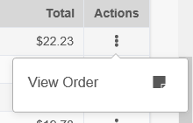

- View Order: Will open the Order Details to view, same as clicking on the order number. This is the only action available for completed or cancelled orders.

Section Sorting: Each column/table will have sorting options available on the upper right-hand corner:

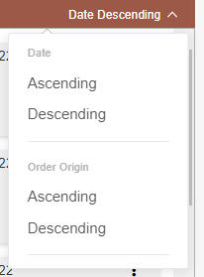

The same options are available for all three columns/tables.

- Date: You can sort the orders by date in either ascending or descending order. Date Descending is also the default sort for all the tables, showing the orders from newest to oldest.
- Order Origin: You can sort the orders by their OEM of origin in either ascending or descending order.
- Total Amount (not pictured): You can sort the orders by their total dollar amount in either ascending or descending order.



Search Orders: If you want to find an order and don’t want to spend time scrolling through the sections, you can use the Search field at the top of the main screen to look up a specific order. Type in all or part of the order number in the field and click the “Search” button to start your search.

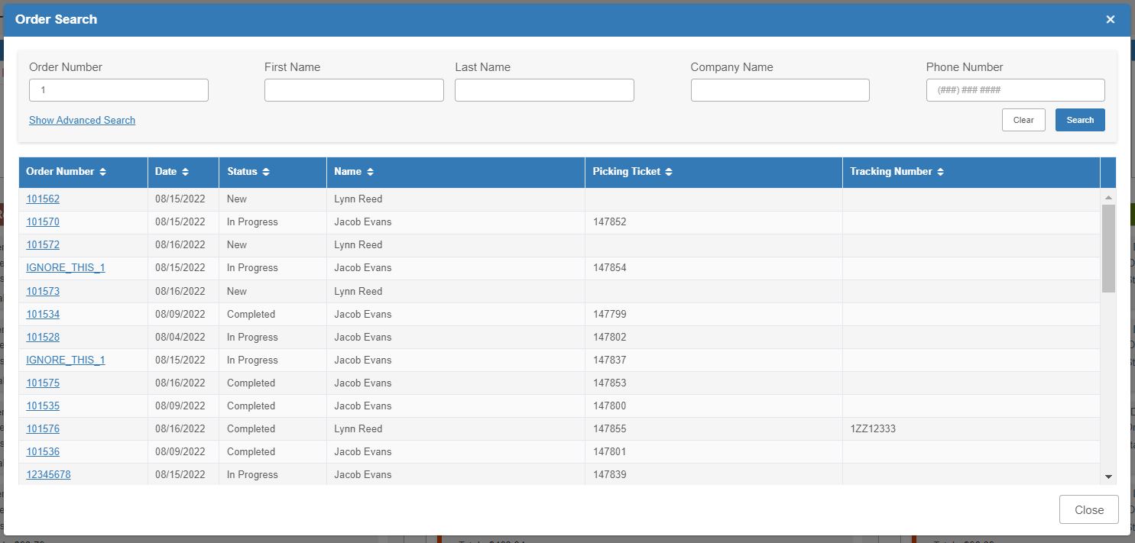

The list of matching results will show each order’s number, date, status, customer name, picking ticket number (if applicable), and tracking number (also if applicable). You can then either select your desired order from the list to open its details or, if you don’t see it right away, use the additional search options to narrow down the results.

Order Number: The original full or partial order number you entered to start the search will fill in this field. You can change it as desired to change your search results.

First Name: Use this field to look up orders by the customer’s first name.

Last Name: Use this field to look up orders by the customer’s last name.

Company Name: Use this field to look up orders by the name of the ordering company (which is different from the ordering customer).

Phone Number: Use this field to look up orders by the attached customer phone number. NOTE: Not every order has a contact phone number included.

You can access additional search options by clicking “Show Advanced Search”:

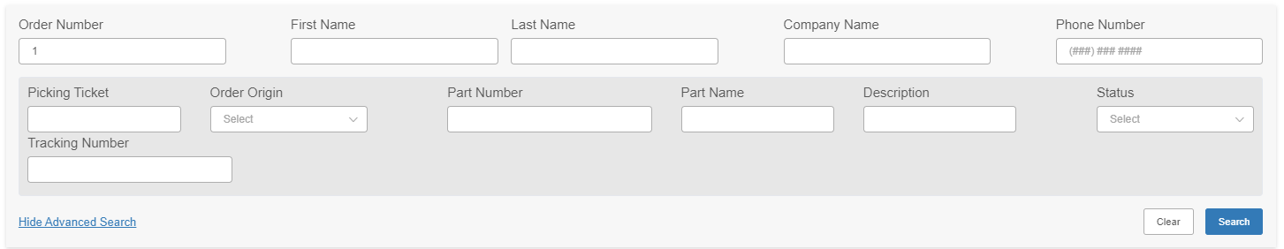

Picking Ticket: Use this field to search by the order’s picking ticket, provided it has been assigned one.

Order Origin: Use this field to search by the order’s OEM of origin. Currently ECOM only supports Kubota and AGCO.

Part Number: Use this field to search by a part number included on the order.

Part Name: Use this field to search by the name of a part on the order.

Description: Use this field to search by the description of a part on the order.

Status: Use this field to search by the order’s status.

Tracking Number: Use this field to search by the order’s tracking number, provided it has been assigned one.



Order Details: Clicking on an order’s number on the main screen or in the Search will open its Order Details screen. The “View” action available in each order’s Action menu will also open the Order Details screen.

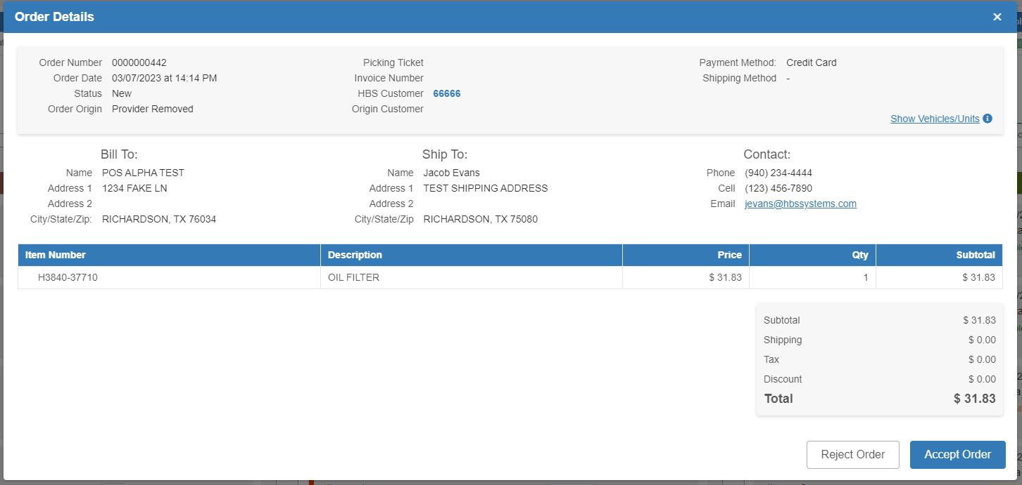

Header:

Order Number: The order number shows here.

Order Date: The date and time that the order was placed appears here.

Status: The order’s status appears here.

Order Origin: The order’s OEM of origin will appear here. Currently, ECOM only supports Kubota and AGCO.

Picking Ticket: If the order has been accepted and made into a POS ticket, the picking ticket number will appear here:

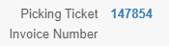

Clicking on the hyperlinked number will open the ticket in POS. It will still appear, but no longer be hyperlinked, once the ticket has been invoiced.

Invoice Number: After the order’s POS picking ticket has been invoiced, the invoice number will appear here:

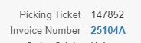

Clicking on the hyperlinked number will open a PDF of the invoice, which you can then download or print if desired.

HBS Customer: When you first open an order’s details after it is created, the system will check the customer information provided against your existing HBS Customers. It specifically compares the name on the order and, if unable to find a match, the customer’s provided email address. If it finds a direct match, it will link the HBS customer to the order and show the customer number in this field:

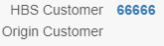

Clicking on the hyperlink will open Customer Balance Inquiry (CB) with the customer’s information pre-filled.

If the program finds more than one customer match when it first checks, the following will appear when you first open the order details:

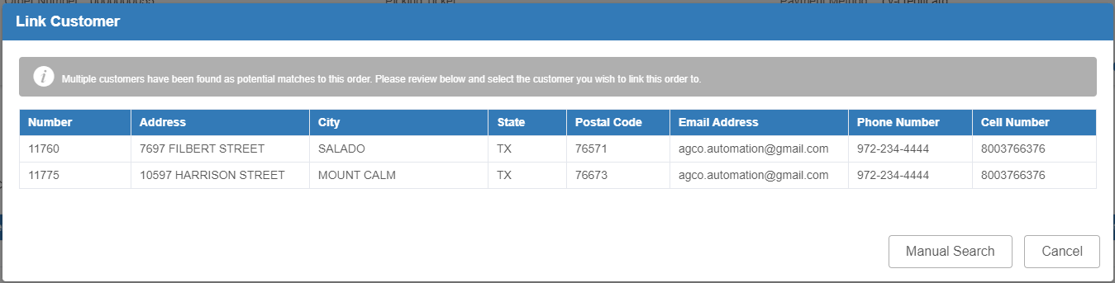

This occurs specifically in the case of duplicate email addresses. You can then pick which customer you want the system to automatically associate with not only the order, but the specific email address going forward. You can also use the “Manual Search” button to open a Customer Lookup screen and find a different customer to assign.

If the program cannot find a customer match, it will show “Link Customer” in the field:

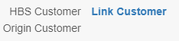

Clicking on the words will open the Customer Lookup, allowing you to select a customer to link the order too.

Origin Customer: This field will show the name or designation of the original customer as listed on the order from the manufacturer. This is the name that the system will initially check against to find a matching HBS customer. This field may be blank if no customer name or designation was used on the original order.

Payment Method: The payment method selected by the customer at the time of purchase will appear here. In the example above, the customer chose to wait and pay for the order when they came to the dealer to pick it up.

Shipping Method: The shipping method selected by the customer at the time of purchase will appear here.

Show Vehicles/Units: Clicking here shows unit information from the OEM of origin relating to any units the customer may have that the OEM has on record (it will be blank if the OEM does not provide any such records). It shows the unit’s make, model, and VIN:

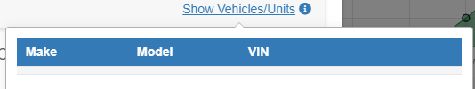

This can be used to point out if the customer may have accidentally ordered parts for the wrong kind of unit.

Bill To: This section shows the billing address the customer entered for the purchase.

Ship To: This section shows the shipping address the customer entered for the purchase.

Contact: This section shows the customer’s contact information, and can potentially hold their telephone number, cell number, and email address. Note that the information will only appear if the customer provided it, and not every customer provides all contact methods.

Item List Grid: The grid lists every part included on the order, its description, unit price, quantity, and extended price for the order (i.e. the unit price multiplied by the quantity on the order). You can also click on the part number in order to open the part’s entry in Parts Inquiry (PI) to view all its information.

Part Number Alerts: The grid will also show either a yellow () or red (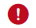) icon next to the part number if there is an issue with the part on the order.

- Insufficient Quantity Alert: If you see the yellow () icon next to a part on the order, this means that you currently have an insufficient on-hand quantity of that part to fulfill the order. If you accept the order while this indicator still shows, you will be forced by the program to create a backorder for the missing quantity.
- Part Not Found: If you see the red () icon next to a part on the order, this means that the part does not currently exist in your inventory. You will have to add it or import it from the price file before you can fulfill the order. If you accept the order while this indicator still shows, you will also be forced by the program to create a backorder as you currently have no quantity of the part on hand.

Totals Calculation: This section below the grid shows the breakdown used to calculate the total order amount.

Subtotal: This value is the total value of all parts on the order (the total of the “Subtotal” column in the grid).

Shipping: This value is the calculated shipping cost for the order.

Tax: This value is the tax calculated on the order.

Discount: This field is only used for AGCO orders, and represents a discount added to the order by AGCO, not by you the user or your dealership. This typically will be the result of AGCO having a promotion or something similar for one or more parts on the order.

Screen Action Buttons: The bottom right-hand corner of the screen will hold different action buttons depending on the current state of the order.

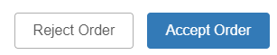

Reject & Accept Order: These buttons will only appear if the order has been received, but not yet approved or reject. They will appear on all orders with a New status that the dealership has not started processing. See sections below on accepting and rejecting orders for more information.

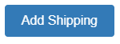

Add Shipping: This button will appear after the order has been accepted, but not completed. It will appear on all orders with an In Progress or Partially Shipped status. See section below on adding shipping for more information.

No Buttons: All orders that have been completed, cancelled, or refunded will not have any action buttons in their screens, just the order information like so:

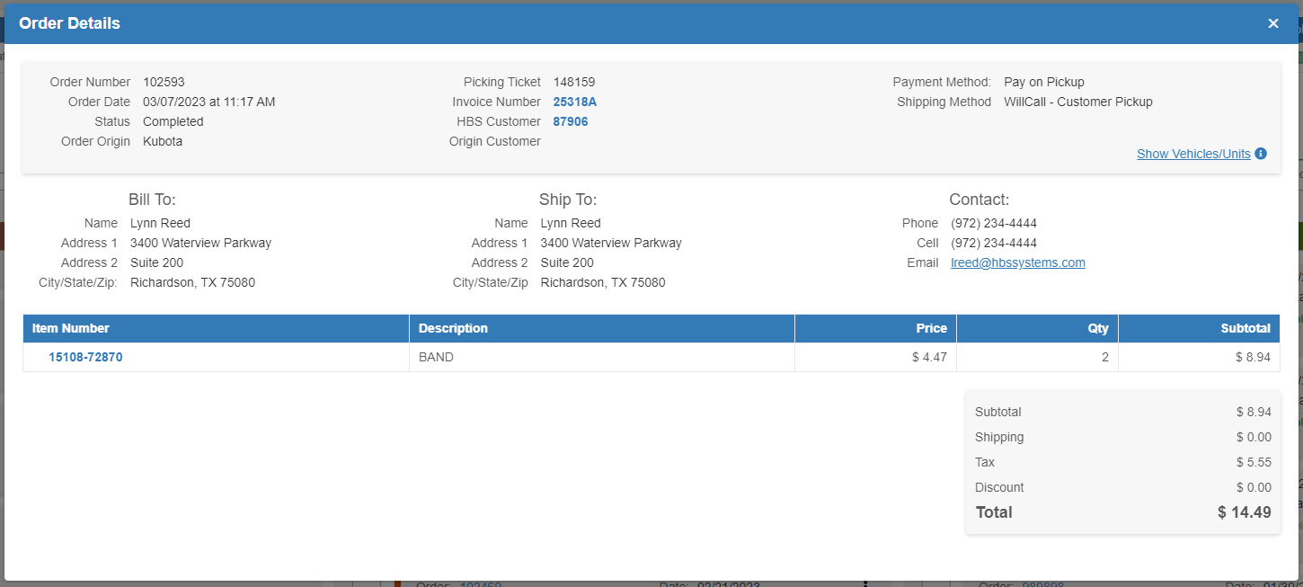



Processing ECOM Orders—General Overview:

Rejecting an Order: If for any reason your dealership needs to reject an order from an OEM, you can begin that process two ways. The first is opening the order’s Details screen and clicking the “Reject Order” button:



The second is by accessing the Actions menu on the order and clicking the “Reject Order” action:



Once you click either option, the following warning will appear:

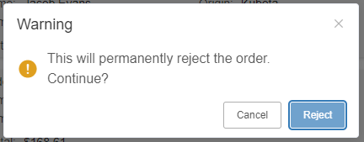

Click Reject to reject the order. The warning will go away and the order will no longer appear in the “Orders Received” section. It will now be in the “Orders Completed” section with a “Cancelled” status, though you may not see it depending on the max number of orders you have the section set to display.

Refunding an Order: If the order was already paid for at the time of cancellation, you will need to go into POS and manually create a ticket to refund the order. ECOM does not include any automatic processes for refunding an order.

Accepting an Order: You can also accept a received order two different ways. You can open the order’s Details screen and click the “Accept Order” button:



Or you can click the “Accept Order” option on the order’s Actions menu:



The program will immediately start accepting in the order from the OEM. If the parts on the order require a backorder, you will be asked to enter an order number for the backorder at this time:

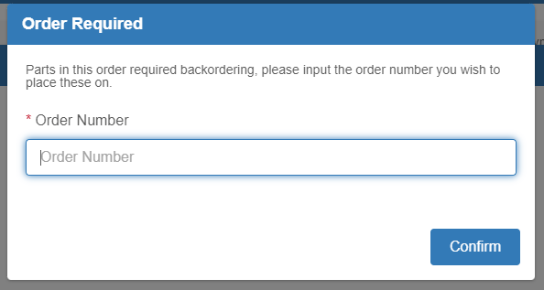

Enter the order number and click “Confirm” to continue. If this is a pay on pickup order, and not a prepaid one, you will also be asked to enter the backorder’s prepaid percentage. The image above is for a prepaid order.

The Accept Order processing screen will show the following when the order is fully accepted in:

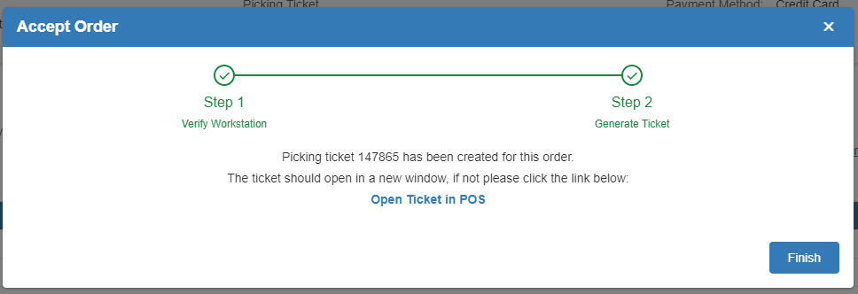

The program will also immediately open the created ticket in POS. If the new POS window fails to open automatically, click “Open Ticket in POS” in the Accept Order screen to open it. Below is an example of what an accepted order will look like in POS:

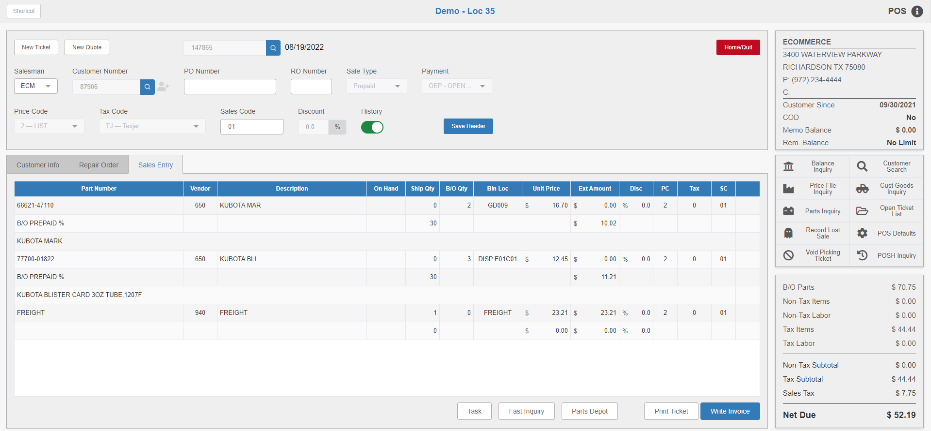

Note that the majority of the ticket will be locked for editing at this point, since you are bringing in a pre-made, and potentially pre-paid, order from an outside seller. If an HBS customer was linked to the order, that customer will be automatically filled in as the ticket customer. At this point you can either invoice the ticket or leave it to return to ECOM. It will still be available in POS and via the hyperlinked ticket number in ECOM at any point up until you invoice it.



Finish Acceptance: When you return to ECOM, you will need to click the Finish button in the Accept Order screen to finish the acceptance process in ECOM. This will return you to the main ECOM screen. The order will no longer be listed in the “Orders Received” section, but will now be in the “Orders Processing” section with a status of “In Progress.”



Shipping and Completing an Order: To begin the process of completing an order in ECOM, you will need to add shipping to it in order to indicate that you have started fulfilling the order. There are two ways to start adding shipping in ECOM. You can open an “In Progress” order’s Details and click the “Add Shipping” button:



Or you can access the order’s Actions menu and click “Add Shipping” there:



Both options will open the Create Shipment screen:

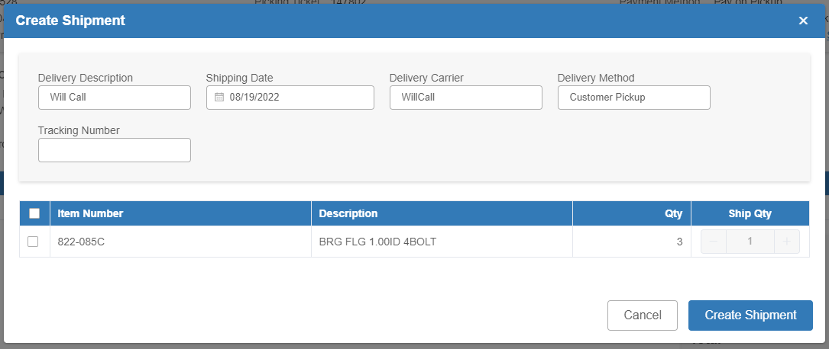

Delivery Description: This field holds the delivery description. It is auto-filled based on the original order, but can be changed if needed.

Shipping Date: This field sets the shipping date for the order. It defaults to the current date, but can be changed as needed.

Delivery Carrier: This field holds the delivery carrier. It is auto-filled based on the original order.

Delivery Method: This field holds the delivery method. It is auto-filled based on the original order.

Tracking Number: This field can hold the order’s tracking number, if applicable.

Item Selection Grid: This grid lists all the items on the order. Select which items will go on the order by checking the box in the far-left column next to the items. This will then let you set the quantity of those items that will come in the shipment using the field in the “Ship Qty” column. You are required to enter a quantity of at least 1 if you have marked the item for the shipment, but if you are unable to send the full quantity in this shipment, you can set it to the partial quantity that will be included. This will allow you to make as many shipments on the order as needed.

Create Shipment: Click this button to close the screen, and update the order’s status. If you only made a partial shipment, the order’s status will change to “Partially Shipped” and it will stay in the “Orders Processing” section. However, if you have finished shipping all items on the order, the order’s status will change to “Completed” and it will be moved to the “Orders Completed” section. You will be able to view it there provided it is among the number of orders you have set to display.

