Charging a Card with EdgePay (EPIN)

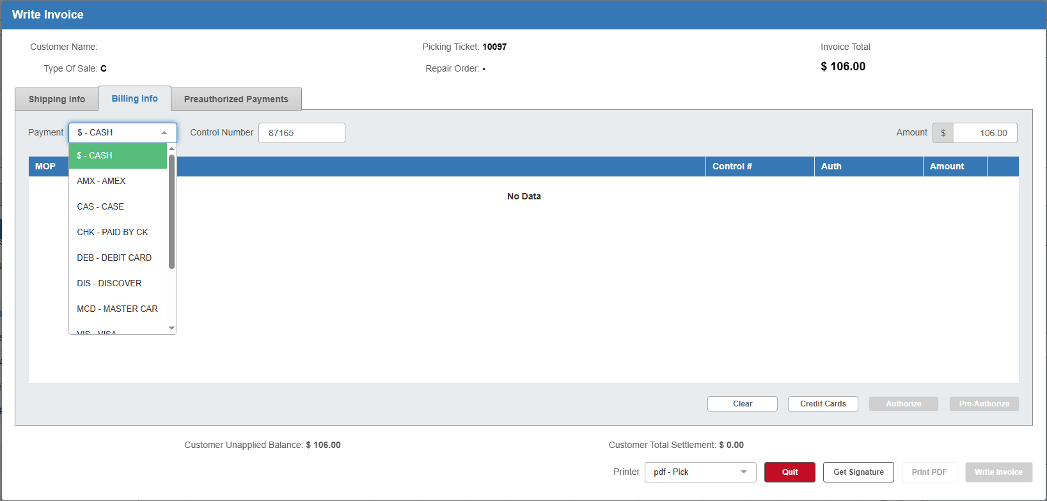

This topic covers how to charge a customer's credit cards using EdgePay Input (EPIN). EdgePay is accessed from within Point-of-Sale (POS), Repair Order Maintenance (ROM), Rental Reservations & Contracts (RENT), and Unit Sale (US) as part of the invoicing routine. After you have pressed the Write button on the main screen of each program to generate the invoice, you can select a credit card as the customer's method of payment.

- In the Description field, choose the type of card the customer wants to use from the drop-down menu.
  - If the customer wants to pay with credit, select the type of credit card.
  - If the customer wants to pay with debit, select “DEB-DEBIT CARD.”
  - NOTE: You will be unable to switch between debit and credit in EdgePay, so you must ensure the selection here is correct.
- Hit “Tab” or "Enter" on the keyboard until you pass through the dollar amount. EdgePay will open in a new window.

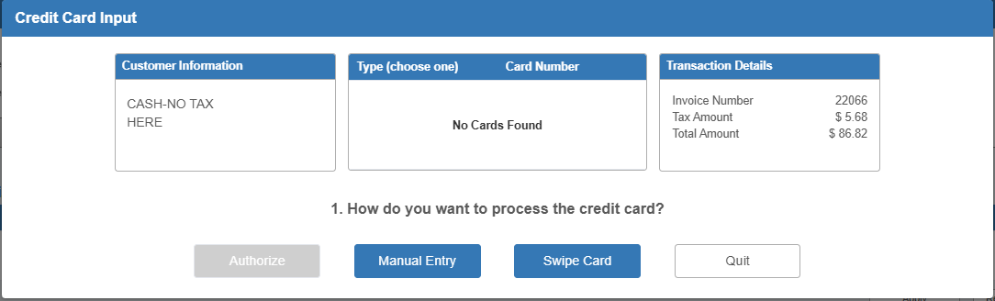

EdgePay Input (EPIN)—Layout:

Customer Information: The Customer Information box displays the customer’s name and address.

Type/Card Number: This box displays the full list of credit cards already available for this customer in the system.

Transaction Details: The Transaction Details box displays the details of the transaction being paid for, which include:

- Invoice number
- Tax amount
- Total amount

Charging a Card in EdgePay Input: There are four different methods of charging a card: three for credit cards, and one for debit cards. Charge a card using the blue buttons on the bottom of the window.

Credit Cards:

Authorize: Use this method if the customer wants to pay with a token. NOTE: This button will not be accessible unless you are using a GPEP processor and the customer is paying with a public credit card.

- Select the card you want from the list in the middle box. The chosen card will highlight in blue and the Authorize button will activate.
- Click Authorize. The program will run the card automatically without requiring any manual action.
- When a signature is required, the program will prompt you to ask the customer for their signature. The customer must sign their name on the terminal to complete the transaction.
- If the transaction is not successful, an error message will display (see below for sample):

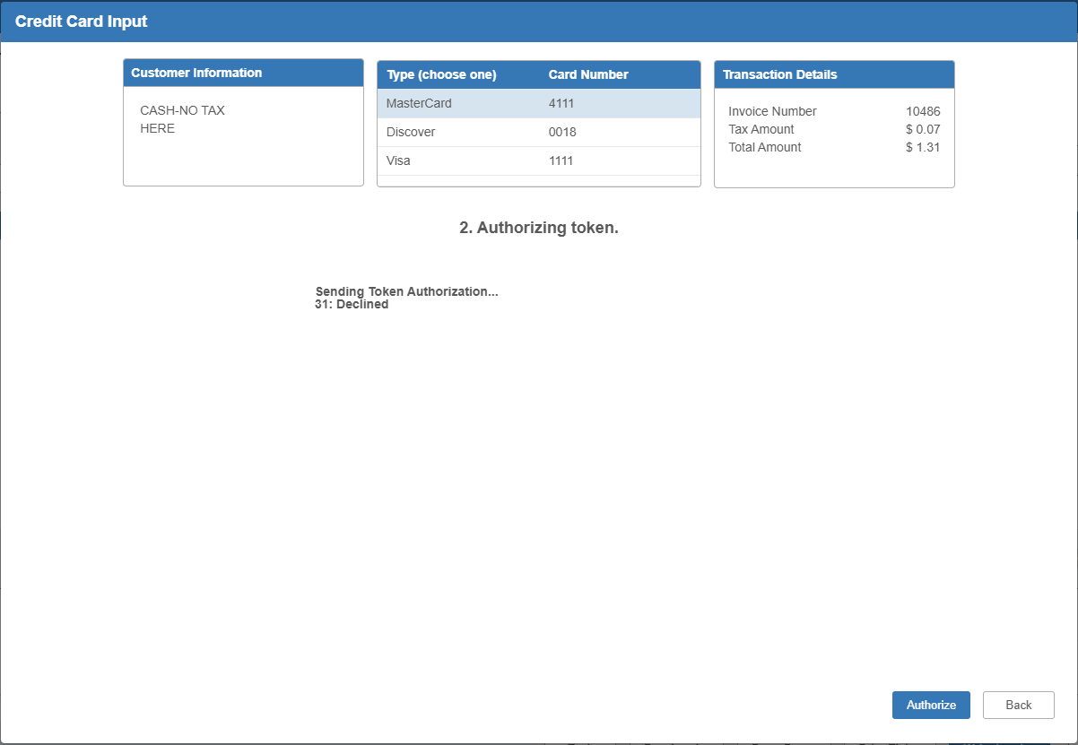

- If the transaction is successful, the program will return to the Invoice screen and display the payment as accepted.
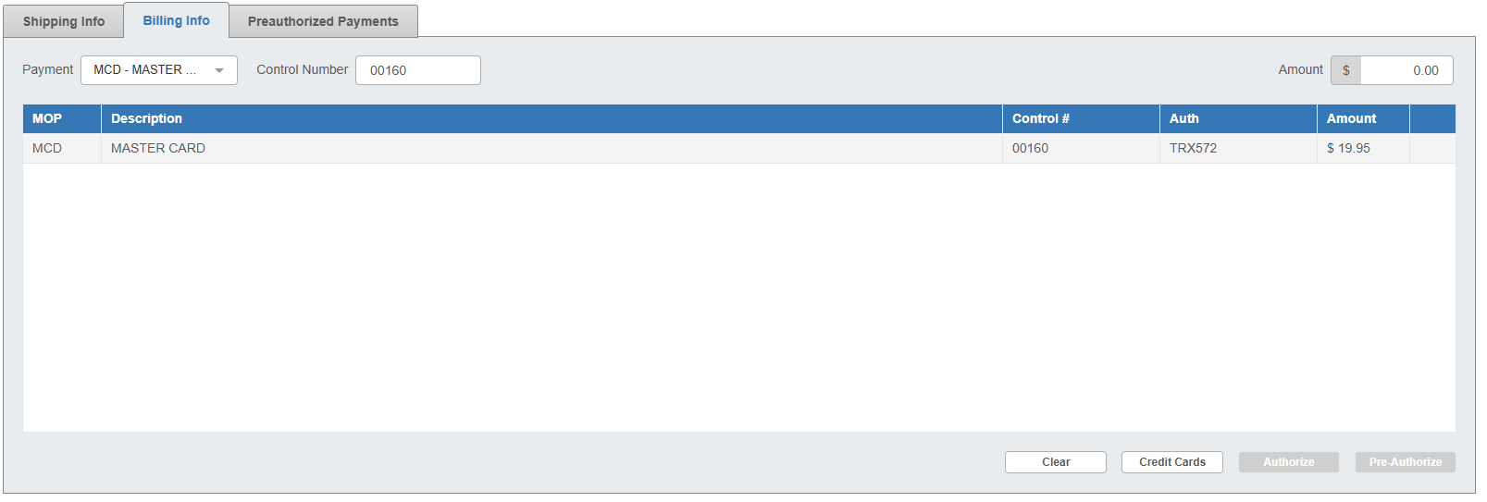



Manual Entry: Use this method to charge the card by manually entering its information.

- Click Manual Entry. NOTE: The screen will prompt you if you want to store the card’s token prior to taking you into the entry screen. Click Yes to store the token after entry.
- The following screen will appear:

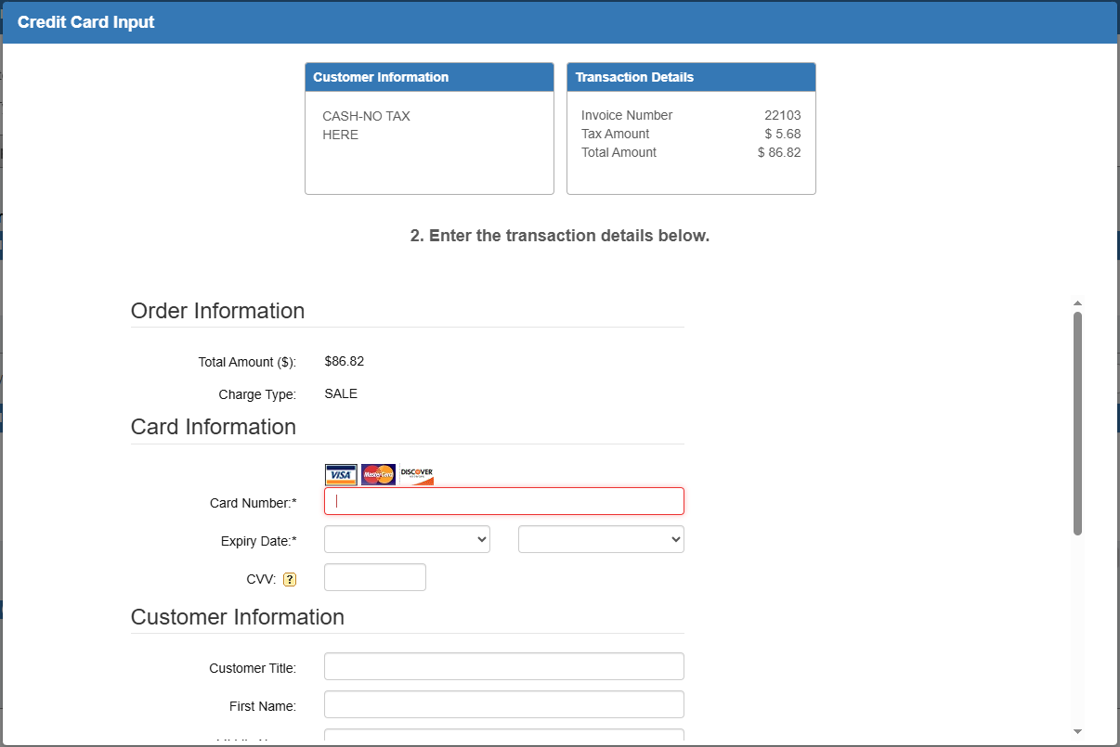

- Fill in the card number. The field will show that it accepts the card number by changing the field’s highlight.
- Select the card’s expiration month and year from the Expiry Date drop-down menus. You can also enter the card’s CCV number and the customer’s information in the fields below, though only the card number and the expiration date are required to complete the transaction.

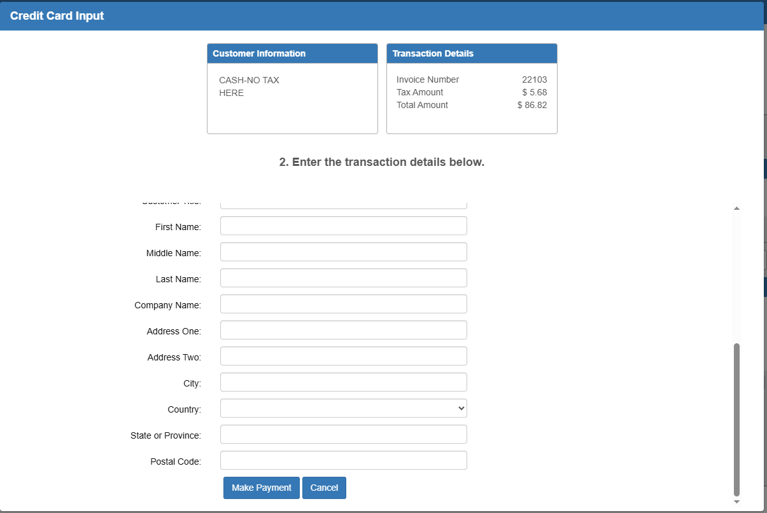

- Click Make Payment. The program will process the transaction and indicate that it was successful before returning to the Invoice screen. NOTE: If the transaction does not go through, the screen will show an error message.


Swipe Card: Use this method to charge the card using a credit card terminal. NOTE: This is the method to use when running a chip transaction.

- Click Swipe Card.
- If for whatever reason the program is not properly connected to your terminal, an error message will appear. For example, “Connecting Remote Client Manager timeout” if you are not connected to Remote Client Manage, which runs your terminal software.
- Process the card through the terminal.
- When a signature is required, the program will prompt you to ask the customer for their signature. The customer must sign their name on the terminal to complete the transaction.
- If the transaction is successful, the program will then return to the Invoice screen, where the transaction will show as accepted for the purchase.

Debit Cards: You can only use Swipe Card to charge a debit card in EdgePay. All other options will be greyed out, as shown in the image below. NOTE: Not all debit cards will render an authorization number with the transaction. Some may simply say “Authorized.”

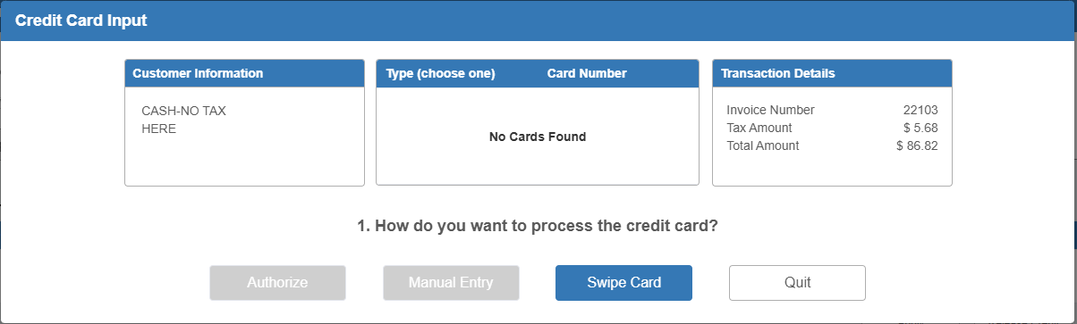

- Click Swipe Card.
- If for whatever reason the program is not properly connected to your terminal, an error message will appear. For example, “Connecting Remote Client Manager timeout” if you are not connected to Remote Client Manage, which runs your terminal software.
- Process the card through the terminal.
- When a signature is required, the program will prompt you to ask the customer for their signature. The customer must sign their name on the terminal to complete the transaction.
- If the transaction is successful, the program will then return to the Invoice screen, where the transaction will show as accepted for the purchase.

Quit: If you want to stop processing the credit card at any point in EdgePay, click
this button to return to the Invoicing screen without creating the payment.
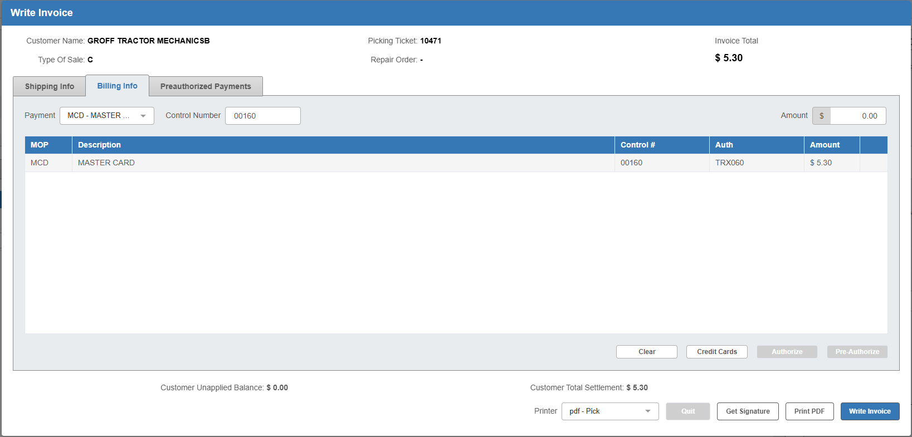

Completing the Ticket: Once you have charged the card and been returned to the Invoice screen, click the Write Invoice button at the bottom of the screen to create the invoice.

Daily Transaction Log: Regardless of whether the transaction is successful or not, it will appear in the daily transaction log, which will automatically print out during the night after the end of a business day.

