Sales Tax Business Presence (STXBP)

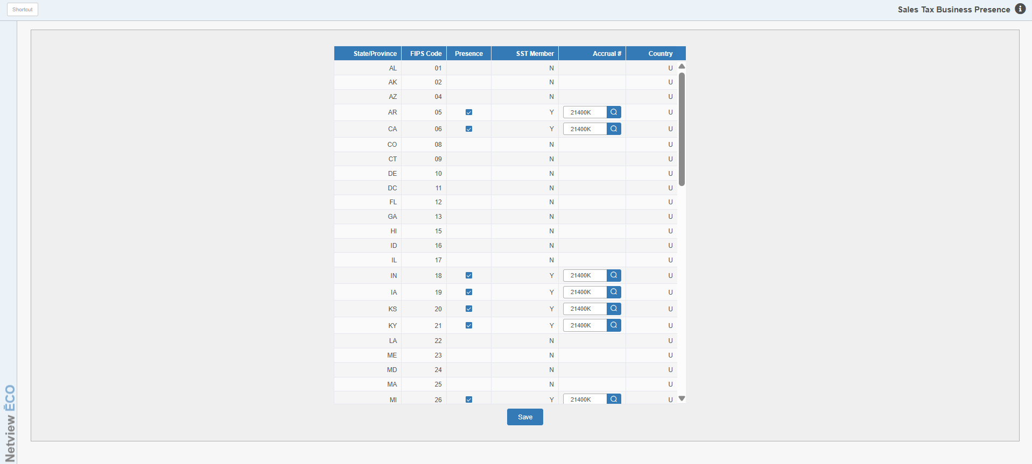

This screen defines the states in which your business operates. A list of all states is shown along with some preferences for each. This should be a one-time setup area unless your company opens a location in another state. For businesses with multiple locations, this step will need to be done in all locations.

SST States Setup:

- In the column labeled Presence, check the states in which your business operates and thus would collect sales tax.
- On the lines where you checked, you will need to enter the Accrual account where the sales tax for that state is to be collected.
- Be sure to save your changes.

Non-SST States Setup: For non-SST states, there is no additional setup needed in this area. Non-SST states sales tax collecting and reporting is strictly based on the tax code used for the transaction.

