AGCO PoS (AGCO):
AGCO has enhanced their current AGCO Parts Integration (API) feeds with the inclusion of Point-of-Sale data. The Point-of-Sale Integration is a process to send transactional data to AGCO. The data consists of parts, service, and wholegoods information. There are multiple ways AGCO utilizes this data to enhance their programs and reports, such as improvements to the MDI (API) program, parts and service marketing, and reporting on Aftersales Financial KPIs.

More information about this integration and enrollment process can be found on the oneAGCO dealer Portal. On the enrollment form, you can select which optional fields you would like to share with AGCO. To access the form, you will have to start at the API page which is found on the Parts tab, then business tools and selecting “API – AGCO parts Integration” (https://my.oneagco.com/web/agco/agco-parts-integration). On the API page you will see the enrollment form on the right side of the screen.

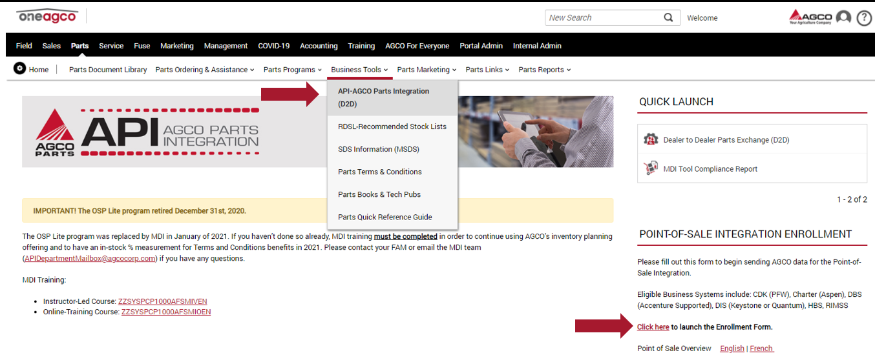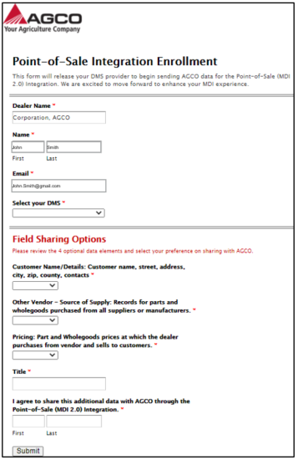

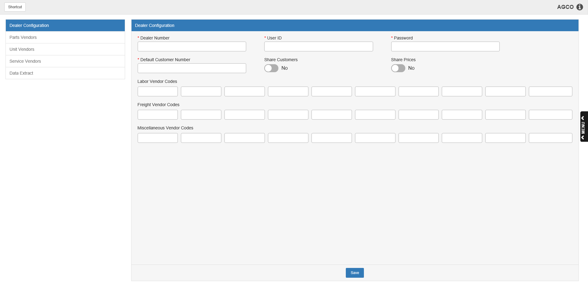
AGCO PoS (AGCO) is where you can access this process in NetView ECO. This program submits POS, Service, and Unit data to AGCO based upon your dealer agreement with AGCO. After setup is completed, your sales history is initially loaded for three years for Parts and Service, and 6 years for Wholegoods/Units. After that point, the program automatically submits your data to AGCO on a nightly basis (comprised of the past 2 weeks of sales history per night).
To access this program, type “AGCO” in the Shortcuts Bar.
Dealer Configuration: Begin setting up the program in this screen, which the program opens to by default. Most of the information required here will be provided to your dealership by AGCO.

Dealer Number: Enter your AGCO dealer store location number here.

User ID: Enter your AGCO-provided user ID here.

Password: Enter your AGCO-provided password here.

Default Customer Number: Enter your dealer cash customer number here (usually 00000 or 00001).

Share Customers: Switch this option on to upload your customer information to AGCO.

Share Prices: Switch this option on to upload your dealer retail/cost prices to AGCO.

Labor Vendor Codes: Use these fields to enter all the Parts labor vendor numbers you have set up in Vendor Master Maintenance (VMM) for use on Point-of-Sale (POS) picking tickets.

Freight Vendor Codes: Use these fields to enter all the Parts freight vendor numbers you have set up in Vendor Master Maintenance (VMM) for use on Point-of-Sale (POS) picking tickets.

Miscellaneous Vendor Codes: Enter your vendor number(s) for Miscellaneous parts in these fields.

Save: Click “Save” to store your dealer settings in the system.

Sidebar Navigation: Use the tab list on the left side of the screen to navigate to the other screens in the program and complete your setup.

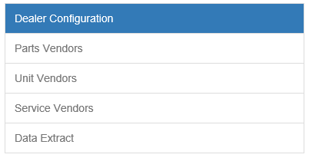

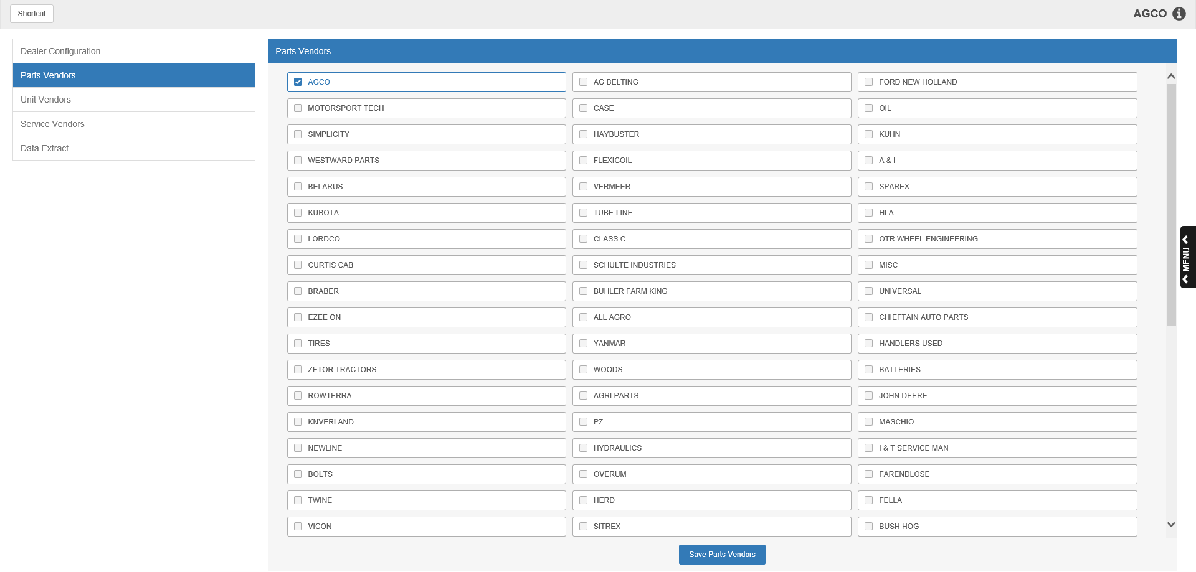

Parts Vendors: Use this screen to select the Parts vendors whose data you wish to send to AGCO. Only Parts vendors selected here will have their data sent to AGCO.

Once you’ve made your selection, click Save Parts Vendors to store the information.

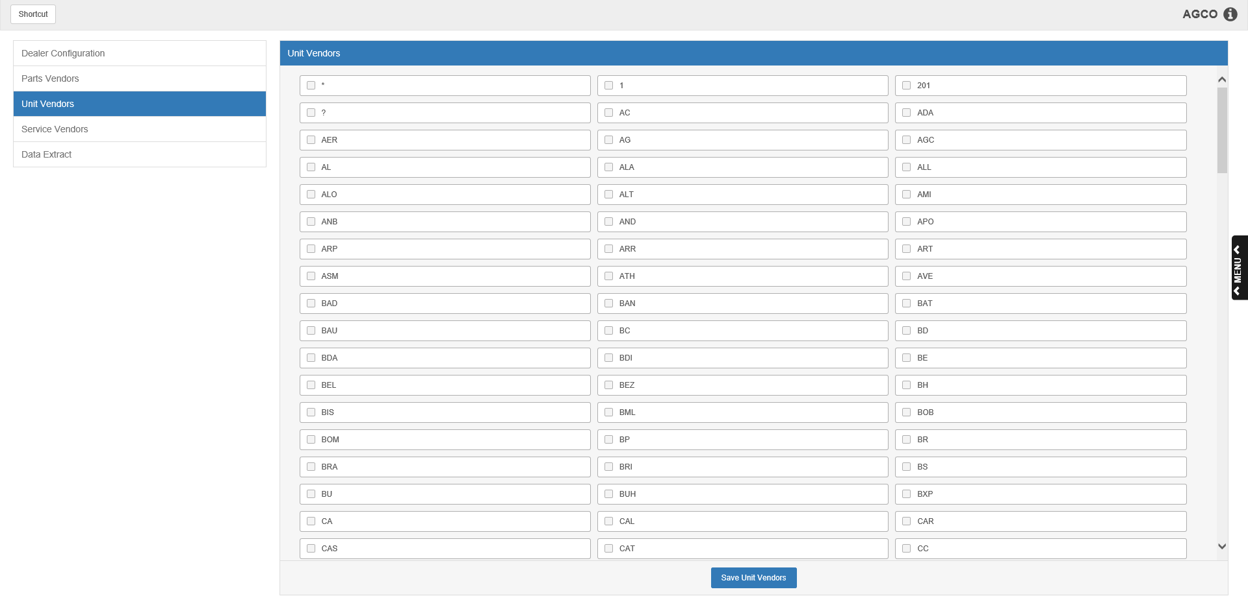

Unit Vendors: Use this screen to select the Units vendors whose data you wish to send to AGCO. Only Units vendors selected here will have their data sent to AGCO.

Once you’ve made your selection, click Save Unit Vendors to store the information.

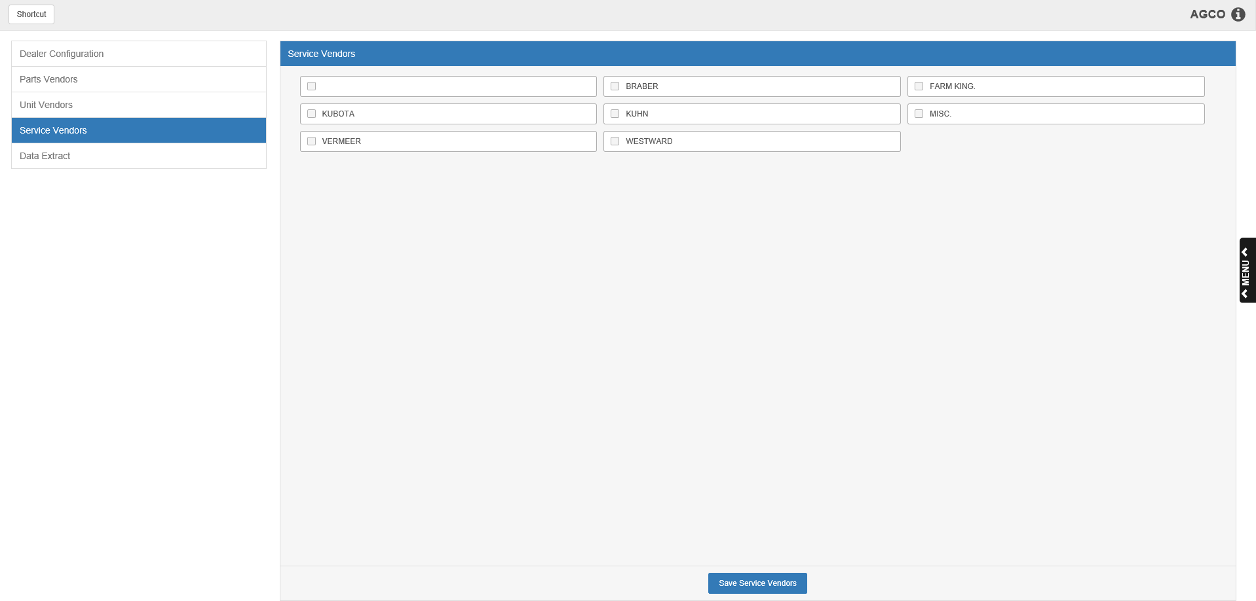

Service Vendors: Use this screen to select the Service vendors whose data you wish to send to AGCO. Only Service vendors selected here will have their data sent to AGCO.

Once you’ve made your selection, click Save Service Vendors to store the information.

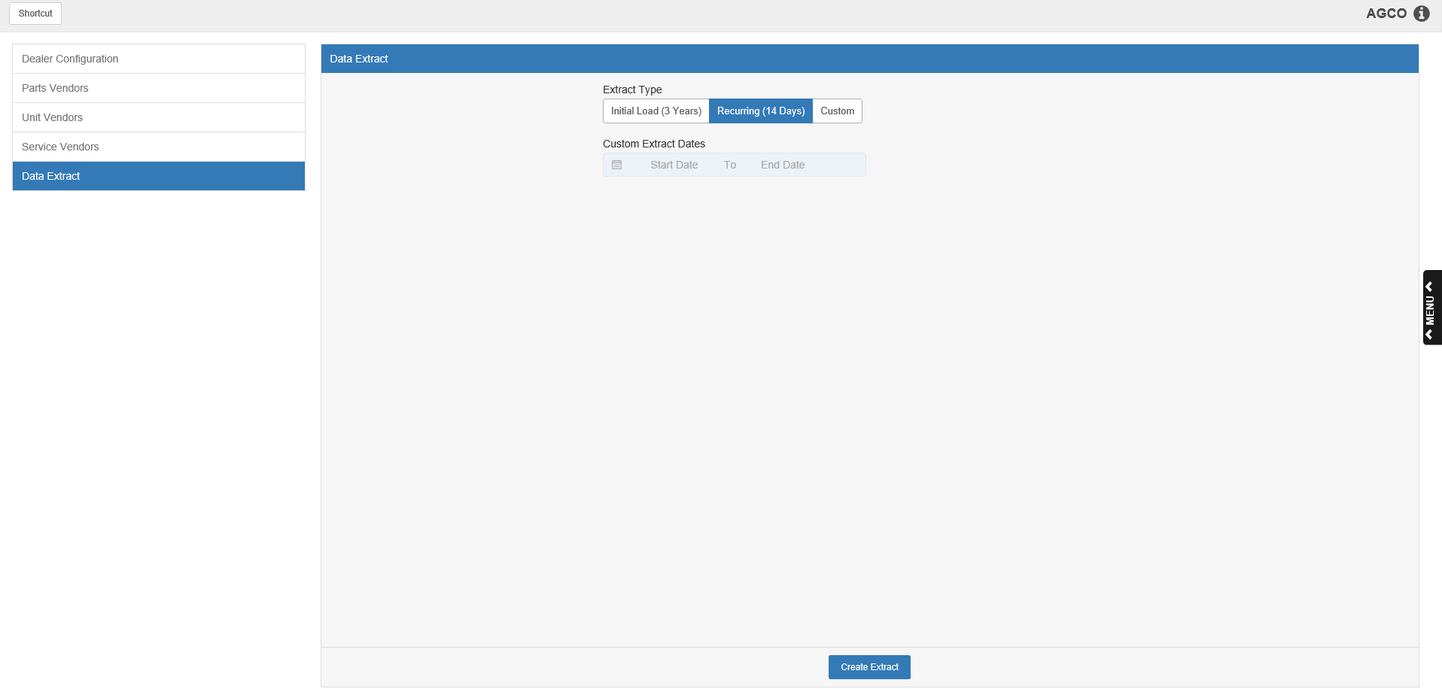

Data Extract: This final screen allows you to make your initial data submission and make manual data submissions to AGCO at any point in time outside your automatic nightly submissions.

Extract Type: Set the type of extract you wish to send to AGCO:

- Initial Load (3 Years): This is the initial manual load you will send to AGCO. It extracts 3 years of sales history for all selected Parts and Service vendors, and 6 years for all selected Unit/Wholegoods vendors.
- Recurring (14 Days): This is the default setting for this screen, and is essentially a manual version of the automatic nightly submission, in case you need to manually extract the data.
- Custom: This setting allows you to send a custom extract to AGCO, comprising of sales history taken from a specified date range which could be longer or shorter than the preset options.

Custom Extract Dates: This field only activates if you select the “Custom” Extract Type. Enter the starting and ending dates for the period of sales history you want to extract and send to AGCO.

Create Extract: Click this button to create your extract and send it to AGCO. If it goes through without any issues, you will receive a message indicating the extract was successful. If the process encounters an error, you will receive an error message indicating what went wrong.

