A/R Credit Report (ARCR)

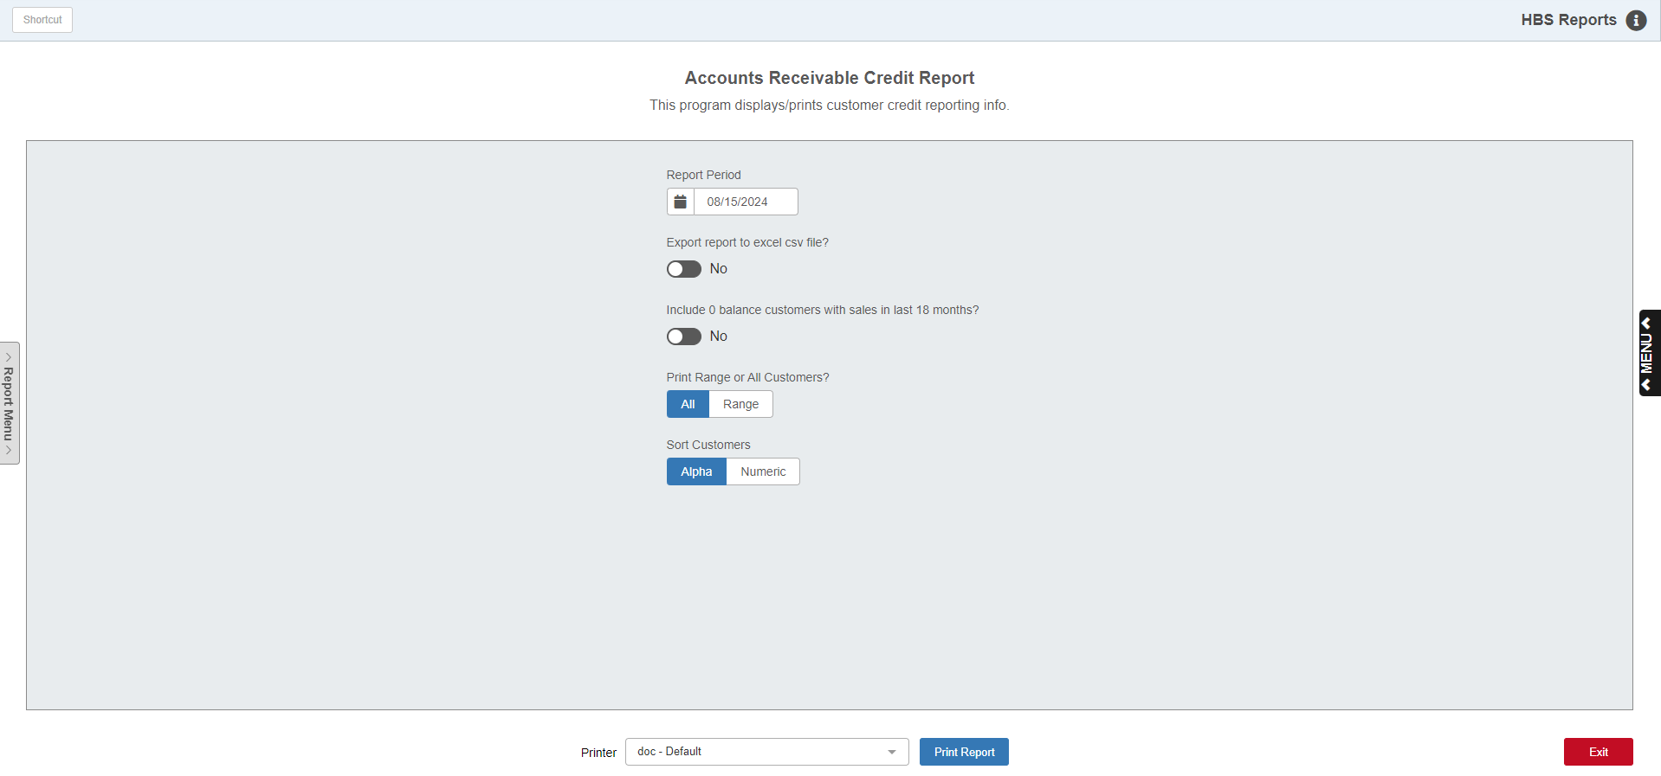

The A/R Credit Report (ARCR) creates a report of customer credit information, including balance history and aging information on their current balance due.

To access this function, either:

- Select “Accounts Receivable” from the menu and open the “Memo Reports” submenu. Click on “A/R Credit Report.”
- Type “ARCR” in the Shortcuts Bar.

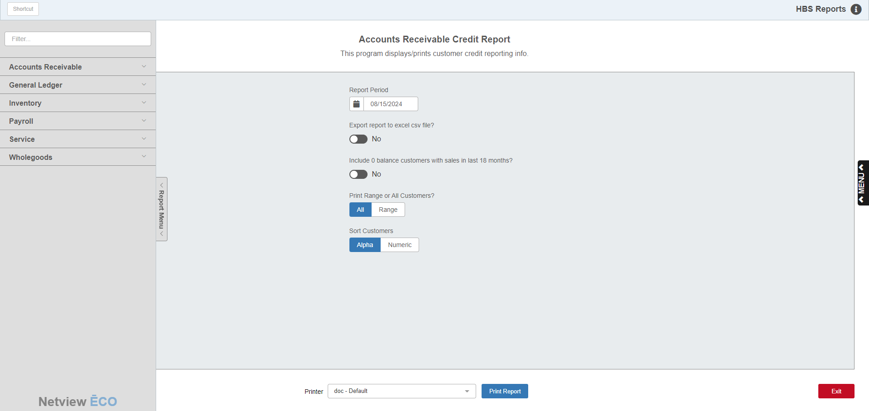

Reports Navigation Menu: This new menu appears on the left side of the screen for all reports and allows the user easy access to all report programs in the system. It is collapsable and can be easily hidden.

Screen Fields

Report Date: Set the date for the report in this field. The report will provide a snapshot of your customers’ credit information as of that date. It defaults to the current date, but can be changed as desired.

Export report to excel csv file?: Set whether or not you want the report to export to Microsoft Excel as a .csv file.

Include 0 balance customers with sales in last 18 months?: Set whether or not you want to include customers on the report that have a zero credit balance, but also have sales in the last 18 months.

Print Range or All Customers?: Set whether you want to print the report for a specific range of customers or for all customers.

Customer Ranges: These fields only appear if you select “Range” at the “Print Range or All Customers?” field.

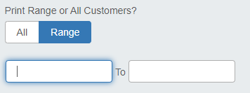

To set a range of customers, enter the starting and ending customer numbers in the fields. You can set up to 5 sets of customer ranges for the report.

Sort Customers: Set whether you want your customers sorted alphabetically by their names or numerically by their customer numbers.

Printer: Set the desired printer to receive the report or leave it as the default.

Print Report: Click this button to print the report.

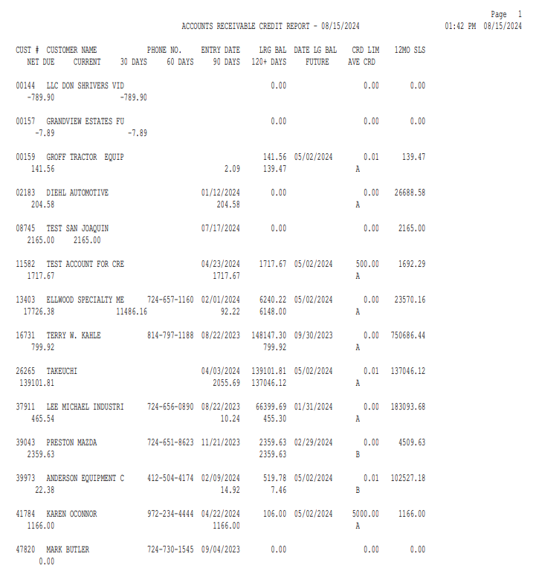

Report Columns:

Customer Number: Shows the customer number.

Customer Name: Shows the customer name.

Phone Number: Shows the customer’s primary phone number.

Entry Date: Shows the date the customer’s record was created.

Largest Balance: Shows the customer’s largest credit balance as of the report date.

Date Largest Balance: Shows the date of the customer’s largest credit balance (as reported on the selected report date).

Credit Limit: Shows the customer’s credit limit as of the report date.

12 Month Sales: Shows the total dollar amount of all sales made to the customer over the last 12 months prior to the report date.

Net Due: Shows the customer's net due amount as of the report date.

Current: Shows the customer's current (less than 30 days old) amount due as of the report date.

30 Days: Shows the customer's amount due that is between 30 and 60 days old as of the report date.

60 Days: Shows the customer's amount due that is between 60 and 90 days old as of the report date.

90 Days: Shows the customer's amount due that is between 90 and 120 days old as of the report date.

120+ Days: Shows the customer's amount due that is over 120 days old as of the report date.

Future: Shows any future amounts due (i.e. amounts from future-dated invoices) the customer has as of the report date.

Average Credit: Shows the customer's average credit rating for the past 12 months as of the report date (A, B, C, D).

