Credit Card Dealer Information (CCDI)

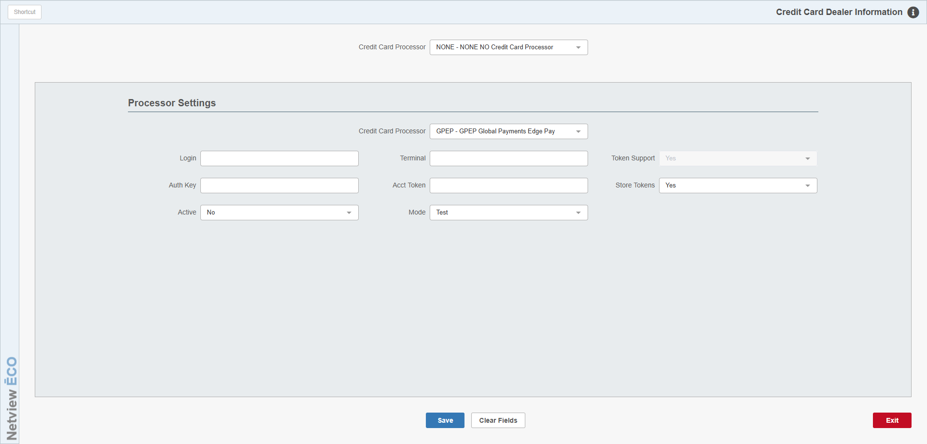

This application allows you to set up how you intend to process your customer’s cards. To open the application, type “CCDI” into the Shortcuts Bar.

NOTE-Installer Information: Corporate firewalls must have these outgoing ports open:

- 26
- 80
- 443
- 11508
- 28716
- 29716
- 49201

Selected Processor: Select the processor type that matches the credit card processor you normally use when charging cards:

- GPEP Global Payments Edge Pay (required to use OpenEdge)
- SMIR Smart Iron (required to use Smart Iron)
- NONE No credit card processor (use only if your dealership does not process credit cards)

Processor Settings: Enter your settings for each processor type in this section. You will only need to do this for processor types that you actually use at your dealership.

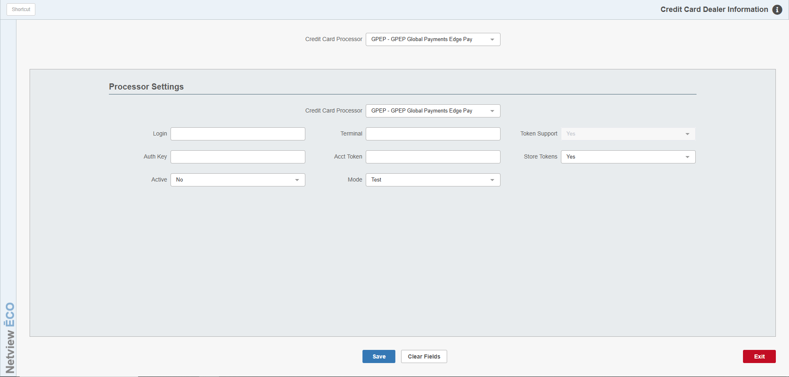

GPEP Global Payments Edge Pay: For this processor type, you will need to fill in the following fields:

Login: Put your X-web login user name for your processor here.

Terminal: Put your processor’s terminal number here.

Token Support: This field will always be inactive and set to Yes by default, as this processor type will always support credit card tokens.

Auth Key: Put your authorization key (provided by OpenEdge) here.

Acct Token: Put your account token number (provided by OpenEdge) here.

Store Tokens: Use this field to set your process for storing credit card tokens.

- Select No if you never want to the processor type to save tokens.
  - NOTE: When set to this option the processor type will still allow and display already saved tokens, but will stop further new ones from being added.
- Select Yes if you always want the processor type to save tokens for credit card payments.
- Select Prompt if you want the processor type to offer the user the option to save the token when it is used.

Active: Select Yes from this menu to ensure the system registers your processor as active.

Mode: Make sure this field is set to Production. Your system will not work otherwise.

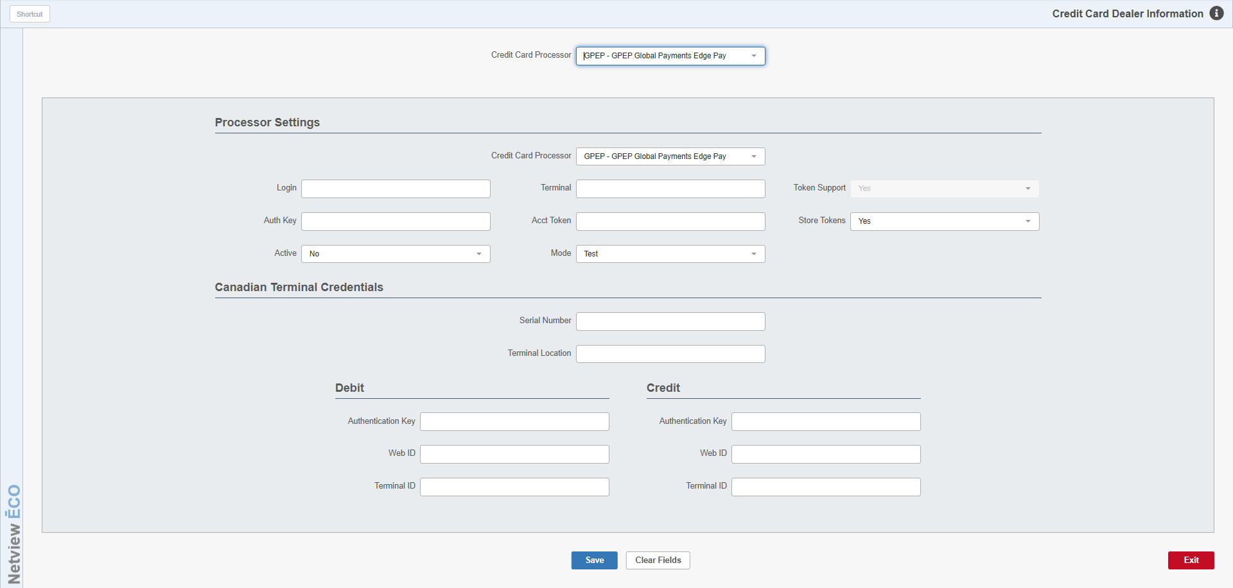

Canadian Terminal Credentials: This section appears for GPEP processors for Canadian dealers ONLY. The information here refers to the specific processing terminal being used with the program. If you have the terminal already connected before accessing CCDI, most of the information should automatically populate the screen. If the terminal is not connected, you will have to enter the information manually.

- Serial Number: This field holds your selected terminal’s serial number. The number should auto-populate if the terminal is connected before you open CCDI.
- Terminal Location: If you have more than one processing terminal in use at your dealership, use this field to indicate which specific terminal this information belongs to. For example, if this terminal is used for your Parts counter, you could call it “Parts1.”
- Debit & Credit Information: Canadian dealers are required to provide separate authentication information to allow the terminal to process debit and credit cards. Enter the Authentication Key, Web ID, and Terminal ID for both card types in the respective fields. This information should auto-populate if the terminal is connected before you open CCDI.
  - NOTE: The data in the Credit information fields must also be placed in the following fields in the Processor Settings section:
    - The Authentication Key data must be placed in the Auth Key field.
    - The Web ID data must be placed in the Login field. NOTE: Use your X-web ID.
    - The Terminal ID data must be placed in the Terminal field.
  - NOTE: The debit credentials must match the pin pad serial number. If your form does not have one listed, call OpenEdge before proceeding.
- Save: Click this button to save the terminal-specific fields.
- Clear Fields: Click this button to clear all the terminal-specific fields. NOTE: The fields will only be cleared, not saved, so if you clear without saving you will lose all your information.
- Delete: Click this button to delete the terminal’s information from the system.

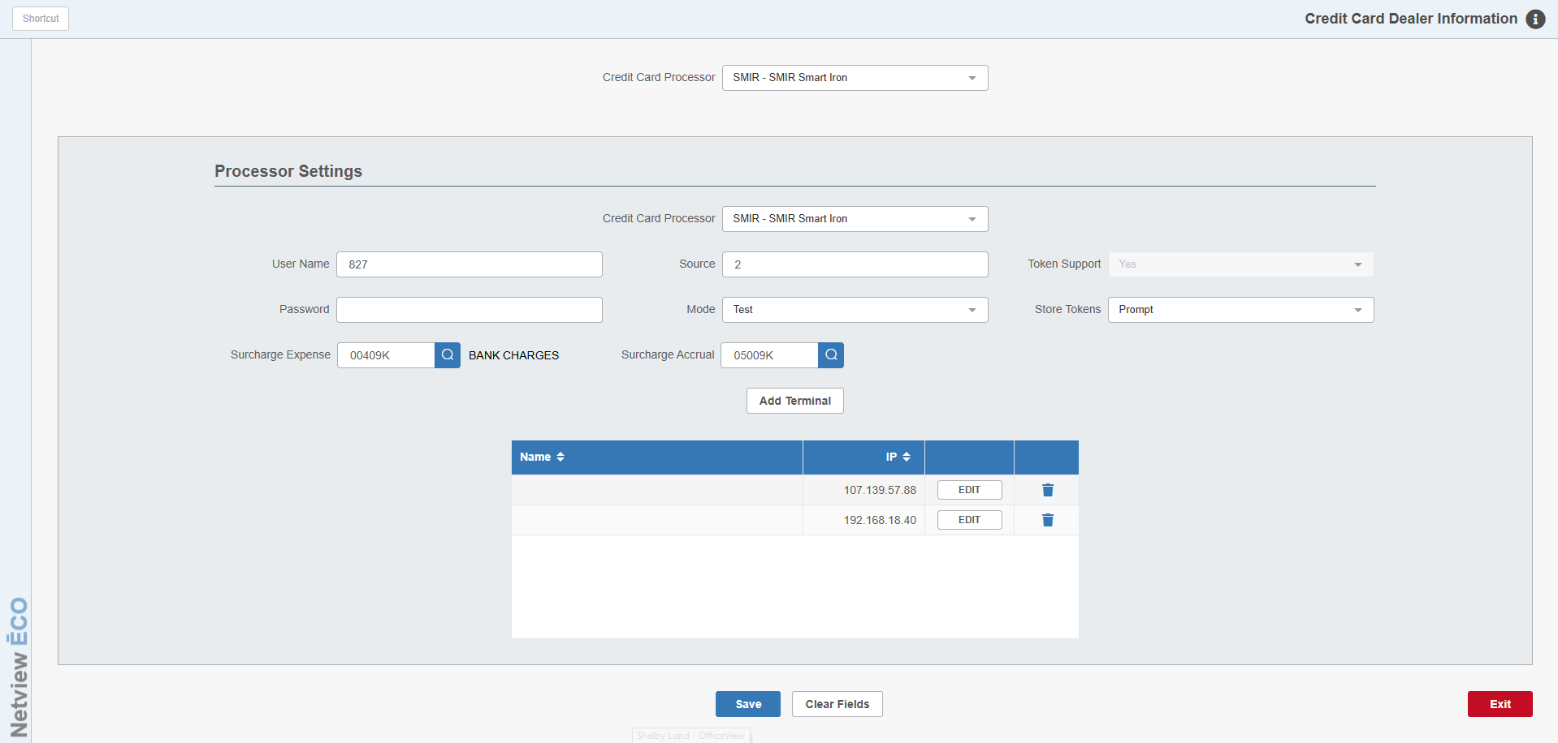
SMIR Smart Iron: For this processor type, you will need to fill in the following fields:

User Name: Put your Smart Iron user name here.

Source: Put your Smart Iron source ID here.

Token Support: This field will always be inactive and set to Yes by default, as this processor type will always support credit card tokens.

Password: Put your Smart Iron password here.

Mode: Make sure this field is set to Production. Your system will not work otherwise.

Store Tokens: Use this field to set your process for storing credit card tokens.

- Select No if you never want to the processor type to save tokens.
  - NOTE: When set to this option the processor type will still allow and display already saved tokens, but will stop further new ones from being added.
- Select Yes if you always want the processor type to save tokens for credit card payments.
- Select Prompt if you want the processor type to offer the user the option to save the token when it is used.

Surcharge Account: Enter the General Ledger account number that you want to receive any surcharges made using this processor type. You can also use the Search icon to look up an account number.

Add Terminal: The Smart Iron processor setup requires that you add all individual terminals being used at your dealership location here in CCDI. Click this button to add a terminal to the system. The following window will open:

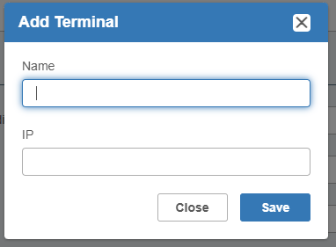

- Name: Enter an identifying name/description for the terminal here. You may want to specify the terminal’s chief use or location within your dealership, for example if it is the one at the Parts sales counter, used by the Service department, etc.
- IP: Enter the specific terminal’s IP address here.

Click Save to save the terminal. The window will close and the terminal will show in the grid.

Once the terminal has been added, you can use the Edit button to modify the terminal’s IP address if needed (the name cannot be changed once added). You can also use the Delete icon to delete the terminal from the list.

Save: Click this button to save your processor settings.

Clear Fields: Click this button to clear all the fields currently displayed on the screen. NOTE: The fields will only be cleared, not saved, so if you clear without saving you will lose all your information.

Exit: Click this button to exit the program at any point. NOTE: This button will not save the screen settings when clicked, so if you click it any unsaved settings will be lost.

