Customer GST Tax Report (CGSTR)

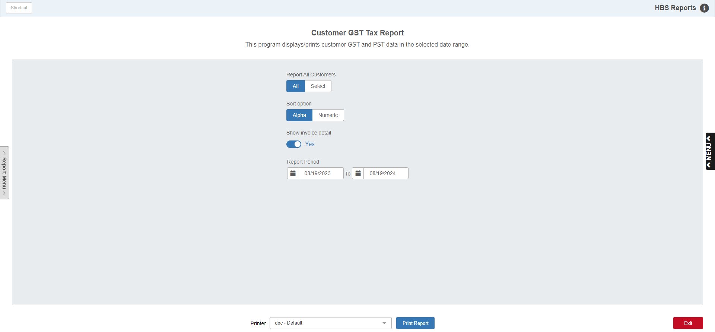

The Customer GST Tax Report (CGSTR) is a **Canadian**-only tax report which details the GST and/or PST tax values on customer invoices over a set period of time. The report can be printed for all customers or for a single customer, and has both Detail and No Detail versions.

To access this function **as a Canadian dealer**, you can:

* Select “Accounts Receivable” from the menu. Choose the “Memo Reports” submenu and click “Customer GST Tax Report.”
* Type “CGSTR” in the Shortcuts Bar.

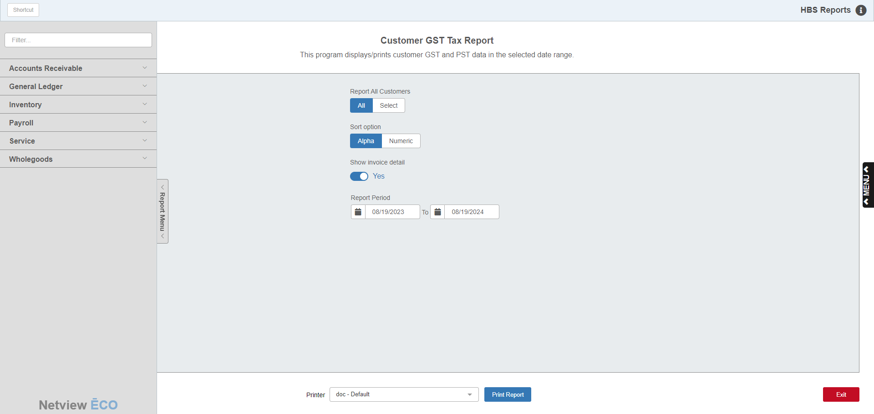

## **Reports Navigation Menu:** This new menu appears on the left side of the screen for all reports and allows the user easy access to all report programs in the system. It is collapsable and can be easily hidden.

Field Definitions:

Report All Customers: Set whether you want to run the report for all customers or for a specific customer.

Sort option: This field only appears if you decide to run the report for all customers. Set whether you want the report sorted alphabetically by customer name or numerically by customer number.

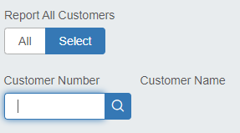

Customer Number/Customer Name: These fields only appear if you decide to select a specific customer for the report. Enter the customer’s number or look it up. The customer’s name will then display to the right of the field.

Show invoice detail: Set whether or not you want to include invoice detail on the report. If you chose not to include invoice detail, each customer on the report will only have a single total line displayed.

Report Period: Set the date range for the report. The range will default to a year leading up to the current date, but can be changed as desired.

Printer: Set the printer to receive the report or leave as the default.

Print Report: Click this button to print the report.

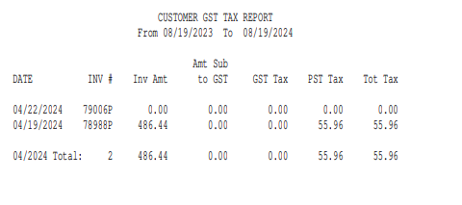

Report Columns--Detail: When invoice detail is included on the report, the report columns provide the following information for each invoice:

Date: Shows the invoice date.

Inv #: Shows the invoice number.

Inv Amt: Shows the invoice’s dollar amount.

Amt Sub to GST: Shows the amount on the invoice subject to GST.

GST Tax: Shows the amount of GST tax for the invoice.

PST Tax: Shows the amount of PST tax for the invoice.

Tot Tax: Shows the total tax amount for the invoice.

Total Lines: Every calendar month on the report has a total line that appears after it, and a similar total line appears for each customer if they had reported invoices in more than one calendar month of the report period. The total lines show slightly different information in each column compared to the invoice detail lines:

Date: Shows the calendar month for the Monthly Total Line (not applicable for a Customer Total Line).

Inv #: Shows the number of invoices for that customer in the calendar month (Monthly Total Line) or on the entire report (Customer Total Line).

Inv Amt: Shows the total dollar amount of all invoices for that customer in the calendar month (Monthly Total Line) or on the entire report (Customer Total Line).

Amt Sub to GST: Shows total dollar amount subject to GST for that customer in the calendar month (Monthly Total Line) or on the entire report (Customer Total Line).

GST Tax: Shows total dollar amount of GST for that customer in the calendar month (Monthly Total Line) or on the entire report (Customer Total Line).

PST Tax: Shows total dollar amount of PST for that customer in the calendar month (Monthly Total Line) or on the entire report (Customer Total Line).

Tot Tax: Shows total dollar amount of all tax for that customer in the calendar month (Monthly Total Line) or on the entire report (Customer Total Line).

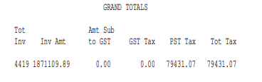

Grand Totals: A Grand Total line appears at the end of the report and provides the following information:

Tot Inv: Shows the total number of all invoices on the report.

Inv Amt: Shows the total dollar amount of all invoices on the report.

Amt Sub to GST: Shows the total dollar amount on the report subject to GST.

GST Tax: Shows the total dollar amount of GST on the report.

PST Tax: Shows the total dollar amount of PST on the report.

Tot Tax: Shows the total dollar amount of all taxes on the report.