Accounting Documents Pre-Journal Report (DRAD)

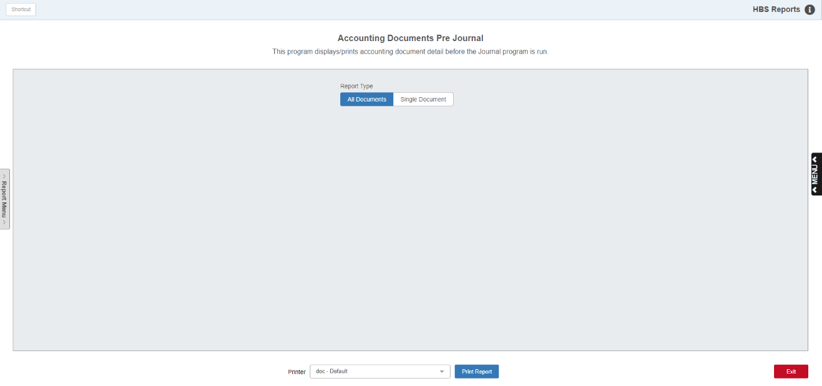

Accounting Documents Pre-Journal (DRAD) lets you print proof sheets of unposted A/R and G/L accounting transactions before posting them to the appropriate Journals. In this way it is similar to running a “memo” report in that it previews the accounting, but does not actually perform it. You can edit any documents listed in a proof sheet up to the point when you post the documents to Journals. **NOTE:** To have data for this report, there will need to be **unposted** A/R and G/L accounting documents waiting to be Journaled.

To access this function, either:

* Select “System Maintenance” from the menu and open the “Data File Review” submenu. Choose the “Accounts Receivable” submenu under that and click on “Accounting Documents (Pre-Journal).”
* Type “DRAD” in the Shortcuts Bar.

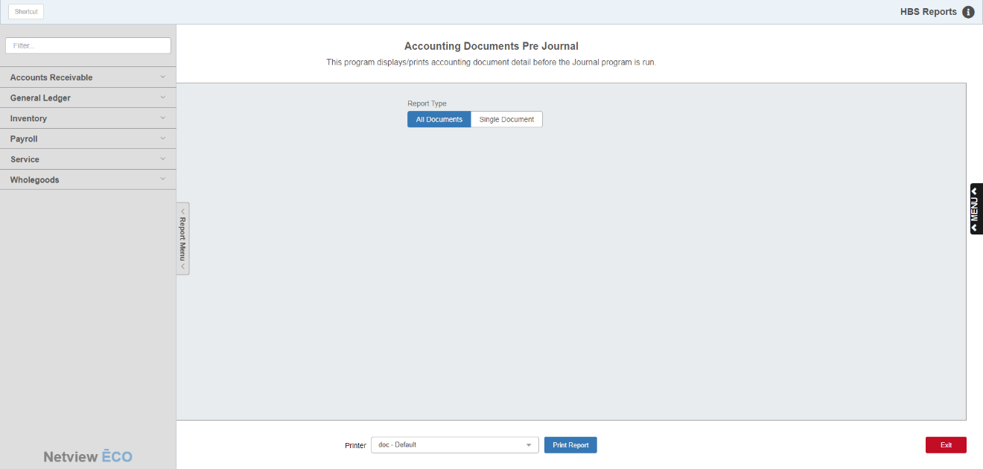

## Reports Navigation Menu: This new menu appears on the left side of the screen for all reports and allows the user easy access to all report programs in the system. It is collapsable and can be easily hidden.

## Screen Fields

Report Type: Choose if you want to include all unposted documents on the report, or if you only want to view a single unposted document’s details.

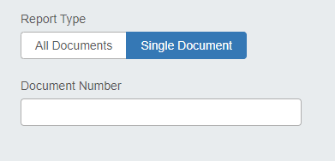

Document Number: This field only appears if you choose to only run the report for a single document. Enter that document’s number in this field.

Printer: Set the printer to receive the report printout or use the default setting.

Print Report: Click this button to print the report.

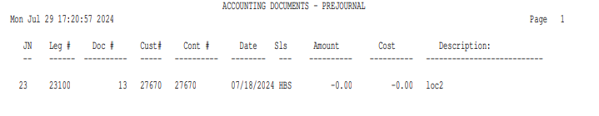

Report Details:

JN: Shows the Journal number for the pending transaction.

Leg #: Shows the G/L account number for the pending transaction.

Doc #: Shows the document number of the pending transaction.

Cust #: Shows any customer number tied to the transaction.

Cont #: Shows the control number for the transaction, if any. In the example above, the control number is the same as the customer number.

Date: Shows the document date.

Sls: Shows the salesperson ID tied to the document.

Amount: Shows the dollar amount of the transaction.

Cost: Shows the dollar cost of the transaction.

Description: Shows a description for the transaction.