A/R Customer Master File Report (DRCM)

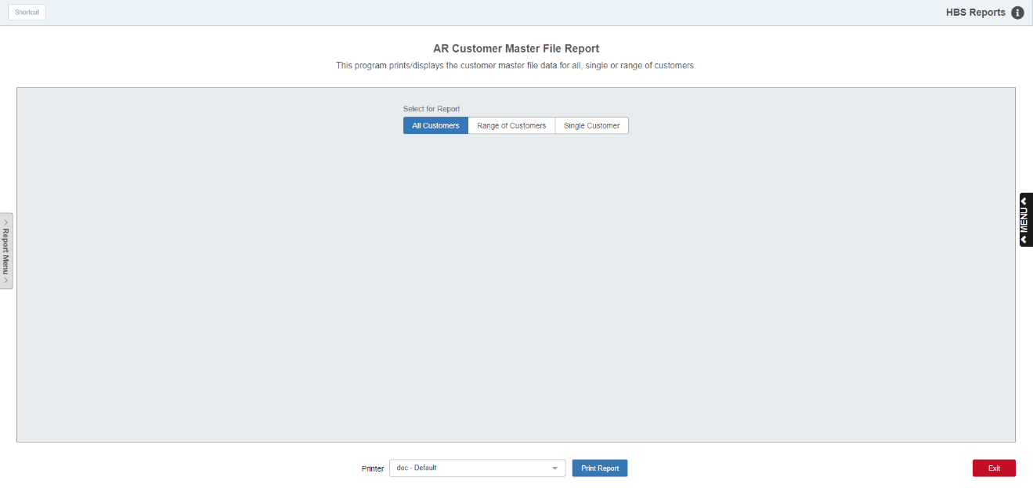

The A/R Customer Master File Report (DRCM) allows the user to print the Customer Master records stored in the system.

To access this function, either:

* Select “System Maintenance” from the menu and open the “Data File Review” submenu. Choose the “Accounts Receivable” submenu under that and click on “Customer Master File.”
* Type “DRCM” in the Shortcuts Bar.

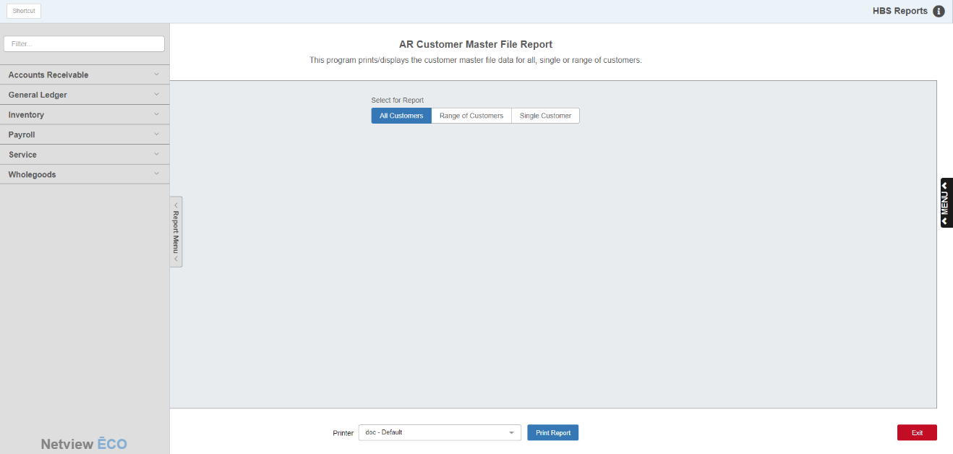

## Reports Navigation Menu: This new menu appears on the left side of the screen for all reports and allows the user easy access to all report programs in the system. It is collapsable and can be easily hidden.

Field Definitions:

Select for Report: Choose whether you want to run the report for all your customers, a specific range of customers, or a single customer.

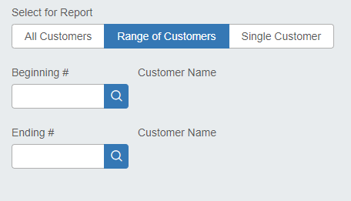

Beginning/Ending #: These fields appear if you choose to specify a range of customer records for the report. Enter the first and last customer numbers of your desired range to set it for the report. The customers’ names will appear to the right of the field.

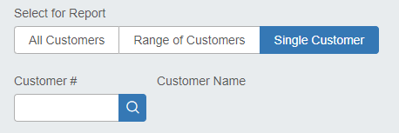

Customer #: This field only appears if you select to run the report for a single customer. Enter the customer’s number here. The customer’s name will then show to the right of the field.

### Printer: Select the printer to receive the printout. A default printer name is pre-filled, but can be changed as necessary using the drop-down menu. Use the pdf printer to view the report on the screen without printing a copy of it.

### Print Report: Click this button to run the report.

Sample Report:

