**Email:** The “Email” column is on the far right of the grid, and displays an envelope icon for each entry.

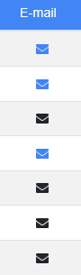

* If the envelope is **blue**, there is an email account associated with that customer entry.
* If the envelope is **black**, there is no email associated with that entry.

**Sending an Email:** To email the customer, click on the blue envelope.  The program then automatically opens a blank email to that customer, provided you have an email program such as Microsoft Outlook™ set up on your computer.

**Adding an Email Address:** To add an email address to a customer entry in NetView Insight search, click on the black envelope in their entry. A blank field will replace the envelope:

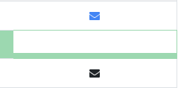

Enter the email address in the field and hit “Enter.” The field will be replaced by a now-blue envelope, indicating that there is now an email address on record for the customer. You can then edit or delete the address using Enter Customer Information (ECI).