**Help:** The Help category is located below the Desktop category on the main menu panel, and is represented by an icon of a question mark.  Clicking on the icon will allow you to access the Help sub-menu about NetView Desktop and its operations.

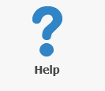

**NetView Guide:** The NetView Guide panel lets you access the Help function that you are reading right now.  Also see the "Help" tab in **“Menu”** under **“NetView Desktop Main Page.”** Features included in the Help are:

* NetView Desktop User Guide
* Table of Contents linked to the different pages within the guide
* Instructional videos included in certain topics
* Search function
* Index
* Glossary of terms

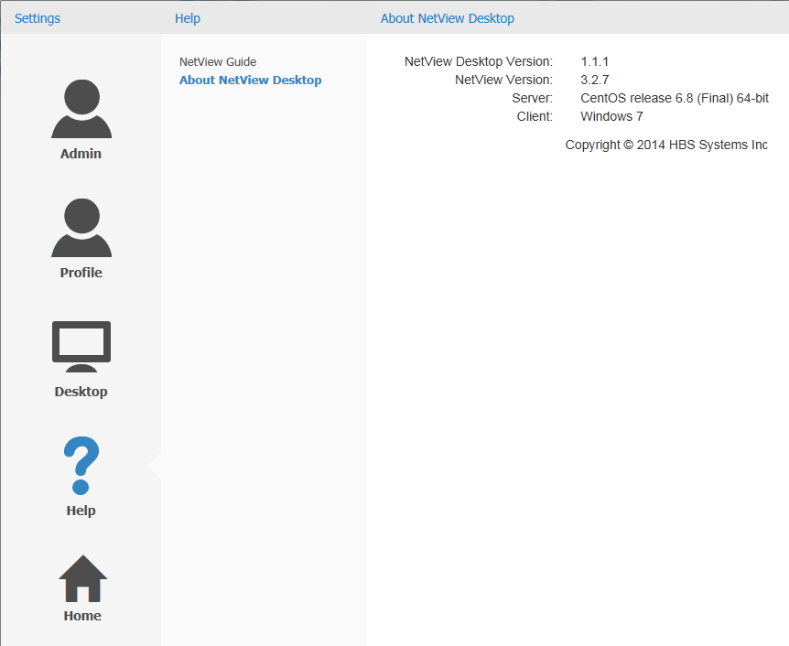

**About NetView Desktop:** The About NetView Desktop panel displays basic information about the program, such as its version, associated server, compatible web browser(s), and its copyright information.