Parts Sales Journal (INPJ):

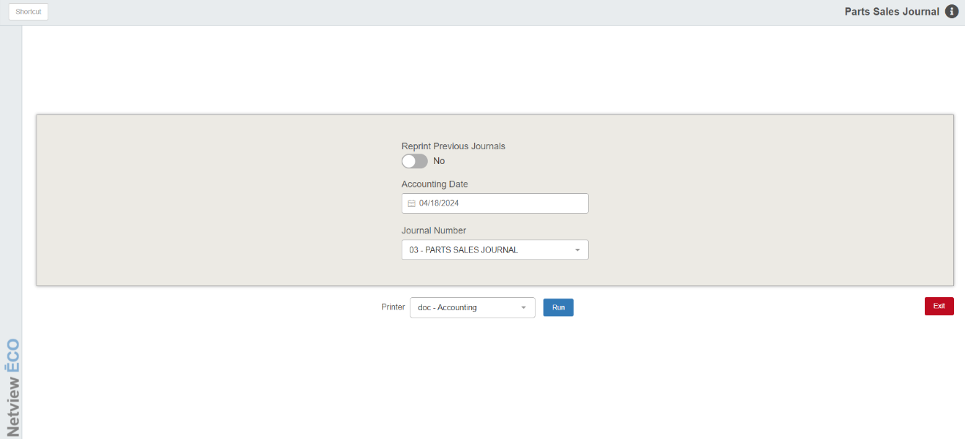

Parts Sales Journal (INPJ) takes any pending Parts Inventory sales transactions that have been recorded in the Daily Parts Profit Report (INPR) and posts them to the General Ledger.

### To access this function, you can either:

### Select “Inventory” from the menu and select “Inventory Post Journal.”

### Type “INPJ” in the Shortcuts Bar.

### Field Definitions:

### Reprint Previous Journals: This option lets you reprint the last journal posted here. Choose Yes to reprint the last journal printout. This is handy if the printer jammed while printing it. In most cases, No will be the typical choice.

### Accounting Date: Use the current date to post all un-posted transactions up to and including today’s date. The current date pre-fills in this field, but you may change the date as needed. You may type a date or select one using calendar button to the right of the field. If you are posting entries from a previous month, use the last day of that month as the Accounting Date, and it will post all un-posted transactions for that period. NOTE: Make sure the date chosen is within the current open accounting period, and also does not violate the Future or Back Date Limits as set in Company Name & Address; Misc Info (CONA).

### Journal Number: This field defaults to Journal 03, the Parts Sales Journal. Do not change this setting, as all Parts sales transactions need to go to this Journal to ensure correct accounting.

### Printer Name: Select the printer to receive the printout. A default printer name is pre-filled but can be changed as necessary. Use the PDF printer to view the report on the screen without printing a copy of it.

### Run: Press this button to run the Journal posting process.

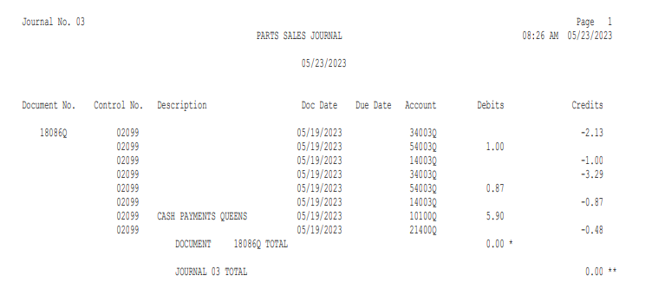

### Sample Journal Printout: The header of this printout includes the date and time the journal was posted, the journal number, and the description of the journal itself. The Journal printouts consist of two sections per Journal: the detail of the entries posted and the Account Activity Summary.

### Journal Number Detail Section:

### Document No.: This field shows the document number for this transaction (check number, invoice number, receipt number, or other reference).

### Control No.: If the account number has a subledger code, you will see the control number here. This could be any of the following:

### Stock Number

### Vendor Number

### Reference Number

### Customer Name

### Description: The description for this line of the transaction will display in this field.

### Doc Date: This field shows the document date entered.

### Due Date: This field shows the due date for the transaction where appropriate.

### Account: This shows the General Ledger account number used for each line of the transaction.

### Debits: If the amount for this individual line was a debit amount, it will appear in this column.

### Credits: If the amount for this individual line was a credit amount, it will appear in this column.

### Document Total: For each transaction posted, a document total is printed. If the transaction posted is in balance, the document total will be 0.00. If an amount other than 0.00 shows for the document total, the document posted out of balance and should be reviewed.

### Journal Total: A Journal total is also printed at the end of the report. If the Journal posted is in balance, the Journal total will be 0.00. If an amount other than 0.00 shows for the Journal total, the Journal was posted out of balance and should be reviewed.

### Account Activity Summary: The final page of the printout shows the Account Activity Summary (see image below). This section summarizes the net dollar amount passed to various account numbers when the journal was posted. The account number, description, and net amount posted shows for each affected account number.

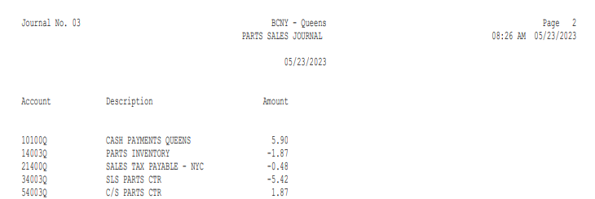

### Exception Report: If there are transactions that have not been posted from a prior period, an Exception Report (see image below) will print with the Journal. It shows the Journal, document number, ledger number, date, and amount of each un-posted transaction.

