IPO Reports (IPOR):

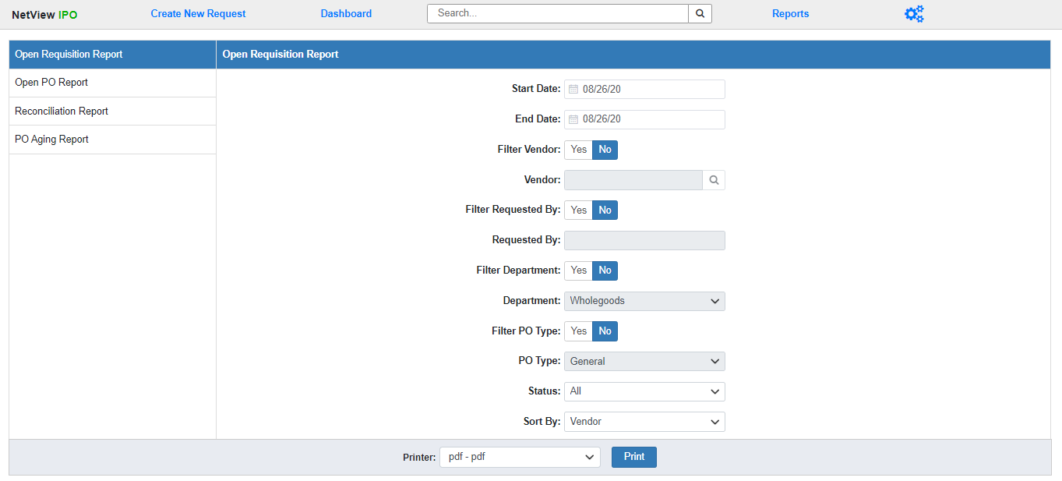

Integrated Purchase Orders (IPO) includes a set of reports which provides information about your current Purchase Orders. To access the Reports screen, open IPO and click “Reports” in the Program Header. You can also enter “IPOR” in the Shortcuts Bar to directly open IPO to this screen.

Select the report you want to run from the sidebar on the left side of the screen. The following topics will cover each of the available reports in detail.