Menu

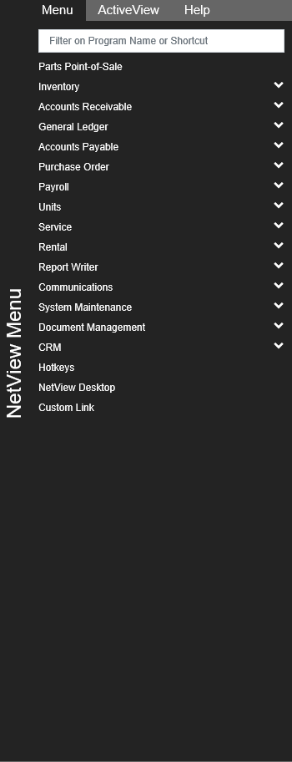

The black NetView Menu panel is located on the far right side of the page.  It consists of three tabs:

* **Applications (Menu)**
* **ActiveView**
* **Help**

**NOTE:** This feature will eventually be included in EVERY application.

**Show/Hide:** To hide the menu, click on the left side where the “NetView Menu” label appears. The menu will disappear, leaving only the label visible. To show the menu again, click the label a second time.

**Viewing Tabs:** Click on a tab header at the top of the menu to view its particular information. The Applications tab, titled “Menu,” appears by default when you access the menu.

**Applications (Menu) Tab:** This tab lists the different categories of NetView applications. **To open an application from the menu**, locate it using the categories and sub-menu options, then click on the application name.  The application will then appear in a new window or tab.

Category Sub-Menus: If a category has a downward-pointing arrow to its right, then there is a sub-menu listed underneath that category. Click on the category name to view the sub-menu options. **NOTE:** Sub-menu options can also have sub-menus, indicated by the same downward-pointing arrow to the right of its name. Again, click the option name to view its sub-menu.

+/- Icons: If a “+” appears to the side of the arrow after opening a category or sub-menu, you can use it to display all options under the category or sub-menu, including those on a sub-menu of the sub-menu.  To hide all options again, click on the “-” that will replace the “+” after you click it.

**ActiveView Tab:** This tab lists all the available ActiveView widgets that you can use to customize your desktop. For more information, see the “**ActiveView Widgets**” topic page.

**Help Tab:** The Help tab contains the **ActiveDesktop User Guide**, which you are currently viewing. To expand it to full-screen, click the icon of two diagonal arrows pointing in opposition directions, located next to the tab name.  The Help screen will then appear in a new browser tab.  Also see the “**Help**” topic under “Settings.”  Features included in the Help are:

* ActiveDesktop User Guide
* Table of Contents linked to the different pages within the guide
* Instructional videos for certain topics
* Search function