**Profile:** The Profile category is located below the Admin category on the main Settings

menu panel, and is represented by an icon of a person’s head and shoulders with “Profile”

displayed beneath it.

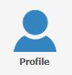

Clicking on the icon will allow you to access the Profile sub-menu to view and change your individual profile settings.

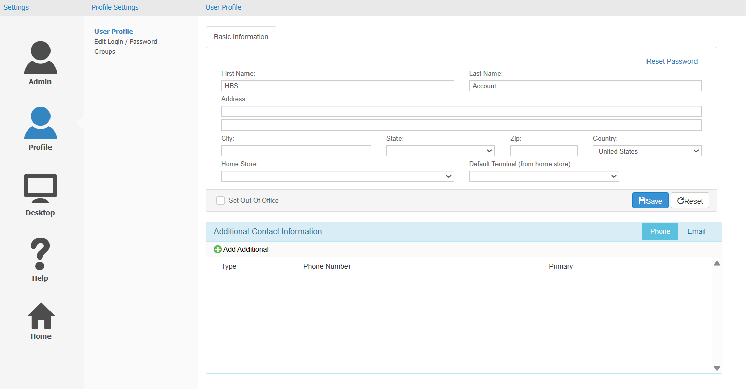

**User Profile:** The User Profile screen displays your basic profile information in a box labeled “Basic Information,” as well as your contact phone numbers and email addresses in a box labeled “Additional Contact Information.” This panel allows you to edit your profile information.

Basic Information: This box shows your name, address, the business location where you work, and, if your location has SmartIron credit card processing set up, the SmartIron card terminal you normally use. You can edit this information at any time and use the **Save** button to update your profile.

**Reset Basic Information:** If for any reason you need to reset your basic information after making changes, but **before saving them**, click **Reset** to revert your changes, then save your profile.

**Set as Out of Office:** Check this box if you will be out of office for a considerable amount of time.  This lets the system know that you will not be available to address any messages requiring immediate action, so it will send notifications to other users who could do the job instead. Make sure to remove the check when you return so the system knows you are back.

Additional Contact Information: The Additional Contact Information box is below the Basic Information box. You can use it to add phone numbers and email addresses to your profile.

**Phone:** To view your contact phone numbers, select the Phone tab in the upper right-hand corner of the box. A list of phone numbers, along with each number’s “type” (work, home, mobile, etc.), will appear in the box.  The box will also indicate which number is your primary phone number.

* To **add** a phone number to the user’s contact list, click **Add Additional**. The following window will open:

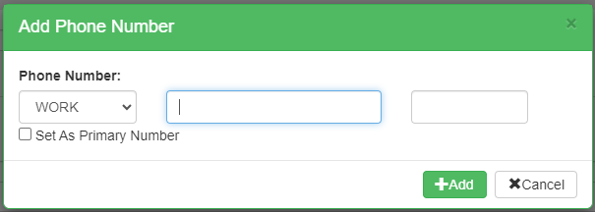

* + Select the phone number’s desired type from the drop-down menu in the first field.
  + Type the phone number into the second field.
  + If there is an extension, type that into the second field.
  + To set the new number as the user’s primary contact, check **Set As Primary Number**.
  + Click the **Add** button to add the new number.
* To **edit** an existing phone number, click the **Edit** icon () next to the number to open the following window:

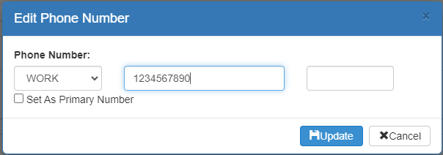

Make changes as desired, then click **Update** to save them.

* To **remove** a phone number on the user’s contact list, click the black **“x”** on the same line as the number. A dialogue box will appear, asking if you really want to remove the number.  Click **Yes** to delete the number.

**Email:** To view your contact email addresses, select the Email tab.  A list of email addresses, along with each address’s “type” (home, work, etc.) will appear in the box, any of which you can set as your primary email. **NOTE:** The user **requires** at least 1 primary email address in order to use the SupportNow Chat feature on the main Desktop.

* To **add** an additional email address to the user’s contact list, click **Add Additional.** The following window will appear:

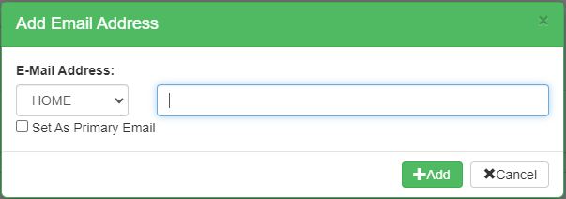

* + Select the address’s desired type from the drop-down menu in the first field.
  + Type the email address itself in the second field.
  + To set the new email as the user’s primary contact email, check **Set As Primary Email**.
  + Click the **Add** button to add the new number.
* To **edit** an email address on the user’s contact list, click the click the **Edit** icon () next to the address to open the following window:

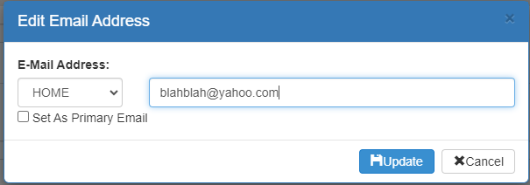

Make changes as desired, then click **Update** to save them.

* To **remove** an email address from the user’s contact list, click the black **“x”** on the same line as the address. A dialogue box will appear, asking if you really want to remove the address.  Click **Yes** to delete the address.

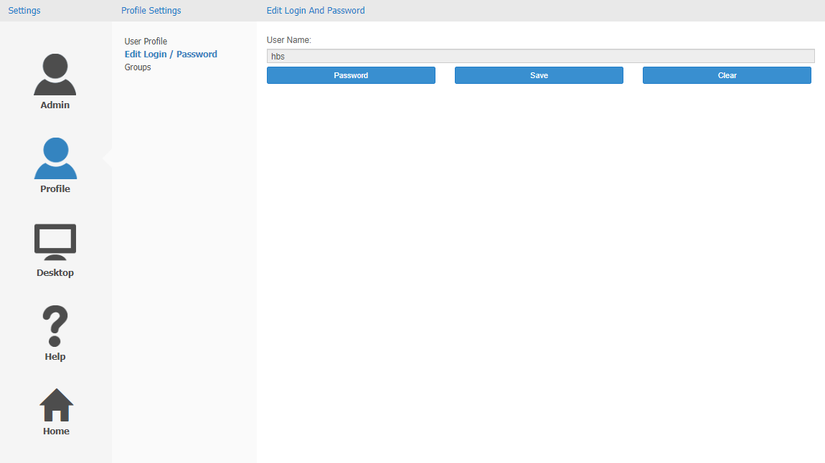

**Edit Login/Password:** The Edit/Login Password panel allows you to change your password. Start by clicking **Password**, which will reveal the following fields:

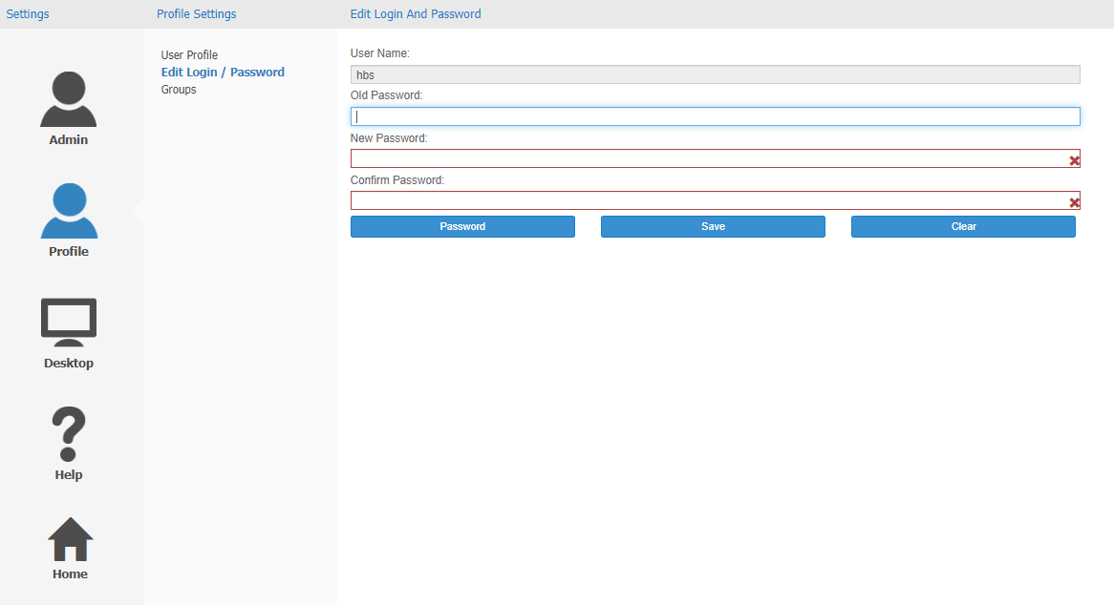

Old Password: Enter your current password here.

New Password:Type your new password here. Make sure the red “X” at the end of the field has turned into a green check mark, indicating your new password has been accepted. **NOTE:** If the red “X” does not go away when you type your password in, then the password does not meet the password requirements set for NetView Desktop. To view the password requirements, click the red “X” and they will appear in a small text bubble.

Confirm Password: Type your new password a second time here.

Save: Click this button to save your new password.

Clear: Click this button to clear the password spaces and re-hide them without changing your password.

**NOTE:** When you change over from your old system to NetView Desktop, you will not be required by the system to change your password, even if it does not match the requirements set in NetView Desktop by the system administrator.  Your system administrator may require you to change your password to comply, but NetView Desktop itself will not.  However, all future passwords must comply with the requirements.  So when you change your password for the first time after the system switch, make sure it fits any requirements.

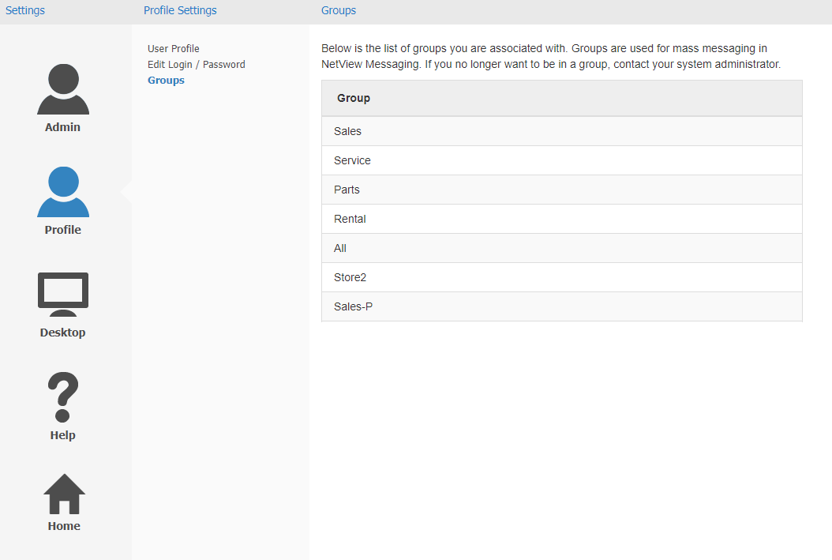

**Groups:** The Groups screen displays what NetView Messaging groups you belong to.  **NOTE:** You cannot change your membership in any group **unless you have administrator privileges**.  If you wish to be added or removed from a group, **contact your system administrator**.