**Promotions:** The Promotions tab shows details for all order promotions currently available for CNH customers.

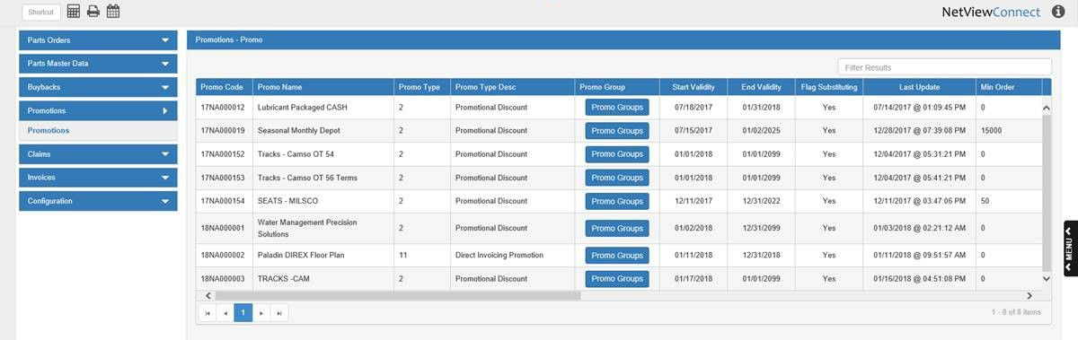

Each entry in the grid represents a single promotion. You can sort the results using the column headers, or filter it by entering specific information in the **Filter Results** field.

**Main Screen-Column Definitions:**

Promo Code: This column shows the promotion code.

Promo Name: This column shows the promotion’s name.

Promo Type: This column shows the promotion’s type code.

Promo Type Desc: This column shows the promotion type’s description.

Promo Group: This column holds the **Promo Group** button, which if clicked shows the promo group details for the particular promotion entry:

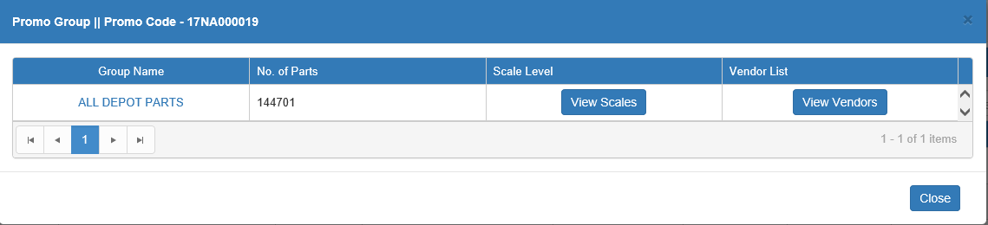

**Group Name:** This column shows the name of the promotion group. It also serves as a **hyperlink** to view a list of the CNH parts that belong to the group:

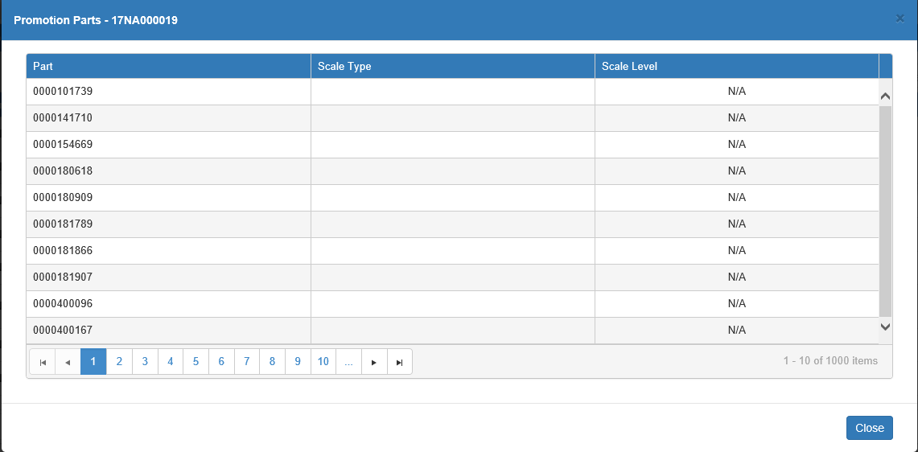

However, this window can only hold up to **1000** entries at a time. If there are more than 1000 parts in the group, a range selection window will appear first and prompt you to select which entries on the list you actually want to view.

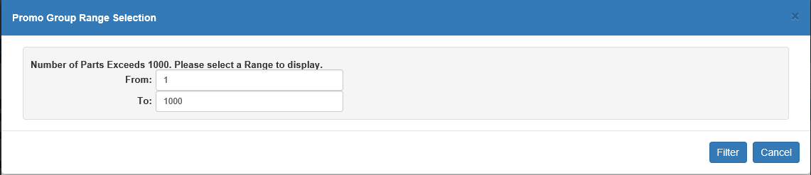

Note that the range is set by the part’s **position on the list**, not its actual part number. For example, in the image above, the range indicates that the program should show the 1st-1000th part entries, not part numbers 1-1000.

**No. of Parts:** This column shows how many parts belong to the group. Note that if this number is **negative** there will not be a parts list to view via the hyperlinked group name.

**Scale Level:** Click the **View Scales** button to see the scale levels for the promo group.

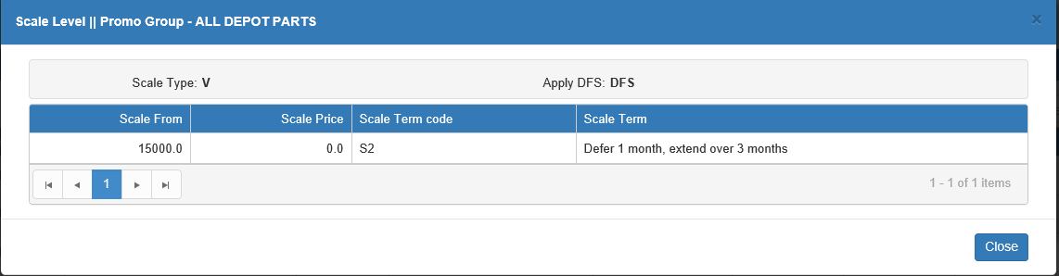

**Vendor List:** Click the **View Vendors** button to view the vendor list for the promo group.

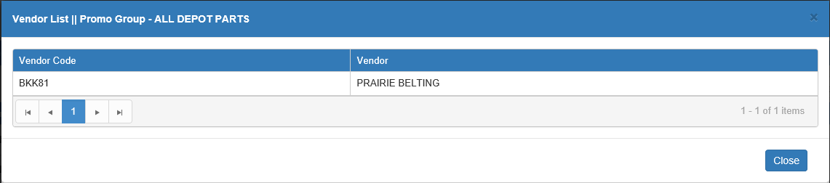

**Close:** Click this button to close the window and return to the main Promotions screen.

Start Validity: This column shows the promotion’s start date, i.e. the first day it becomes valid.

End Validity: This column shows the promotion’s end date, i.e. the last day it is valid.

Flag Substituting: This column indicates whether or not the promotion will still apply in the case of a part substitution.

* If it says “Yes,” then the promotion will apply even if the original promoted part is substituted for a non-promotion one.
* If it says “No,” then the promotion will no longer apply if the part is substituted.

Last Update: This column shows the last date and time that the promotion’s information was updated by CNH.

Min Order: This column shows the minimum dollar amount in orders that the dealer must make to be eligible for the promotion.

Min Qty: This column shows the minimum part quantity that the dealer must order to be eligible for the promotion.

Max Fence: This column shows the maximum number of times a dealer can apply the promotion within a specific time period. For example, a dealer may only able to receive a certain promotion 10 times in a month.

Current Fence: This column shows the current number of times a dealer has applied the promotion within the set time period of the fence. For example, the max fence could be set to 10 times per month, but since the dealer has only used the promotion twice in a month, the number in this column would be “2.”

Commitment Enroll From: If you have committed to a promotion, this column shows the start date of your commitment period.

Commitment Enroll To: If you have committed to a promotion, this column shows the end date of your commitment period.

Commitment Perc: If you have committed to a promotion, this column shows your commitment percentage.

Delivery Order Type: This column shows the delivery order type for the promotion, if applicable.

Promo Message: This column shows the actual details of the promotion and how it works.