Repair Order History (ROH)

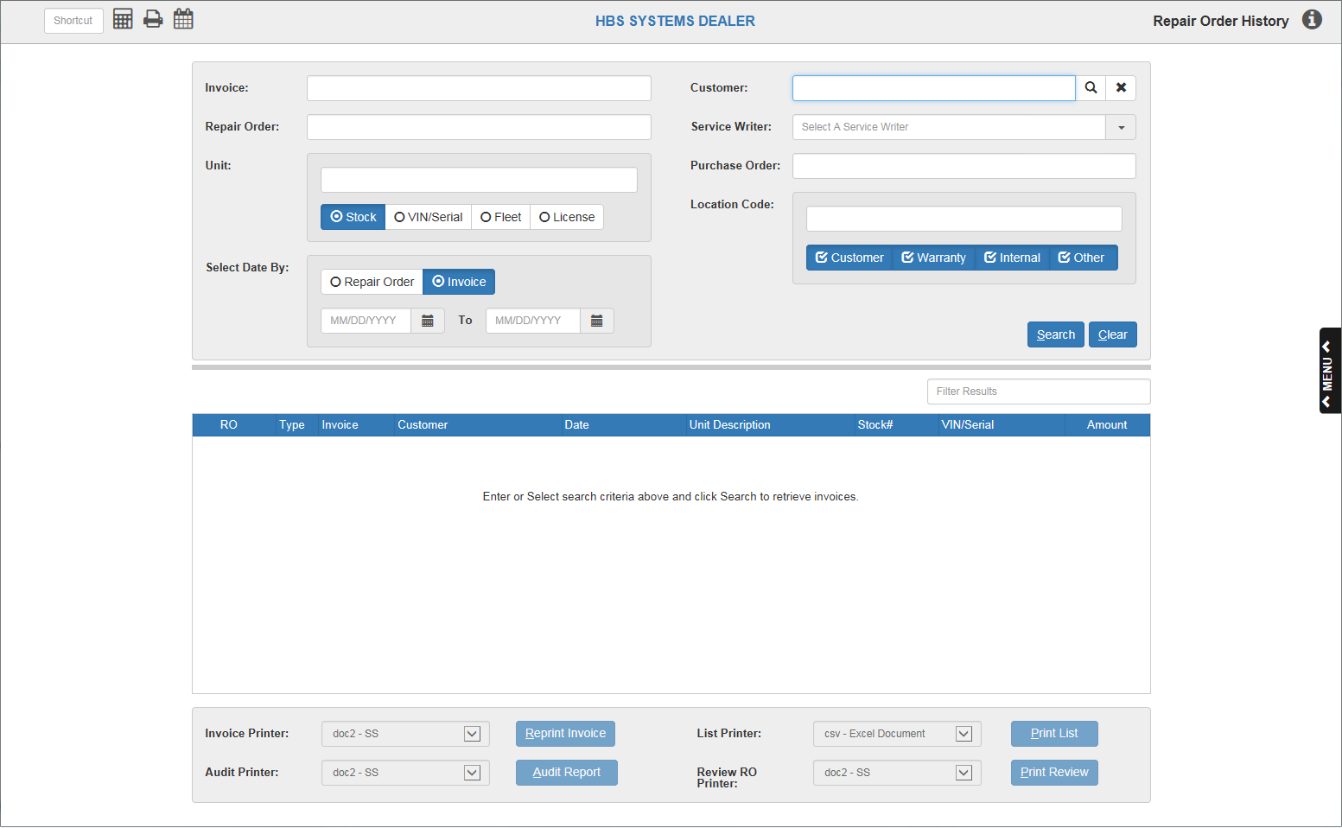

Repair Order History (ROH) allows you to view older repair orders that have been closed and stored in your history.

* To access this program, you can:
  + Type “ROH” into the Shortcuts Bar.
  + Select “Service” from the menu and click “Repair Order History.”

**Field Definitions**

Invoice: To search by invoice number, type the invoice number in this field.

Customer: To search by customer, type the customer number in this field.

* To clear the field, click the “X” icon beside it.
* **Customer Search:** You can also search for a customer by all or part of their name in this field and clicking the Search icon.
  + The following screen will appear:

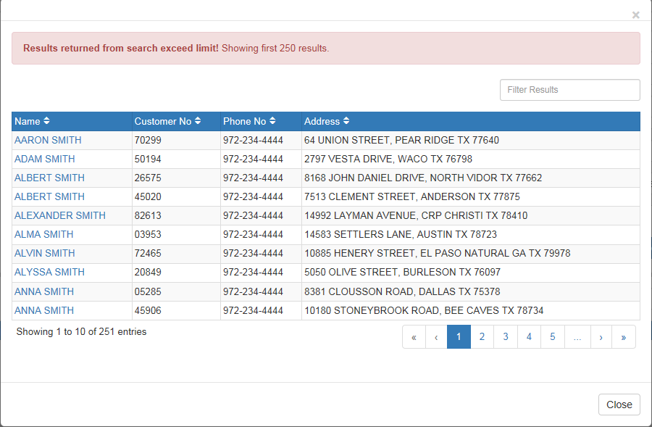

* + Click the customer’s name if you see it on the first page of results.
  + If you do not see the customer’s name, use the search tools to locate it.
    - **Page Numbers**: Use the page numbers and arrows to navigate between pages of results.
    - **Filter Bar**:Use the Filter Bar in the upper right-hand corner to narrow down your results by entering in more specific information, such as:
      * More of the customer’s name
      * All or part of the customer number
      * All or part of the customer’s phone number
      * All or part of the customer’s address
  + Once you have selected a customer’s name, their information will populate the Customer field like so:



Repair Order: To search by repair order number, type the number into this field.

Service Writer: To search by service writer, type either the service writer’s name or number in this field.

* Once you begin typing, a drop-down menu listing potential service writers by their number and name will appear below the field.

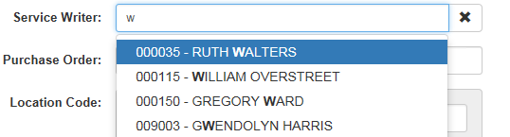

* Type until you see the service writer you’re looking for, then select their name from the menu.
* Once you’ve selected your writer, the information will fill in the field as shown below:



* To clear the field, click the “X” icon to the right of the field.

Unit: To search for by unit, select one of the unit ID types listed below the field and type the associated number into the field. The number could be one of the following:

* Stock number
* VIN/Serial number
* Fleet number
* License number

Select Date By: Use this feature to search for repair orders created within a set of dates.

* Choose whether the document is a **Repair Order** or **Invoice**.
* Set the date range by either:
  + Typing the starting and ending dates into the two fields.
  + Using the Calendar icon by each field to select a date, which will automatically fill into the field(s).
    - **Year Feature:** This search allows you to automatically enter the first and last dates of a year by simply typing that year into the first and second fields, respectively. This then lets you search for all orders created during that year.

Purchase Order: To search by purchase order number, type the number in this field.

Location Code: To search by location code, type the code in this field and select one or more types to which it applies (you can select up to all four at the same time). The types are:

* Customer
* Warranty
* Internal
* Other

**Search:** Once you have typed in your desired search criteria, click “Search.” You can also simply click “Search” to pull up all the available records in the application. If the search finds any results, they will fill the Results Box below.

**Clear:** To clear any filled-in search fields of their information, click “Clear.”

**Results Box:** This information box will list the information of any orders returned by a search.

Filter Bar:Use the Filter Bar above the box’s right corner to narrow down your results by typing in further information that might be listed in one of the box’s columns, such as the RO number or the customer’s name. You will receive results for even partial information, like a first name or half of an order number.

Sortable Headers: Use the column headers to sort the data by various criteria, depending on the header used. See “Column Definitions” below for how each header sorts the information.

Column Definitions:

* **RO:** The repair order number will appear in this column. The column header sorts the data numerically by RO number, both ascending and descending.
* **Type:** The order’s type will appear in this column. The column header sorts the data alphabetically or reverse alphabetically by the type letter.
* **Invoice:** The order’s invoice number will appear in this column. The column header sorts the data numerically by invoice number, both ascending and descending.
* **Customer:** The customer’s name will appear in this column. The column header sorts the data alphabetically or reverse alphabetically by the first letter of the first name.
* **Date:** The order’s date will appear in this column. The column header sorts the data chronologically or reverse chronologically by date.
* **Unit Description:** The unit description will appear in this column. The column header sorts the data in the following ascending order (with everything reversed if done descending):
  + Entries with no description (appear last if sorted in reverse)
  + Numerically by first number in description (descending numeric order when sorted in reverse)
  + Alphabetically by first letter in description if there are no numbers (reverse alphabetically before the descending numbers when sorted in reverse)
* **Stock#:** The unit’s stock number will appear in this column. The column header sorts the data numerically by stock number, both ascending and descending.
* **VIN/Serial:** The unit’s VIN/serial number will appear in this column. The column header sorts the data numerically by VIN/serial number, both ascending and descending.
* **Amount:** The dollar amount of the order will appear in this column. The column header sorts the data numerically by dollar amount, both ascending and descending.

**Printing:** The application provides three different printing methods through which you may print one or more of your orders.

Invoice Printer/Reprint Invoice: This printer becomes active once you select a repair order from the Results Box.

* To reprint the repair order invoice:
  + Select a printer from the Invoice Printer drop-down menu.
  + Click “Reprint Invoice.”

Audit Printer/Audit Report: This printer becomes active once you select a repair order from the Results Box.

* To audit the report and print the results:
  + Select a printer from the Audit Printer drop-down menu.
  + Click “Audit Report.”

List Printer/Print List: This printer becomes active once the Results Box fills in with one or more repair order entries.

* To print the full list of results contained in the box:
  + Select a printer from the List Printer drop-down menu.
  + Click “Print List.”

Review RO Printer/Print Review: This printer becomes active once the Results Box

fills in with one or more repair order entries.

* To review a repair order:
  + Select a printer from the Review RO Printer drop-down menu.
  + Click “Print Review.”