Rental Reports (RR)

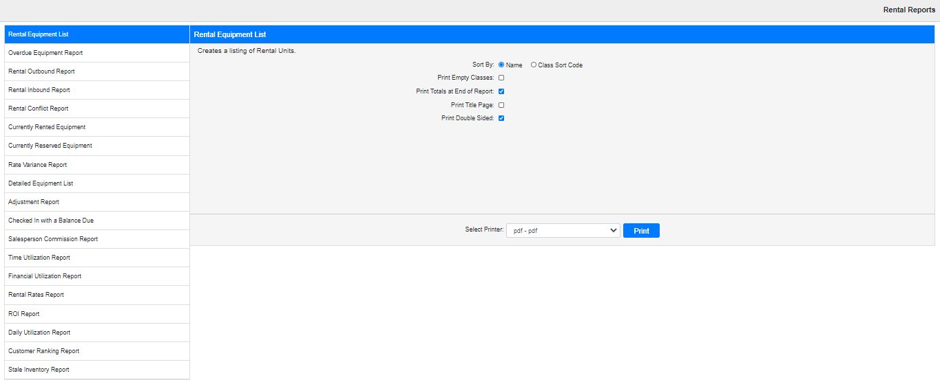

Rental Reports (RR) is the main reporting program for Rental.

To access this function, you can either:

* Select “Rental” from the menu and click “Rental Reports.”
* Type “RR” in the Shortcuts Bar.

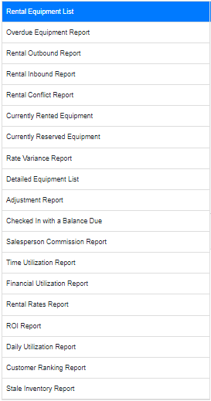

**Select Report:** Use this sidebar menu to select which report you want to create.

**NOTE: The following topics will cover the reports featured in this program.**