**Rental Rates Report:** The Rental Rates Report in Rental Reports (RR) creates a report of the Rental rates.

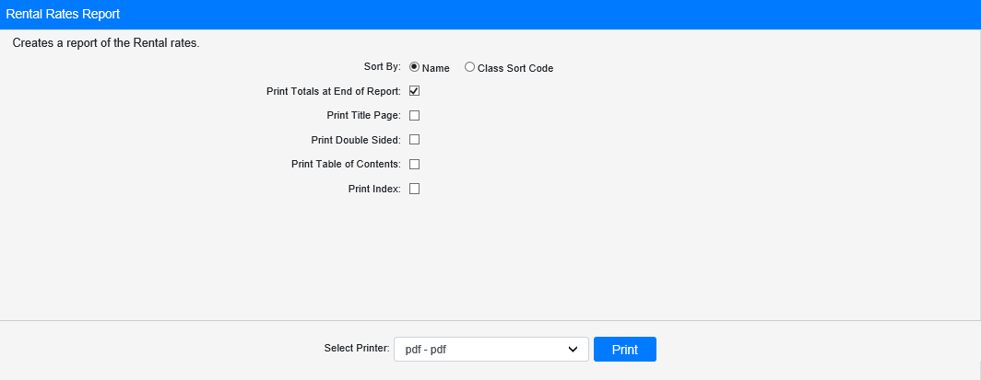

**Field Definitions:**

Sort By: Choose to sort the report by

* Name
* Class Sort Code

Print Totals at End of Report:

* **Check** this box to print a total class count at the end of the report.
* Leave it **unchecked** to omit the totals.

Print Title Page:

* **Check** this box to print a title page with the report.
* Leave it **unchecked** to print the report without one.

Print Double Sided:

* **Check** this box to print the report double-sided.
* Leave it **unchecked** to print the report single-sided.

Print Table of Contents:

* **Check** this box to print a table of contents with the report.
* Leave it **unchecked** to print the report without one.

Print Index:

* **Check** this box to print an index with the report.
* Leave it **unchecked** to print the report without one.

Select Printer: Select the printer to receive the report. Use the **pdf** printer to preview the report.

**Click “Print” to print the report.**

**Sample Report:**

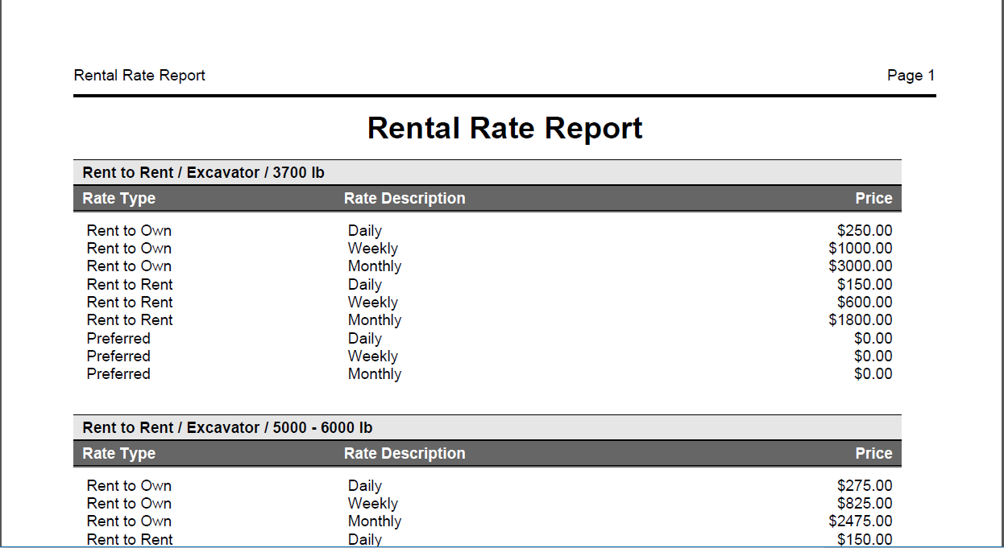

This example of the report is sorted by **Name**. The rate types are listed with their description and price.