### STXHM - Sales Tax History Maintenance

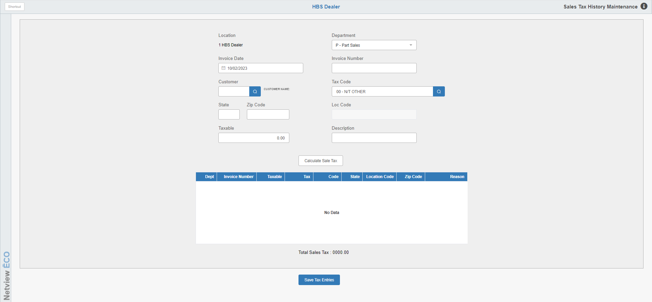

This program provides the ability to add records to the system collected sales tax information, as **manual** entries affecting sales tax made in other programs do not contribute to the Sales Tax reports. This maintenance program could be used to create entries in the Sales Tax database for manual entries, especially to ensure any reversed sales ended up on the Sales Tax reports. For example, if you reversed a unit sale with a G/L entry in G/L Document Entry (GLED), you would need to add that adjustment in this program.

### Field Definitions:

### Location: Shows the current dealer location.

### Department: Identify the department needing the adjustment. Choose from:

### Parts

### Rental

### Service

### Units

### Invoice Date: Enter the date of the transaction.

### Invoice #: Enter the invoice number of the transaction.

### Customer #: Enter the customer number or look it up.

### Tax Code: Choose the tax code that applies to the transaction.

### State: Enter the state where the transaction occurred.

### Zip Code: Enter the zip/postal code where the transaction occurred.

### If the transaction is to be taxed at the dealership tax rate, enter the dealership’s code.

### If it is to be taxed at the rate coded on the customer’s address, enter that zip/postal code.

### Loc Code: This field is only used for Washington state taxes. Enter the state location code where the transaction occurred.

### Taxable: Enter the taxable/non-taxable amount of the transaction. It will be flagged as:

### Taxable if the tax code chosen is taxable

### Non-taxable if the tax code chosen is non-taxable

### Description: Enter a short description of the transaction.

### Calculate Tax: Press this button to have the system calculate the tax for the transaction.

### For SST states, it will use the customer’s geo code to perform the calculation.

### For non-SST states, it will use the tax code to determine the tax.

Entry for an SST state:

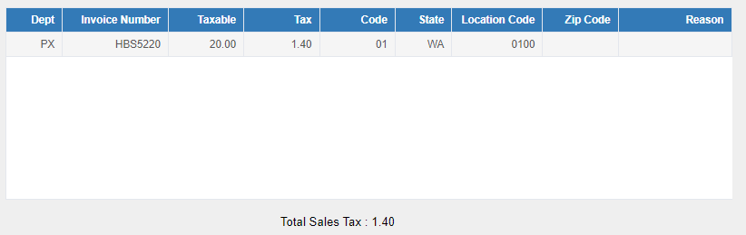

Entry for a non-SST state:

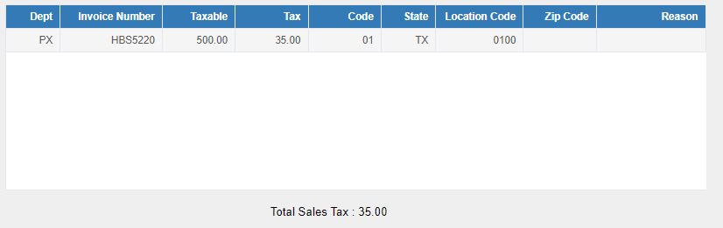

**Save Tax Entries:** Press the **Save Tax Entries** button to save the transaction to the sales tax transaction file.